HEALTH STAR RATING STAKEHOLDER WORKSHOP

Brisbane 29 June 2016

Combined session including food industry stakeholders and public health stakeholders (Attendees: 31)

SUMMARY REPORT
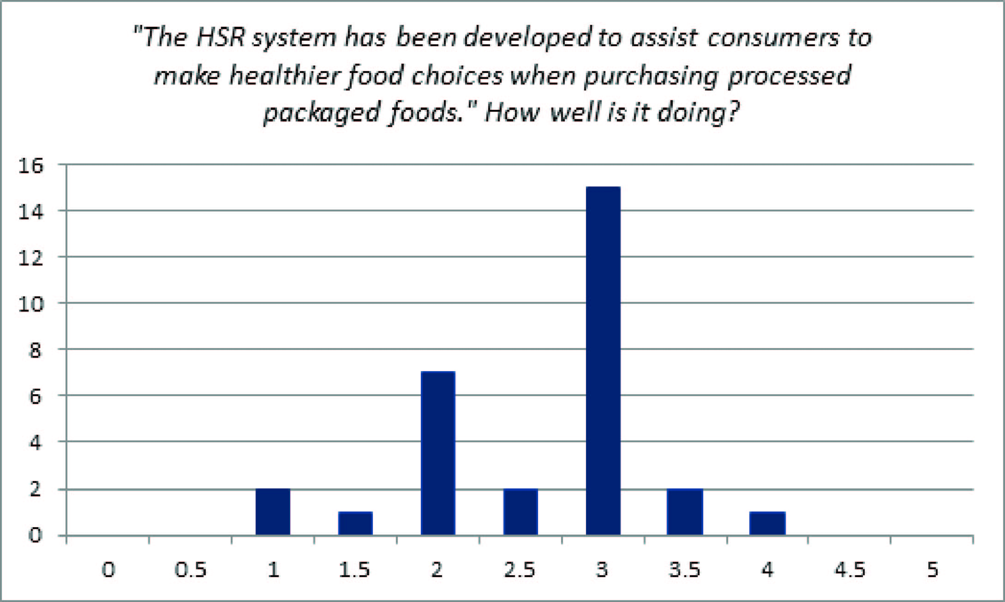

Key messages for consideration by the Health Star Rating (HSR) Advisory Committee
The outcomes of the workshop are not a consensus statement. The ‘messages’ described below reflect the main themes and views of attendees in general.

- More consumer awareness and education is required with improved key messages, especially to allay points of confusion. Messages should reinforce that the HSR system is for processed packaged food only and that fresh choices should be made over packaged food.
- Consistency across all packaged products would be achieved if the HSR system were made mandatory with formalised monitoring and enforcement.
- Alignment of the HSR system with the Australian Dietary Guidelines (ADGs) needs to be reconsidered, particularly in relation to discretionary and core foods.
- The format and delivery of the workshop was generally well received.

Main areas of discussion
There was discussion around the consumer education campaign and it was thought that there is confusion about what products the HSR system is designed for and how to use it. Attendees felt that further education is required in clear simple terms to clarify that comparisons should be made within food categories, that the HSR is for processed packaged foods and that fresh whole foods should be chosen over packaged food. There was also discussion around using existing systems and communication channels to disseminate information and to utilise public relations activities and social media more effectively.

There was discussion about making the HSR system mandatory as this would result in the HSR being applied consistently across all products and provide clear rules and formalised quality control. There was a comment, however, that before making the system mandatory we must ensure that it is as effective as it can be.

Some discussion around the alignment of the HSR system with the ADG focussed on distinguishing between core and discretionary foods. Some felt that there is room for improvement in this space and that the HSR should be used to highlight core foods rather than discretionary foods. There was some discussion around the treatment of sugar (natural [intrinsic] vs added) and the option of introducing a cap within the algorithm on sugar and salt. Other comments in relation to the algorithm included: splitting the broad ‘food’ category; creating more specific comparisons or developing better cross category comparisons; consideration of serve sizes in relation to small serve size packs; consideration of combination foods/cross category foods e.g. pizza/sandwiches. Other comments were that the star rating should be based on food ‘as is’ not once prepared.

There was consensus that the HSR logo is simple and easy to understand. The ‘star’ is familiar and provides a quick way to compare items rather than trying to interpret the ‘back of pack’. It has visual impact and improves food label literacy especially for those with low literacy/numeracy levels or who come from a non-English speaking background. In general it was felt that the HSR enables consumers to make an informed healthier choice within a food category.

