**Health Star Rating (HSR) Advisory Committee (HSRAC)**

**Form of the food (‘as prepared’) rules for the HSR system**

**Appendices**

Contents

Appendix 1 – Current ‘as prepared’ rules in the Guide for Industry 2

Appendix 2 – FSC provisions relevant to ‘as prepared’ products 3

Appendix 3 – HSR modelling using AUSNUT 2011-13 data 5

Appendix 4 – Summary of public submissions 8

Appendix 5 – Outcomes from workshops 9

Appendix 6 – TAG modelling using HSR database 12

Appendix 7 – Potential amendments to Guide for Industry 30

Appendix 8 – AFGC ‘decision tree’ 32

Appendix 9 – Testing and analysis of a previous version of the ‘decision tree’ 36

## Appendix 1 – Current ‘as prepared’ rules in the Guide for Industry

Glossary[1]

|  |  |
| --- | --- |
| As sold | The food as sold such that the food can be prepared with other food or consumed as sold. |
| As consumed | The food as consumed including foods that are required to be prepared according to directions prior to consumption. |

**Step 2: Determine the form of the food for the HSR[2]**

The HSR and hence nutrient content values used to determine it should apply to the form of the food as determined in accordance with the following:

* the food as sold if the food can be either prepared with other foods or consumed as sold
* the food as prepared if the food is required to be prepared and consumed according to directions on the label
* the food after it is reconstituted with water and ready for consumption if the food requires reconstituting with water
* the food after it is drained and ready for consumption if the food requires draining before consuming.

In all cases the HSR should be based on the form of food for which the NIP information has been displayed2. If the HSR is based on food ‘as consumed’, the label should clearly specify elsewhere on the pack the directions for preparation or cooking.

Standard 1.2.7-7 provides information on requirements on the form of food if a nutrition content claim or health claim is made in addition to displaying a HSR.

For breakfast cereals, the NIP and HSR should be for the cereal as sold. For products that can be used in a number of ways by the purchaser, such as breadcrumbs, the HSR should apply to the product as sold.

Standard 1.2.8-13 (3) provides additional NIP requirements where nutrient content is based on food that is intended to be prepared or consumed with another food.

2 In some cases the NIP information for the form of the food may be displayed per serve, whilst the information in the HSR label for the same form of the food, may be displayed per 100g. E.g. A condensed soup is intended to be prepared (and consumed) in accordance with specific directions. Information in the NIP and the HSR label should reflect the nutritional values in the prepared product. In the NIP, information is presented per serve and per 100g as sold and per serve as prepared. In the HSR system label, the information is presented per 100g as prepared.

## Appendix 2 – FSC provisions relevant to ‘as prepared’ products

# (asterisk references a FSC defined term)

**Standard 1.2.7       Nutrition, health and related claims[3]**

*1.2.7—7    Form of food to which provisions of this Standard apply*

If this Standard imposes a prerequisite, condition, qualification or any other requirement on the making of a claim, that prerequisite, condition, qualification or requirement applies to whichever of the following forms of the food is applicable:

(a)      if the food can be either prepared with other food or consumed as sold—the food as sold;

(b)      if the food is required to be prepared and consumed according to directions—the food as prepared;

(c)      if the food requires reconstituting with water—the food after it is reconstituted with water and ready for consumption;

(d)      if the food requires draining before consuming—the food after it is drained and ready for consumption.

**Standard 1.2.8       Nutrition information requirements[4]**

*1.2.8—11    Requirement for dehydrated or concentrated food*

If the label on a package of a food for sale indicates that the food should be reconstituted with water before consumption, the nutrition information panel must express the information required by this Standard as a proportion of the reconstituted food.

*1.2.8—12    Food intended to be drained before consumption*

If the labelling for a food for sale contains directions indicating that the food should be drained before consumption, the nutrition information panel must:

(a) express the information required by this Standard as a proportion of the drained food; and

(b)       clearly indicate that the information relates to the drained food.

*1.2.8—13    Food intended to be prepared or consumed with other food*

(1) This section applies to a food for sale if the labelling indicates that it is intended to be prepared or consumed with at least one other food.

(2)      The nutrition information panel may comply with the requirement in subsection (4).

(3)      If a *claim requiring nutrition information is made about the food, the nutrition information panel must comply with the requirements in subsections (4) and (5).

(4)      The requirement is that the nutrition information panel includes an additional column at the right hand side of the panel, specifying, in the same manner as set out in the panel:

         (a)      a description of the additional food; and

         (b)      the amount of the additional food; and

         (c)      the *average energy content of the combined foods; and

         (d)      the average quantities of nutrients contained in the combined foods; and

         (e)      the average quantities of biologically active substances contained in the combined foods.

(5)      The requirement is that the nutrition information panel specifies the weight or volume of the serving size of the food as prepared.

## Appendix 3 – HSR modelling using AUSNUT 2011-13 data

Analysis was undertaken using AUSNUT (Australian Food and Nutrient Database) 2011-13 data to estimate how common preparation practices may impact on HSRs.

The AUSNUT dataset provides data representing the average nutrient content for a broad range of products ‘as sold’ and ‘as prepared’ according to various preparation methods. The data for the ‘as sold’ version of each food is based on nutrient analysis, with the ‘as prepared’ data generally calculated using a recipe approach based on the recommended instructions for preparing the product on pack.

Table 1 below provides predicted HSRs for ‘as sold’ and ‘as prepared’ forms of the same product for most of the categories impacted by the ‘as prepared’ rule, noting that data for recipe mixes/bases has not been captured.

Results demonstrate that:

* HSRs are generally improved for the prepared version of the food, although this increase is variable - from a difference of +0.5 between dry cake mixes and prepared cakes (0.5 → 1), to +4 between skim milk powder and prepared skim milk (0.5 → 4.5)
* A number of products impacted by the ‘as prepared’ rule are not typically prepared solely with water
* For some dry products (e.g. gravy, stock, milk powder) the HSR ‘as prepared with water’ provides greater differentiation than HSR calculated ‘as sold,’ in particular the reduced salt vs regular salt or full fat vs skim versions of the same products.
* The differentiation between full fat and skim milk powders may be further enhanced when these foods are mixed with non-dairy beverage powders (e.g. coffee, chocolate), which also causes a HSR Category shift from Category 1 to Category 1D.

Note: There may be discrepancies between “HSR group” and core/discretionary flags due to the greater differentiation between products at a disaggregated level.

Table 1: HSRs for sample foods ‘as sold’ and ‘as prepared’ according to various preparation methods:

|  |  |  |  |  |  |
| --- | --- | --- | --- | --- | --- |
| HSR group | Food name | HSR | Core /  discretionary | Form of the food: | Food prepared with: |
| Category 1 - Beverages | | | | | |
| Core Dairy - beverages | Coffee mix, with beverage whitener & sugar, dry powder | ★ | D | Dry/Unprepared |  |
| Core Dairy - beverages | Coffee, prepared from coffee mix with sugar & whitener, no added milk |  | D | Prepared | Water |
| Core Dairy - beverages | Coffee mix, with beverage whitener & intense sweetener, dry powder |  | D | Dry/Unprepared |  |
| Core Dairy - beverages | Coffee, prepared from coffee mix with intense sweetener & whitener, no added milk |  | D | Prepared | Water |
| Beverages, non-dairy | Beverage base, chocolate flavour, dry powder |  | D | Dry/Unprepared |  |
| Core Dairy - beverages | Beverage base, chocolate flavour, prepared with reduced fat milk |  | C | Prepared | Milk – reduced fat |
| Core Dairy - beverages | Beverage base, chocolate flavour, prepared with skim milk |  | C | Prepared | Milk - skim |
| Beverages, non-dairy | Beverage base, chocolate flavour, prepared with water |  | D | Prepared | Water |
| Beverages, non-dairy | Cordial base, variety of flavours, regular |  | D | Dry/Unprepared |  |
| Beverages, non-dairy | Cordial, variety of flavours, regular, recommended dilution |  | D | Prepared | Water |
| Beverages, non-dairy | Cordial base, variety of flavours, intense sweetened |  | D | Dry/Unprepared |  |
| Beverages, non-dairy | Cordial, variety of flavours, intense sweetened, recommended dilution |  | D | Prepared | Water |
| Core Dairy - beverages | Milk, powder, cow, regular fat |  | C | Dry/Unprepared |  |
| Core Dairy - beverages | Milk, powder, cow, skim |  | C | Dry/Unprepared |  |
| Core Dairy - beverages | Milk, cow, fluid, prepared from dry powder, regular fat, standard dilution |  | C | Prepared | Water |
| Core Dairy - beverages | Milk, cow, fluid, prepared from dry powder, skim, standard dilution |  | C | Prepared | Water |
| Category 2 - Foods |  |  |  |  |  |
| Non-core foods | Soup, variety of flavours, instant dry mix |  | D | Dry/Unprepared |  |
| Non-core foods | Soup, variety of flavours, prepared instant dry mix |  | D | Prepared | Water |
| Non-core foods | Soup, variety of flavours, condensed, canned |  | C | Dry/Unprepared |  |
| Non-core foods | Soup, variety of flavours, condensed, canned, prepared with milk and water |  | C | Prepared | Milk & water |
| Non-core foods | Soup, variety of flavours, condensed, canned, prepared with water |  | C | Prepared | Water |
| Non-core foods | Cake mix, dry powder | ★ | D | Dry/Unprepared |  |
| Non-core foods | Cake, prepared from dry powder, uniced |  | D | Prepared | Egg, milk, fat |
| Core Cereals | Pancake, plain, dry mix |  | C | Dry/Unprepared |  |
| Core Cereals | Pancake, plain, prepared from dry mix |  | C | Prepared | Water |
| Non-core foods | Gravy powder, dry mix |  | D | Dry/Unprepared |  |
| Non-core foods | Gravy, prepared from dry powder with water |  | D | Prepared | Water |
| Non-core foods | Gravy powder, dry mix, reduced salt |  | D | Dry/Unprepared |  |
| Non-core foods | Gravy, prepared, reduced salt, commercial |  | D | Prepared | Water |
| Core Dairy - yoghurt, soft cheese | Custard powder, dry mix, commercial |  | C | Dry/Unprepared |  |
| Core Dairy - yoghurt, soft cheese | Custard, dairy, vanilla, prepared from dry mix |  | C | Prepared | Milk & sugar |
| Non-core foods | Stock, dry powder or cube |  | D | Dry/Unprepared |  |
| Non-core foods | Stock, liquid, all flavours (except fish), prepared from commercial powder or cube |  | C | Prepared | Water |
| Non-core foods | Stock, dry powder or cube, reduced salt |  | D | Dry/Unprepared |  |
| Non-core foods | Stock, liquid, all flavours, reduced salt, prepared from commercial powder or cube |  | C | Prepared | Water |
| Non-core foods | Pasta in sauce, dry mix |  | C | Dry/Unprepared |  |
| Non-core foods | Pasta in cream based sauce, prepared from dry mix with regular fat milk cows & margarine spread |  | C | Prepared | Milk & fat |
| Non-core foods | Pasta in tomato based sauce, prepared from dry mix with water & margarine spread |  | C | Prepared | Water & fat |
| Core Cereals | Noodle, wheat, instant uncooked |  | C | Dry/Unprepared |  |
| Core Cereals | Noodle, wheat, instant, boiled, drained |  | C | Prepared | Water, drained |
| Core Cereals | Noodle, wheat, instant, boiled, undrained |  | C | Prepared | Water, undrained |
| Vegetables | Potato, mashed, dried powder |  | C | Dry/Unprepared |  |
| Vegetables | Potato, mashed, prepared from dried powder with cows milk or water |  | C | Prepared | Milk & water |
| Non-core foods | Rice, flavoured, instant dry mix |  | C | Dry/Unprepared |  |
| Non-core foods | Rice, flavoured, prepared from dry mix |  | C | Prepared | Water |

## Appendix 4 – Summary of public submissions

The first round of consultations involved a public submission process which opened on 19 May 2017 via the Australian Department of Health Consultation Hub and closed on 30 June 2017. A total of 74 submissions were received from various stakeholders, as summarised below.

| **BACKGROUND / INTEREST GROUP** | **% OF TOTAL SUBMISSIONS** |
| --- | --- |
| Consumer group | 9 |
| General Public | 34 |
| Government | 11 |
| Industry | 18 |
| Public Health | 26 |
| Other | 2 |
| TOTAL | 100 % |

A summary of submissions is available at <http://www.healthstarrating.gov.au/internet/healthstarrating/publishing.nsf/Content/stakeholder-engagement>.

## Appendix 5 – Outcomes from workshops

**Summary of feedback on options from stakeholder consultation workshops**

|  |  |
| --- | --- |
| **1. Status quo.** The ‘as prepared’ rules remain unchanged - foods may display a HSR based on the product ‘as prepared’ according to the instructions on the product packaging. Manufacturers could clearly indicate on the front of the pack that the HSR is based on the 'as prepared' nutrition information values. | |
| **PROS:**   * Enables consistency with other pack labelling (FSC, NIP, HSR, serving suggestion, recipe). * Consistency with the FSC and dietary guidelines to avoid consumer confusion. * Relates to the product as it is intended to be consumed by manufacturers/retailers. On-pack specific preparation instructions are provided for consumers to prepare and consume the product. * Many foods are required to be made up prior to consumption are not able to be consumed ‘as sold’. * Allows comparability with like foods. | **CONS:**   * May increase consumer confusion. * May lead to unfair/inappropriate/inaccurate comparisons if food is not prepared according to instructions. * Might not be interpreted consistently across industry and consumer/health groups. |
| **2. ‘As sold’ only.** The HSR is calculated on the product ‘as sold’. The ‘as prepared’ rules would cease to exist. | |
| **PROS**:   * Provide incentive for manufacturers to decrease risk nutrients to improve product HSR. * ‘As sold’ would maintain the simplicity of the HSR system. * Where there are various ways of making up food products, using ‘as prepared’ can be misleading, while ‘as sold’ reflects the single product nutrition profile. | **CONS**:   * ‘As sold’ could diminish comparison between foods consumed in the same format (ie liquid), by falsely indicating variances between different forms of the same product when sold, ie dry vs reconstituted. * ‘As sold’ HSR information may not align with other on-pack labelling information, including the NIP. |
| **3. Multiple HSRs on pack.** The HSR is calculated on the product ‘as sold’ and ‘as prepared’. Multiple HSR ratings are displayed on front of pack with either the ‘as sold’ or ‘as prepared’ rating the most prominent on the label. A build on this option is that the ‘as sold’ HSR rating could be on the front of the pack with ‘as prepared’ HSR on the back label, located beside the recipe directions and/or NIP. | |
| **PROS**:   * Would satisfy supporters of both ‘as sold’ and ‘as prepared’. * Increases transparency, which may increase the credibility of the system. | **CONS**:   * Could be confusing for consumers and may reduce the simplicity of the scheme. * Consumer research would be required to determine whether multiple HSR labelling, as a significant change to the HSR system, would aid consumer understanding and drive behaviour change or cause consumer confusion. |

|  |  |
| --- | --- |
| **4. ‘As sold’ with exemptions.** The HSR is calculated on the product ‘as sold’ but certain exemptions would apply and these exemptions would need to be clearly outlined in the HSR industry guidance information. Exemptions that could be considered under this option include, but are not limited to, exemptions for specific foods; foods rehydrated with water only; and/or foods diluted with water only; and/or drained of water. | |
| **PROS**:   * ‘As sold' works well for most foods. For categories such as cake mixes, soups and drink flavourings, 'as prepared', ‘rehydrated' and 'drained' rules to determine HSR could continue. This may be more useful and meaningful to consumers than 'as sold' and allow fair comparisons. * Rehydrating with water was suggested as the only circumstance where ‘as prepared’ is allowed – this accounts for dilution but the rating couldn’t be improved by added ingredient foods. This option may better align the HSR ratings for foods with dietary guideline recommendations. * Suggested exemptions are for foods rehydrated or diluted by the addition of water only or draining of water. This could be the simplest option for consumers and wouldn’t be open to potential HSR manipulation by addition of nutritious food ingredients for positive HSR modifying points. | **CONS:**   * May be difficult to develop exemptions that are not ambiguous for industry or consumers. |

Average ranking of options at each workshop are below, noting that the rankings only reflect the views of those participants at the particular workshop.

**Graph 1. Sydney**

**Graph 2. Auckland**

**Graph 3. Melbourne Stakeholder group**

Full summaries for each workshop are available at <http://www.healthstarrating.gov.au/internet/healthstarrating/publishing.nsf/Content/stakeholder-engagement>.

## Appendix 6 – TAG modelling using HSR database

*HSR system database*

The initial database used in the development of the HSR system was expanded with data provided by food industry. This revised HSR database includes product nutrient data for over 5,800 food products across 42 food categories based on the Australian Guide to Health Eating, such as fats and oils, core cereals and dairy, processed and unprocessed fruits and vegetables, animal protein etc. Data cover the range of HSR nutrient levels found in Australian and New Zealand foods, including fruit, vegetable, nut and legume (FVNL) and fibre content data for all foods where applicable. The data are not independently verified.

To undertake the ‘as prepared’ modelling, the revised database needed to be supplemented with additional information from food manufacturers and retailers. The TAG requested and received additional product data from food manufacturers for 445 food products for use in the modelling (as shown in Table 1) to which the ‘as prepared’ rules apply (manufacturers did not provide data confirming which of these products currently display the HSR). The additional data included information on the form of the nutrient data provided (dry versus prepared) and information regarding how the product should be prepared as instructed on the product label (i.e. with water, milk, fat, meat and vegetables etc). The majority of the data was for the prepared form of the food (n=367), rather than the dry/unprepared form of the food (n=78). Data for the dry/unprepared plus prepared versions of the same food was only provided in a small number of cases (n=49). This is a significant limitation of this analysis. However, the data available does provide coverage of key product categories and thus serve as an representation of how HSRs would change if ‘as sold’ with specific exemptions for rehydration and dilution with water or draining of water is adopted.

**Table 1:** Additional product data submitted by food manufacturers for ‘as prepared’ TAG modelling

|  |  |
| --- | --- |
| **Australian Guide to Healthy Eating category** | **Number of products** |
| Core Cereals – breakfast | 45 |
| Core Cereals – pasta/flour/grains | 19 |
| Core Dairy – beverages | 10 |
| Core Dairy – beverages dry mix/milk powder | 36 |
| Non-core foods – bakery/cake mixes | 6 |
| Non-core foods – beverage dry mixes | 8 |
| Non-core foods – cordial | 2 |
| Non-core foods – custard/desserts | 7 |
| Non-core foods – jelly | 13 |
| Non-core foods – meals/meal bases | 125 |
| Non-core foods – sauces/condiments | 63 |
| Non-core foods – soups/stocks | 100 |
| Protein – plant | 1 |
| Vegetables – processed | 10 |
| **TOTAL** | **445** |

Table 2 presents some examples of product types included in this analysis, by Australian Guide to Health Eating (AGHE) category

**Table 2:**

|  |  |
| --- | --- |
| **AGHE category** | **Product examples** |
| Beverages, non-dairy | Cordial, coffee powder, hot chocolate powder |
| Core cereals | Instant noodles, porridge sachets |
| Core dairy – beverages | Milk powder, milk flavouring powders |
| Core dairy – yoghurt, soft cheese | Custard powder, chocolate dessert powder |
| Non-core foods | Meal base, jelly, tinned soup, stock powder |
| Vegetables | Tinned vegetables, dehydrated vegetables |

**Note:** breakfast cereals (e.g. porridge), currently not permitted to apply the ‘as prepared’ rules, have been included to assist in demonstrating how ‘as sold’ may impact on core foods. However, implementation of this option will have no effect on porridge and similar products.

*Methods*

All data analysis appearing as results in this report were conducted on the most recent active database of HSR foods compiled as set out above. All HSR parameters (profiler and scaling parameters) are as per the current version of the algorithm obtainable from the HSR website[5], or otherwise as defined in the current Guide for Industry. The database was used in its “formula active” state so that:

1. All HSR algorithm parameters could be flexed if need be to illustrate optional interventions requested by TAG and/or paper authors
2. Food data could be sorted, filtered, classified and segregated for analysis, by HSR category, Australian Bureau of Statistics category, various groups or sub-groups
3. All results could be compiled and held within the same spreadsheet database of foods selected for the purpose
4. Results could be quickly de-identified and sent to TAG members
5. Requests for ad hoc analysis by TAG members could be readily undertaken, including ad hoc re-scaling and re-categorisation of foods

The analysis was undertaken using the most recent version of Microsoft Excel for Mac (version 16.11.1) and the Microsoft software partner add-in application XLSTAT 2017: Data Analysis and Statistical Solution for Microsoft Excel[6]. XLSTAT provides a wide range of data analysis and charting capabilities. Some attempt was made to avoid more obscure methods, such that most results are simple bar charts or scatter plots, however some modelling tools may have been applied so as to predict general trends from limited data. This includes quantile/percentile methods for setting end-points so as to roll outliers into the ½ or 5-star categories during scaling, use of Weibull curves (a graphical method of portraying a distribution of malleable shape determined by the underlying data) for predicting the “maximum likelihood” distribution of expected star ratings from limited though high quality data, standard food modelling techniques for predicting dilution effects on nutrient content, and standardised residuals from linear regression to predict the sensitivity of star ratings to the different nutrients, for example within food categories. Note that when regression is used, such as in the case of standardised residuals and scatterplots where trends are indicated, 95% confidence intervals or 95% confidence ellipses are used to provide readers with an estimate of the predictive reliability of the underlying data. Further details of all analysis types and techniques may be obtained from TAG.

*Results*

Notes on outputs:

* For graphs 3-6, the horizontal axis scale is correct for the distribution curves rather than for the bars.
* The horizontal axis shows the distribution of all possible HSRs as a range of ‘star points.’ The actual HSR is calculated by dividing the star points by two, for example 7 star points means a HSR of 3.5, 1 star point means a HSR of 0.5, noting that no product can achieve higher than a HSR of 5 in practice.
* The bars depicting HSR scores are approximations only and show only the food composition data provided by food industry.
* The distribution curves (Weibull curves) are valuable for predictive purposes, showing the maximum likelihood of HSR scores for each category under consideration, based on the data available.

Graph 1 illustrates the current distribution of products calculated ‘as prepared’ according to on-pack instructions by HSR. Note that these results are contingent upon the data provided by industry.

**Graph 1:**

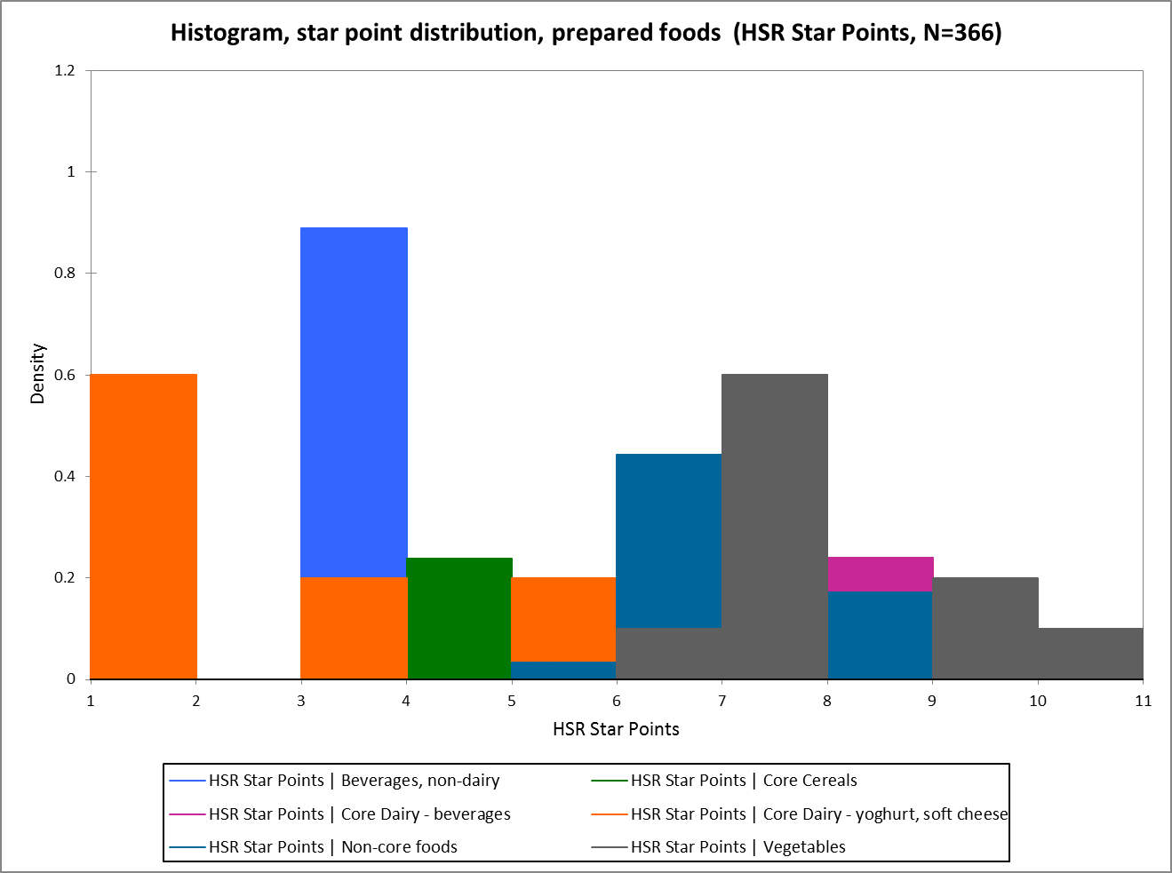

Graph 2 provides a predicted distribution of HSRs ‘as prepared’ according to current guidance. Note that these results are contingent upon the data provided by industry.

**Graph 2:**

Core Cereals

Vegetables

Core Dairy, yoghurt, soft cheese

Beverages, non-dairy

The HSR scores for non-prepared (as sold) foods generally distribute HSR scores in alignment with the dietary guidelines. For example, discretionary food products such as dry sauce mixes, dairy dessert mixes and meal bases ‘as sold’ have a low HSR, and porridge and rice have a high HSR. A range of food product categories are included: dry sauce mixes, dairy dessert mixes, meal bases (low HSR) and porridge (high scores). Note, sample numbers are small (n=78) and breakfast cereals currently cannot display a HSR ‘as prepared.’

**Graph 3:**

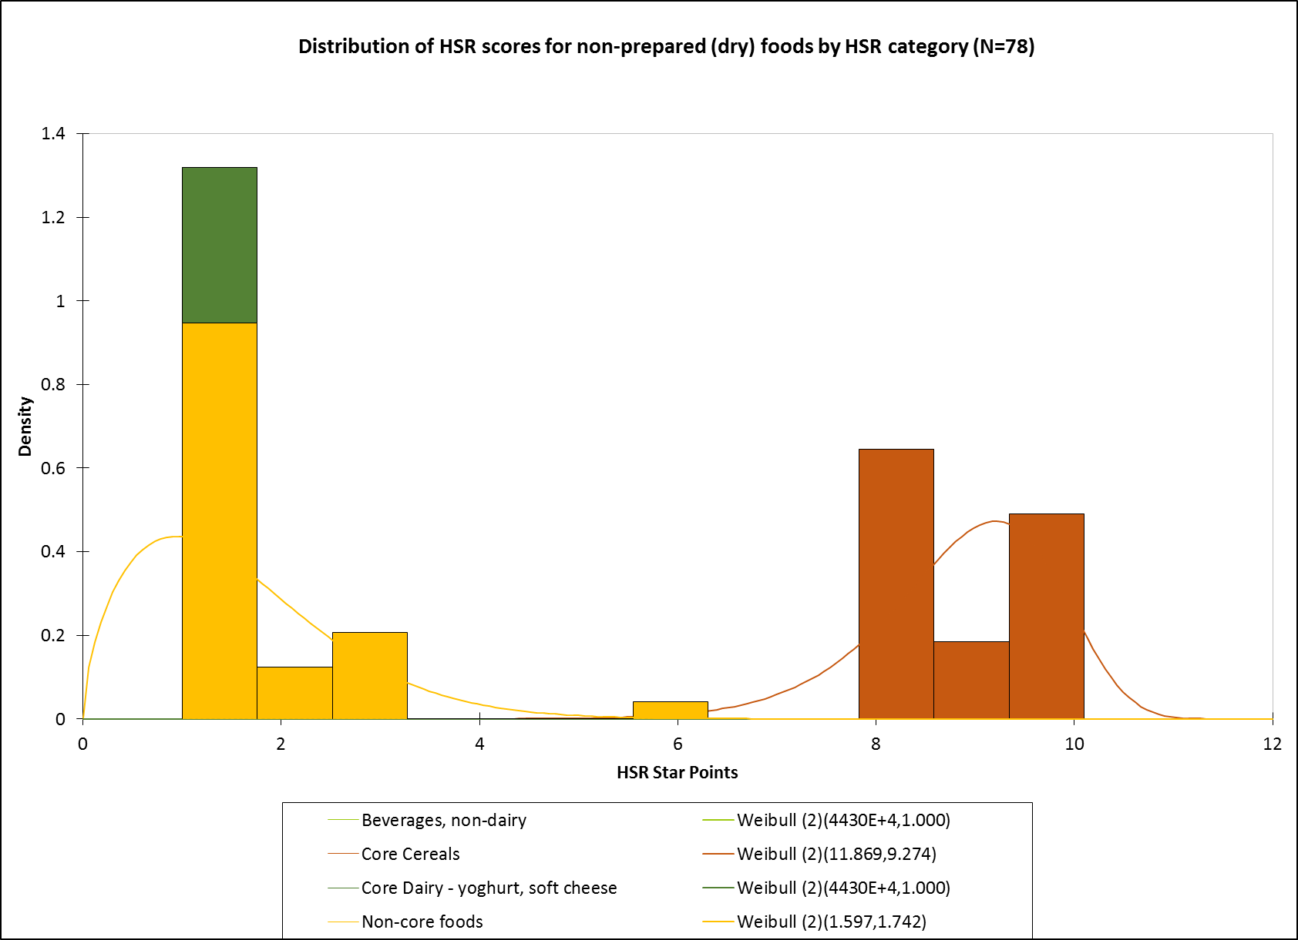

The distribution of HSR scores for core foods ‘as sold’ vs ‘as prepared’ shows that calculating a HSR for the food when prepared generally decreases the HSR score. This is due to the dilution of positive nutrients, with the effect more significant at higher HSR scores. Products depicted include vegetable stocks (low HSR score) and milk powders, rice/noodle/pasta dishes and porridge (high HSR score). Note: porridge, which is not permitted to apply the as prepared rules, has been included to assist in demonstrating how the ‘as sold’ option may impact on core foods

**Graph 4:**

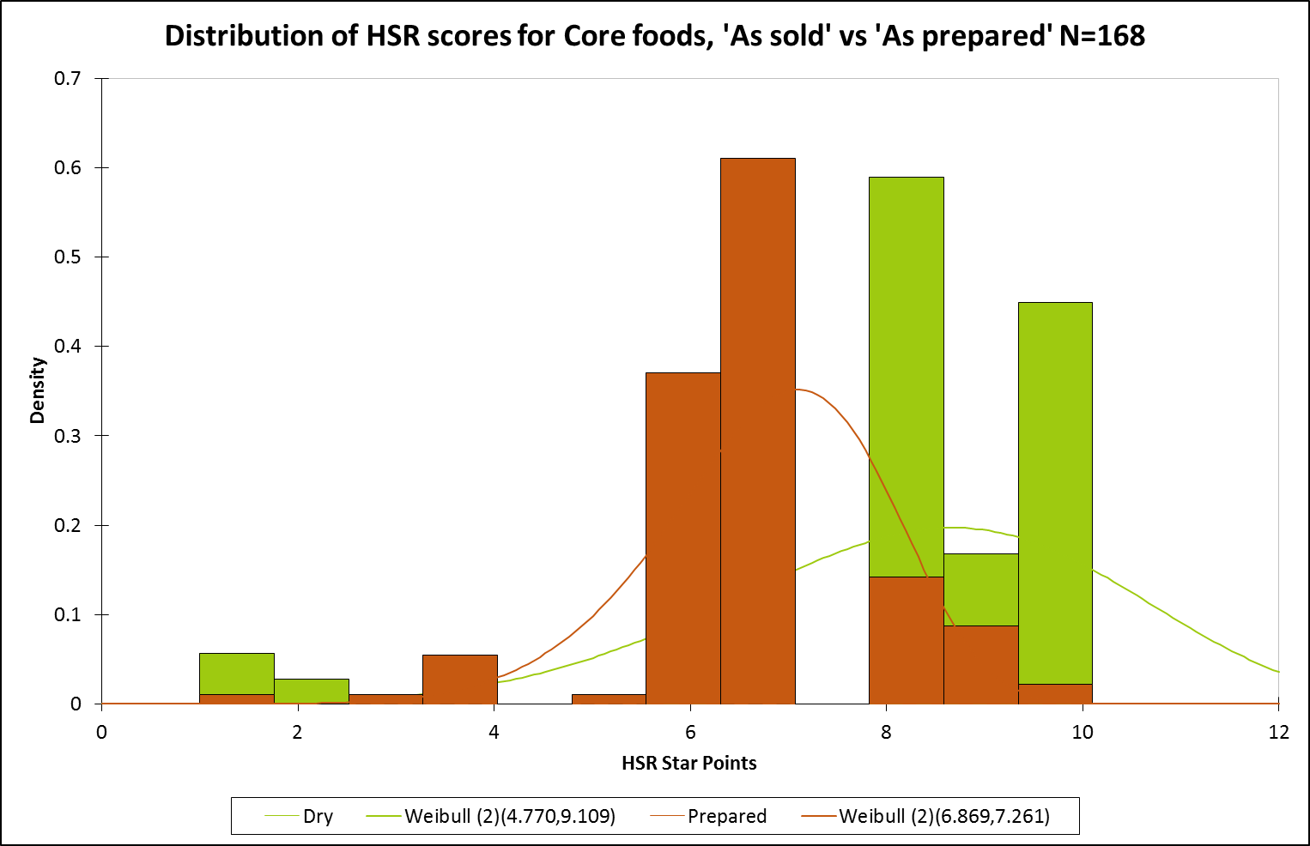

The distribution of HSR scores for discretionary foods ‘as sold’ vs ‘as prepared’ shows that calculating the HSR ‘as prepared’ generally considerably increases the HSR score due to the dilution of negative nutrients. Products all had low HSR scores ‘as sold’ (<1.5) and received HSRs of 2.5 – 4 ‘as prepared.’ Foods modelled included vegetable soup mixes, jellies, sauce and gravy mixes, and drink powders.

**Graph 5:**

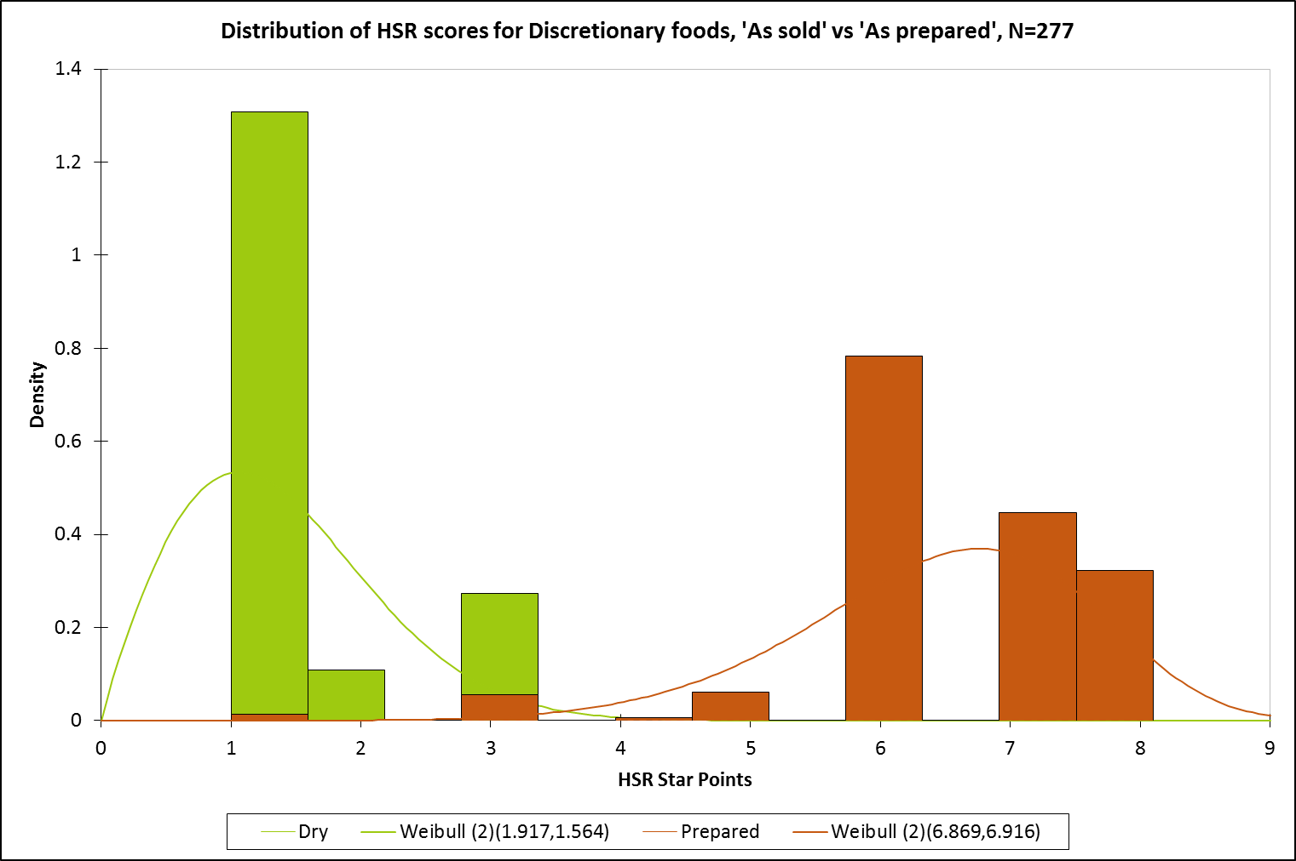

Modelling of foods ‘as sold’ vs ‘as prepared with water only’ shows that calculating the HSR score as prepared with water generally centres and narrows the range of HSRs. Foods with low HSRs ‘as sold’ tend to score higher when ‘prepared with water only’ and foods with higher HSRs ‘as sold’ tend to score lower when ‘prepared with water only’ due to the dilution of negative and positive components, respectively. The opposite effect is likely to be the case for removing water, i.e. draining. Note: food sample numbers are small (n=49)

**Graph 6:**

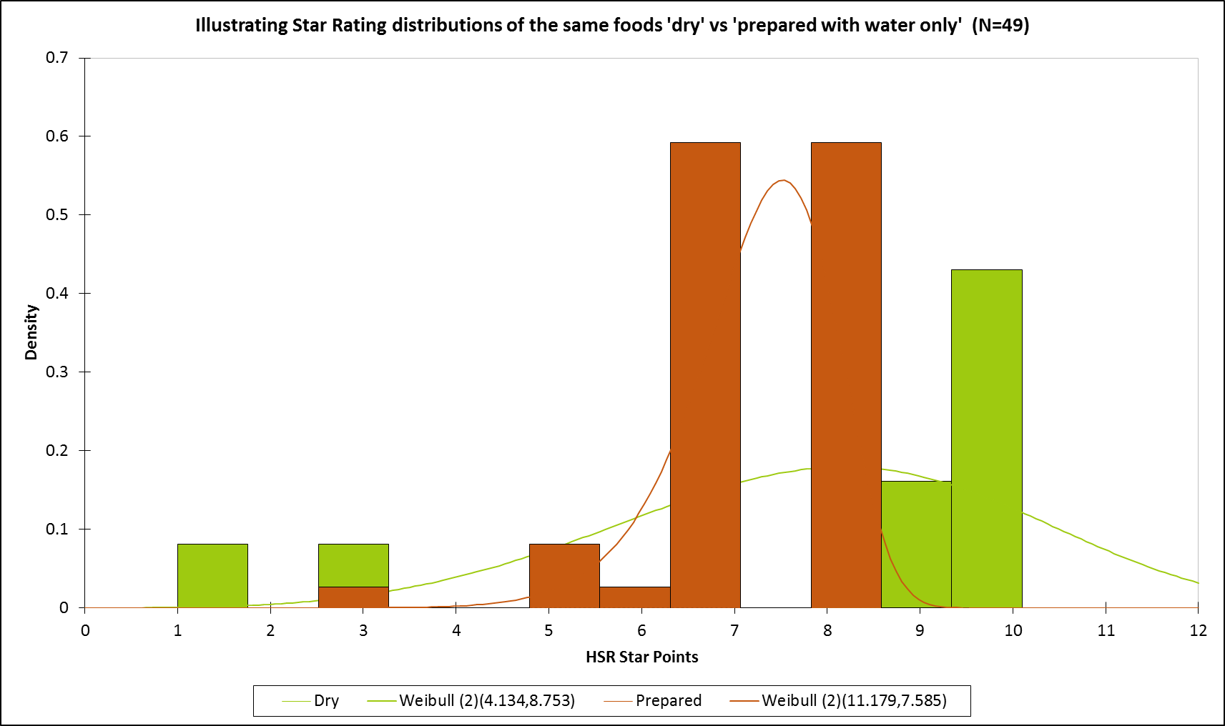

The scatter plots below (graphs 7-14) are for discretionary foods only (which best illustrate the differences between scores calculated ‘as sold’ vs ‘as prepared’ according to current guidance). These demonstrate how the risk associated nutrient content per 100g generally improves as a result of preparation (vertical axis) and as a result improves the star rating (horizontal axis). Alternatively, positive nutrients such as protein may increase by addition to prepared foods, increasing the star rating (see for example graph 12). The plots also indicate (for example graph 14) how dry foods rich in FVNL due to dehydration and with low star ratings due to high sodium content benefit from dilution of the sodium but do not benefit from dilution of FVNL.

The graphs demonstrate that the impacts of dilution are various, often dramatically impacting star ratings, and sometimes counter-intuitive. Given the inconsistencies of the HSR response to dilution the graphs suggest that constraining the HSR response to dilution methods (such as allowing dilution by water only) is a more preferable approach than attempting to accommodate all possible methods of “dilution” such as addition of foods in different HSR categories.

**Graph 7:**

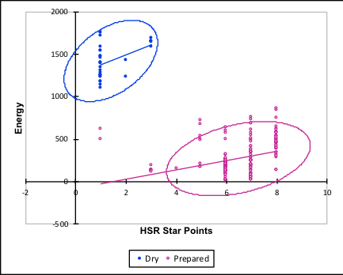

**Graph 8:**

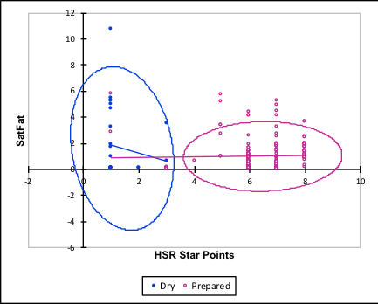

**Graph 9:**

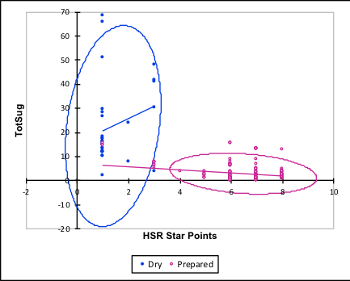

**Graph 10:**

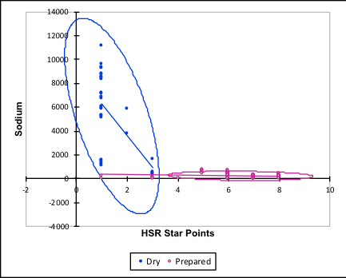

**Graph 11:**

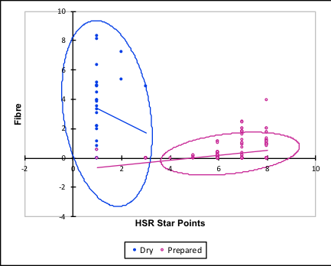

**Graph 12:**

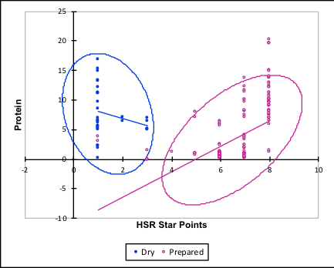

**Graph 13:**

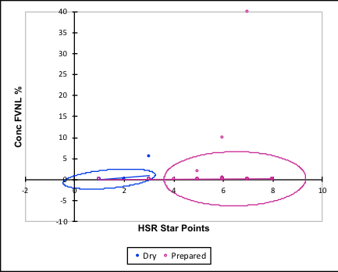

**Graph 14:**

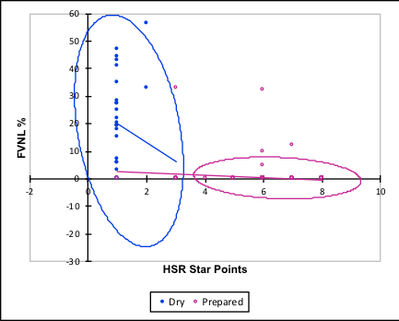

The following plots (graphs 15-22) illustrate the effect of preparation with water. Both positive and negative components are diluted, such that the star ratings tend to centralise more (i.e. towards that of water, usually scaling at 2 stars). Hence foods of high star rating will generally decrease and the distribution shrink with dilution and foods of lower star rating will generally improve yet also shrink in terms of the span of ratings.

**Graph 15:**

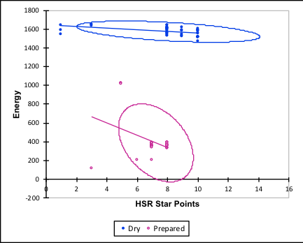

**Graph 16:**

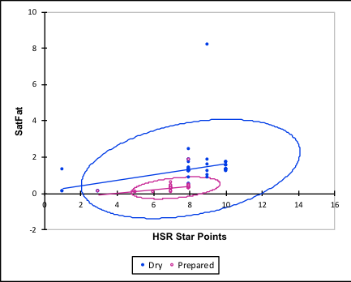

**Graph 17:**

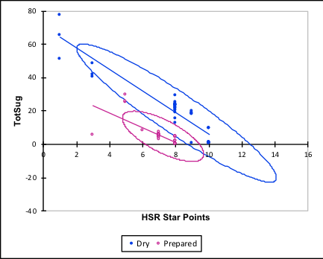

**Graph 18:**

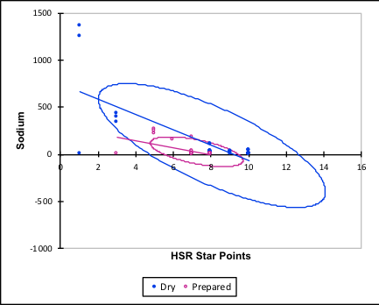

**Graph 19:**

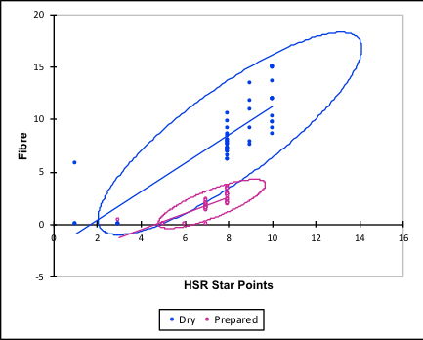

**Graph 20:**

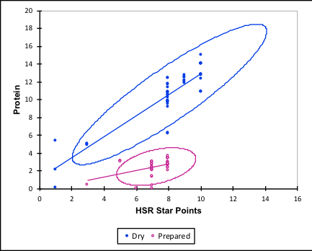

**Graph 21:**

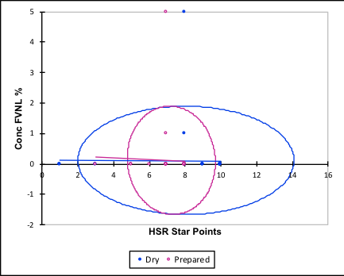

**Graph 22:**

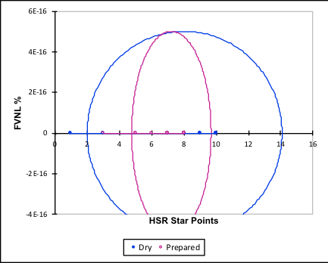

## Appendix 7 – Potential amendments to Guide for Industry

**Tracked changes**

Glossary

|  |  |
| --- | --- |
| As sold | The food in the form in which it is ~~as~~ sold ~~such that the food can be prepared with other food or consumed as sold~~. |
| ~~As consumed~~ | ~~The food as consumed including foods that are required to be prepared according to directions prior to consumption.~~ |

**Step 2: Determine the form of the food for the HSR**

The HSR ~~and hence nutrient content values used to determine it~~ should apply to the form of the food as determined ~~in accordance with the following~~ below:

* the food as sold, if the food can be ~~either prepared with other foods or~~ consumed as sold or prepared/cooked without additions or draining (e.g. frozen pizzas, frozen meals, bacon)
* the food as sold, if the food can be prepared with ingredients other than water and/or in a number of ways (e.g. breakfast cereals, breadcrumbs, recipe bases, sauce mixes, powdered beverage flavourings)
* ~~the food as prepared if the food is required to be prepared and consumed according to directions on the label~~
* the food after it is reconstituted with water only and ready for consumption, if the food requires reconstituting ~~with water~~ (e.g. stock powders, jelly powders)
* the food after it is diluted with water only and ready for consumption, if the food requires dilution (e.g. cordials, condensed soups)
* the food after it is drained and ready for consumption, if the food requires draining ~~before consuming~~ (e.g. tinned legumes).

In all cases the HSR should be based on the NIP for the appropriate form of the food ~~for which the NIP information has been displayed~~~~1~~ above, noting that in some cases the NIP for this form of the food may be displayed both per serve and per 100g/mL whilst the information in the HSR label for the same form of the food should be displayed per 100g/mL.

If the HSR is based on the form of the food ~~‘as consumed’~~ following reconstitution with water, dilution with water or draining, the label should clearly specify elsewhere on the pack the directions for this preparation ~~or cooking~~.

Please note that this guidance on the form of the food differs from that contained in the Code:

* Standard 1.2.7-7 provides information on requirements on the form of food if a nutrition content claim or health claim is made in addition to displaying a HSR.

~~For breakfast cereals, the NIP and HSR should be for the cereal as sold. For products that can be used in a number of ways by the purchaser, such as breadcrumbs, the HSR should apply to the product as sold.~~

* Standard 1.2.8-13 (3) provides additional NIP requirements where nutrient content is based on food that is intended to be prepared or consumed with another food.

~~1~~ ~~In some cases the NIP information for the form of the food may be displayed per serve, whilst the information in the HSR label for the same form of the food, may be displayed per 100g. E.g. A condensed soup is intended to be prepared (and consumed) in accordance with specific directions. Information in the NIP and the HSR label should reflect the nutritional values in the prepared product. In the NIP, information is presented per serve and per 100g as sold and per serve as prepared. In the HSR system label, the information is presented per 100g as prepared.~~

**Clean version**

Glossary

|  |  |
| --- | --- |
| As sold | The food in the form in which it is sold |

**Step 2: Determine the form of the food for the HSR**

The HSR should apply to the form of the food as determined below:

* the food as sold, if the food can be consumed as sold or prepared/cooked without additions or draining (e.g. frozen pizzas, frozen meals, bacon)
* the food as sold, if the food can be prepared with ingredients other than water and/or in a number of ways (e.g. breakfast cereals, breadcrumbs, recipe bases, sauce mixes, powdered beverage flavourings)
* the food after it is reconstituted with water only and ready for consumption, if the food requires reconstituting (e.g. stock powders, jelly powder)
* the food after it is diluted with water only and ready for consumption, if the food requires dilution (e.g. cordials, condensed soups)
* the food after it is drained and ready for consumption, if the food requires draining (e.g. tinned legumes).

In all cases the HSR should be based on the NIP for the appropriate form of the food above, noting that in some cases the NIP for this form of the food may be displayed both per serve and per 100g/mL whilst the information in the HSR label for the same form of the food should be displayed per 100g/mL.

If the HSR is based on the form of the food following reconstitution with water, dilution with water or draining, the label should clearly specify elsewhere on the pack the directions for this preparation.

Please note that this guidance on the form of the food differs from that contained in the Code:

* Standard 1.2.7-7 provides information on requirements on the form of food if a nutrition content claim or health claim is made.
* Standard 1.2.8-13 (3) provides additional NIP requirements where nutrient content is based on food that is intended to be prepared or consumed with another food.

## Appendix 8 – AFGC ‘decision tree’

# (note that this appendix, including introduction, has been provided by the AFGC – 12 April 2018 version)

**Introductory Note**

The Health Star Rating (HSR) front of pack labelling is designed to assist Australians to healthier diets as described by the Australian Dietary Guidelines through their packaged food choices. It does this by encouraging consumers[7] to compare products at point of purchase on the basis of their nutritional quality, as shown by the HSR labelling.

For it to be most valuable to consumers HSR labelling should:

1. reflect the nutritional value of the product with the HSR label being consistent with other labelling on the pack, including health claims and mandatory nutritional information
2. provided substantial discrimination between similar products reflecting differences in their nutritional profiles
3. allow meaningful, proper ‘like with like’ comparisons. The HSR is designed to allow comparisons within product categories. For greatest value to consumers, it should also allow direct comparisons between similar products *as consumed,*
4. be used in a consistent manner by industry when applied to similar products to reinforce its understanding and value to consumers.

Many packaged food products are ‘ready to eat’ when purchased requiring minimal preparation, if any, by consumers. In these cases the HSR is provided on an *‘as sold’* basis. Other products (which are relatively small in number) are designed to be used, or prepared, by consumers in a particular, and specified, way. In these cases ‘directions for use’ are provided on the label by food companies. The directions for use are often critical for the product to provide its full value to consumers. That is, if the directions are not followed closely, the quality of product is not realised. In these cases an HSR label provided on an *‘as prepared’* basis is often more appropriate.

‘*As prepared*’ information and ‘*directions for use*’ concepts on food labelling are well understood by most consumers. The Food Standards Code also recognises the usefulness of providing nutritional information ‘*as prepared*’ with specific requirements for its presentation in the Nutrition Information Panel based on the overall nutritional profile of the product as intended to be consumed. Other nutrition labelling schemes such as the National Heart Foundation ‘Tick’ labelling and the Front-of-Pack Traffic Light labelling in the UK have recognised the usefulness to consumers of information be presented ‘as prepared’ on some products.

Determining whether the HSR should be displayed ‘as prepared’ or ‘as sold’ is not always straight forward. Consequently a draft Decision Tree and accompanying text have been developed to help food industry apply the HSR labelling in a sound and consistent way most helpful to consumers in and their selecting healthy diets. Accompany notes provide further information for companies to assist their use of the Decision Tree to determine which type of HSR labelling they should (i.e. “as prepared” or “as sold”) will be most useful to consumers.

**DETERMINING WHEN TO USE HSR LABELLING – ‘AS SOLD’ VS ‘AS PREPARED’ – Proposed Advice for Manufacturers**

The primary objective of the HSR labelling is to assist consumers to make healthy eating choices, consistent with the advice of the Australian Dietary Guidelines, by comparing the nutritional profile of similar products as they are consumed. Packaged foods may be ‘ready to eat’, require specific preparation to be a consumable product, or be intended to be used in one or more ways with other ingredients. This is recognised in nutrition labelling regulations (i.e. the Nutrition Information Panel) that allow nutrition information to be presented for products both ‘as sold’ or ‘as prepared’, with the manufacturer determining which labelling provides the most useful information for consumers so that they can make an informed choice between like products. Similarly when applying the HSR labelling manufacturers should determine the most appropriate labelling consistent with the following principles.

The labelling should:

1. Reflect the composition of food as it is ready to be consumed and in a form that is useful for the consumer to make comparisons between similar products.
2. Align with permissions for claims provided by the NPSC of *Standard 1.2.7 Nutrition, Health and Related Claims*. That is, products with high star rating should generally qualify for carrying health claims, and *vice versa*.
3. Be applied in a manner consistent with the use of ‘as prepared’ allowed on labels by the FSC, to maintain the overall integrity of the HSR system.
4. Be clear that the HSR applies to the product either ‘as sold’ or ‘as prepared’ solely using specific ingredients in specific amounts and not to any alternative preparations or consumption on the product (similar to a warranty that only applies when the stated directions for use are complied with).

If the product is not ‘ready to eat’, then the consumer may have more or less flexibility in preparing the product. If the ‘directions’ required for a consumable product are critical in type and amount for the quality and nutritional profile of the product to meet the consumer’s expectations of the end product, then the ‘as prepared’ label may be appropriate. In this case ‘as prepared’ would accurately reflect the nutritional profile of the expected end product and be able to be compared to similar foods.

If the type or amount of ingredients in the ‘directions’ can be varied and the end product will still meet the consumer’s expectations, the end product is unknown and the HSR may not reflect the product as consumed. In this case the HSR is unlikely to provide useful information either ‘as sold’ or ‘as prepared’ because neither will reflect the food or drink that is consumed.

A decision tree (below) can be used to assist companies determining if their products should be labelled with the HSR on an ‘as sold’ or ‘as prepared’ basis. The following notes are provided to assist companies to use the decision tree.

*Companies are reminded that use of the HSR by Special Purpose Foods and Supplementary Foods is limited elsewhere in the Style Guide.*

1. **Is the product required to carry a NIP by the Food Standards Code to provide consumers with useful nutritional information?**

Single ingredient foods or foods used in very small quantities that do not affect the nutrient intakes of consumers are not required to carry a NIP e.g. salt, vinegar, ground spices. Likewise it is of no value to consumers for some of these products to carry an HSR.

1. **Can the product be consumed ‘as is’ (excluding thawing, cooking)** **even if this is not the intended end product or meal?**

If the product can be consumed essentially as it comes from the pack (or without any substantial transformation during preparation by thawing or heating) then the HSR label should be applied ‘as sold’. This will include breakfast cereal, ready-to-eat canned soup, canned fruit, ready-to-eat custard and liquid pasta sauce, liquid sauces, liquid sauce mixes for casseroles/slow cookers, syrups and pastes that can be used in a number of different ways.

1. **Can the product be consumed and compared to similar products only after a simple dilution, rehydration with water or draining of a liquid?**

A simple dilution or rehydration with specific amounts of water that results in a product that can be compared with similar products, provides the most useful information to consumers when the HSR is labelled ‘as prepared’ because this reflects the end product that will be consumed. If a products needs to be drained of water, brine, vinegar or oil before it can be sensibly consumed then ‘as prepared’ will also provide the most useful information to consumers . For example vegetables/ fish canned in oil, brine, vinegar or water. For fruit in juice, water or syrup ‘as sold’ should applied because the liquid is more likely be consumed.

1. **Are there specific ingredients (types and amounts) in the ‘directions’ that are critical for the end product as expected by the consumer (i.e. if ingredients are varied the end product would not meet consumer expectations)?**

For some products the ‘directions for use’ are critical for the quality of the final product. For example, a cake mix. Omission of other ingredients (such as egg) will result in a product which is inferior in quality and does not meet consumer expectations. In these cases ‘as prepared’ is the most appropriate label. If the type of ingredients (e.g. meat, vegetables or milk) can be varied by consumers to achieve the product they intended then ‘as prepared’ may well not reflect the actual end product consumed. Companies should note that ‘serving suggestions’ are unlikely to qualify for the ‘as prepared’ label.

1. **Can consumers vary the ingredients in the ‘directions’ for the product to be consumed without it significantly affecting the quality of the end product as expected by the consumer (e.g. type/amount of meat, vegetables, milk) ?**

For some products there may be some flexibility in preparation. Where a variety of end products using differing ingredients in type or amount will still meet the consumer’s expectations of what they will consume, neither the ‘as sold’ nor the ‘as prepared’ HSR offers meaningful information about the end product that is consumed. In this case, companies may choose not to use the HSR.

**Decision Tree – Determining ‘as sold’ vs ‘as prepared’ HSR Labelling**

|  |  |  |  |  |
| --- | --- | --- | --- | --- |
| 1. Is the product required to carry a NIP by the Food Standards Code to provide consumers with useful nutritional information? | ► | **NO** Examples, salt, vinegar, ground spices are exempt from nutrition labelling requirements in the Food Standards Code | ► | **Use of the HSR graphic may not provide useful information to consumers** **on the unprepared product which is not the food or drink that will be consumed** |
| ▼ |  |  |  |  |
| **YES** |  |  |  |  |
| ▼ |  |  |  |  |
| 2. Can the product be consumed ‘as is’ (excluding thawing, cooking) even if this is not the intended end product or meal? | ► | **YES** Examples, liquid pasta sauce, liquid sauces, liquid sauce mixes for casseroles/slow cookers, syrups, breakfast cereal, ready-to-eat canned soup, canned fruit, ready-to-eat custard, pesto | ► | **As sold** as per the NIP |
| ▼ |  |  |  |  |
| **NO** |  |  |  |  |
| ▼ |  |  |  |  |
| 3. Can the product be consumed, and compared to similar products, only after a simple dilution or rehydration with water or draining of a liquid? | ► | **YES** Examples, cordial, gravy mix, pancake mix, some dehydrated soups, stock powder, milk powder, dehydrated vegetables, canned vegetables/fish/olives, hot drink mixes containing powdered dairy products, some dehydrated sauce mixes | ► | **As prepared** as per the NIP |
| ▼ |  |  |  |  |
| **NO** |  |  |  |  |
| ▼ |  |  |  |  |
| 4. Are there specific ingredients (types and amounts) in the ‘directions’ that are critical for the end product as expected by the consumer (i.e. if ingredients are varied the end product would not meet consumer expectations)? | ► | **YES** Examples, cake mix, dehydrated powdered pasta and rice products, dehydrated sauce mixes some canned or packet soups, dessert and pudding mixes | ► | **As prepared** as per the NIP (using the specific ingredients) |
| ▼ |  |  |  |  |
| **NO** |  |  |  |  |
| ▼ |  |  |  |  |
| 5. Can consumers vary the ingredients in the ‘directions’ for the product to be consumed without it significantly affecting the quality of the end product as expected by the consumer (e.g. type/amount of meat, vegetables, milk) |  | **YES** Examples, milk flavourings, syrups, custard powder, yogurt mixes where type of milk is not critical, recipe bases, powdered sauce mixes for casseroles/slow cookers, where type of meat or vegetables is not critical | ► | **Use of the HSR graphic may not provide useful information to consumers on the unprepared product which is not the food or drink that will be consumed** |

## Appendix 9 – Testing and analysis of a previous version of the ‘decision tree’

The Food and Nutrition Policy Section, Preventive Health Policy Branch, Australian Department of Health, tested a previous version of the ‘decision tree’ with several product categories that may be eligible to display a HSR ‘as prepared.’ This was intended to assess the robustness of the ‘decision tree’ and highlight any advantages of or concerns with this approach.

Results indicated that applying the ‘decision tree’ to several product categories of interest does not necessarily produce a conclusive result. For example, of the possible outcomes in the ‘decision tree’:

* milk flavouring powders and recipe bases may exit at ‘do not use,’ ‘as sold,’ ‘as prepared,’ or ‘refer to the HSR Advisory Committee’
* cake mixes, pasta sauces and breakfast cereals may exit at ‘as prepared,’ ‘as sold’ or ‘refer to the HSR Advisory Committee’
* stock powders and cordials may exit at ‘do not use’ or ‘as prepared with water’

In addition, TAG considered the ‘decision tree’ and provided feedback which highlighted how the ‘decision tree’ may provide ambiguous advice, resulting from subjective components at key junctures of the ‘decision tree’ and accompanying text.

The AFGC were intending to address this feedback in the revised, current version of the ‘decision tree,’ at Appendix 8.

1. Guide for Industry to the Health Star Rating Calculator (v.6), 2018, p. 1

   <http://www.healthstarrating.gov.au/internet/healthstarrating/publishing.nsf/Content/guide-for-industry-document>
2. Guide for Industry to the Health Star Rating Calculator (v.6), 2018, p. 7

   <http://www.healthstarrating.gov.au/internet/healthstarrating/publishing.nsf/Content/guide-for-industry-document>
3. Australia New Zealand Food Standards Code, 2017, Standard 1.2.7 – Nutrition, health and related claims (F2017C01048), <https://www.legislation.gov.au/Series/F2015L00394>
4. Australia New Zealand Food Standards Code, 2017, Standard 1.2.8 – Nutrition information requirements (F2017C00311), <https://www.legislation.gov.au/Series/F2015L00395>
5. http://www.healthstarrating.gov.au/
6. Addinsoft, 2017, XLSTAT 2017: Data Analysis and Statistical Solution for Microsoft Excel
7. The HSR Front of Pack Labelling System is supported by a Government social marketing campaign