HEALTH STAR RATING STAKEHOLDER WORKSHOP

Sydney - 4 August 2016

Combined morning session including food industry stakeholders and public health stakeholders (Attendees: 52)

Summary report
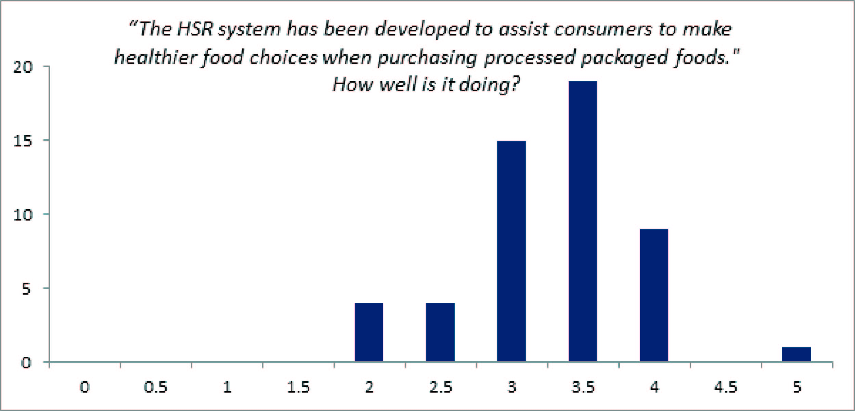

Key messages for consideration by the Health Star Rating (HSR) Advisory Committee
The outcomes of the workshop are not a consensus statement. The ‘messages’ described below reflect the main themes and views of attendees in general.

- The education campaign is essential to ensuring that consumers clearly understand the system and its context. There is a call for a wider campaign to include general context of the system within wider nutritional messages and specific elements such as cross category comparisons.
- The algorithm should be reviewed. The aim of the review should be based on widely accepted science, consider alignment of the stars with messages of the Australian Dietary Guidelines (ADG), and enable evidence to inform Ministers on the effectiveness of the system.
- Consideration of making the system mandatory should be considered as part of the review but at the end of the voluntary implementation period.
- Developing consumer trust will be essential to this system delivering health benefits. A range of mechanisms need to be employed to ensure that this is developed and focused heavily on the need for all stakeholders, government, industry and public health/consumers to work together and provide a united message to consumers.
- The format of the workshop generally worked well. This model provides an effective way to bring together stakeholders and should be employed during the next few critical review periods.
- This format should remain transparent and open with information provided to stakeholders in a timely manner and on a regular basis.
Main areas of discussion
It was acknowledged that the HSR system, which is generally good but needs some tweaking, has been embraced by industry, and this wide scale adoption appears to have begun changing consumer behaviour and promoting reformulation. However caution needs to be taken with reformulation to ensure that there are no unintended consequences of this.

A big concern for the system is consumer trust and understanding. This needs to be supported by an extended communication plan. This communication plan should build on existing messages of how to use the system, but these should be developed into a more detailed awareness of the HSR system, and then extended into how it fits in the wider nutritional context of the ADG/Australian Guide to Healthy Eating. To develop trust government endorsement/ownership needs to be more clearly communicated.

A strong message throughout the session was the need to ensure a co-ordinated message between government, public health/consumer associations and industry. This should help to establish trust in the system, and this combined approach should be maintained during the next three years to ensure an effective and efficient review period.

The desire to review the nature of the algorithm and some system rules was discussed extensively. General considerations should be given to the way that core foods are treated within the system and the concern that, although the HSR is intended to be used on processed foods, the consumer message from the system may be undermining their inherent healthiness. Other specific issues that were discussed were the inclusion of wholegrains and the consideration of using added sugars rather than total sugars within the algorithm.

Generally it was felt that the algorithm should be reviewed at five years if the science indicates it is needed.

Along with the algorithm the ‘as prepared’/’as consumed’ rules and associated communications need to be reconsidered.

The need for making the system mandatory was discussed, and it was challenged if this actually was a synonym for coverage – and could this be done without the need to mandate. It was acknowledged that in some sectors there does seem to be evidence of cherry picking, regarding what products are using the HSR system, but it should be noted that the implementation period is five years and, therefore, these considerations should only be had after this period awarded by Ministers has expired.

More money is needed for the education and market research associated with the system, and this funding should come from all stakeholders.

