HEALTH STAR RATING STAKEHOLDER WORKSHOP

Melbourne 18 May 2016

Industry Stakeholders (Attendees: 78)

INDUSTRY SUMMARY REPORT
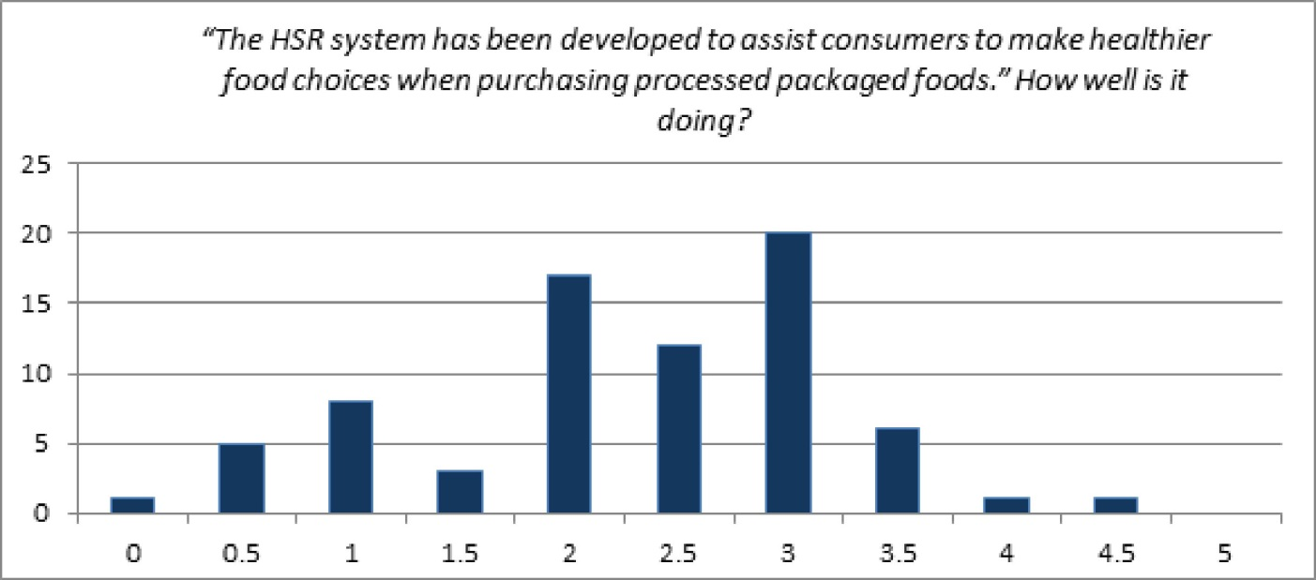

Key messages for consideration by the Health Star Rating (HSR) Advisory Committee
The outcomes of the workshop are not a consensus statement. The ‘messages’ described below reflect the main themes and views of attendees in general.

- The education campaign should be reviewed to ensure that it is effectively providing an adequate understanding of the system to the target audience. There should be a stronger emphasis on communicating the system within the wider context of healthy eating messages, i.e. alignment with the Australian Dietary Guidelines (ADG).
- The algorithm should be reviewed. Widely accepted science should be considered, consider alignment of the stars with messages of the ADG, and enable evidence to inform Ministers on the effectiveness of the system.
- The system review process should be transparent enabling broad stakeholder engagement. Outcomes should be nimble, balancing consumer needs with implementation costs to industry.
- Current and future workshop/meeting outcomes and research data should be provided in a timely manner.
- The format of the workshop generally worked well and should be used as a model for future workshops, with the addition of more background information.

Main areas of discussion
The HSR system is required and its principle is well founded. Government endorsement gives the system credibility and it is essential that this involvement and ongoing funding is continued. Industry as a whole should be commended on the speed and level of uptake of this voluntary system, which should remain voluntary. Positive reformulation is occurring, but there is concern about the unintended consequences of this.

The logo provides clear simple interpretive information and will help to promote ‘healthier’ choices, but there is a significant need to improve the education campaign to ensure consumers understand how to use this system, especially with regard to cross category comparisons, guidance on portion control and within wider nutritional guidance (i.e. closer alignment to the ADG). The tag line ‘the more stars the healthier’ was seen as misleading in certain situations. There is a strong view that we need to understand clearly whether the use of the stars is actually changing consumer behaviour, and if so, is this in a positive direction.

Education/promotion of the campaign is seen as critical to its success, especially to culturally and linguistically diverse and low socioeconomic status consumers. However consideration should be given to changing the algorithm and system rules, balancing simplicity with effectiveness and, therefore, less of a need to educate.

Although in principle out of the scope of the system, education should focus on promoting the consumption of fresh foods, which are often not star rated (as unprocessed and unpackaged), and this discussion was extended to other single ingredient foods that are unable to modify their nutritional profile and compete with processed foods.

It is perceived that ‘negative’ media content, which is primarily focusing on a few outlier products, may seriously undermine the credibility and potential benefits of this initiative. It was considered that this needs to be addressed by amending the system, in conjunction with ensuring accurate messages are delivered to the right audience.

Significant discussion on the options for amending the algorithm included considering: scope of foods eligible for stars; fat type; total/added sugars; grains; production processes; and nutrients associated with core foods i.e. calcium. Further concerns around the algorithm extended to the 100g/100ml reference volume being inappropriate for all categories and consideration being given to revising the ‘as prepared’ rules (e.g. addition of milk vs rehydration).

The current and future reviews of the system must be nimble and responsive. There was significant discussion regarding the timing of the formal review and the need for small tweaks to be undertaken now. However, when planning these changes and review periods consideration needs to be given to industry and the cost of implementation.

