HEALTH STAR RATING STAKEHOLDER WORKSHOP

Melbourne 18 May 2016

Public Health Stakeholders (Attendees: 22)

PUBLIC HEALTH SUMMARY REPORT
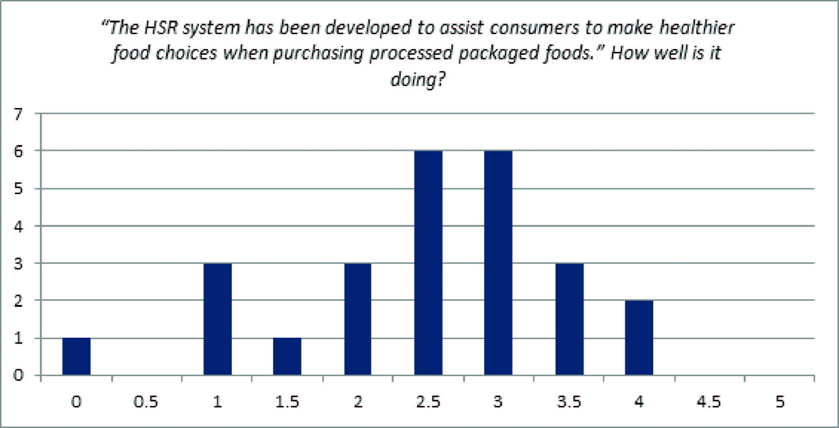

Key messages for consideration by the Health Star Rating (HSR) Advisory Committee
The outcomes of the workshop are not a consensus statement. The ‘messages’ described below reflect the main themes and views of attendees in general.

- The algorithm and supporting system rules should be reviewed. The main aim should be to achieve greater alignment of the HSR system with the messages of the Australian Dietary Guidelines (ADG) and Australian Guide to Healthy Eating (AGHE).
- The changes to the system should take place sooner than the five year review period, and be supported by a more targeted education campaign that focuses on the wider nutritional messages and the HSR system in this context.
- To minimise consumer confusion and ensure use across all products, the system should be made mandatory.
- The format of the workshop generally worked well. It will be used as a model for future workshops with minor modifications, primarily increasing the amount of background information provided.

Main areas of discussion
Significant discussion was targeted to the HSR system and its current alignment to the ADG/AGHE and the potential for greater alignment through review of the algorithm.

Many believe that the HSR system does not align with wider nutritional advice and the system should have a greater emphasis on distinguishing between discretionary and core foods. This distinction needs to be clearly communicated through education and the social media campaign so that core foods are over promoted in relation to processed and packaged foods and that the general public understand the context of the HSR. However, some delegates acknowledged that the social marketing and education around the HSR is already helping communicate some wider nutritional messages.

It was acknowledged that the HSR helps provide people with information about processed and packaged products. It is simple (especially for culturally and linguistically diverse and low literacy groups) and an easily recognisable system, but on some products the design elements are not contrasting enough. It is seen as much better than the daily intake guide (DIG), but there is concern that it could be another confusing message when used in conjunction with other health logos (i.e. Heart Foundation Tick, Be Treatwise, DIG). Further information should be communicated on how the score is calculated, exemptions and the government endorsement of this system.

Changes should be made to the algorithm and system much sooner than the five year period, and these changes should be directed by consumer feedback and scientific evidence. These changes should help to defend much of the negative media around the scheme and improve consumer confidence. These changes should include: treatment of ‘discretionary’ foods, rating of core foods, fruit juices, high sugar cereals and sodium weighting. Reviewing the system as a whole should consider ‘as prepared’ rules, serve sizes and build in processing benefits.

Industry should be congratulated on the positive industry uptake (despite the uptake currently not being across full product ranges), and the reformulation that it has encouraged. Many believe that this system should be mandatory but the current government endorsement helps with the legitimacy and credibility of the system. Despite the desire for the system to be made mandatory, it was questioned whether the HSR is the most appropriate use of public health resources and further comments were made that all jurisdictions should be more heavily involved in the oversight of this system.

