Health Star Rating Advisory Committee

Two year progress review report on the implementation of the Health Star Rating system – June 2014 – June 2016
April 2017

Table of Contents

Executive summary 3
Introduction 5
The HSR system 5
HSR guidance materials 5
Artwork 6
Monitoring the implementation of the HSR system 7
Summary outcomes of the monitoring of the HSR system in Australia 7
Label Implementation and consistency with the HSR system Style Guide (AoE1) 7
Consumer awareness and ability to use the HSR system correctly (AoE2) 11
Nutrient status of products carrying a HSR system graphic (AoE3) 14
Industry Surveys 15
Summary outcomes of the monitoring of the HSR system in New Zealand 16
Label Implementation and Consistency with the HSR system Style Guide (AoE1) 17
Consumer awareness and ability to use the HSR system correctly (AoE2) 18
Nutrient status of products carrying a HSR system graphic (AoE3) 19
Industry Surveys 20
Social marketing campaigns 21
Australian campaign 22
Campaign Aim and Objectives 22
Key Campaign Messages 23
Communication Mix 23
Campaign evaluation 24
New Zealand campaign 24
Phase 1: Scene setting (unpaid media from September / October 2015) 25
Phase 2: Momentum building (paid media from March 2016) 25
Phase 3: Embed campaign and reinforce messaging 25
Summary of stakeholder engagement in Australia 25
Workshops 25
Requests for information 27
HSR e-Newsletter 28
Website 28
Summary of stakeholder engagement in New Zealand 28
Media commentary in Australia 30
Media commentary in New Zealand 30
Issues raised by stakeholders 30
Consider amendments to the algorithm and stronger alignment with Dietary Guidelines 31
Increase education campaign activities 31
Consider making the system mandatory 31
Transparent review processes 31
Summary of anomaly and dispute submissions 31
Anomaly submissions 31
Dispute submissions 32
Five Year Review of the HSR system 32
Conclusion 33
Appendix 1 34
Front of pack labelling Project Committee-Objectives and principles for the development of a front-of-pack labelling (FoPL) system 34
Appendix 2 37
Governance Arrangements 37
Appendix 3 41
The National Heart Foundation of Australia Report on the monitoring of the implementation of the Health Star Rating system in the first two years: Year 1 (June 2014 to June 2015), and Year 2 (June 2015 to June 2016) (Attachment 1) 41
Appendix 4 42
New Zealand Ministry for Primary Industries (MPI) Monitoring report on the implementation of the HSR system in New Zealand (Attachment 2) 42
Appendix 5 43
Figure A5.1: Examples of campaign print and out of home advertising, and public relations video in Australia 43
Appendix 6 44
Health Star Rating System Campaign Evaluation Report - June 2016 by Pollinate Research (Attachment 3) 44
Appendix 7 45
Figure A7.1: Examples of campaign print, web tiles and out of home advertising, in New Zealand 45
Appendix 8 46
Definition of an anomaly 46
Health Star Rating System Policy Context – What is an anomaly? 46
Background 46
Context 46
Anomalies 46
Appendix 9 47
Table A9.1: Register of potential anomalies submitted to the HSRAC for consideration 47

Executive summary
Since its inception in June 2014, there has been significant uptake of the Health Star Rating (HSR) system by the food industry. In Australia at the end of Year 1 (June 2014 - June 2015) the HSR system graphic was displayed on 363 products. As at June 2016, there were 2,031 products displaying the HSR system graphic in Australia. At the end of Year 2, the system was displayed across more than twice as many food categories as Year 1, and implemented by nearly three times the number of manufacturers. The majority of the products displaying the HSR system graphic were consistent with the HSR guidance documents.
The HSR system is also appearing on a growing number of products on shelves in New Zealand supermarkets. Uptake of the HSR graphic (excluding the use of the energy icon only) on products has increased from 39 at the end of April 2015 to 807 at the end of April 2016.
The system is already encouraging manufacturers to reformulate with several companies changing product formulations in order to obtain a higher star rating. Reformulation actions include reducing sodium, sugars and saturated fat and, in some cases, increasing the content of ingredients with nutritional benefits such as fibre.
Communication campaigns have been developed to support the implementation of the HSR system through activities designed to inform consumers and encourage industry participation. The campaigns have generated significant increases in awareness of the system by consumers. In Australia, total spontaneous (unprompted) awareness of HSR was 26 per cent of all respondents surveyed in June 2016 - this is higher than that of the mandatory Nutrition Information Panel, and all other nutrition logos or labelling except for the longstanding Heart Foundation Tick.
Figure 1: Awareness of nutrition logos and labelling
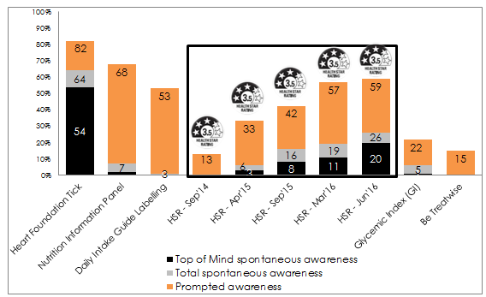
Base: All respondents (n=1007)
The HSR system is also having an influence on purchasing habits with more than one in two consumers who are aware of the system reporting that the HSR played a factor in what product they purchased.
A number of stakeholder workshops have been undertaken since 2014, initially to disseminate information about the HSR system, provide an update on current work underway and obtain feedback from stakeholders about their experiences or issues with the HSR system. Stakeholder workshops held in 2016 have focussed on discussions on a range of key issues identified during the implementation of the system. The workshops have been successful and have been well attended by the food industry and the public health community. The issues raised in the workshops, are being considered as part of the five year review. If possible, some of these issues may be addressed prior to the completion of the five year implementation period.
In conclusion, implementation of the HSR system has progressed well over the first two years surpassing all expectations. The system continues to have a growing presence in the retail food market with good coverage across products, categories, and manufacturers. Consumer sentiment towards the system has also increased since implementation. Structures are in place to deal with anomalies and other system issues as they arise. Ongoing progress on the implementation of the system will be provided in the five year review and presented to the Australia and New Zealand Ministerial Forum on Food Regulation (Forum) in mid-2019.

Introduction
In December 2011, the Forum agreed to support Recommendation 50 of Labelling Logic: Review of Food Labelling Law and Policy, namely that an interpretive Front-of-Pack Labelling (FoPL) scheme should be developed.
In its response, the Forum noted that the food labelling regulatory framework must strike a balance between seeking to ensure good public health outcomes (both short and longer term) and ensuring a strong and profitable food industry.
At its 14 June 2013 meeting, the Forum agreed to a FoPL scheme that, except for agreed exemptions, applies to all packaged, manufactured or processed foods presented ready for sale to the customer in the retail sector. The objectives and principles for the FoPL system are at Appendix 1.
The system, entitled the HSR system, gives consumers at-a-glance nutrition information about the food they are buying. It is a joint Australian, state and territory government and New Zealand Government initiative developed in collaboration with industry, public health and consumer groups.
On 27 June 2014, the Forum agreed that the HSR system should be implemented voluntarily over five years with a review of the progress of implementation after two years. The period for the two year review is 27 June 2014 - 26 June 2016.
Subsequent to this decision, on 20 November 2015, members of the Forum agreed that a formal review of the system should also be carried out after five years of implementation.
The Health Star Rating Advisory Committee (HSRAC) has been tasked with overseeing the voluntary implementation of the HSR system, including the social marketing campaign and the monitoring and evaluation component of the HSR system. For further information on the governance arrangements of the system please refer to Appendix 2.

The HSR system
The voluntary HSR system is a FoPL system that rates the overall nutritional profile of packaged food and assigns it a rating from ½ a star to 5 stars. It provides a quick, easy, standard way to compare similar packaged foods. The more stars, the healthier the choice.
Ultimately, the HSR system aims to assist consumers to make healthier food choices and guide consumer choices by:
- enabling comparison between similar packaged foods;
- being readily understandable and meaningful for the whole population; and
- increase awareness of packaged foods, within the context of the overall diet.
The system is funded by the Commonwealth government, the New Zealand Government and all Australian jurisdictions.
From June 2014, food manufacturers started to apply a HSR to the front of food product packaging.

HSR guidance materials
Guidance tools were developed to help food manufacturers apply the HSR to their products. They include the Guide for Industry to the HSR Calculator, a technical guide for industry with information to help use the Calculator, and a HSR system Style Guide, which includes information on how to apply the graphic to food product packaging. An artwork file containing the HSR graphic is also available on the HSR website to aid manufacturers when designing new packaging.
All of the guidance documents are available on the HSR website. Use of the Guide for Industry to the HSR Calculator, the HSR system Style Guide and the artwork file allows the HSR system to be implemented consistently.

Artwork
Companies have the choice of displaying the following range of HSR system graphics as set out in the HSR system Style Guide:
Figure 2: Health Star Rating system graphic

Health Star Rating system graphics
Option 1
HSR + energy icon + 3 prescribed nutrient icons + optional nutrient

Option 2
HSR + energy icon + 3 prescribed nutrient icons
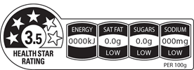
Option 3
HSR + energy icon
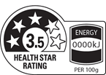
Option 4
HSR only
Option 5
Energy icon only

Monitoring the implementation of the HSR system
The monitoring and evaluation of the HSR system is overseen by a trans-Tasman advisory group known as the HSR Advisory Committee (HSRAC). In April 2015, the HSRAC determined that the areas of enquiry for the purposes of monitoring and evaluating the HSR system would be:
- label implementation and consistency with the HSR system Style Guide (AoE1);
- consumer awareness and ability to use the HSR system correctly(AoE2); and
- nutrient status of products carrying a HSR system label (AoE3).
The National Heart Foundation of Australia (the Heart Foundation) has been engaged to undertake data collection and analysis in Australia, for the three key areas of enquiry. The New Zealand Ministry for Primary Industries (MPI) has responsibility for the collection and analysis of comparable data in New Zealand.
In line with an agreed project plan and methodology, the Heart Foundation:
- developed a program logic framework (the Framework) to assess the implementation and impacts of the HSR system; and
- developed and delivered a suite of data collection strategies to assess what was achieved, in line with the Framework.
The Heart Foundation framework guides monitoring and reporting against the three areas of enquiry (in both Australia and New Zealand).
In July 2015, the HSRAC agreed that the Heart Foundation would also undertake (in Australia):
- an audit of star ratings against the HSR Calculator;
- more regular monitoring of uptake of the HSR system, with reporting to occur in October 2015 and February and June 2016; and
- additional survey work under Area of Enquiry 2 - Consumer awareness and ability to use the HSR system correctly – building on the initial survey work undertaken by market research company Pollinate in April 2015.
In December 2015, the HSRAC agreed to further expand the scope of the work being undertaken by the Heart Foundation in Australia, to include an assessment of products carrying an HSR in ALDI supermarkets (in addition to the assessments already being undertaken in Woolworths and Coles supermarkets). Monitoring and evaluation activities in New Zealand align closely with those being carried out in Australia.

Summary outcomes of the monitoring of the HSR system in Australia
For each of the identified areas of enquiry, the Heart Foundation has undertaken an assessment for the periods 27 June 2014 to 26 June 2015 and 27 June 2015 to 26 June 2016. The results of the first two years of monitoring are included in the Year 2 Report on the monitoring of the implementation of the Health Star Rating system (June 2014 – June 2016) at Appendix 3.

Label Implementation and consistency with the HSR system Style Guide (AoE1)
Assessed under three sub-sections:
- uptake of the HSR system by manufacturers and retailers;
- consistency in implementation of the HSR graphic against the Style Guide; and
- a comparison of the HSR system value displayed on pack to that determined by the HSR Calculator.

Uptake of the HSR system by manufacturers and retailers
In Year 2, there were 2,031 HSR products, out of an eligible 14,102 products from the FoodTrackTM database, representing 14.4% of the total product suite. This is nearly five times the amount of HSR products in Year 1 (n = 363, 2.9% of total FoodTrackTM product suite).
Table 1 below compares the number of HSR products displaying each HSR option of the HSR system graphic between Year 1 and Year 2.
Table 1: Comparison of the number and proportion of HSR Products, by HSR Option, in Year 1 and Year 2
HSR Option | Number of HSR Products (n) in Year 1 | Proportion of total HSR Products (%) in Year 1 | Total number of HSR Products (n) in Year 2 | Proportion of total HSR Products (%) in Year 12 | Change from Year 1 to Year 2
Option 1 | 121 | 33 | 314 | 15 | ↓
Option 2 | 49 | 13 | 628 | 31 | ↑
Option 3 only | 51 | 14 | 250 | 12 | ↓
Option 4 | 90 | 25 | 668 | 33 | ↑
Option 5 only | 31 | 9 | 112 | 6 | ↓
Combined | 21 | 6 | 59 | 3 | ↓
Total | 363 |  | 2031

Sixty-three manufacturers and retailers from the 793 recorded in FoodTrackTM in Year 2 had HSR Products in Year 2 (8%), compared to 23/666 in Year 1 (3.5%).
In Year 2, the greatest number of HSR Products was observed for Private Label – Coles (n = 606, 36% of FoodTrackTM products), and Private Label – Woolworths (n = 545, 27% of FoodTrackTM products), who collectively made up more than half of the total product count in Year 2 (57%, 1151/2031).
The remaining 28 manufacturers or retailers that had more than five HSR products are displayed in Figure 3 below:
Figure 3: Manufacturers and retailers with more than five HSR products in Year 2, compared to Year 1.
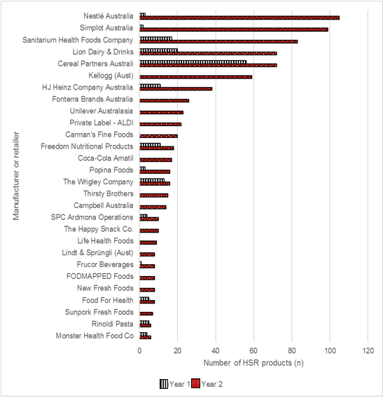
In August-September 2016, 5,560 HSR Products were identified in-store and online – a more than 3.5 times increase September 2015, 1,526.
At the same implementation point, uptake of the Daily Intake Guide (DIG) was 1,167 products, compared to 5,560 HSR products (nearly 5 times higher).
Figure 4: Comparison of uptake of the HSR system to the uptake of the DIG, over time.
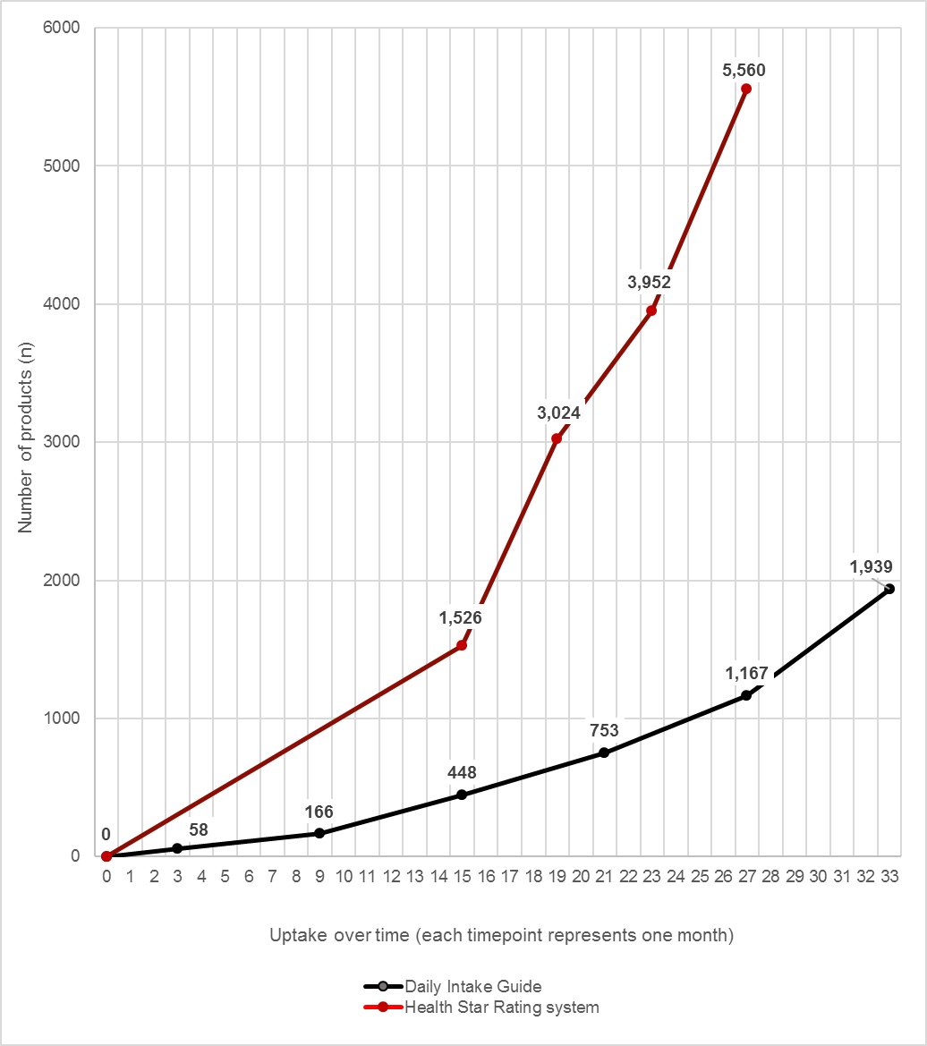

Consistency in implementation of the HSR graphic against the Style Guide
Consistency with the Style Guide remained above 90% for both years, increasing from 93% in Year 1 to 94% in Year 2.
Option 4 of the HSR graphic had the highest level of consistency in Year 2 (99%), while Option 3 and Option 4 of the HSR graphic had 100% consistency in Year 1.
In both years, the most common Technical Variation was that the Nominated Reference Measure differed to the recommendations in the Style Guide, accounting for 36% of the total number of Technical Variations in Year 2 and 65% in Year 1.

A comparison of the HSR system value displayed on pack to that determined by the HSR Calculator
In Year 1, 99% of HSR Products with complete data (314/318) matched the Calculated HSR.
In Year 2, 97% of HSR Products with complete data (1755/1804) matched the Calculated HSR.
In Year 2, of the 49 HSR Products for which the HSR on pack did not match the Calculated HSR:
  - 30 HSR Products had a HSR on pack that was understated, compared to the Calculated HSR.
  - 19 HSR Products had a HSR on pack that was overstated, compared to the Calculated HSR.

Consumer awareness and ability to use the HSR system correctly (AoE2)
Assessed under four sub-sections:
- awareness of the HSR system;
- consumer knowledge and understanding of the HSR system;
- correct use of the HSR system; and
- the level of trust consumers have in the HSR system.
Online data was collected from a nationally representative sample of consumers. To be eligible to participate in the survey, participants were required to be the main or shared grocery buyer in the household and be 18 years of age or over.

Awareness of the HSR system
When purchasing food at the supermarket and choosing between two similar products, price remained the most common factor that influenced purchasing decisions, at 41% in July 2016 (Figure 6).

Figure 5: When buying food at the supermarket, what is the main thing that influences your choice between two similar products?
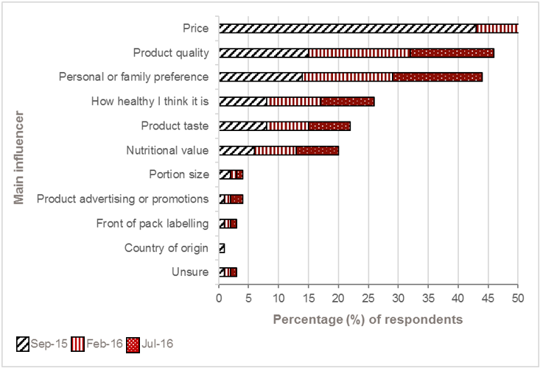

Excluding brand names, the HSR system was the third most recognised food logo in the supermarket.
Unprompted awareness of the HSR system increased from 3% in April 2015 to 13% in July 2016. Unprompted awareness continued to remain higher amongst females, persons aged under 35, those with an annual household income of more than $50,000 or with a body mass index in the healthy weight range.
Prompted awareness of the HSR system rose significantly, to 67% in July 2016 - a 26% increase compared to September 2015 (Figure7). The increased awareness was driven by product coverage (i.e. seeing products in the supermarket or in a catalogue) rather than by direct promotion and/or advertising of the HSR system.

Figure 6: Prompted awareness of the HSR system over time.
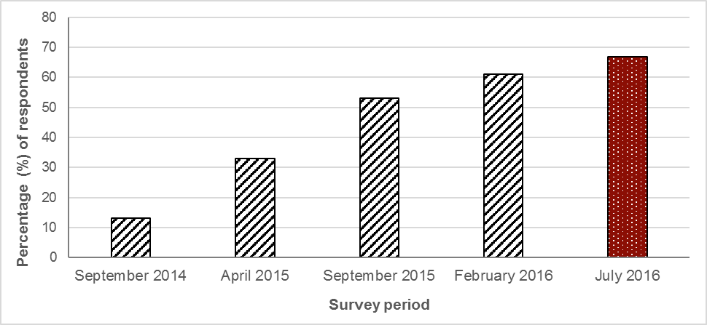
Sample: September 2014 n = 1,000; April 2015 n = 1,011; September 2015 = 2,036; February 2016 = 2,005; July 2016 =2,003.

Consumer knowledge and understanding of the HSR system
Amongst respondents who were aware of the HSR system, most had a broad understanding of what the HSR system represents on food packaging.
Most respondents were aware that the number of stars on a product is determined by the nutritional analysis of products, or based on the healthiness of a product.
There was an increase in the latest survey results (July 2016, compared to February 2016) in the proportion of respondents who reported that the HSR system makes it easier to identify healthier options.
The Option 1 HSR system graphic with the most detailed nutrient information remained the preferred style of respondents as it was the easiest to understand, recognise and provides sufficient information.

Correct use of the HSR system
Close to three in five respondents who reported purchasing a HSR Product reported that the rating scale had influenced their purchasing decision, with more than half of those influenced purchasing a different product to what they would normally purchase.

The level of trust consumers have in the HSR system
Along with the increased awareness of the HSR system and the proportion of respondents who reported having purchased a HSR Product, the perceptions towards the system in July 2016 increased significantly compared to the previous surveys.
Significantly more respondents (compared to February 2016 survey) reported that they viewed the HSR system as trustworthy, easy to understand, credible, and a reliable system (Table 2).

Table 2: How strongly do you agree or disagree that the HSR system…?
Strongly Agree / Agree | Sep-14 (%) | Apr-15 (%) | Sep-15 (%) | Feb-16 (%) | Jul-16 (%)
Is a system I trust | 34 | 38 | 51 | 48 | 54
Is easy to understand | 67 | 59 | 72 | 69 | 72
Is easy to use | n/a | 58 | 72 | 68 | 72
Sample: September 2014 n= 1,000; April 2015 n=1,011; September 2015 n= 1,084; February 2016 n= 1,213; July 2016 n=1,335.

Nutrient status of products carrying a HSR system graphic (AoE3)
The most commonly displayed HSR on pack in Year 1 and Year 2 was 4.0 stars, which was on 29% and 25% of HSR products, respectively.
The number of products displaying each HSR on pack in Year 2 compared to that of Year 1 is outlined in the Figure 8 below.
Figure 7: Number of HSR Products (n) displaying each HSR on pack, in Year 1 and Year 2
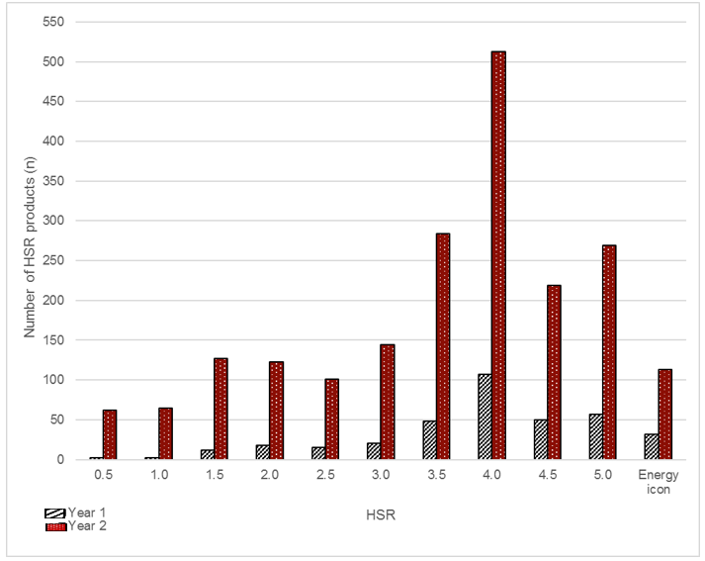
The Food HSR Category Class (2) had the majority of HSR products in both Year 1 and Year 2 (Year 1 284/363, 78% and Year 2 1621/2020 80%).
In Year 1 and Year 2, there were 254 of the same HSR products, 96% of which displayed the same HSR in Year 1 as in Year 2.

Industry Surveys
In June 2016, the Heart Foundation conducted telephone interviews with 36 representatives from Australian food and beverage companies with products displaying the HSR system. Companies interviewed were classified according to business size, based on the number of employees.
The interviews identified that companies were motivated to implement the HSR system on their products for a range of reasons including:
- demonstrating the company’s commitment to health and nutrition, and transparency.
- improving the company’s competitive advantage by creating a point of difference, improving brand awareness and reputation, and meeting [perceived] consumer demand for the HSR system.
- meeting retailer requirements.
Of the companies interviewed, the majority (61%) had implemented the HSR system across a subset of their products however some of these companies reported intending to expand the number of their products displaying the HSR system.
Companies identified that size of a product’s package and available space was the most important consideration when choosing which HSR system graphic to use. Other important considerations were the appropriateness of the graphic to the product, and the simplicity of the graphic.
There was a range of experiences reported about the implementation of the HSR system for companies interviewed including:
- some companies found the Government’s materials and workshops were useful and easy to use, making them feel supported throughout the implementation process. Other interviewees reported issues with the resources provided, noting the delay in the release of the Style Guide, (perceived) lack of clarity in the Style Guide, HSRC not working on occasions, and difficulty in determining the figures to input into the HSRC;
- large companies reported difficulties with implementation in relation to their internal processes, the time taken to reach decisions and build consensus around decisions;
- some small and medium sized companies were more likely to report being challenged in the implementation process due to their lack of nutrition expertise, and having difficulties calculating FVNL and fibre contents; and
- some companies highlighted that the implementation process created additional costs for their business in terms of packaging and resources (i.e. staff).
Views of the impact of HSR system were mixed. While most companies stated that they had not experienced any change since implementing the HSR system, some reported significant changes such as:
- several companies reported increasing sales, particularly for those products with ‘higher’ HSRs, or on specific product lines displaying the HSR system graphic. However, most companies reported no change to sales;
- a couple of companies reported that implementation of the HSR system had positively influenced how their brand and/or product is perceived. However other companies felt that implementation of the HSR system had negatively impacted on their brand and reputation due to the negative perceptions and criticism of the HSR system; and
- several companies reported having used the HSR system to guide the formulation and reformulation of their products, to guide nutrient targets, and/or increase the HSR system rating of their products.
The consultation with companies highlighted some areas for improvement:
- many companies reported that they would like to see more consumer education around the HSR system and how to use it correctly. Interviewees agreed that education and awareness was best placed to come from the Government as it adds credibility and ensures that consumers are aware that this is a Government-led scheme.
- while many companies reported that their products were accurately reflected by the HSR they receive, issues were raised about the ability of the HSRC to accurately reflect the perceived ‘healthiness’ of a product, or how ‘processed’ the product is. Some companies highlighted that these ‘inconsistencies’ were reducing consumers’ trust in the system.
- some companies thought that the HSR system should be applied to a limited set of products (e.g. ‘core foods’), which others thought it should be expanded to cover all supermarket products.
- there was also the suggestion of shifting the focus of the HSR system from nutrients to have a greater focus on whole foods and dietary patterns, but if the existing focus on nutrients was to stay, companies reported they would like to see greater clarity on definitions. Specifically, several companies requested greater clarity as to the inclusion and exclusion criteria as to what constitutes fruit, vegetable, nut and legume (FVNL) content.
Many of the companies interviewed were happy with how the HSR system is currently functioning and reported that they were looking to expand the coverage of the HSR system across more of their products. To support this process, many companies reported having introduced internal goals and benchmarks. However, some companies reported that the [perceived] anomalies in the HSR Calculator would need to be addressed before they would implement the HSR system across all of their products.

Summary outcomes of the monitoring of the HSR system in New Zealand
In New Zealand the data to inform the monitoring and evaluation of the HSR system is coordinated by the Ministry for Primary Industries (MPI) based on the agreed areas of enquiry. Data on the HSR uptake and nutrients status is collected in February to April each year; and the consumer research was conducted in November 2015. The results of the first two years of monitoring are included in the MPI monitoring report on the Implementation of the HSR system in New Zealand at Appendix 4.

Label Implementation and Consistency with the HSR system Style Guide (AoE1)
Assessed under two sub-sections:
- Uptake of the HSR system by manufacturers and retailers
- Consistency in implementation of the HSR graphic against the Style Guide.

HSR Uptake
In quarter one of 2016, 807 products were labelled with the HSR graphic in the Nutritrack database. New Zealand data excludes all products labelled using Option 5, Energy icon only. This represents 5.3% of the total product sample and 7.2% of household purchased products. A substantive increase in HSR uptake was achieved in comparison to the 39 products were labelled with a HSR graphic in Q1 2015, representing 0.3% of products surveyed, and 0.8% of household purchased products.
The food groups with the highest rates of uptake of the HSR system in Q1 2016 include: cereals and cereal products, packaged fresh fruits and vegetables, sauces and spreads, bread and bakery products, dairy and alternatives, and convenience foods (Figure 8). The food categories with the highest percentage of purchased products labelled with the HSR were Other (e.g. breakfast beverages) (38%); Cereal and cereal products (22.8%); Sauces and spreads (16%).
Figure 8: Comparison of the number of products (n) displaying Health Star Rating (HSR) by food category, in 2015 and 2016
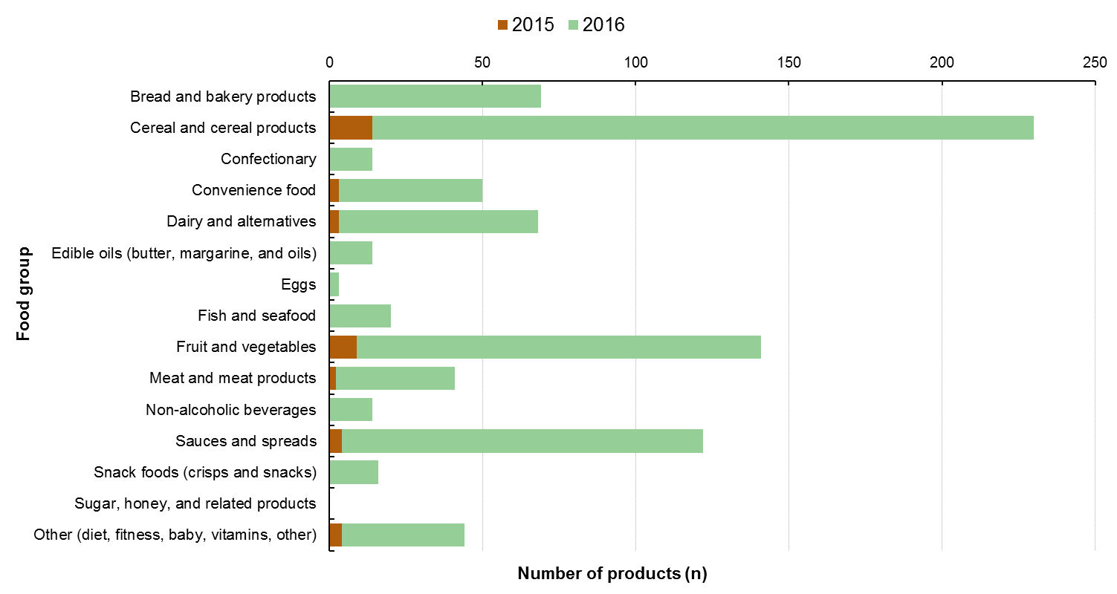
Of those products displaying the HSR graphic options 2 and 4 were the most commonly used in Q1 of both 2015 and 2016. In 2016, approximately one third of the sample carried Options 2 or 4. Option 3, the use of the HSR graphic and energy icon, was the least commonly used in both years (Figure 9).

Figure 9: Percentage of products displaying HSR system graphic, by HSR option (2015 and 2016)

Consistency with the HSR Style Guide
There were few inconsistencies in the presentation of the HSR system graphic with the HSR system Style Guide in 2015 and 2016. Due to the low uptake in 2015 (n=39), results are limited to the sub-sample of products surveyed in 2016.
The most common inconsistency with the implementation of the HSR graphic compared with the HSR Style guide involved legibility of the graphic. This issue was found on 12% of sampled products and were mostly a result of the use of non-contrasting background colours (9% of products). Other common issues included use of incorrect reference measure (3% of products), inconsistent nutrient values displayed in the nutrient icon and nutrition information panel (4% of products), and the graphic not being placed on the front of the pack (3.5% of products).

Consumer awareness and ability to use the HSR system correctly (AoE2)
A baseline consumer survey was conducted by the market research company Colmar Brunton in November 2015. In total 1, 767 shoppers were interviewed online between 19 October and 16 November 2015.
Follow-up data on the consumer awareness and ability to use the HSR system was conducted between September and October 2016 and falls outside the two year implementation review window. A brief description of the two surveys is provided below.
Awareness (unprompted and prompted) of the HSR
Unprompted awareness of the HSR system prior to the NZ HSR consumer campaign was 3% at baseline and increased to 9 % in Q3 2016. Prompted awareness of the HSR system prior to the NZ HSR consumer campaign was 38% and 61% after the campaign was introduced. 44 % of low income shoppers, 36% of Māori shoppers and 65% of Pacific shoppers recognised the HSR when prompted with an image.
Consumer knowledge and understanding of the HSR system
Close to half of shoppers provided comments that suggested an accurate understanding of HSR (51% in 2015; 49% in 2016). The most common response being: the higher the rating the healthier the product. Around two thirds (67% both years) could correctly answer that, when comparing two similar products the one with more stars is generally the healthier option.
In both years, those least likely to understand HSR are those on a low income who rarely check how healthy products are.
Accurate and effective utilisation of the HSR system
Shoppers’ understanding of how to use the HSR correctly has improved. Compared to 2015, more shoppers in the general population now understand the HSR should not be used to compare products in different categories and were able to correctly use the system to identify the healthier product.
Just over half of shoppers who had used the HSR said it encouraged them to try a product they would not normally buy (55% in 2015; 57% in 2016). Most of the remaining shoppers said it confirmed they should buy their usual product.
Trust, reliability and credibility in the HSR system.
Trust, confidence and believability in the HSR system has not changed since 2015 in New Zealand. Nearly half (45%) reported feeling confident using the HSR to choose packaged foods, yet 39% of shoppers say they trust the HSR. Consistent with the 2015 results, the majority of shoppers (59%) agree that the HSR can help them make food shopping decisions for them and their family.

Nutrient status of products carrying a HSR system graphic (AoE3)
The most common star rating displayed on pack was 4.0 stars in both 2015 and 2016. In 2016, the median rating was 4.0 stars (interquartile range: 3 - 4.5 stars). Figure 10 shows the distribution of star ratings on surveyed packaged foods in 2015 and 2016.
Figure 10: Number of products (n) displaying each Health Star Rating (HSR) (0.5 to 5 stars), in 2015 and 2016
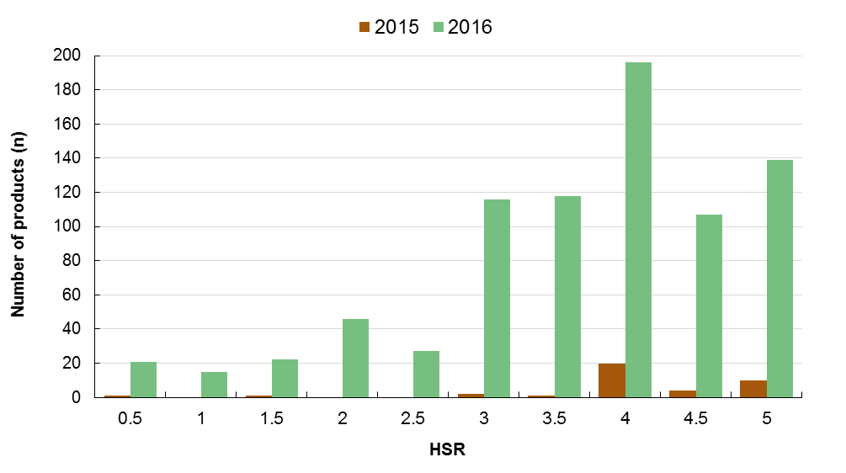

In 2015 and 2016 a range of stars from 0.5 to 5.0 were displayed on pack, but this differed by food category. The range of stars varied from 0.5 to 5 stars only in the meat and meat products; and non-alcoholic beverages categories. There was almost no variation in the star ratings of the food categories: edible oils, eggs, and fish and seafood products (Figure 11).
Figure 11: Box and whisker plot of the Health Star Ratings* overall by food group, for products displaying the HSR in 2016
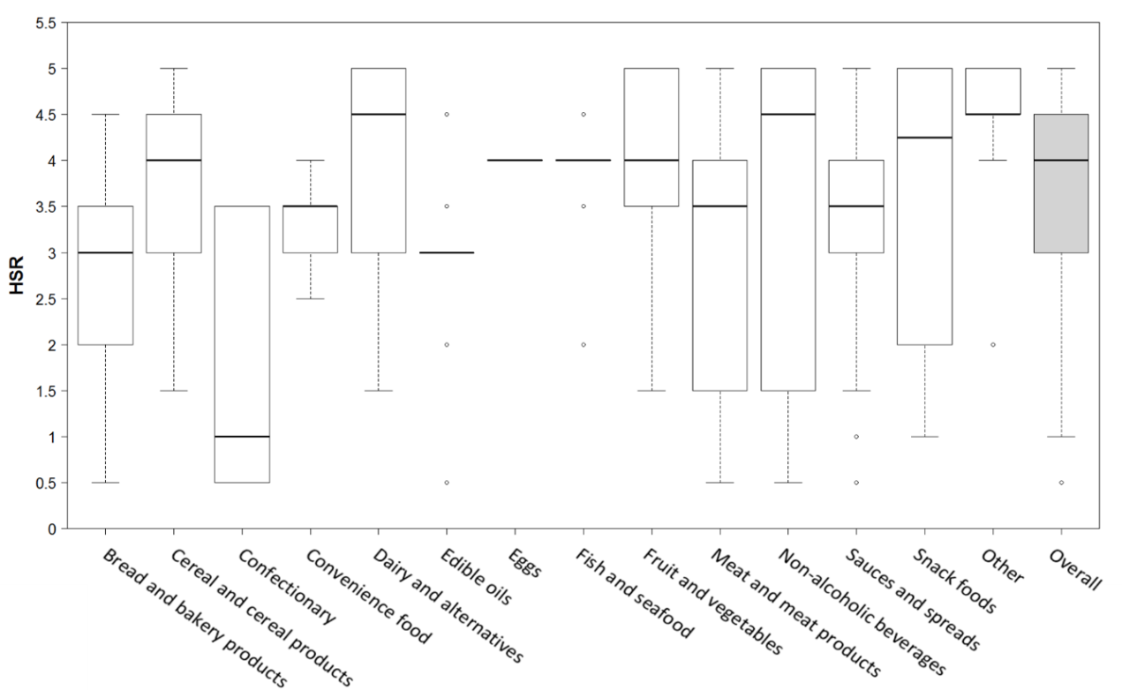

* Box represents the median and interquartile range (IQR), whiskers extend to the most extreme data point which is no more than 1.5 times the IQR from the box, and circles beyond the whiskers are extreme values.
Of those products displaying the HSR graphic in early 2016, 53% of products were available prior to the introduction of HSR (Q1 2014). A comparison of the nutrient content 2014 and 2016 was undertaken to determine the extent of product reformulation. In 2016, 86% of the products had been reformulated since 2014. Small but significant favourable changes were observed in energy, sodium, and fibre contents compared with product composition prior to adoption of the HSR system.
A comparative analysis of those that did not display HSR labels in 2016 but were available in 2014 (n=8,840) showed that reformulation of HSR-labelled products was greater than that of non-HSR-labelled products.

Industry Surveys
In mid-2016, 17 in-depth interviews with a range of New Zealand food businesses were completed. Participants were selected to include small and large businesses, a range of food categories, retailers of in-house label brands, business that have and have not implemented the HSR system, and a spread of geographical locations across New Zealand.
The participants ranged from those that had embraced the system and were in the process of implementation across the entire product range (‘Advocates’); those that had a high level of knowledge but were keeping an eye on how the system (‘Alerts’); those that were ‘Ambivalent’ and had low knowledge, to those that philosophically disagreed with the system and considered there to be significant flaws (‘Antis’).
Those industry participants who were motivated to use the system could see the benefit to their products, brand and company, and perceived an alignment with their organisational values. Whereas those that were less inclined to adopt the system at present did not consider there was a solid business case, that there was a lack of visibility of HSR, or that there were inherent flaws to the HSR system. The ‘Antis’ considered the HSR to be irrelevant to their consumers and at odds to their organisational values.
Most participants considered that while the HSR system is relatively straightforward, it had a number of flaws. Whilst some are working around the perceived flaws, the flaws have become barriers to implementation for others. Some of the perceived flaws include:
- ‘category 2’ being too broad and generic, resulting in unrelated products being compared;
- HSR system being advantageous for dairy products, with three distinct dairy categories;
- HSR system not referencing serving size, which is more closely related to people’s eating habits;
- inconsistencies when determining what ingredients can be incorporated in a product’s calculations. For example, the ability of some breakfast foods; (porridge oats which need preparing) to incorporate the milk component in their HSR calculations); and
- lack of consumer understanding that the HSR system provides for comparisons within categories and that this is not reflected in the communication tools.
Packaging logistics play a key role decisions around implementation, specifically regarding fit with brand, priority of claims and real estate available. In addition, some food businesses have to work in with third parties (e.g. contract manufacturers, overseas suppliers) which can increase implementation timelines. Some participants commented on the difficulty in demonstrating a return on investment with implementing the HSR system and raised questions around ongoing compliance and how the system will be policed.
Participants suggested that MPI needs to take a key role in consumer education, and to drive a more effective consumer campaign with shorter timelines. It was also considered that greater consultation with industry was required and that evidence on the efficacy of the HSR system was required.

Social marketing campaigns
Social marketing campaigns were developed in Australia and New Zealand to support the rollout of the HSR system.
The Australian HSR campaign developed the basket mnemonic and the campaign phrase ‘the more stars the healthier’. Three people (talent) who appeal to and resonate across the Australian population have been used in the campaign. Packaged products are shown as a comparison of similar products (HSR help you choose the healthier option between similar packaged products); including contextualised in shopping and meal preparation environments, and with packaged food products contextualised in a total nutritious diet. The campaign was developed by the Department of Health.
The New Zealand HSR campaign was developed by the Health Promotion Agency, with an initial focus on raising household shoppers’ awareness and recognition of the HSR. The New Zealand campaign used animated boxed cereals and humour to focus the messaging on grocery products rather than the consumer. The core campaign strapline is “Healthier is easy when you look for the stars”.

Australian campaign
To support the rollout of the HSR system in Australia, the Commonwealth Department of Health developed a communication campaign, including advertising, public relations, online communication and stakeholder support activities, to inform consumers and encourage industry to participate in the initiative.

Campaign Aim and Objectives
The campaign aims to support the implementation of the HSR system through activities designed to educate consumers, and encourage increased industry participation.

Marketing objective
- Educate consumers regarding the HSR system and how it can inform purchase decisions.

Primary communications objectives
- Raise awareness of the HSR system’s implementation.
- Develop understanding of how to read the HSR labels.
- Prompt consideration of nutrition and the HSR system as part of purchasing behaviour.
- Develop consumer confidence in the HSR as an independent and informative nutritional guide.

Secondary communications objectives
- Support industry implementation of the HSR system.

Target Audience
Primary audience: Consumers (grocery buyers 18+ years), in particular the main grocery buyer responsible for choosing foods for the household.
Secondary audience: Industry (retailers and food manufacturers).
The campaign has a focus on low socio-economic consumers, as they are more likely to have low health literacy levels; affecting their ability to use and interpret existing nutrition labels. These groups are also more likely to be overweight or obese and experience higher rates of diet-related chronic disease such as diabetes, heart disease and cancer.
Market testing conducted for the campaign has also ensured that communication materials appeal to and can be understood by other groups who experience higher rates of nutrition-related chronic illness, such as Indigenous people(s), ethnic groups and the elderly.
Market research and existing scientific literature show that consumers with high nutritional literacy tend to use and understand existing nutrition information panels. It is therefore of secondary importance for the campaign to target this group because of their existing nutritional literacy. The campaign media buy incidentally reaches this group so they can incorporate the HSR in to their decision making process, or use it to help inform other members of their family.
Print and online advertisements have been translated into Mandarin, Cantonese, Arabic, Greek, Vietnamese and Italian, based on recommendations from the Government master media buying agency.

Key Campaign Messages
- A HSR system label is available on the front of many packaged foods.
- The HSR indicates the overall healthiness of the food.
- The more stars displayed, the healthier the food.
- You can make healthier choices by using the HSR system label to compare the nutritional profile of packaged food products at a glance.
Second tier messages included in supporting communications (e.g. public relations):
- Good nutrition contributes significantly to maintaining a healthy weight, and good quality of life.
- The HSR system is being applied consistently by all participating manufacturers.
- The HSR Calculator is robust and was developed with technical input from Food Standards Australia New Zealand. The HSR System has been developed collaboratively by governments, industry, public health, consumer and other expert bodies.
- The HSR system is being voluntarily implemented by the food industry to help consumers make informed choices.
- HSR-labelled packaged foods should be consumed in the context of total diet, incorporating all five food groups.

Communication Mix
A mix of advertising, public relations, online communication and stakeholder support activities has been used to communicate campaign messages. The media strategy and buy has been refined for each phase of campaign activity, as the creative concepts are further developed and as labelling presence strengthens in the market.
Creative concepts focus on using the HSR to compare two similar products, such as two breakfast cereals, pasta sauces, or muesli bars. Initial products for the campaign images were chosen as ones most likely to implement the system quickly - noting the voluntary nature of the HSR system and therefore need to predict what products may be labelled to coincide with any campaign activity (and that consumers could then find in a retail environment). Three people (talent) have been used across the campaign materials reflecting a diversity of ‘real Australians’. Subsequent PR materials expanded on the HSR message, to position HSR-labelled packaged foods in the context of total diet, incorporating all five food groups. Examples of campaign material from Australia can be found at Appendix 5.
The basket mnemonic was developed as the branding to accompany HSR materials and resources.
Three phases of campaign activity have been conducted during the first two years of the HSR implementation period.
Phase 1 (digital only) – December 2014 – February 2015
Phase 2 – mid-June-August 2015
Phase 3 - February – May 2016

Campaign evaluation
The Department of Health contracted market research company Pollinate to conduct research to track the HSR campaign. Research commenced in September 2014, prior to the campaign launch in December 2014. In total, five surveys have been conducted, three relating to campaign evaluation and two relating to consumer use and understanding of the HSR (note this work is now being continued by the Heart Foundation). The two Pollinate surveys relating to consumer use and understanding shared some common metrics and were undertaken with the same specifications as the campaign evaluations.
Key findings from evaluation of Australian campaign activity:
- Awareness of the HSR has reached 59% (June 2016, up from 42% after the previous burst of campaign activity in September 2015).
- Likelihood to use the HSR on a regular basis has increased from 47% in September 2015 to 50% in June 2016.
- The majority of people want to see the HSR on packaged foods - 65% stated they would like the HSR on more products.
- The HSR is creating positive behaviour change. Of those aware of the HSR, 33% have bought a new product because it had a higher HSR than their usual product (16% among the total sample).
- Of those who have bought a new product because it had a higher HSR than their usual product, 79% have continued to buy this new product with a higher HSR rating (12% of the total sample).
- 1 in 4 Australians (25%) have seen the Government’s HSR campaign, and the campaign has helped drive awareness, understanding and trust in the HSR system.
- There has been a very strong response to the campaign call to action - 77% of people who are campaign recognisers have carried out at least one of the behavioural objectives of the campaign: using the HSR in store and trying to eat healthier are the strongest outcomes.
The evaluation report of phase 3 (incorporating comparisons to earlier phases) is at Appendix 6.

New Zealand campaign
In New Zealand a separate HSR campaign was developed by the Health Promotion Agency and commenced in March 2016. The cornerstone of the campaign is a series of videos depicting animated breakfast cereal boxes, which play as advertisements on TV-on-demand web channels and YouTube.

Phase 1: Scene setting (unpaid media from September / October 2015)
Build integrity of the HSR to support consumer trust and familiarity of the system through public communications and stakeholder engagement i.e. prime the consumer market with supportive messages.

Phase 2: Momentum building (paid media from March 2016)
Build momentum with strategically sequenced paid media along with continued public communications and stakeholder engagement.
Phase 2 of the New Zealand consumer marketing and education campaign, which included the paid media, was launched in March 2016. The campaign initially comprised video content online, followed by visual prompts and messages in supermarkets as this is where most grocery shopping and decision-making occurs. The focus was on breakfast cereals because this category already contained many health star rated products. It also offers the opportunity to remind shoppers to use HSR to compare similar types of packaged foods. Examples of campaign material from New Zealand can be found at Appendix 7.
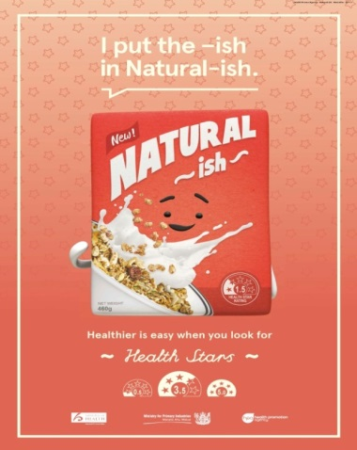
Roll-out of the consumer campaign comprised:
- 14 March 2016 - online videos and online advertising
- 20 March 2016 - posters in bus shelters in main cities (Auckland, Wellington and Christchurch)
- 21 March - vertical fins and floor banners in the cereal aisle of Countdown stores for one month in 174 stores and in top 50 stores until June 30.
- mid-April targeted digital mailer to New World shoppers.
- adverts in Countdown’s household grocery mailers in April, May and June
- 16 June cinema (movie) advertising through Val Morgan for three weeks.

Phase 3: Embed campaign and reinforce messaging
Campaign promotion will continue until June 2018. To date, it has comprised:
- Regular presence on TV on-demand web channels (2 weeks every month to end 2016, then restarting in 2017)
- Adshels in main centres in August and Nov/Dec 2016 & Feb 2017
- Online shopping web banners & bag inserts for Countdown online shoppers
- In-store radio ads playing in all Countdown stores (Nov/Dec 2016)
- Banner adverts in Countdown household mailers on an adhoc basis.
- Discussions are continuing between HPA and Foodstuffs on promotional activities to support HSR.
HPA continues to work closely with Progressive Enterprises (Countdown) on promotional opportunities as they arise. Campaign messaging will be reassessed once the 12-month consumer research follow-up findings are available (late Jan 2017).

Summary of stakeholder engagement in Australia

Workshops
As part of its oversight role, the HSRAC has been particularly focused on developing and implementing strategies for communication with stakeholders. This includes industry engagement via the SMAG, stakeholder workshops, and direct liaison with food companies. The HSRAC has held several stakeholder workshops since 2014.
Table 3: List of Stakeholder Engagement 2014-2016
DATE | LOCATION | TYPE OF ENGAGEMENT
10 April 2014 | Melbourne | Workshop to consider HSR graphic design.
11 April 2014 | Sydney | Workshop to consider HSR graphic design.
9 May 2014 | Perth | Workshop with the Chamber of Commerce and Industry of Western Australia to provide information on the HSR system.
18 June 2014 | Melbourne | Focused workshop for Small to Medium Enterprises (SME) to disseminate information on the HSR system.
19 June 2014 | Adelaide | Focused workshop for SMEs to disseminate information on the HSR system.
26 August 2014 | Sydney | Workshop to disseminate current information about the HSR system including how to use the HSR Calculator and Style Guide, how to display the HSR graphic on food packaging, and an overview of the social marketing campaign.
19 September 2014 | Melbourne | Workshop to disseminate current information about the HSR system as outlined above. (as in 26/8/14)
17 October 2014 | Perth | Workshop to disseminate current information about the HSR system as outlined above. (as in 26/8/14)
26 March 2015 | Hobart | Workshop to disseminate current information about the HSR system as outlined above. (as in 26/8/14)
8 May 2015 | Sydney | Workshop to disseminate current information about the HSR system as outlined above (as in 26/8/14) including case study presentations from two companies.
20 May 2015 | Brisbane | Workshop to disseminate current information about the HSR system as outlined above. (as in 26/8/14)
27 May 2015 | Melbourne | Workshop to disseminate current information about the HSR system as outlined above (as in 26/8/14) including case study presentations from two companies.
24 June 2015 | Sydney | HSRAC Chair presented at the Dietitians Association of Australia (DAA) Food Labelling and Policy Update event.
23 July 2015 | Canberra | HSRAC Chair presented at a meeting with the Food and Beverage Importers Association.
29 July 2015 | Adelaide | Workshop to disseminate information about the HSR system as outlined above. (as in 26/8/14)
2 December 2015 | Perth | Workshop to disseminate information about the HSR system as outlined above.
18 May 2016 | Melbourne x 2 | Facilitated workshops to understand how the HSR system is operating, the strengths of the system, the challenges to implementing the system and the opportunities for improvement to the system.
22 June 2016 | Perth | HRSAC Chair presented at the National Conference of the Australian Health Promotion Association.
22 June 2016 | Perth | Facilitated workshop to understand how the HSR system is operating, the strengths of the system, the challenges to implementing the system and the opportunities for improvement to the system.
28 June 2016 | Brisbane | HSRAC Chair presented at the Annual Convention of the Australian Institute of Food Science and Technology (AIFST).
29 June 2016 | Brisbane | Facilitated workshop to understand how the HSR system is operating, the strengths of the system, the challenges to implementing the system and the opportunities for improvement to the system.
4 August 2016 | Sydney x 2 | Facilitated workshops to understand how the HSR system is operating, the strengths of the system, the challenges to implementing the system and the opportunities for improvement to the system.
25 November 2016 | Sydney | Targeted consultation with public health stakeholders that had raised issues with the HSR system.
15 December 2016 | Adelaide | Targeted consultation on the HSR system with dietitians and nutrition professionals.
The workshops were well attended, with stakeholders from small, medium and large business, public health and consumer organisations, marketing and public relations representatives and state and territory and New Zealand government officials. Details of the issues raised in the 2016 workshops are outlined in individual summary reports which can be found on the HSR website. The HSRAC is considering issues raised at the workshops in the context of the five year review.
In addition, on 16 March 2015 the FoPL Secretariat hosted a jurisdictional webinar in order to provide an update on the social marketing campaign and proposal for phase two activities. Approximately 50 people participated in this webinar, including a large number of participants from NSW local area health services. Attendees at the webinar were shown the phase 2 campaign materials and had opportunity to ask questions about the campaign.
The Social Marketing Advisory Group (SMAG) also met with representatives of Nestle to hear firsthand their experiences of implementing the HSR system and development of associated campaign materials. Nestle has provided case study presentations to stakeholder workshops in Sydney and Melbourne in 2015, which has been a valuable and informative process for industry, HSRAC representatives and jurisdictional representatives who attended.

Requests for information
The FoPL Secretariat is responsible for providing timely and effective organisational support to the HSRAC and its sub-committees, including responding to queries about the HSR system. The FoPL Secretariat responds to queries related to the implementation of the HSR system from stakeholders via the HSR hotline and the FoPL inbox. Since June 2014 over 800 queries have been responded to by the FoPL Secretariat.
Responses are provided in accordance with HSR system guidance documents, such as the HSR system Style Guide, and Guide for Industry to the HSR Calculator. Where a response requires interpretation of HSRAC decisions or information contained in guidance documents, the FoPL Secretariat liaises with the HSRAC Chair to prepare the response, which may include further liaison with HSRAC members, as determined by the HSRAC Chair.

HSR e-Newsletter
The monthly HSR e-Newsletter provides information and updates to stakeholders on the HSR system. At the end of June 2016 approximately 279 people received this newsletter, with a steady increase in subscriptions generated through contact on the HSR hotline, stakeholder workshops, and new subscribers.

Website
The HSR system website was launched on Saturday 6 December 2014. Information about the HSR system can be found on the HSR website including material for consumers and the public health community, the HSR Calculator and the Guide for Industry to the HSR Calculator, the HSR Style Guide, the HSR artwork and information about the Committees overseeing the HSR system implementation. It also provides a facility for enquiries. From 6 December 2014 to 30 June 2016 there were 179,565 visits to the website.

Summary of stakeholder engagement in New Zealand
MPI and HPA continue to engage with key stakeholders - seeking opportunities to raise the level of awareness of HSR and to ensuring the system is well understood by key stakeholders. The emphasis of all stakeholder engagement in New Zealand continues to be that HSR is just one tool to help make healthy eating choices, as well as covering where the HSR sits in relation to the Ministry of Health’s Healthy Eating and Activity Guidelines.
Table 4: List of Stakeholder Engagement 2014-2016 in New Zealand
DATE | LOCATION | TYPE OF ENGAGEMENT
October 2014 | Auckland x 2 | Workshop to disseminate information about the HSR system including how to use the HSR Calculator and Style Guide, how to display the HSR label graphic on food packaging, and an overview of the social marketing campaign.
October 2014 | Hawkes Bay | Focussed workshop for Small to Medium Enterprises (SME) to disseminate information on the HSR system
June 2015 | Auckland | Presentation at Agencies for Nutrition Action (ANA) National Conference
October 2015 | Auckland | Workshop to an Industry Forum to disseminate information about the HSR system
November 2015 | Wellington | Presented the approach for the HSR consumer campaign to the ANA Board.
December 2015 | Auckland | Presented to the Asian Forum (People working in communities with Asian populations).
December 2015 | Wellington | Presentation at the joint Australia and New Zealand Nutrition Society Conference
February 2016 | Auckland | Presented to Healthy Auckland Together (Special interest group made up on people working in the nutrition sector in Auckland).
February 2016 | Wellington | Presented to Dietitians NZ.
March 2016 | Christchurch | Presented to Canterbury Regional Nutrition & Physical Activity Network
March 2016 | Christchurch | Presented to Christchurch Dietitians
March 2016 | Dunedin | Presented to ANA Dunedin Forum
April 2016 | Whakatāne | Presented to ANA Forum Whakatāne
May 2016 | Hamilton | Presented to ANA Forum Hamilton
May 2016 | Palmerston North | Presented to ANA Palmerston North Forum
25 May 2016 | Wellington | Ministry of Health Industry Forum on the Childhood Obesity Strategy
June 2016 | Wellington | Presentation to Advertising Standards Authority Review Board
1 July 2016 | Wellington | Workshop with community representatives to get feedback on HSR and label reading resource including what would be useful in their work with communities.
19 August 2016 | Wellington | Otago University Webinar (Webinar for academics and those working in public health).
August 2016 | Wellington | Workshops with Wellington and Christchurch regional Dietitians
September 2016 | Wellington | Presentation at the Dietitians Association of New Zealand Meeting.
October 2016 | Auckland | Facilitated workshop with a range of stakeholders to understand how the HSR system is operating, the strengths of the system, the challenges to implementing the system and the opportunities for improvement to the system.
20 October 2016 | Auckland | Presentation on HSR at the Ministry of Health Reducing Childhood Obesity – Food and Beverage Industry Forum
November 2016 | Auckland | Presentation to Auckland regional Dietitians
November 2016 | Auckland | Presentation to the Food and Grocery Council Health and Technical Working Group
November 2016 | Northland | Workshop with the Health Eating, Active Living (HEAL) network in Northland

MPI and HPA have presented on the HSR system and campaign to a number of stakeholder groups. This has included presentations at several conferences, meetings with professional groups, industry organisations, nutrition and public health academics, and government agencies throughout New Zealand.
Initial stakeholder workshops have focused on explaining the system and encouraging uptake. MPI recently hosted a stakeholder workshop in Auckland on 12 October. The workshop was attended by 36 stakeholders with approximately a third being public health stakeholders and the remaining two thirds being industry stakeholders. The Chair of the HSRAC attended from Australia. The aim of the workshop, as with the Australian 2016 workshops, was to understand how the HSR is operating, the strengths of the system, the challenges to implementing the system and the opportunities for improvement to the system.
Resources
Other stakeholder engagement has included the development of resources for the nutrition and education sectors. In 2015 an infographic sheet entitled “How to use the Health Star Ratings” was produced along with a fact sheet for stakeholders including the media. In 2016 two fact sheet type resources have been developed for health workers, one on Healthy Eating and the role of the HSR in that and the other on the Algorithm.
Website
The MPI website provides HSR system information and links to the documents provided on the Australian HSR website. In addition to information on the HSR Calculator and HSR Style Guide, it also provides information on the companies using the HSR system and the number of products displaying the HSR. Information is also provided on Governance and how New Zealand fits into the trans-Tasman system including the New Zealand Health Star Rating Advisory Group. In addition, further information specifically for industry stakeholders on how to use the system on their products is provided on the MPI industry facing webpage. Since its development to June 2016 there have been 3,570 visits to the webpage.

Media commentary in Australia
A media metrics report has been commissioned for the two year review period, June 2014 - June 2016 and will be provided as an addendum to this report.

Media commentary in New Zealand
There has been a range of media activities with both a positive and negative perspective. The negative media is predominantly coming from a small number of people with a focus on high levels of a single nutrient (usually sugar), or those who perceive the HSR as promoting packaged foods. Lack of promotion of healthy eating in general (including the Healthy Eating and Activity Guidelines) is an issue for HSR in both New Zealand and Australia. In the absence of promoting general dietary advice, HSR is being left to fill this void which is not its purpose. Work is needed to increase promotion of general healthy eating advice to set the context for HSR to operate within.
The New Zealand HSR Advisory Group highlighted that having some agreed messages would enable more timely responses. Draft messages have been prepared and will be finalised for this use.

Issues raised by stakeholders
Consultation in 2016 has raised the following themes that capture the issues raised to date for consideration by HSRAC. Some stakeholder issues may be addressed prior to the five year review, however, evidence will be required to support any changes made to the HSR system.

Consider amendments to the algorithm and stronger alignment with Dietary Guidelines
Some stakeholders consider that the algorithm should be reviewed. The aim of such a review should be to: ensure that the algorithm is based on widely accepted science; consider stronger alignment of the system with the Australian Dietary Guidelines (ADG)/Australian Guide to Healthy Eating (AGHE)/New Zealand Dietary Guidelines (NZDG); and provide evidence to support any proposed amendments to the Calculator.
The HSRAC has established a Technical Advisory Group (TAG) to assist in a review of the HSR Calculator as part of the five year review process. The group is initially tasked with analysing the performance of the HSR Calculator, with a secondary task of responding to technical issues and related matters referred to it by the HSRAC.
The TAG will also consider whether the star ratings being produced by the HSR Calculator currently align with the ADG/AGHE/NZDG.

Increase education campaign activities
The education campaigns for the HSR system are essential to ensuring that consumers clearly understand the system and its context, increasing their trust in the system and ultimately changing their purchasing behaviours. Stakeholders have recommended that the campaign: include information about the HSR system within the context of wider nutritional messages such as the dietary guidelines; and address specific elements such as cross category comparisons.
In Australia, the SMAG and the Department of Health will consider the communication aspects and continued incorporation of ADG messages and other specific messages required. Social marketing activities including campaign materials will be evaluated throughout the implementation period and will also be considered as part of the five year review.

Consider making the system mandatory
The system is currently voluntary however some stakeholders have asked the HSRAC to consider recommending making the system mandatory to increase the uptake of the system and provide clear rules and formalised quality control to ensure the HSR is applied consistently across all products.
This will be a decision for Ministers and will be considered as part of the five year review of the system.

Transparent review processes
The HSRAC is committed to a transparent five year review process. A project timeline in relation to activities being conducted as part of the five year review will be published on the HSR website once finalised and it is envisaged that consultation will continue throughout the review period.

Summary of anomaly and dispute submissions

Anomaly submissions
The HSRAC is responsible for the assessment of potential anomalies that may be identified within the HSR Calculator. The Forum agreed to a process for the HSRAC to assess potential anomalies.
As defined in Appendix 8, the HSR system should:
- be consistent with the ADGs and the New Zealand Eating and Activity Guidelines; and
- enable valid comparisons between packaged foods based on agreed food components (energy, saturated fat, total sugars, sodium, protein, dietary fibre and FVNL).
For the purposes of the HSR system, an anomaly occurs when a star rating is inconsistent with the ADG, or when used to make comparisons within a food category or across comparable food categories would mislead consumers. The HSRAC takes both factors into account as part of its considerations.
In the first two years of implementation there have been 17 submissions regarding potential anomalies with the HSR Calculator: seven in 2014; eight in 2015; and two in 2016. Of these 17 anomaly submissions one was deemed to be an anomaly. The anomaly was that when calculating a HSR, the fruit, vegetable, nut and legume (FVNL) percentage for canned vegetables and legumes is based on ‘as sold’, while the compositional data for these products is based on ‘as consumed’ (drained). Whilst this is consistent with the Food Standards Code, it hinders the HSR that can be achieved for canned vegetable and legume products and does not reflect what is consumed. There is also a significant difference in the FVNL percentage between ‘as sold’ versus ‘as consumed’ (drained).
The HSRAC determined that this submission was an anomaly and that the percentage of FVNL should be calculated on ‘as consumed’ (drained) as this would more accurately reflect the nutrient values in the pack. The issue was rectified through a minor amendment to the Guide for Industry to the HSR Calculator.
A table summarising the anomaly submissions is at Appendix 9.

Dispute submissions
The HSRAC has agreed to a process for assessing and resolving disputes. This process will address dispute notices related to the HSR system in an equitable, objective and unbiased manner. The dispute resolution process is separate to the process for assessing potential anomalies within the HSR Calculator. In the first two years of implementation there have been no dispute submissions.

Five Year Review of the HSR system
At its 20 November 2015 meeting, the Forum noted that a formal review will be undertaken after five years (June 2019).
The HSRAC has commenced planning for the formal five year review of the HSR system. As funding for the HSR system is approved until June 2019 and the HSRAC is appointed until June 2019, HSRAC agreed that the five year review of the HSR system should be tabled at the Forum meeting in mid-2019.
Although HSRAC will need to be a part of the review process, it is considered that a degree of independence is required and independent management and oversight of the review is an important factor to ensure a credible and unbiased report. An independent consultant will be engaged to conduct the five year review. The HSRAC has also established a Technical Advisory Group to assist with the review of the HSR system Calculator.
In the lead up to the reporting on the five year review of the HSR system, evidence and information will be collected, analysed and considered for reporting to Ministers. A formal public submission process will be undertaken as part of the five year review of the HSR system. Further consultation with stakeholders may be required and will be determined by HSRAC as the five year review progresses.

Conclusion
The uptake of the HSR system is tracking well. In Australia, at the end of Year 2, the system was implemented by nearly three times the number of manufacturers and the HSR graphic was displayed on 2031 products - nearly five times the amount of products at the end of Year 1. In New Zealand there has been a marked increase in the amount of products displaying the HSR graphic from 39 products at the end of April 2015 to 807 products at the end of April 2016. Industry adherence to the HSR Style Guide is good and the majority of manufacturers and retailers are displaying the correct HSR on pack.
There has been a significant increase in consumer awareness in both countries over the first two years of implementation, with prompted awareness of the HSR system more than doubling in the last 15 months in Australia and increasing in New Zealand (from 38% to 61%) over a 12 month period. In Australia more than half of respondents reported that they had purchased a product displaying the system, while in New Zealand around one in five respondents had used the HSR when purchasing a product. Perceptions towards the HSR system have also increased in Australia with significantly more respondents viewing the system as trustworthy. In New Zealand, trust, confidence and believability in the system have not changed since 2015.
Structures are in place to deal with anomalies and system issues as they arise. The HSR website that provides information on the HSR system for industry, consumers and the public health community has been accessed 179,565 times in the first two years of implementation. Trends indicate that the system is being implemented successfully and that consumer use and understanding of the system is increasing.

Appendix 1

Front of pack labelling Project Committee-Objectives and principles for the development of a front-of-pack labelling (FoPL) system

Context:
In December 2011, the Legislative and Governance Forum on Food Regulation (FoFR) agreed to support Recommendation 50 of Labelling Logic: Review of Food Labelling Law and Policy (the Blewett Review), namely that an interpretive Front-of-Pack Labelling (FoPL) system should be developed. In its response, FoFR was careful to emphasise its view that the divergence of stakeholder views regarding FoPL means that government is best placed to lead a collaborative process to deliver on this task. However, FoFR was also careful to point out that the food labelling regulatory framework must strike a balance between seeking to ensure good public health outcomes (both short and longer term) and ensuring a strong and profitable food industry.

FoFR therefore proposed to undertake a collaborative design process with industry, public health and consumer stakeholders, with a view to reaching a broad consensus on a possible approach to interpretive FoPL. The stated aims and objectives of the process were to:

- move away from the current divisive debate and polarised views by building on the common ground among stakeholders;
- focus on addressing issues of concern, exploring new approaches and exploring possibilities for building on existing schemes;
- help avoid the proliferation of different FoPL systems and the potential for consumer confusion from conflicting or inconsistent nutrition messages.

The FoFR response also stated that “it is important that consensus is on the basis that the approach adopted achieves the aims and objectives set out in the [Australia and New Zealand Food Regulation Ministerial Council] Policy Statement.” A copy of the Policy Statement is attached for reference, but key elements are extracted below to assist in discussion.

To give effect to the FoFR wishes the Department of Health and Ageing has convened a FOPL Project Committee of stakeholders to develop Front of Pack Labelling System.

To provide a foundation for the Project Committee’s task of developing a front-of-pack labelling system, this paper focuses upon three key elements of any system design process – namely objectives, scope and system design principles.

Objectives of a FoPL System:
According to the FOFR Policy Statement:

A FOPL scheme is a scheme that can guide consumer choice towards healthier food options and aims to:
Guide consumer choice by:
- Enabling direct comparison between individual foods that, within the overall diet, may contribute to the risk factors of various diet related chronic diseases.
- Being readily understandable and meaningful across socio-economic groups, culturally and linguistically diverse groups and low literacy/low numeracy groups.
- Increasing awareness of foods that, within the overall diet, may contribute positively or negatively to the risk factors of diet related chronic diseases.

For the purposes of the Project Committee’s work, this objective can more succinctly be expressed as:

‘To provide convenient, relevant and readily understood nutrition information and/or guidance on food packs to assist consumers to make informed food purchases and healthier eating choices.’

Scope:
The Project Committee will develop a FoPL system combining both interpretive and informative elements within the following parameters:

- One system will be developed that is widespread, simple and interpretive.
- The priority focus will be packaged, manufactured or processed foods presented ready for sale to the consumer in the retail sector.

Design and Implementation Principles:
In its response, FoFR explicitly stated that the collaborative approach should include consideration of the possibilities for building on existing schemes. It is therefore critical that a set of criteria be developed against which both new and existing schemes can be considered. In the context of this paper, these criteria are referred to as design and implementation principles, which are as follows:
Design
- The FoPL system should synthesize, simplify and translate substantiated nutritional information and present it to inform food choice and support healthy eating.
- The system should be widely understood including by those most at risk from poor nutrition and associated health risks.
- The system may be based on symbols, numbers, words, colours and/or quantifiable attributes of the food products, or combinations of these elements.
- The system should enable appropriate comparisons between foods based on agreed and consistent measures.
- The system should be aligned with other food regulation, public health policies, and authoritative sources of dietary advice including:
  - Australian Dietary guidelines
  - Ministerial Guidelines and Statements
  - Nutrition, Health and Related claims regulations and industry codes.
- The system should be based on elements that inform choice on balance by assessing both health-benefit and health-risk associated food components.
- The system should comprise both the FoPL scheme and consumer education elements.
Implementation
- Implementation must be practical, widespread, properly resourced and consistent with the agreed system.
- The system must include stakeholders in a formal and agreed ongoing process of engagement.
- The system should be fully and effectively monitored and evaluated both at a fixed time and on an ongoing basis, based on evidence, and against agreed performance indicators.
- Implementation should include a well-resourced, on-going social marketing program led by Government and supported by industry and the wider public health sector.

Appendix 2

Governance Arrangements

Previous governance arrangements
In March 2012, a FoPL Steering Committee was established by the Forum to lead the development process, comprising officials from each state/territory and a representative from the Australian Health Ministers’ Advisory Council (AHMAC).
The FoPL Steering Committee established a FoPL Project Committee to develop the system. It comprised cross members from the FoPL Steering Committee and representatives from industry and public health and consumer organisations. The FoPL Project Committee developed the objectives and principles for the FoPL system at Appendix 1.
The FoPL Project Committee commissioned two working groups to report on technical design, and on implementation, evaluation and education. The work of the Technical Design Working Group (TDWG) and Implementation Working Group (IWG) is now complete, and the committees have been disbanded. The FoPL Project Committee was formally dissolved on 15 May 2014, after the HSRAC was established.
The scope of the review of the progress of implementation after two years was agreed by the HSRAC and the former FoPL Steering Committee.

Current governance arrangements
The current governance arrangements for the implementation of the HSR system are outlined in the diagram below:
Diagram A2.1: HSR System Committee Structure
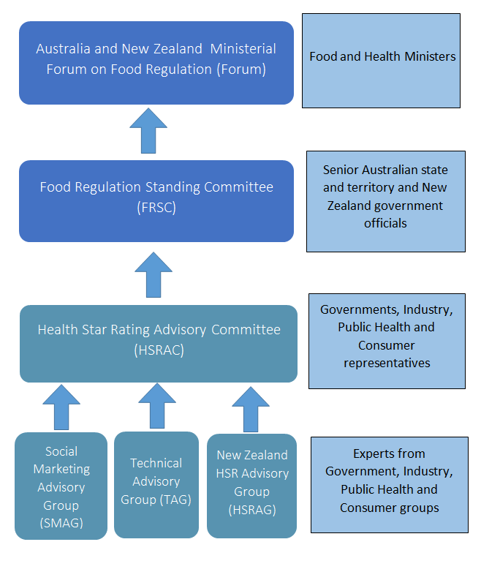

Australia and New Zealand and Ministerial Forum on Food Regulation (the Forum)
The Forum includes Ministers responsible for food from across Australia and New Zealand and is primarily responsible for the development of domestic food regulatory policy and the development of policy guidelines for setting domestic food standards.

Food Regulation Standing Committee (FRSC)
FRSC is the sub-committee of the Forum. Membership of FRSC comprises senior officials of departments for which the Ministers represented on the Forum have portfolio responsibility.
FRSC is responsible for coordinating policy advice to the Forum and ensuring a nationally consistent approach to the implementation and enforcement of food standards. It also advises the Forum on the initiation, review and development of FRSC activities. In November 2015, the Forum agreed to absorb the work of the FoPL Steering Committee into the FRSC.

HSR Advisory Committee (HSRAC)
On 13 December 2013, the Forum agreed that the membership of the FoPL Oversight and Advisory Committee (FoPLOAC, now known as the HSRAC) would comprise nine representatives with equal representation across three stakeholder groups:
- Government (state and federal)
- Industry - professional associations for producers and for retailers with at least one member from the Australian Food and Grocery Council
- Community - public health and consumers
The Chair is a senior government official appointed by the Forum from among the government representatives.
In June 2014, New Zealand announced that it would be implementing the HSR system, and the Forum agreed a further HSRAC member from New Zealand should be included.
The HSRAC brings together stakeholders from industry, government, consumer and public health in a spirit of ongoing collaboration.
The role of the HSRAC is to oversee the voluntary implementation of the HSR system, including the social marketing campaign and the monitoring and evaluation component of the system. The HSRAC is responsible for providing advice to the FRSC about these elements.
The HSRAC has met thirteen times since its inception. Meeting outcomes are published on the HSR website.
In November 2015, the Forum agreed to proposed changes to the HSRAC governance arrangements including for the HSRAC to report to FRSC who absorbed the work of the FoPL Steering Committee, and extending the tenure of the HSRAC to five years to coincide with the extended implementation period.
Membership of the HSRAC has remained unchanged except for the Australian National Retailers Association’s (now the Retail Council) representative who formally resigned as a member of the HSRAC in 2015. The Retail Council advised that they would not be nominating a replacement member. The Forum agreed to appoint a new retail industry representative on the HSRAC.
Further information about HSRAC and the Terms of Reference for the HSRAC is on the HSR website.

Social Marketing Advisory Group (SMAG)
The SMAG was established to assist in the development, implementation and evaluation of the Australian HSR social marketing campaign. The SMAG provides feedback and guidance about campaign elements to the Department of Health and the HSRAC.
The SMAG consists of members with specific expertise in communications and social marketing from relevant industry and consumer/public health groups, as well as jurisdictions. The SMAG is chaired by a representative of the Commonwealth Government Department of Health. The first meeting of SMAG was held on 28 April 2014.

Monitoring and Evaluation Reference Network
At the 27 April 2015 HSRAC meeting, members discussed the need to involve appropriate state and territory representatives in monitoring activities and that a network should be convened. It was agreed that the network would be comprised of interested jurisdictional representatives and would be chaired by the HSRAC Chair.
The Network provides opportunities for information sharing, discussion and for states and territories to be updated on the monitoring and evaluation activities occurring under the auspices of the HSRAC. The Heart Foundation join the Network meetings, where required, to answer any questions that participants may have about monitoring activities.

Jurisdictional group
One of the roles of the FoPL Secretariat is to facilitate information sharing between jurisdictions and the HSRAC jurisdictional representatives in relation to items discussed at meetings of the HSRAC.
Some jurisdictions asked for additional information on the issues considered by HSRAC so pre-HSRAC jurisdictional teleconferences are now held prior to HSRAC meetings with relevant representatives from states and territories.

Technical Advisory Group (TAG)
The HSRAC has established a TAG to assist in a review of the HSR system Calculator. HSRAC agreed on the membership of the group at its 7 August 2016 meeting. Membership consists of a tripartite expert group from industry, government and public health organisations and is chaired by the Australian Government Department of Health. The purpose of the TAG is to assist in the analysis and review of the performance of the HSR system Calculator and respond to technical issues and related matters referred to it by the HSRAC. Advice provided by the TAG will support the five year formal review of the HSR system. The first meeting of the TAG was a teleconference held on 18 October 2016.

New Zealand Health Star Rating Advisory Group (NZ HSRAG)
In 2012, a New Zealand Advisory Group on FoPL, now renamed the New Zealand Health Star Rating Advisory Group (NZ HSRAG), was appointed by the then Minister for Food Safety, Hon Kate Wilkinson, to develop an approach to voluntary interpretive front of pack labelling in New Zealand.
The NZ HSRAG comprises people from government, the food industry, academia and consumer organisations, public health, and is chaired by MPI.
The NZ HSRAG was tasked to:
- Consider the latest evidence regarding FoPL
- Consider global developments in FoPL, particularly in Australia and New Zealand
- Identify areas of common ground shared by stakeholder groups
- Provide advice on evaluation strategies for FoPL based on the above
- Identify, if possible, a pragmatic approach to FoPL that may be used on a voluntary basis
As part of its report the NZ HSRAG developed a set of principles to guide the development of a voluntary interpretive front of pack labelling system in New Zealand and identified the steps necessary to implement and evaluate such a system.
In 2014, the NZ HSRAG analysed the Australian developed HSR system against their principles and agreed that the system met the intent of these principles.
The Chair of the NZ HSRAG sits on the HSRAC as the New Zealand member. The NZ HSRAG, continues to provide advice on and oversight of the implementation of the HSR system in New Zealand.

Appendix 3

The National Heart Foundation of Australia Report on the monitoring of the implementation of the Health Star Rating system in the first two years: Year 1 (June 2014 to June 2015), and Year 2 (June 2015 to June 2016) (Attachment 1)

Appendix 4

New Zealand Ministry for Primary Industries (MPI) Monitoring report on the implementation of the HSR system in New Zealand (Attachment 2)

Appendix 5

Figure A5.1: Examples of campaign print and out of home advertising, and public relations video in Australia.

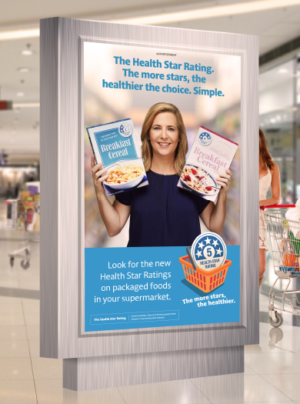

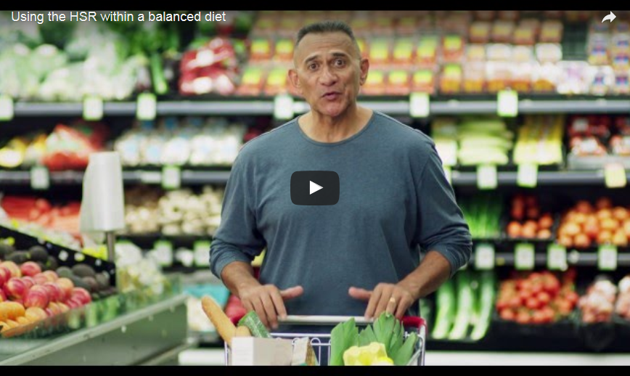

Appendix 6

Health Star Rating System Campaign Evaluation Report - June 2016 by Pollinate Research (Attachment 3)

Appendix 7

Figure A7.1: Examples of campaign print, web tiles and out of home advertising, in New Zealand.

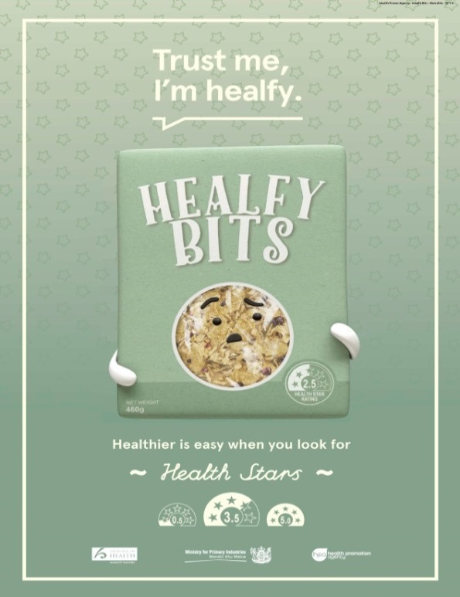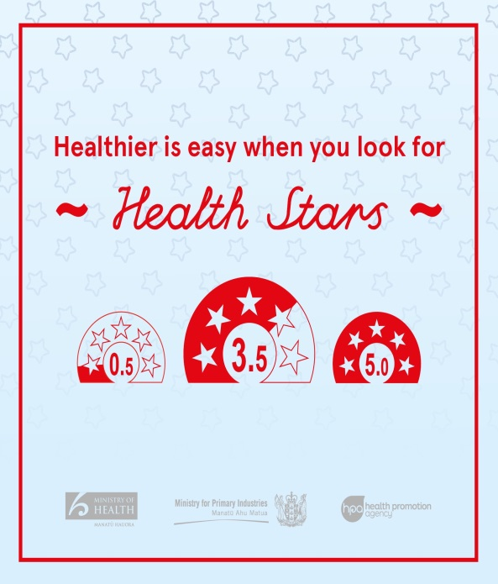

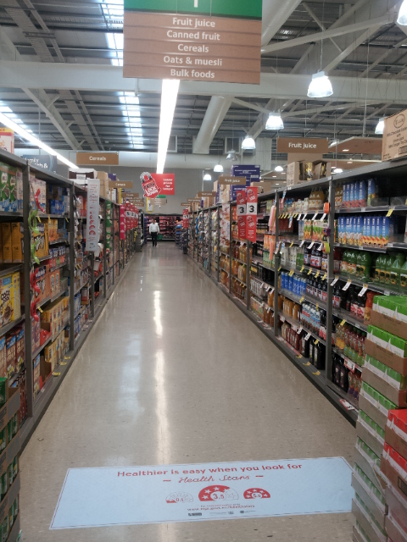

Appendix 8

Definition of an anomaly

Health Star Rating System Policy Context – What is an anomaly?

Background
The development of the Health Star Rating (HSR) system was guided by the Australia and New Zealand Food Regulation Ministerial Council’s (now the Australia and New Zealand
Ministerial Forum on Food Regulation (Forum)) Front of Pack Labelling Policy Statement
(2009) and the Front-of-Pack Labelling (FoPL) Project Committee’s Objectives and Principles for the Development of a front of pack labelling system. These documents together with Forum policy decisions made during the development of the HSR system provide the basis for assessing potential anomalies.

Context
- The purpose of the HSR system is to provide convenient, relevant and readily
understood nutrition information and/or guidance on food packs to assist consumers to make informed food purchases and healthier eating choices.
- The priority focus of the HSR system is packaged food products presented for retail sale through supermarkets and similar retail outlets.
- The HSR system enables valid comparisons between foods based on agreed and consistent measures. Comparisons are enabled in the first instance between packaged foods within a category, and as a second order between food categories.
- The HSR is calculated using the HSR Calculator, which analyses agreed food components, specifically energy, saturated fat, total sugars, sodium, protein, dietary fibre, and fruit/vegetable/nut/legume (FVNL) content in order to calculate a star rating.
- The HSR is intended to interpret the balance of agreed food components and guide consumer choice based on the product’s nutritional qualities. It is not intended to guide the portions or volumes consumed.
- Packaged water as regulated in the Australia New Zealand Food Standard Code Standard 2.6.2 – Non-alcoholic Beverages and Brewed Soft Drinks receives an automatic 5-star rating.

Anomalies
The HSR system should:
- be consistent with the Australian Dietary Guidelines (ADG); and
- enable valid comparisons between foods based on agreed food components (energy, saturated fat, total sugars, sodium, protein, dietary fibre and FVNL).
For the purposes of the HSR system, an anomaly occurs when a star rating is inconsistent with the ADG, or when used to make comparisons within a food category or across comparable food categories would mislead consumers. The HSR Advisory Committee will take both factors into account as part of its considerations.

Appendix 9

Table A9.1: Register of potential anomalies submitted to the HSRAC for consideration
To be deemed an anomaly, the Health Star Rating (HSR) system produces star ratings of individual products or groups of products that are either:
- inconsistent with the Australian Dietary Guidelines (ADG); or
- do not enable valid comparisons between foods based on the agreed food components (energy, saturated fat, total sugars, sodium, protein, dietary fibre and fruit, vegetables, nut and legumes (FVNL)).

Application number | Date Submitted | Brief description of application (as submitted by applicant) | Date Considered by HSRAC | HSRAC determination | Rationale | Outcome / Next steps
2014-1 | 3-Apr-14 | The HSR system does not reflect contemporary scientific evidence on replacement of saturated fat with polyunsaturated fat and prevention of cardiovascular disease. Instead of guiding consumers to choose fat and oils that are low in saturated fat and good sources of polyunsaturated fat, they are steered to choose spreads and oils with the lowest fat content. | 26-Aug-14 | Rejected: after receipt of independent technical advice, application is deemed not an anomaly. | The ADG* promotes both the reduction of fat intake, and a replacement of fat consumed with polyunsaturated forms (as opposed to saturated forms). The HSR Calculator negatively double scores saturated fat content and therefore promotes the reduction of total fat and a shift to unsaturated forms. As a consequence it is not deemed that the HSR Calculator is inconsistent with the ADG. | No further action.
2014-2 | 10-Jul-14 | The HSR system assesses oil and fats solely on their energy, saturated fat, sodium and sugar content, and ignores positive health attributes in fats and oils from natural extraction processes such as antioxidants and other well documented nutritional characteristics. Of particular concern is that the HSR system ignores well documented negative health by-products, such as trans-fat, that result when oils are subjected to a refining and hydrogenation process. | 26-Aug-14 | Rejected: application is deemed not an anomaly as it is outside the defined scope of the HSR system. | The HSR system assesses foods based on the macro nutrients saturated fat, energy, total sugar, sodium [salt], protein, fibre and FVNL. Other nutrients or processing methods outside of the scope of the HSR system may be promoted to consumers using other means, such as Standard 1.2.7 of the Australia and New Zealand Food Standards Code – Nutrition, Health and Related Claims (Standard 1.2.7) if this applies. | No further action.
2014-3 | 14-Jul-14 | Just-add-water' instant drink preparations (coffee, hot chocolate, chai etc.) fall into the Category 1 – Beverages (other than dairy beverages), rather than Category 1D- Dairy Beverages as they deliver less than 10% RDI calcium/serve and contain more than 25% of non-dairy ingredients. As a result these products appear to be unfairly represented (as they are categorised alongside soft drinks, rather than milk based coffees and flavoured milks) and renovation by industry is not encouraged as there is no way within this category to increase the star rating unless you add in fibre or protein, which is not what the consumer is expecting or demanding from these products. | 26-Aug-14 | Rejected: application is deemed not an anomaly. | Due to the significantly different nutritional composition between traditional milk based coffees and water based coffee preparations, it has been determined that it is unfair to compare one to the other. | No further action.
2014-4 | 8-Aug-14 | The definition of what is considered a constituent, an extract or as an isolate of FVNL (including coconut, spices, herbs, fungi, seeds and algae). | 26-Aug-14 | Rejected: application is deemed not an anomaly. | Standard 1.2.7 clearly defines mycoprotein as an extract and therefore is not eligible for FVNL points under the HSR system. | No further action.
2014-5 | 16-Sep-14 | The FVNL % for canned vegetables and legumes is based on as sold, while the compositional data for these products is based on as consumed (drained). Whilst this is consistent with the Food Standards Code characterising ingredient % calculation, it hinders the HSR that can be achieved and does not reflect what is consumed. There is a significant difference in the FVNL % between as sold (52% - 62%) versus as consumed (drained) (approx. 90%) and consequent modifying points. | 31-Oct-14 | Accepted: application is deemed an anomaly. | The existing Characterising Ingredients and Components of Standard 1.2.10 of the Australia and New Zealand Food Standards Code which is referred to in the Guide for Industry to the HSR Calculator, was written purely for the purpose of product labelling and does not support the purpose and intent of the HSR system. The HSRAC has determined that it is appropriate to provide an exemption to adopting this calculation method when determining the HSR. | The Guide for Industry to the HSR Calculator was updated accordingly and uploaded to the HSR website on 3 March 2015.
2014-6 | 13-Oct-14 | The HSR Calculator rates some “core” dairy foods at the lower end of the rating scale. In contrast some nutrient poor, energy dense “discretionary” foods: cakes, biscuits, chips, jelly, and icy poles are scoring 3 to 5 stars. This is contrary to the ADG and misleads consumers as to the healthiness of foods when comparing between foods particularly between “core” dairy foods and “discretionary” foods. | 31-Oct-14 | Rejected: application is deemed not an anomaly. | The HSR Calculator has been technically developed to rate the nutritional quality of the product within their product categories. The categories have been developed in order to support the recommendations of the ADG. Discretionary foods are allowed as part of the ADG, and as the HSR system does not promote volumes or food consumption frequency this issue is not deemed to contradict the ADG. | No further action.
2014-7 | 21-Oct-14 | Not all plain (nothing added) frozen vegetables score a HSR of 5 stars. This is inconsistent with the ADG which recommends individuals “enjoy a wide variety of nutritious foods from [the] five food groups everyday [including] plenty of vegetables of different types and colours”. | 17-Feb-15 | Rejected: application is deemed not an anomaly. | Throughout the development of the HSR system, the Technical Design Working Group and Front of Pack Labelling Project Committee concluded that giving all vegetables a 5 star rating would impact on ratings for other food products and create a lack of differentiation for many processed foods. It would also alter the scores of other products within Category 2 – other foods. | No further action.
2015-1 | 2-Jan-15 | Products that contain both dairy and non-dairy components [such as cheese and crackers], but do not meet the requirements to be categorised as a category 2D food because they contain more than 25% non-dairy food, receive a low HSR score that is not representative of the combined food nor comparable to products that may be considered 'comparable' products. | 17-Feb-15 | Rejected: application is deemed not an anomaly. | When cheese and crackers are presented in a single package, the crackers usually comprise more than 25% of the product. The HSRAC therefore agreed that the product should not be categorised as a dairy product, rather it falls into Category 2 – other foods. | No further action.
2015-2 | 2-Jan-15 | By adding positive nutrients such as protein and fibre boosters, to non-core food products such as a processed protein bar, manufacturers can develop products that score a HSR of 5, even when the natural protein and fibre content of the remaining ingredients remains negligible if not zero. This product group scores too highly compared with other similar products/groups i.e. the product group receives an inappropriate HSR. | 17-Feb-15 | Rejected: application is deemed not an anomaly. | The HSR Calculator was not designed to discern different types of fibre. | No further action.
2015-3 | 2-Jan-15 | One potato chip product scores much higher than all other varieties. This is because the baseline points are just below 13, which means it is the only variety of chip that is eligible to count its protein points for the HSR. By slightly reducing the sodium and sat fat, but increasing the sugar, the product falls just below the baseline points thresholds and when compared to other products it receives an unrealistically high HSR. | 17-Feb-15 | Rejected: application is deemed not an anomaly. | The HSRAC noted that there will be some outliers as a result of products that sit on or near the cut-points for the various nutrients. The example illustrates that by undertaking simple reformulation, a higher HSR is possible within that category. | No further action.
2015-4 | 10-June-15 | A juice product which appears to be aimed at children scores five stars despite its high energy and sugar content. The label states that the product contains “one serve of fruit” and “no added sugar”. However a single serve is defined as 250mL, equivalent to two serves of fruit according to the ADG, and a single serve contains 25.3g sugar.  The rating obtained by the product and, as a result, the message being portrayed to consumers, is contrary to the advice provided in the ADG and Australian Guide to Healthy Eating. | 17-July-15 | Rejected: application is deemed not an anomaly. | The product displays an accurate HSR and does not represent an anomaly according to the agreed definition. The matter raised pertains to serve sizes appropriate for children, the marketing of products to children and the potential for these products to be inconsistent with the ADG relevant to children, rather than the validity and accuracy of the HSR system and HSR Calculator outputs. The issue raised should be considered as part of the evaluation of the HSR system at the end of the five year implementation period. | No further action, however, this issue should be considered as part of the evaluation of the HSR system.
2015-5 | 6-July-15 | The system does not recognise that some foods fill special dietary needs and as a result does not provide sufficient differentiation between categories of products.  Within the algorithm there is insufficient distinction between types of fats and insufficient weight is allocated to sugar quantities. | 2-Oct-2015 | Rejected: application is deemed not an anomaly. | The HSRAC determined that during the development of the HSR system a very specific decision was made regarding the treatment of fat within the HSR algorithm. It was determined that for the purposes of the HSR system, saturated fat, a high risk nutrient, would be the only type of fat to contribute to HSR baseline points, noting that total fat content would be considered by way of the baseline points allocated for energy content.  - The Committee also determined that a very considered and purposeful decision was made regarding the role of allergens and foods manufactured for special dietary needs and it was determined that these considerations would be out of scope. | No further action.
2015-6 | 13-July-15 | Bottled water receives five stars whilst  bottled flavoured water with a small amount of added sugar (or flavour etc.) receives only two stars suggesting that there is greater difference in ‘healthfulness’ than actually exists. | Submission withdrawn | N/A | N/A | N/A
2015-7 | 21-Aug-15 | Honey is unfairly treated within the HSR system due to its high level of naturally occurring sugar.  Most consumers perceive honey as a “healthier” product and a 1-star score may undermine that perception. | 2-Oct-2015 | Rejected: application is deemed not an anomaly. | The HSRAC noted that the HSR system was not designed for single ingredient foods and that whilst there is no expectation that the HSR system be applied to such products, they were not excluded from the system. The HSRAC also noted that some suppliers of honey may wish to apply the HSR system, (even if only the energy icon) further supporting the position not to exclude this entire category of product from the HSR system. | The issue will be put forward for consideration as part of the evaluation of the HSR system; and a new frequently asked question, outlining that the HSR system is not designed for some product categories will be uploaded to the HSR website.
2015-8 | 14-Dec-15 | Eggs receive only four stars despite being a natural food and containing essential vitamins and minerals. | Submission withdrawn | N/A | N/A | N/A
2016-1 | 2-Feb-16 | The HSR Calculator does not reflect the true health nature of beverages that are ‘fortified waters’ (i.e. water with vitamins, minerals, flavours added). | N/A | Rejected: application is deemed not an anomaly. | The HSRAC has considered the treatment of beverages and in particular ‘flavoured or fortified’ waters on several occasions and has determined that it is satisfied that these products: do not present an anomaly; and are receiving appropriate ratings under the HSR system. Whilst water is essential for life, beverages such as these are not and it is not seen as necessary to portray them any differently or more favourably than any other beverage product. | No further action.
2016-2 | 11-Mar-16 | Many fruit varieties and some whole fresh vegetables would receive less than five stars under the HSR system. This puts these products at a disadvantage compared to other 5-star rated products like fruit juices; and implies that fruit juice is healthier than or as healthy as whole fruits and vegetables. This is inconsistent with recommendations in the Australian Guide to Healthy Eating. | N/A | Rejected: application is deemed not an anomaly. | Although it may be applied, the system is not intended for unprocessed or minimally processed fruits and vegetables.  Throughout the development of the HSR system, the Technical Design Working Group and Front-of-Pack Labelling Project Committee concluded that giving all vegetables a five star rating would impact on ratings for other food products and create a lack of differentiation for many processed foods. It would also alter the scores of other products within Category 2 – other foods. | No further action.

Uptake was assessed using the retail food database, FoodTrackTM. FoodTrackTM data is collected annually on a rolling schedule. At any single point in time, data for each category may be out dated by 1-11 months. Point in time collections involve the collection of data from every category within a single month period.
At the end of Year 2 the system was displayed across more than twice as many food categories as Year 1 (n=74 vs. n=36), and implemented by nearly three times the number of manufacturers (n=63 vs. n=23).
Uptake was assessed using the retail food database Nutritrack. Nutritrack data is collected in the first quarter of each year. Uptake of the HSR in New Zealand is limited to only those products displaying the Health Star Rating graphic (i.e. display of the energy icon only is excluded).
“Top of mind” means that HSR was the ‘first mention’ of a respondent. “Total spontaneous” mentions is top of mind and other spontaneous mentions (other unprompted mentions) combined.
Respondents were asked: Apart from brand names, can you think of any nutrition logos or labelling that you have seen on food packaging to help you decide how healthy it is? If so, what was it that you saw? The following question was: Which of the following nutrition logos or labelling on food packaging have you heard of? with a bank of images/logos to select from.
Excludes those products for which it has been deemed not appropriate to implement the HSR system.
↓ indicates a decrease and ↑ indicates an increase in the proportion of products displaying that particular HSR Option from Year 1 to Year 2
Excludes results for Private Label – Coles and Private Label – Woolworths as these have been reported previously, in text.
Data for the uptake of the Daily Intake Guide (DIG) front-of-pack labelling system was available as a whole number encompassing in-store counts only, for ALDI, IGA, Coles and Woolworths. As the two time points of implementation and uptake of the DIG and the HSR system differed (i.e. the dates and year), uptake has been reported in months post implementation, as a standardised measure, where zero (0) on the x-axis represents the point of implementation for both the HSR system and the DIG, and each time point thereafter represents months 1, 2 and 3 etc. post implementation.
For further information on the different types of Technical Variations identified please refer to the National Heart Foundation of Australia Report on the monitoring of the implementation of the Health Star Rating system in the first two years: Year 1 (June 2014 to June 2015), and Year 2 (June 2015 to June 2016) , Section 1.3.22.
Energy and nutrient information may be presented on a ‘per 100g or 100mL’ basis, ‘per pack’ (when presented as a single portion), or ‘per [reference portion]’ (when presented as a multipack with individual pre-portioned units intended for consumption in a single sitting), or ‘per [serve size]’ according to Section 3.8 of the Style Guide. The nominated reference measure should be placed to the right hand side of the graphic.
In the Sep14 and Apr 15 all respondents were asked these questions. In Sep 15, Feb 16 and Jul 16 only those with prompted awareness of the HSR system were asked these questions.
Using the definition provided by the Australian Bureau of Statistics (ABS), small companies were classified as businesses with less than 20 employees (n=10), medium as between 20 and 200 employees (n=14), and large as those with more than 200 employees (n=12).
https://www.youtube.com/watch?v=3lgo_uaLUKg&index=6&list=PLFuNzCi2KRzdSHeVKyfS_N1mxdn1sr05u
http://healthstarrating.gov.au/internet/healthstarrating/publishing.nsf/content/home
http://www.mpi.govt.nz/food-safety/whats-in-our-food/food-labelling/health-star-ratings/
Legislative and Governance Forum on Food Regulation (convening as the Australia and New Zealand Food Regulation Ministerial Council) Response to the Recommendations of Labelling Logic: Review of Food Labelling Law and Policy (2011); Page 8
Above, n1; Page 52
Above, n1; Page 52
http://www.foodsafety.govt.nz/industry/general/labelling-composition/health-star-rating/FoPL-advisory-group-background.pdf

