Report on the monitoring of the implementation of the Health Star Rating system in the first two years of implementation: June 2014 to June 2016.

2017

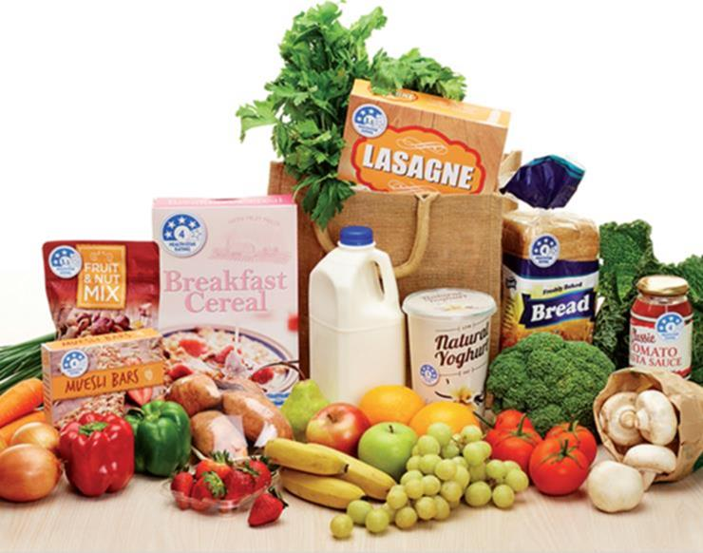

Prepared for the Commonwealth Department of Health

Submitted by the National Heart Foundation of Australia, March 2017

Reporting periods: June 2015 to June 2016 (Year 2), June 2014 to June 2015 (Year 1)

For enquiries about this report, please contact:

Front-of-Pack Labelling Secretariat Australian Government Department of Health

GPO Box 9848, Canberra, ACT, 2601

Phone: 1800 099 658

[Email: frontofpack@health.gov.au](mailto:frontofpack@health.gov.au)

© 2017 National Heart Foundation of Australia, ABN 98 008 419 761

Suggested citation: National Heart Foundation of Australia. Report on the monitoring of the implementation of the Health Star Rating system in the first two years of implementation: June 2014 to June 2016. Commissioned by the Commonwealth Department of Health. Melbourne, Australia: National Heart Foundation of Australia, 2017.

Disclaimer: This materialhas been developed by the Heart Foundation for general information. The statements and recommendations it contains are, unless labelled as ‘expert opinion’, based on independent review of the available evidence.

While care has been taken in preparing the content of this material, the Heart Foundation and its employees cannot accept any liability, including for any loss or damage, resulting from the reliance on the content, or for its accuracy, currency and completeness. The information is obtained and developed from a variety of sources including, but not limited to, collaborations with third parties and information provided by third parties under licence. It is not an endorsement of any organisation, product or service.

This material may be found in third parties’ programs or materials (including, but not limited to, show bags or advertising kits). This does not imply an endorsement or recommendation by the National Heart Foundation of Australia for such third parties’ organisations, products or services, including their materials or information. Any use of National Heart Foundation of Australia materials or information by another person or organisation is at the user's own risk.

The entire contents of this material are subject to copyright protection.

COR-214.0117

Contents

Contents 3

Acknowledgments 14

Project staff 14

Funding 14

Health Star Rating system graphics 15

Year 2 of the Health Star Rating system at a glance 16

Key achievements 16

Findings for consideration in the future 16

Executive summary 17

Chapter 1: Label implementation and consistency with the Health Star Rating system Style Guide 17

Chapter 2: Consumer awareness and ability to use the Health Star Rating system correctly 18

Chapter 3: Nutrient status of products carrying a Health Star Rating system graphic 19

Chapter 4: Industry’s experience with the Health Star Rating system 19

Health Star Rating system graphics 21

Background and objectives 22

Agreement to develop the Health Star Rating system 22

What is the Health Star Rating system? 22

Objective of the Health Star Rating system 23

Implementation of the Health Star Rating system 23

Monitoring and evaluation of the Health Star Rating system: Areas of enquiry 23

Project objective 23

Supplementary work 24

Program logic framework 25

General methodology 28

Food composition data and Health Star Rating products: FoodTrackTM 28

Customising FoodTrack™ for this project 29

Notes about the Year 2 report 29

Chapter 1: Label implementation and consistency with the Health Star Rating system Style Guide 31

1.1 Chapter summary 34

1.1.1 Uptake of the Health Star Rating system 34

1.1.2 Comparison of point-in-time uptake of the Health Star Rating system to the Daily Intake Guide 35

1.1.3 Consistency in implementation of the Health Star Rating system graphic with the Health Star Rating Style Guide 35

1.1.4 Assessment of the Health Star Rating displayed on pack using the Health Star Rating Calculator 36

Health Star Rating system graphics 37

1.2 Methodology 38

1.2.1 Uptake of the Health Star Rating system by manufacturers and retailers, and Health Star Rating categories 38

1.2.2 Comparison of the uptake of the Health Star Rating system to the uptake of the Daily Intake Guide 39

1.2.3 Consistency in implementation of the Health Star Rating system graphic with the Health Star Rating system Style Guide 39

1.2.4 Assessment of Health Star Rating displayed on pack against that determined by the Health Star Rating Calculator 41

1.2.5 Data analysis 42

1.3 Results 42

1.3.1 Uptake of the Health Star Rating system, by Health Star Rating category 42

1.3.2 Uptake of products displaying Option 5 of the Health Star Rating system graphic, by Health Star Rating category 51

1.3.3 Uptake of the Health Star Rating system, by manufacturers and retailers 53

1.3.4 Uptake of products displaying Option 5 of the Health Star Rating system graphic, by manufacturers and retailers 62

1.3.5 Comparison of uptake of the Health Star Rating system to the top-selling food and beverage categories 63

1.3.6 Comparison of Health Star Rating products to those products on which displaying the Health Star Rating system graphic is perceived important by consumers 65

1.3.7 Results from Waves 1–4 of point-in-time monitoring of uptake of the Health Star Rating system 67

1.3.8 Comparison of uptake of the Health Star Rating system to uptake of the DIG 67

1.3.9 Summary of Health Star Rating options displayed on pack 69

1.3.10 Assessment of Health Star Rating options, by manufacturer and retailer 72

1.3.11 Assessment of Health Star Rating options, by Health Star Rating category 77

1.3.12 Option 1 of the Health Star Rating system graphic 81

1.3.13 Optional nutrient 83

1.3.14 Option 2 of the Health Star Rating system graphic 85

1.3.15 Option 3 of the Health Star Rating system graphic 88

1.3.16 Option 4 of the Health Star Rating system graphic 90

1.3.17 Option 5 of the Health Star Rating system graphic 93

1.3.18 Combined versions of the Health Star Rating system graphic 95

1.3.19 Multipacks 96

1.3.20 Consistency in implementation of the Health Star Rating system graphic with the Health Star Rating Style Guide 98

1.3.21 General Variations from the Style Guide 99

1.3.22 Technical variations from the Style Guide 100

1.3.23 Design variations from the Style Guide 104

1.3.24 Assessment of the Health Star Rating displayed on pack against the calculated Health Star Rating 107

1.3.25 Assessment of the Health Star Rating displayed on pack against the calculated Health Star Rating: multipack assessment 111

Chapter 2: Consumer awareness and ability to use the Health Star Rating system correctly 112

2.1 Chapter summary 115

2.1.1 Awareness of the Health Star Rating system 115

2.1.2 Understanding of what the Health Star Rating system represents 115

2.1.3 Use of the Health Star Rating system 115

2.1.4 Advertising awareness 115

2.1.5 Perceptions and attitudes towards the Health Star Rating system 116

Health Star Rating system graphics 117

2.2 Methodology 118

2.2.1 Survey design and sample 118

2.2.2 Online panel partner 118

2.2.3 Survey questionnaire 119

2.2.4 Data analysis and reporting 120

2.2.5 Accuracy of results 120

2.2.6 Sample characteristics 120

2.3 Results – Section A: General supermarket shopping 122

2.3.1 Main influence when choosing between two products 122

2.3.2 Frequency of visits to the supermarket 122

2.3.3 Supermarkets visited in the past month 123

2.3.4 Average spend per visit to the supermarket 124

2.3.5 Comparing the healthiness of products 124

2.3.6 Use of the nutrition information panel 125

2.4 Results – Section B: Awareness of food logos 126

2.4.1 Unprompted awareness of food logos 126

2.4.2 Unprompted awareness of the Health Star Rating system 127

Age group 127

Gender 127

Household income 128

Body mass index 128

Indigenous status 128

Language spoken at home 129

Location – metropolitan versus regional/rural 129

Household structure – children 129

2.4.3 Prompted awareness of food logos 130

2.4.4 Prompted awareness of the Health Star Rating system 131

Age group 131

Gender 132

Household income 132

Body mass index 132

Indigenous status 133

Language spoken at home 133

Location – metropolitan versus regional/rural 133

Household structure – children 133

2.5 Results – Section C: Knowledge and understanding of the Health Star Rating system 135

2.5.1 Understanding of what the Health Star Rating system means 135

2.5.2 Understanding of how the Health Star Rating on a product is determined 135

2.5.3 Statements about the Health Star Rating system 136

2.5.4 Using the Health Star Rating system 137

2.5.5 Understanding what one star or five stars means 138

2.5.6 Statements about the Health Star Rating system – a product with more stars… 139

2.5.7 Easiest to understand 140

2.5.8 Easiest to recognise 140

2.5.9 Provides sufficient information 141

2.5.10 Preferred option 142

2.6 Results – Section D: Purchasing behaviours 143

2.6.1 Purchased a product displaying the Health Star Rating system graphic (a Health Star Rating product) 143

2.6.2 The Health Star Rating system influenced choice 144

2.6.3 How the Health Star Rating system influenced choice 145

2.6.4 Reasons why the Health Star Rating system did not influence choice 145

2.6.5 Continue to buy the product 146

2.6.6 Likelihood of the Health Star Rating system influencing choices in the future 146

2.6.7 Health Star Rating system graphic comparison – which is the healthier option? 147

2.6.8 Foods and/or beverages purchased in the supermarket displaying the Health Star Rating system graphic (a Health Star Rating product) 149

2.6.9 Foods and/or beverages on which it is important to display the Health Star Rating system graphic 151

2.7 Results – Section E: Advertising awareness 153

2.7.1 Awareness and source of Health Star Rating system advertising 153

2.7.2 Product advertised or promoted 155

2.7.3 Influence advertising had on purchasing a product displaying the Health Star Rating system graphic (a Health Star Rating product) 156

2.8 Results – Section F: Attitudes and perceptions about the Health Star Rating system 157

2.8.1 Statements about the Health Star Rating system – perceptions and attitudes 157

2.8.2 Trust in the Health Star Rating system 158

Age group 158

Gender 158

Household income 159

BMI 159

Language spoken at home 159

Location – metropolitan versus regional/rural 159

Household structure – children 160

2.8.3 Level of confidence in the Health Star Rating system 160

2.9 Results – Section G: Health attitudes and behaviours 161

2.9.1 Concern about the healthiness of food purchased 161

2.9.2 Perceived healthiness of diet 161

2.9.3 Changes to diet 162

2.9.4 Type of changes made to diet 162

2.9.5 Type of changes made to diet 163

Chapter 3: Nutrient status of products carrying a Health Star Rating system graphic 164

3.1 Chapter summary 166

3.1.1 Nutrient status of Health Star Rating products in Year 1 and Year 2 166

Health Star Rating system graphics 167

3.2 Methodology 168

3.2.1 Data analysis 168

3.3 Results 169

3.3.1 Distribution of the Health Star Rating on Health Star Rating products in Year 1 and Year 2. 169

3.3.2 Mean Health Star Rating of Health Star Rating products in Year 1 and Year 2 170

3.3.3 Distribution of the Health Star Rating, by Health Star Rating category class 172

3.3.4 Nutrient status of Health Star Rating products 178

3.3.5 Nutrient status of Health Star Rating products, by nutrient 179

3.3.6 Changes in the Health Star Rating on Health Star Rating products over time 186

Chapter 4: Industry’s experience with the Health Star Rating system 191

4.1 Chapter summary 193

Health Star Rating system graphics 195

4.2 Methodology 196

4.2.1 Interview design and sample 196

4.2.2 Interviewees 196

4.2.3 Discussion guide 198

4.3 Results: Insights 199

4.3.1 Motivators for implementing the Health Star Rating system 199

4.3.2 Rationale for product coverage and Health Star Rating graphic selection 200

4.3.3 Implementing the Health Star Rating system 203

4.3.4 Impact of the Health Star Rating system 204

4.3.5 Areas for improvement 206

4.3.6 Future intentions 207

Appendix 1. Wave 4 uptake report 209

Report for Wave 4 of point-in-time uptake monitoring of the Health Star Rating system, in Australian supermarkets in August to September 2016 209

Background 209

Methodology 209

Results 211

Appendix 2. Compliance checklist 226

Appendix 3. Definitions for percentage fruit, vegetable, nut, legume, and percentage concentrated fruit or vegetables 235

Appendix 4. Area of enquiry 2 survey 238

Appendix 5. Industry survey discussion guide 260

Appendix 6. Text-based Alternatives for Figures 262

Abbreviations and acronyms 301

Glossary 302

References 304

Figures and Tables  
  
Figure I. Program logic framework for the monitoring and evaluation of implementation of the Health Star Rating system 26

Table I. Key features of data coverage and data collection using the FoodTrackTM platform 28

Table 1.1. Health Star Rating (HSR) calibration category and associated HSR category class 40

Table 1.2. Health Star Rating (HSR) categories that had 10 or less HSR products in Year 2 42

Table 1.3. Health Star Rating (HSR) categories that had more than 10 HSR products in Year 2 43

Figure 1.1. Health Star Rating (HSR) categories that had more than 10 HSR products in Year 2, compared with Year 1 45

Table 1.4. Comparison of the proportion of Health Star Rating (HSR) products in each HSR category, in Year 1 and Year 2 46

Table 1.5. Number of Health Star Rating (HSR) products displaying Option 5, by HSR category, in Year 1 and Year 2 50

Table 1.6. Manufacturers and retailers that had five or less Health Star Rating (HSR) products in Year 2 51

Figure 1.2. Manufacturers and retailers with more than five Health Star Rating (HSR) products in Year 2, compared with Year 1 54

Table 1.7. Manufacturers and retailers that had more than five Health Star Rating (HSR) products in Year 2 55

Table 1.8. Comparison of the proportion of Health Star Rating (HSR) products for each manufacturer and retailer, in Year 1 and Year 2 56

Table 1.9. Comparison of the number of Health Star Rating (HSR) products displaying Option 5, by manufacturer and retailer, in Year 1 and Year 2 59

Table 1.10. Top-selling Retail World (RW) categories, and their equivalent Health Star Rating (HSR) categories 60

Figure 1.3. Proportion of Health Star Rating (HSR) products in each Retail World category, in Year 1 and Year 2 61

Table 1.11. Top-ranking survey categories, and their equivalent Health Star Rating (HSR) categories 62

Figure 1.4. Proportion of Health Star Rating (HSR) products (%) in each survey category, in Year 1 and Year 2 63

Figure 1.5. Comparison of uptake of the Health Star Rating (HSR) system to the uptake of the Daily Intake Guide (DIG), over time 65

Table 1.12. Comparison of the number and proportion of Health Star Rating (HSR) products, by HSR option, in Year 1 and Year 2 67

Figure 1.6. Number of Health Star Rating (HSR) products and number of HSR system graphics assessed, by HSR option, in Year 2 68

Figure 1.7. Number of Health Star Rating (HSR) products (n) displayed by Private label – Coles and Private label – Woolworths, by HSR option, in Year 2 70

Figure 1.8. Number of Health Star Rating (HSR) products (n), by manufacturers and retailers (> 20 HSR products), by HSR option, in Year 2 70

Figure 1.9. Number of Health Star Rating (HSR) products (n), by manufacturers and retailers (< 20 HSR products), by HSR option, in Year 2 72

Figure 1.10. Number of Health Star Rating (HSR) products (n), by manufacturers and retailers, by HSR option, in Year 1 73

Figure 1.11. Number of Health Star Rating (HSR) products (n), by HSR category (≥ 30 HSR products), by HSR option, in Year 2 75

Figure 1.12. Number of Health Star Rating (HSR) products (n), by HSR category (< 30 HSR products), by HSR option, In Year 2 76

Figure 1.13. Number of Health Star Rating (HSR) products (n), by HSR category, by HSR option, in Year 1 77

Figure 1.14. Number of Health Star Rating (HSR) products (n) displaying Option 1 of the HSR system graphic, by manufacturers and retailers, in Year 1 and Year 2 78

Figure 1.15. Number of Health Star Rating (HSR) products (n) displaying Option 1 of the HSR system graphic, by HSR category, in Year 1 and Year 2 79

Figure 1.16. Number of Health Star Rating (HSR) products displaying Option 1 of the HSR system graphic (n), by optional nutrient, in Year 1 and Year 2 80

Table 1.13. Number of Health Star Rating (HSR) products displaying the top-three optional nutrients, by HSR category, in Year 1 and Year 2 81

Table 1.14. Number of Health Star Rating (HSR) products displaying the top-three optional nutrients, by manufacturers and retailers, in Year 1 and Year 2 82

Table 1.15. Number of Health Star Rating (HSR) products displaying Option 2 of the HSR system graphic, by manufacturer or retailer, in Year 1 and Year 2 83

Figure 1.17. Number of Health Star Rating (HSR) products (n) displaying Option 2 of the HSR system graphic, by HSR category, in Year 1 and Year 2 84

Figure 1.18. Number of Health Star Rating (HSR) products (n) displaying Option 3 of the HSR system graphic, by manufacturers and retailers, in Year 1 and Year 2 85

Figure 1.19. Number of Health Star Rating (HSR) products (n) displaying Option 3 of the HSR system graphic, by HSR category, in Year 1 and Year 2 86

Figure 1.20. Number of Health Star Rating (HSR) products (n) displaying Option 4 of the HSR system graphic, by manufacturers and retailers (excluding top 2), in Year 1 and Year 2 88

Figure 1.21. Number of Health Star Rating (HSR) products (n) displaying Option 4 of the HSR system graphic, by HSR category (≥ 10 HSR products), in Year 1 and Year 2 89

Figure 1.22. Number of Health Star Rating (HSR) products (n) displaying Option 5 of the HSR system graphic, by manufacturers and retailers, in Year 1 and Year 2 90

Figure 1.23. Number of Health Star Rating (HSR) products (n) displaying Option 5 of the HSR system graphic, by HSR category, in Year 1 and Year 2 91  
Table 1.16. Number of Health Star Rating (HSR) products displaying a combined version of the HSR system graphic, by HSR category, in Year 1 and Year 2 92

Figure 1.24. Number of multipacks, by Health Star Rating (HSR) option, by display method, in Year 2 93

Table 1.17. Number of multipacks, by Health Star Rating (HSR) category, in Year 1 and Year 2 93

Table 1.18. Number of Health Star Rating (HSR) products not intended to display the HSR system graphic, by HSR option, in Year 1 and Year 2 95

Figure 1.25. Proportion of Health Star Rating (HSR) system graphics (%), by HSR option, that were consistent with the Style Guide, in Year 1 and Year 2 96

Table 1.19. Number of technical variations from the Style Guide, in Year 1 and Year 2 97

Figure 1.26. Number of Health Star Rating (HSR) system graphics (n) displaying the top-three technical variation themes, by HSR category, in Year 2 99

Table 1.20. Number of design variations from the Style Guide, in Year 1 and Year 2 100

Figure 1.27. Number of Health Star Rating (HSR) system graphics (n) displaying the top-three design variation themes, by HSR category, in Year 2 102

Table 1.21. Summary of Health Star Rating (HSR) products that were eligible for assessment, in Year 1 and Year 2 103

Table 1.22. Health Star Rating (HSR) categories in which the calculated HSR did not match that displayed on pack 104

Table 2.1. Sample characteristics of the populations surveyed for Waves 1–3 of AoE 2 114

Figure 2A1. When buying food at the supermarket, what is the main thing that influences your choice between two similar products? 116

Table 2A1. On average, how often do you visit a supermarket to do your grocery shopping? 117

Figure 2A2. Which supermarkets have you visited in the past month? 117

Table 2A2. On average, how much do you spend in one visit to the supermarket? 118

Figure 2A3. When choosing a new food during grocery shopping, how often do you compare how healthy products are? 119

Figure 2A4. On average, when at the supermarket, do you look at the nutrition information panel on…? 119

Figure 2B1. Apart from brand names, thinking about different logos that help customers choose the food they buy in the supermarket, which ones are you aware of? 120

Table 2B1. Age group 121

Table 2B2. Gender 121

Table 2B3. Household income 122

Table 2B4. Body mass index 122

Table 2B5. Indigenous status 122

Table 2B6. Language spoken at home 122

Table 2B7. Location 123

Table 2B8. Children at home 123

Figure 2B2. Which of the following are you aware of on food packaging? 124

Figure 2B3. Prompted awareness of the Health Star Rating system over time 125

Table 2B9. Age group 125

Table 2B10. Gender 126

Table 2B11. Household Income 126

Table 2B12. Body mass index 126

Table 2B13. Indigenous status 127

Table 2B14. Language spoken at home 127

Table 2B15. Location 127

Table 2B16. Children at home 127

Figure 2C1. When the Health Star Rating system is on the packaging of food, what do you think it means? 128

Figure 2C2. In your opinion, how is the number of stars on a product determined? 129

Table 2C1. How strongly do you agree or disagree that the Health Star Rating system…? 129

Figure 2C3. How would you use the Health Star Rating (HSR) system? 130

Figure 2C4. If a food product has one star, what do you think this means? 131

Figure 2C5. If a food product has five stars, what do you think this means? 132

Table 2C2. How strongly do you agree or disagree that a product with more stars means…? 132

Table 2C3. The Health Star Rating (HSR) system can be displayed in five different ways. Please select the style you believe is the easiest to understand. 133

Table 2C4. The Health Star Rating (HSR) system can be displayed in five different ways. Please select the style you believe is the easiest to recognise? 134

Table 2C5. The Health Star Rating (HSR) system can be displayed in five different ways. Please select the style you believe provides sufficient information 134

Table 2C6. Overall, please select the style you prefer the most. 135

Table 2D1. In the past three months, have you purchased a product that had the Health Star Rating system? 136

Table 2D2. Age group 136

Table 2D3. Gender 137

Table 2D4. Household Income 137

Table 2D5. Body mass index 137

Table 2D6. Language 137

Table 2D7. Location 137

Table 2D8. Children at home 137

Table 2D9. Did the Health Star Rating system on the product influence your choice? 138

Table 2D10. How did it influence your choice? 138

Figure 2D1. Why didn’t the Health Star Rating system influence your choice? 139

Table 2D11. Have you continued or will continue to buy the product? 139

Table 2D12. How likely or unlikely is the Health Star Rating system to influence choices you make in the future when buying food? 140

Table 2D13. Please select which you think is a healthier option in each pair 140

Table 2D14. Please select which you think is a healthier option in each pair 140

Table 2D15. Please select which you think is a healthier option in each pair 141

Table 2D16. Please select which you think is a healthier option in each pair 141

Table 2D17. Please select which you think is a healthier option in each pair 141

Figure 2D2. Please select which foods and/or beverages you purchased in the supermarket had the Health Star Rating system on them 143

Figure 2D3. Please select which foods and/or beverages you believe it is important to have the Health Star Rating system on 145

Table 2E1. In the last three months, do you remember seeing, hearing or reading any advertising or promotions about the Health Star Rating system? 146

Figure 2E1. Where had you seen, or heard about the Health Star Rating system? 147

Table 2E2. Which organization or company did the advertising or promotion(s)? 148

Figure 2E2. What product or products were being advertised or promoted? 148

Table 2E3. After seeing or hearing this advertising or promotion(s) for products with a Health Star Rating system, did it influence you to buy a product or products you normally wouldn’t buy? 149

Table 2F1. How strongly do you agree or disagree that the Health Star Rating system…? 150

Table 2F2. How strongly do you agree or disagree that the Health Star Rating system…? 150

Table 2F3. How strongly do you agree or disagree that the Health Star Rating system…? 151

Table 2F4. Age group 151

Table 2F5. Gender 151

Table 2F6. Household income 152

Table 2F7. Body mass index 152

Table 2F8. Language 152

Table 2F9. Residential location 152

Table 2F10. Children at home 153

Table 2F11. What best describes your level of confidence in the Health Star Rating system…? 153

Table 2G1. In general, thinking about all the food you buy, how concerned are you about how healthy the food is for you…? 154

Table 2G2. Thinking about your diet, would you say that what you usually eat is…? 154

Table 2G3. Over the past six months, have you made any changes to your diet? 155

Figure 2G1. Which of the following changes have you made in the past six months to your diet? 155

Figure 2G2. For which of the following reasons did you make changes to your diet? 156

Figure 3.1. Number of Health Star Rating (HSR) products (n) displaying each HSR on pack, in Year 1 and Year 2 163

Figure 3.2. Mean Health Star Rating (HSR) displayed on pack, by HSR category class, in Year 1 and Year 2 165

Figure 3.3. Number of Health Star Rating (HSR) products (n) displaying each HSR on pack, within the ‘1 – Beverages’ HSR category class, in Year 1 and Year 2 166

Figure 3.4. Number of Health Star Rating (HSR) products (n) displaying each HSR on pack, within the 1D – Dairy Beverages HSR category class, in Year 1 and Year 2 167

Figure 3.5. Number of Health Star Rating (HSR) products (n) displaying each HSR on pack, within the 2 – Food HSR category class, in Year 1 and Year 2 168

Figure 3.6. Number of Health Star Rating (HSR) products (n) displaying each HSR on pack, within the ‘2D – Dairy’ food HSR category class, in Year 1 and Year 2 169

Figure 3.7. Number of Health Star Rating (HSR) products (n) displaying each HSR on pack, within the ‘3 – Oils and spreads’ HSR category class, in Year 1 and Year 2 170

Figure 3.8. Number of Health Star Rating (HSR) products (n) displaying each HSR on pack, within the ‘3D – Cheese and processed cheese’ HSR category class, in Year 1 and Year 2 171

Table 3.1. Number of Health Star Rating (HSR) products, in each HSR category class, for each nutrient, in Year 1 and Year 2 172

Figure 3.9. Mean energy content of Health Star Rating (HSR) products, by HSR category class, in Year 1 and Year 2 174

Figure 3.10. Mean saturated fat content of Health Star Rating (HSR) products, by HSR category class, in Year 1 and Year 2 175

Figure 3.11. Mean sugars content of Health Star Rating (HSR) products, by HSR category class, in Year 1 and Year 2 176

Figure 3.12. Mean sodium content of Health Star Rating (HSR) products, by HSR category class, in Year 1 and Year 2 177

Figure 3.13. Mean protein content of Health Star Rating (HSR) products, by HSR category class, in Year 1 and Year 2 178

Figure 3.14. Mean fibre content of Health Star Rating (HSR) products, by HSR category class, in Year 1 and Year 2 179

Table 3.2. Presence (and absence) of Health Star Rating (HSR) products, in Year 1 and Year 2 180

Table 3.3. Health Star Rating (HSR) products present in Year 1 and Year 2, for which the HSR did not match 180

Figure 3.15. Number of Health Star Rating (HSR) products (n) displaying each HSR on pack, for products displaying the same HSR in Year 1 and Year 2 181

Figure 3.16. Number of Health Star Rating (HSR) products (n) in each HSR category, for products displaying the same HSR in Year 1 and Year 2 182

Figure 3.17. Number of Health Star Rating (HSR) products (n) displaying each HSR on pack, for HSR products that were new in Year 2 183

Table 3.4. Number of Health Star Rating (HSR) products in each HSR category with a calculated HSR in Year 1 that differed to that displayed on pack in Year 2 184

Figure 4.1. Distribution of interviewees by company size 191

Figure 4.2. Range of Health Star Rating (HSR) system rating, by company size 192

Figure 4.3. Coverage of products by company size 195

Table 4.1. Reformulation of products 199

Figure 4.4. Intentions to expand coverage of Health Star Rating system by company size 202

Figure A1-1. Comparison of the uptake of the Daily Intake Guide to the Health Star Rating system, over time 206

Table A1-1. Uptake of the Health Star Rating system by manufacturer and brand 207

Acknowledgments

Project staff

* Project Manager – Ms Xenia Cleanthous, Manager Nutrition Data & Analysis, Health Outcomes Division, National Heart Foundation of Australia
* Ms Rachael Reynolds, Nutrition Data Officer, Health Outcomes Division, National Heart Foundation of Australia
* Ms Theresa Pham and Ms Adrianna Denke, Nutrition Field Officers, Health Outcomes Division, National Heart Foundation of Australia
* Casual Nutrition Data Collection team for FoodTrackTM
* Mr Bill Stavreski, National Director Data & Evaluation, Health Outcomes Division, National Heart Foundation of Australia
* Ms Cliona Fitzpatrick, Research and Evaluation Consultant, Health Outcomes Division, National Heart Foundation of Australia
* Ms Clare Saunders, Health Economist, Health Outcomes Division. National Heart Foundation of Australia
* Professor Manny Noakes, Research Program Director, Food and Nutrition, Commonwealth Scientific and Industrial Organisation (CSIRO)
* Dr Jill Freyne, Principle Research Scientist, Health and Biosecurity, CSIRO
* Mr Simon Gibson, Software Engineer, Health and Biosecurity, CSIRO
* Ms Karen Harrap, Senior Engineer, Health and Biosecurity, CSIRO

Funding

The National Heart Foundation of Australia was awarded the funding for the Tender number Health/74/1415; Monitoring and evaluation of the implementation of the Health Star Rating system, in May 2015.

Health Star Rating system graphics

| Health Star Rating system graphics |
| --- |
| Option 1  HSR + energy icon + 3 prescribed nutrient icons + optional nutrient |
| Option 2  HSR + energy icon + 3 prescribed nutrient icons  The Option 2 graphic showing the Health Star Rating, the Energy icon and 3 prescribed nutrients. |
| Option 3  HSR + energy icon  The Option 3 graphic showing the Health Star Rating and the Energy icon. |
| Option 4  HSR only  The Option 4 graphic showing the Health Star Rating only. |
| Option 5  Energy icon only  The Option 5 graphic showing the Energy icon only. |

Year 2 of the Health Star Rating system at a glance

Key achievements

* Point-in-time uptake of the Health Star Rating (HSR) system is trending well, with presence on 5,560 products at months 26–27 of implementation – nearly five times that of the Daily Intake Guide at the corresponding time point.
* Most manufacturers and retailers in Year 2 continued to implement the HSR system graphic consistent with the HSR Style Guide (94% of products).
* Most manufacturers and retailers in Year 2 (97% of those eligible to be assessed) continued to display the correct HSR on pack.
* Awareness of the HSR system has continued to increase since Year 1: prompted awareness has more than doubled, increasing from 33% of respondents in April 2015 to 67% in July 2016; and unprompted awareness increased from 3% in April 2015 to 13% in July 2016.
* Based on those aware of the HSR system, 56% of consumers in July 2016 reported purchasing an HSR product – a sevenfold increase since April 2015. The system also continues to have an influence on purchasing habits, with almost three in five respondents reporting that the HSR was a factor in which product they purchased (July 2016).
* Positive perceptions towards the HSR system continued to increase in 2016. In the July 2016 survey, significantly more respondents than in the February 2016 survey reported that they viewed the HSR system as trustworthy, easy to understand, credible and reliable; also, as with previous surveys, almost three in five agreed that the HSR system was relevant both personally and to their family.

Findings for consideration in the future

* Although uptake of the HSR system continues to track well, the proportion of the retail food supply that is HSR products needs to continue to increase in order to optimise impact.
* While the absolute number of Australians buying HSR products is on the rise, relative to awareness, it has not grown.
* Despite prompted awareness of the HSR system being on the rise, it is still not ‘front of mind’ for most Australians; the level of unprompted awareness is the key driver that influences use and understanding of the HSR system.
* While most Australians have a broad understanding of what the HSR system means on packaging, a large proportion still lack knowledge of its correct meaning. The HSR system, however, does work in influencing consumers’ decision-making when selecting a product.
* There has been little change in the proportion of Australians who see the HSR system as trustworthy and/or reliable, both of which are key drivers of usage.

Executive summary

This report details the results from Year 1 (June 2014 to June 2015) and Year 2 (June 2015 to June 2016) of monitoring the implementation of the Health Star Rating (HSR) system.

The HSR system rates the overall nutritional profile of packaged food products in Australian supermarkets, and assigns each food product a rating from half a star to five stars. It provides a quick, easy and standard way to compare similar packaged foods. The star rating component of the HSR system is underpinned by the Health Star Rating Calculator (HSRC). The HSRC works differently depending on the HSR category that a food or beverage is classified into. The HSR system therefore works best when comparing products within category.

The three areas of enquiry (AoEs) that were addressed as part of this monitoring are described below:

* AoE 1 – Label implementation and consistency with the HSR system Style Guide.
* AoE 2 – Consumer awareness and ability to use the HSR system correctly.
* AoE 3 – Nutrient status of products carrying a HSR system graphic.

The Heart Foundation was also required to conduct more regular monitoring of the uptake of the HSR system over three time points within the two-year period. The results from this additional monitoring work are also included in this report. In addition, the Heart Foundation consulted with Australian food and beverage manufacturers and retailers that have implemented the HSR system, to gain insights into their experience with this process. This is reported in Chapter 4: Industry’s experience with the HSR system.

Chapter 1: Label implementation and consistency with the Health Star Rating system Style Guide

Area of enquiry 1 (AoE1) was assessed under four subsections: uptake of the HSR system in FoodTrackTM, comparison of point-in-time uptake of the HSR system to the Daily Intake Guide (DIG), consistency in implementation of the HSR system graphic with the HSR Style Guide (the Style Guide), and a comparison of the HSR displayed on pack to that determined by the HSRC.

In Year 1, there were 363 HSR products, representing 2.9% of all eligible products in FoodTrackTM. In Year 2, this rose to 2031 HSR products (14.4%). In Year 2, 89% of eligible HSR categories in FoodTrackTM had at least one HSR product, more than double the percentage in Year 1 (44%). In both Year 1 and Year 2, ‘Ready-to-eat breakfast cereals’ had the highest number of HSR products (n = 59 and 153, respectively), followed by ‘Confectionery’ in Year 2 (n = 143), and ‘Mueslis’ in Year 1 (n = 37). In Year 2, however, the HSR system graphic was displayed on the greatest proportion of products in the ‘Ready-to-eat breakfast cereals’ HSR category (78%), followed by ‘Breakfast drinks’ (76%), ‘Hot cereals – flavoured’ (68%), ‘Hot cereals – plain’ (68%) and ‘Mueslis’ (50%).

Sixty-three manufacturers and retailers from the 793 recorded in FoodTrackTM (8%) in Year 2 had HSR products, compared with 23/666 in Year 1 (3.5%). In Year 2, the greatest number of HSR products was observed for Private label – Coles (n = 606, 36% of all Private label – Coles products in FoodTrackTM), and Private label – Woolworths (n = 545, 27% of all Private label – Woolworths products in FoodTrackTM), which collectively made up more than half of the total HSR product count in Year 2 (57%, 1151/2031). In Year 2, more than 85% of products in FoodTrackTM for Sanitarium Health Foods Company and Cereal Partners Australia were HSR products, and Kellogg (Aust) was the manufacturer with the largest increase in HSR products since Year 1 (n = 0 vs n = 59, 58% of their products in FoodTrackTM).

In August to September 2016 (months 26–27 since implementation), 5,560 HSR products were identified in-store and online – a more than 3.5 times increase from September 2015 (month 15 since implementation), when 1,526 HSR products were identified. At months 26–27, uptake of the DIG was 1,167 products, compared with 5,560 HSR products at the equivalent time point for the HSR system (nearly five times higher).

Option 2 and Option 4 were displayed on most HSR products in Year 2 (628/2031, 31%) and (668/2031, 33%), respectively. This differed from Year 1, where Option 1 was displayed on the greatest number of HSR products (121/363, 33%). Option 5 was displayed on the least number of HSR products in Year 1, representing 9% (31/363) and Year 2, representing 6% (112/2031).

All HSR products were permitted to display the HSR system graphic in both years; however, 4% (72/2031) were not intended to display it in Year 2 compared with 1% (4/363) in Year 1. Consistency with the Style Guide remained above 90% for both years, increasing from 93% in Year 1 to 94% in Year 2.

In both years, the most common technical variation was that the nominated reference measure (NRM) differed from the recommendations in the Style Guide, accounting for 36% of the total number of technical variations in Year 2 and 65% in Year 1.

In Year 1, 98% of HSR products with complete data to be assessed (309/315) matched the calculated HSR, and in Year 2, 97% of HSR products with complete data to be assessed (1755/1804) matched the calculated HSR.

Chapter 2: Consumer awareness and ability to use the Health Star Rating system correctly

AoE2 was assessed under four subsections: awareness of the HSR system, consumer knowledge and understanding of the HSR system, correct use of the HSR system and the level of trust consumers have in the HSR system. This assessment was conducted over three waves (September 2015, February 2016 and July 2016), with a sample of more than 2,000 Australian adults for each wave.

Of those surveyed, unprompted awareness of the HSR system increased from 3% in April 2015 to 13% in July 2016. Prompted awareness of the HSR system rose significantly, to 67% in July 2016 – a 26% increase compared with the September 2015 result.

Among respondents who were aware of the HSR system, most had a broad understanding of what the HSR system represents on food packaging. Compared with February 2016, the latest survey results (July 2016) showed an increase in the proportion of respondents who reported that the HSR system makes it easier to identify healthier options. However, a large proportion of respondents still lacked knowledge of the correct meaning of the HSR system.

In line with an increase in awareness, a significantly higher proportion of respondents in the latest survey (July 2016) reported that they had purchased an HSR product. However, relative to the awareness of the HSR system, the increase in the number of respondents who reported buying HSR products was small.

Almost three in five respondents who reported purchasing an HSR product reported that the rating scale had influenced their purchasing decision. More than half of those who had been influenced purchased a different product to what they would normally purchase.

Despite the significant increase in awareness of the HSR system, there was only a slight increase in the proportion of respondents who could recall hearing or seeing any advertising featuring the HSR system. The reported increase in awareness of the HSR system was driven by product coverage (i.e. seeing products in the supermarket or in a catalogue) rather than by direct promotion or advertising of the HSR system.

Along with the increased awareness of the HSR system and the proportion of respondents who reported having purchased an HSR product, positive perceptions towards the system in July 2016 increased significantly compared with the previous surveys. Significantly more respondents (compared with the February 2016 survey) reported that they viewed the HSR system as trustworthy, easy to understand, credible and reliable. As with previous surveys, almost three in five agreed the HSR system was personally relevant and relevant to their family.

Chapter 3: Nutrient status of products carrying a Health Star Rating system graphic

The most commonly displayed HSR on pack in Year 1 and Year 2 was 4.0, which appeared on 29% and 25% of HSR products, respectively. In both Year 1 and Year 2, the lowest star ratings, 0.5 and 1.0, were displayed on the least number and proportion of products (HSR 0.5: Year 1 n = 2, 0.6% and Year 2 n = 62, 3%; and HSR 1.0: Year 1 n = 2, 0.6% and Year 2 n = 65, 3%). The ‘2 – Food’ HSR category class had the majority of HSR products in both Year 1 and Year 2 (Year 1 284/363, 78% and Year 2 1621/2020, 80%). In Year 1 and Year 2, there were 254 of the same HSR products, 96% of which displayed the same HSR in both years.

Chapter 4: Industry’s experience with the Health Star Rating system

This chapter is supplementary to the current areas of enquiry. Telephone interviews were conducted with 36 representatives from Australian food and beverage manufacturers and retailers (companies) with products displaying the HSR system (HSR products). A discussion guide was used to understand the full experience of these companies in implementing the HSR system on their products.

Companies were motivated to implement the HSR system for a range of reasons including:

* demonstrating the company’s commitment to health and nutrition, and transparency
* meeting retailer requirements
* improving the company’s competitive advantage by creating a point of difference, improving brand awareness and reputation, or meeting [perceived] consumer demand for the HSR system.

Size of a product’s package and available space was the most important consideration when choosing which option of the HSR system graphic to implement. Other important considerations were the appropriateness of the graphic to the product and the simplicity of the graphic.

A range of experiences were reported about the implementation of the HSR system for the companies interviewed. Some interviewees found the government’s materials and workshops were useful and easy to use, making them feel supported throughout the implementation process. Other interviewees reported issues with the resources provided, noting the delay in the release of the Style Guide, a [perceived] lack of clarity in the Style Guide, the HSRC not working on occasions, and difficulty in determining the figures to input into the HSRC. Some small and medium sized companies were more likely to report challenges in the implementation process due to lack of nutrition expertise, and difficulty in calculating fruit, vegetable, nut, legume (FVNL) and fibre contents.

Views of the impact of HSR system were mixed. Although most companies stated that they had not experienced any change since implementing the HSR system, some reported significant changes. For example, several companies reported increasing sales, particularly for those products with ‘higher’ HSRs, or on specific product lines displaying the HSR system graphic. However, most companies reported no change to sales. A couple of companies reported that implementation of the HSR system had positively influenced how their brand or product is perceived. However, other companies felt that implementation of the HSR system had negatively impacted on their brand and reputation due to the negative perceptions and criticism of the HSR system. Several companies reported having used the HSR system to guide the formulation and reformulation of their products, to guide nutrient targets or increase the HSR system rating of their products.

The consultation with companies highlighted some areas for improvement. Many companies reported that they would like to see more consumer education around the HSR system and how to use it correctly. Interviewees agreed that government was best placed to deliver education and awareness because this would add credibility and ensure that consumers are aware that the HSR system is a government-led scheme. While many companies reported that their products were accurately reflected by the HSR they receive, they raised issues about the ability of the HSR Calculator (HSRC) to accurately reflect the perceived ‘healthiness’ of a product or how ‘processed’ the product is. Some companies highlighted that these ‘inconsistencies’ were reducing consumers’ trust in the system. There was also the suggestion of shifting the focus of the HSR system from nutrients to have a greater focus on whole foods and dietary patterns, but if the existing focus on nutrients were to stay, companies reported they would like to see greater clarity on definitions. Specifically, several companies requested greater clarity about the inclusion and exclusion criteria as to what constitutes FVNL.

Many of the companies interviewed were happy with how the HSR system is currently functioning, and thus reported that they were looking to expand the coverage of the HSR system across more of their products. To support this process, many companies reported having introduced internal goals and benchmarks. However, some companies reported that the [perceived] anomalies in the HSRC would need to be addressed before they would implement the HSR system across all of their products.

Health Star Rating system graphics

| Health Star Rating system graphics |
| --- |
| Option 1  HSR + energy icon + 3 prescribed nutrient icons + optional nutrient |
| Option 2  HSR + energy icon + 3 prescribed nutrient icons  The Option 2 graphic showing the Health Star Rating, the Energy icon and 3 prescribed nutrients. |
| Option 3  HSR + energy icon  The Option 3 graphic showing the Health Star Rating and the Energy icon. |
| Option 4  HSR only  The Option 4 graphic showing the Health Star Rating only. |
| Option 5  Energy icon only  The Option 5 graphic showing the Energy icon only. |

Background and objectives

Agreement to develop the Health Star Rating system

In December 2011, the Australia and New Zealand Ministerial Forum on Food Regulation (the Forum) agreed to support Recommendation 50 of Labelling Logic: Review of Food Labelling Law and Policy (1); namely, that an interpretive front-of-pack labelling (FoPL) scheme should be developed.

At its 14 June 2013 meeting, the Forum agreed to implement a voluntary FoPL scheme – the Health Star Rating (HSR) system – that, except for agreed exemptions, could be applied to all packaged, manufactured or processed foods presented ready for sale to the customer in the retail sector.

What is the Health Star Rating system?

The HSR is a FoPL system that rates the overall nutritional profile of packaged food products in Australian supermarkets, and assigns each food product a rating from half a star to five stars. It provides a quick, easy and standard way to compare similar packaged foods.

The star rating component of the HSR system is underpinned by the HSRC, which was developed by the former FoPL Technical Design Working Group, in consultation with Food Standards Australia New Zealand (FSANZ). The HSRC comprises a modified version of the Nutrient Profiling Scoring Criterion that was developed by FSANZ for the purpose of Standard 1.2.7 – Nutrition, Health and Related Claims (2). The Forum endorsed the HSRC on 13 December 2013. The HSRC works differently depending on the HSR category that a food or beverage is classified into. The HSR system therefore works best when comparing products within category.

The HSR system includes a graphic that displays information icons for energy, saturated fat, sugars and sodium, and can include one optional nutrient (e.g. calcium or fibre). The HSRC, however, takes into account a greater number of food components than those displayed. These other components include fruit, vegetable, nut and legume (FVNL) content and, in some instances, calcium, fibre and protein. Thus, the HSR system recognises the role of cereals, lean meat, dairy products, fish and FVNL as important components of a healthy diet. Taking these components into account, points are allocated based on the nutritional composition of 100 g or 100 mL, based on the units used in the nutrition information panel (NIP) of a food product. Energy, saturated fat, sugars and sodium were chosen for presentation because they contribute to overweight and obesity, and to diet-related chronic disease (e.g. cardiovascular disease and type 2 diabetes)..

The HSR system is a joint initiative of Australian, state and territory, and New Zealand governments, and was developed in partnership with industry, public health and consumer groups. There are some food products that should not display the HSR system graphic, such as alcoholic beverages and formulated products for infants. In addition, some foods are not intended to display the HSR system graphic, such as fresh, unpackaged food (e.g. fresh fruit and vegetables) and non-nutritive products (e.g. tea and coffee, and vinegar); however, some manufacturers have chosen to implement the HSR system on these products.

Objective of the Health Star Rating system

The objective of the HSR system is to provide convenient, relevant and readily understood nutrition information and/or guidance on food packs to assist consumers to make informed food purchases and healthier eating choices (3).

Implementation of the Health Star Rating system

The Health Star Rating Advisory Committee (HSRAC) is responsible for overseeing the monitoring and evaluation of the HSR system, and for providing advice to the then FoPL Steering Committee (now to the Food Regulation Standing Committee, FRSC), and in turn to the Forum on related matters. The FRSC is the subcommittee of the Forum, and is responsible for coordinating policy advice to the Forum and advising on FRSC activities. The Australian Government Department of Health (the Department) provides secretariat support to the HSRAC, which comprises members from industry, government (Australia and New Zealand), consumer and public health groups.

At its meeting on 27 June 2014, the Forum agreed that the HSR system should be voluntarily implemented over five years (27 June 2014 to 26 June 2019), with a review of the progress of implementation after two years. Implementation of the HSR system officially began on 27 June 2014. Subsequent to this decision, on 20 November 2015, members of the Forum agreed that a formal review of the system should also be carried out after five years of implementation.

Monitoring and evaluation of the Health Star Rating system: Areas of enquiry

At its 15 July 2014 meeting, the HSRAC agreed that the three areas of enquiry (AoEs) for the purposes of monitoring and evaluating the HSR system would be as follows:

* AoE 1 – Label implementation and consistency with the HSR system Style Guide.
* AoE 2 – Consumer awareness and ability to use the HSR system correctly.
* AoE 3 – Nutrient status of products carrying a HSR system graphic.

In March 2015, the Department put out a request for tender for the provision of services to monitor and evaluate the implementation of the HSR system in Australia. The National Heart Foundation of Australia (the Heart Foundation) submitted a request for tender and was awarded this in May 2015 (Tender number Health/74/1415).

Project objective

The objective of this project is to monitor and evaluate the implementation, awareness and use, and changes in the food supply, of the HSR system in Australia over a two-year period (27 June 2014 to 26 June 2016). This objective will be addressed under the three AoEs described above.

In addition, the Heart Foundation was required to conduct more regular monitoring of the uptake of the HSR system over three time points within the two-year period. The results from this additional monitoring work are included in this report.

Supplementary work

As a supplementary component to this report, the Heart Foundation consulted with Australian food and beverage manufacturers and retailers that have implemented the HSR system, to gain insights into their experience with this process. This is reported here in Chapter 4: Industry’s experience with the HSR system.

Program logic framework

To assess the implementation and impact of the HSR system, a program logic framework (hereafter referred to as the framework) was developed under the required deliverables:

* outline key outcomes desired from the monitoring and evaluation of the HSR system and relevant indicators of achievement
* address the three AoEs, and detail all activities to be carried out and data to be obtained to successfully report against each AoE
* identify data sources and methods to be used for the purpose of the ongoing collection of all data and information necessary for successful monitoring for the HSR system implementation period (27 June 2014 to 26 June 2019).

The general principle of a framework is to provide a visual representation, usually linear, of a sequence of steps that need to occur for a project to meet its desired outcomes. The general flow of a framework is inputs, activities and output, outcomes and impact (4). For completeness, the framework used here will include the outcomes up to 26 June 2016 (i.e. the two-year period) and also the impact thereafter for the two-to-five-year period (up to 26 June 2019). The work for this project is for the first two years of the implementation period only (June 2014 to June 2016).

The framework was implemented to specifically address the monitoring, evaluation and reporting for the implementation of the HSR system against the three AoEs. It was developed by the Project Team and agreed to by the HSRAC at the 2 October 2015 teleconference, and is outlined in Figure I.

Figure I. Program logic framework for the monitoring and evaluation of implementation of the Health Star Rating system

| *PROGRAM LOGIC FRAMEWORK FOR THE MONITORING AND EVALUATION OF THE HEALTH-STAR RATING (HSR) SYSTEM* | | |
| --- | --- | --- |
| HEALTH STAR RATING (HSR) OBJECTIVE: ‘To provide convenient, relevant and readily understood nutrition information and/or guidance on food packs to assist consumers to make informed food purchases and healthier eating choices’  HEART FOUNDATION OBJECTIVE: *To objectively monitor and evaluate the implementation, awareness and use, and changes in the food supply, of the HSR system over a two-year period (June 2014 - June 2016)* | | |
| Area of Enquiry 1 (AOE1)  *Label implementation and consistency with the HSR system Style Guide* | **Area Of Enquiry 2 (AOE2)**  *Consumer awareness and ability to use the HSR system correctly* | **Area Of Enquiry 3 (AOE3)**  *Nutrient status of products carrying a HSR system label* |
| Inputs  *FUNDING DOCUMENTS / REPORTS, STAFF, EQUIPMENT / TECHNOLOGY* | | |
| ACTIVITIES AND OUTPUTS | | |
| * Establishment of analytical methods * Establishment of standard operating procedures * Monitoring of: * Uptake of HSR by manufacturers and retailers * Implementation of HSR against style guide * HSR displayed on pack compared to HSR Calculator * Develop / implement metrics * Periodic reporting | * Determine information and data requirements * Develop / implement quantitative and/or qualitative research to establish and monitor consumer: Awareness, knowledge, intentions and behaviours * Develop / implement metrics * Periodic reporting | * Establish automated reporting in FoodTrack database (with CSIRO) * Develop analytical methods, operating procedures for: * Nutrient status of products * Changes in nutrient profile * Develop / implement metrics * Periodic reporting |
| OUTCOMES (UP TO YEAR TWO) | | |
| * Objective measurement/assessment against indicators, including: * Uptake of HSR by manufacturers and retailers * Implementation of HSR against style guide * HSR displayed on pack compared to HSR Calculator | * Objective measurement/assessment against consumer indicators, including: * Awareness, understanding of HSR * Accurate use of HSR, trust in HSR * Assessment to cover key population demographics | * Objective measurement/assessment against indicators, including * Nutrient status of products * Changes in nutrient profile |
| IMPACT (TWO TO FIVE YEARS)  *Assessment of the medium to long term impact of HSR is out of scope of current project.* | | |
| * Medium to long term uptake of HSR by manufacturers and/or retailers, including coverage across categories and food products. | * Medium to long term impact of HSR on consumer behaviours, including extent of use, proactive use of HSR by consumers and effective consumer use and acceptance * Impact of HSR on health and/or lifestyle risk factors. | * Medium to long term impact of HSR on nutrient status across food categories and changes to nutrient profiles. |

General methodology

Food composition data and Health Star Rating products: FoodTrackTM

Access to retrospective and current food composition data for HSR products, and for products that do not display the HSR system graphic, was required for assessment against AoE 1 and AoE 3. FoodTrackTM – a cloud-based SQL database – was used to provide current and retrospective data. FoodTrackTM is a food composition database that contains nutrient and other information (e.g. manufacturer, brand, ingredients and FoPL) on food products sold in major Australian supermarkets (Coles, Woolworths and ALDI). It is a joint initiative between the Heart Foundation and the Commonwealth Scientific Industrial Research Organisation (CSIRO), and was first implemented in February 2014.

Data is collected using the FoodTrackTM platform on a rolling annual collection schedule; that is, every category is collected every year. The collection process involves trained field officers with a background in nutrition or dietetics, or both. The field officers use a custom-designed application (app) for an iPad mini to collect the data and selected images. Once the data is collected, it is uploaded into a remote database. Data can then be accessed through a web portal, and extracted and audited in-house by Heart Foundation staff. Auditing of all products in FoodTrackTM is conducted continuously throughout the year.

The first year of data collection was completed in early 2014, with nutrient and product data collected for more than 14,000 products. The second year of data collection was completed in early 2015, and data is being collected annually thereafter. FoodTrackTM houses data for more than 80 fresh and packaged food and beverage categories across more than 90% of the Australian retail market.

Data for HSR products has been recorded using FoodTrackTM since its inception in 2014. This includes the presence (or absence) of an HSR system graphic on the pack, and any required accompanying information such as the ingredients list, the nutrition information panel and the product descriptor information.

Table I outlines a summary of the key features of the FoodTrackTM platform.

Table I. Key features of data coverage and data collection using the FoodTrackTM platform

| Feature | Information |
| --- | --- |
| Number of categories collected | > 80 food and beverage categories, including some fresh foods |
| Category coverage | > 90% of the national retail market, within stores collected, within each category collected |
| Product coverage | > 14,000 products annually |
| Stores visited | Nationally representative sample across major supermarkets in metropolitan Victoria (Coles and Woolworths ongoing, and ALDI since 2016) |
| Collection frequency | All data updated annually, new products also recorded |
| Collection schedule | Rolling collection throughout the year, seasonality factored in to schedule, where possible |
| Key exclusions from dataset | Infant formula and food for infants, alcoholic beverages, supplements (vitamins and minerals) |

Customising FoodTrack™ for this project

To meet the project requirements, FoodTrack™ was customised to include additional variables for reporting. Products in FoodTrack™ were mapped to a categorisation system specifically for this project, including key inclusions and exclusions within each category. This was done in consultation with the Department. All products that fell within the required time frame for reporting were allocated according to categorisation system, and mapped to the four variables described below.

1. **HSR primary category** – This is a primary categorisation system that is matched closely to the primary categories used in the Australian Health Survey (5). Each HSR primary category encompasses multiple HSR categories. For example the ‘Non-alcoholic beverages’ HSR primary category contains the following HSR categories: ‘Fruit and vegetable juices’, ‘Breakfast drinks’, ‘Milk modifiers and flavourings’, ‘Sugar (or artificially) sweetened beverages’ and ‘Tea and coffee’.
2. **HSR category** – This is the main categorisation system used specifically for this project.
3. **HSR category class** – This is the categorisation system of HSR products as outlined in the HSR Guide for Industry to the HSRC (6), whereby every HSR product is categorised into one of the following six category classes:
   * 1 – Beverages
   * 1D – Dairy beverages
   * 2 – Food
   * 2D – Dairy food
   * 3 – Oils and spreads
   * 3D – Cheese and processed cheese.

Each category class aligns with a different algorithm that underpins the HSRC – a tool that manufacturers and retailers can use to determine the HSR of their product(s).

1. **HSR Year** – This is the time frame that relates specifically to the year of implementation of the HSR system:
   * Year 1 – the first year of implementation of the HSR system (June 2014 to June 2015)
   * Year 2 – the second year of implementation of the HSR system (June 2015 to June 2016).

All technical changes to the FoodTrackTM platform were performed by senior software engineers at CSIRO in consultation with the Project Manager.

Notes about the Year 2 report

The following information about the content provided in the Year 2 report should be noted:

* Any data reported from FoodTrackTM or from the point-in-time uptake reporting are not sales weighted.
* Data collected in FoodTrackTM do not represent 100% of the Australian retail food supply. It is therefore possible that the entire manufacturer and retailer product suite is not 100% represented in FoodTrackTM; that is, there may be products (either displaying the HSR system graphic or not) that were not captured during the two-year reporting period in FoodTrackTM.
* Data reported for Year 1 in this report may differ from that reported in ‘Report on the monitoring of the implementation of the Health Star Rating system – Year 1’ because of updates to HSR category classifications and requested changes to some reporting methodology.
* Packaged foods for which it has been deemed not appropriate to implement the HSR system (see the HSR Style Guide (7)) have been excluded from this report.
* Data for the retailer Private label – ALDI was collected in FoodTrackTM from February 2016 onwards, which is part of the Year 2 reporting window (June 2015 to June 2016); therefore, no data are reported for Year 1 for this category, and for Year 2 the data do not represent the complete 12 month window.
* At the time of data collection in FoodTrackTM, Lion Dairy & Drinks owned the Coon brand of cheeses, of which there were two HSR products in Year 2. The Coon brand is now owned by the Warrnambool Cheese & Butter Factory Company.
* In the Year 1 report ‘Report on the monitoring of the implementation of the Health Star Rating system – Year 1’, products manufactured by Cereal Partners Australia (a joint venture of Nestlé Australia and General Mills) and Nestlé Australia were reported under one manufacturer name, ‘Nestlé Australia’. In this Year 2 report, these products have been classified according to their primary manufacturer; that is, Cereal Partners Australia or Nestlé Australia. Counts for Year 1 may therefore differ to those in the Year 1 report.
* There were 82 HSR categories in Year 1 and 83 HSR categories in Year 2, because ‘Water’ was not collected in Year 1.
* The ‘Water’ HSR category was collected in FoodTrackTM for Year 2 only; therefore, no data were reported for Year 1 for this category.
* The ‘Recipe concentrates’ HSR category was included twice within the Year 2 reporting period (June 2015 to June 2016), because of the structure of the FoodTrackTM collection schedule. Four ‘Recipe concentrate’ HSR products were identified in each collection of this HSR category within the Year 2 reporting period. These have been assessed individually where relevant, and have been included individually in product counts because they were collected almost 12 months apart (July 2015 and June 2016).
* The ‘Formulated foods’ HSR category refers to products that have been marketed as a specific formulation to meet certain needs. This category includes protein bars, protein shakes and meal replacements; it does not relate to the definition of ‘formulated’ as per the Food Standards Code.

# Label implementation and consistency with the Health Star Rating system Style Guide

Chapter 1: Label implementation and consistency with the Health Star Rating system Style Guide 31

1.1 Chapter summary 33

1.1.1 Uptake of the Health Star Rating system 33

1.1.2 Comparison of point-in-time uptake of the Health Star Rating system to the Daily Intake Guide 34

1.1.3 Consistency in implementation of the Health Star Rating system graphic with the Health Star Rating Style Guide 34

1.1.4 Assessment of the Health Star Rating displayed on pack using the Health Star Rating Calculator 35

Health Star Rating system graphics 36

1.2 Methodology 37

1.2.1 Uptake of the Health Star Rating system by manufacturers and retailers, and Health Star Rating categories 37

1.2.2 Comparison of the uptake of the Health Star Rating system to the uptake of the Daily Intake Guide 38

1.2.3 Consistency in implementation of the Health Star Rating system graphic with the Health Star Rating system Style Guide 38

1.2.4 Assessment of Health Star Rating displayed on pack against that determined by the Health Star Rating Calculator 39

1.2.5 Data analysis 41

1.3 Results 41

1.3.1 Uptake of the Health Star Rating system, by Health Star Rating category 41

1.3.2 Uptake of products displaying Option 5 of the Health Star Rating system graphic, by Health Star Rating category 49

1.3.3 Uptake of the Health Star Rating system, by manufacturers and retailers 51

1.3.4 Uptake of products displaying Option 5 of the Health Star Rating system graphic, by manufacturers and retailers 59

1.3.5 Comparison of uptake of the Health Star Rating system to the top-selling food and beverage categories 60

1.3.6 Comparison of Health Star Rating products to those products on which displaying the Health Star Rating system graphic is perceived important by consumers 62

1.3.7 Results from Waves 1–4 of point-in-time monitoring of uptake of the Health Star Rating system 64

1.3.8 Comparison of uptake of the Health Star Rating system to uptake of the DIG 64

1.3.9 Summary of Health Star Rating options displayed on pack 66

1.3.10 Assessment of Health Star Rating options, by manufacturer and retailer 69

1.3.11 Assessment of Health Star Rating options, by Health Star Rating category 74

1.3.12 Option 1 of the Health Star Rating system graphic 78

1.3.13 Optional nutrient 80

1.3.14 Option 2 of the Health Star Rating system graphic 82

1.3.15 Option 3 of the Health Star Rating system graphic 85

1.3.16 Option 4 of the Health Star Rating system graphic 87

1.3.17 Option 5 of the Health Star Rating system graphic 90

1.3.18 Combined versions of the Health Star Rating system graphic 91

1.3.19 Multipacks 92

1.3.20 Consistency in implementation of the Health Star Rating system graphic with the Health Star Rating Style Guide 95

1.3.21 General Variations from the Style Guide 96

1.3.22 Technical variations from the Style Guide 96

1.3.23 Design variations from the Style Guide 99

1.3.24 Assessment of the Health Star Rating displayed on pack against the calculated Health Star Rating 102

1.3.25 Assessment of the Health Star Rating displayed on pack against the calculated Health Star Rating: multipack assessment 105

## Chapter summary

### Uptake of the Health Star Rating system

* In Year 1, there were 363 HSR products, representing 2.9% of all eligible products in FoodTrackTM. In Year 2, this rose to 2,031 HSR products (14.4%).
* In Year 1, 91% of HSR products used Options 1–4 of the HSR system graphic (shown at the end of Section 1.1), compared with 94% in Year 2.
* In Year 2, 89% of eligible HSR categories in FoodTrackTM had at least one HSR product, more than double the percentage in Year 1 (44%).
* In Year 1, Option 5 (Energy icon only) of the HSR system graphic was exclusively displayed on products in both the ‘Confectionery’ and ‘Relishes, chutneys and pastes’ HSR categories.
* In Year 2, Option 5 (Energy icon only) of the HSR system graphic was displayed in seven HSR categories. Of these HSR categories in Year 2, the one with the greatest proportion of HSR products displaying Option 5 was ‘Sugar (or artificially) sweetened beverages’ (79%), which increased from 0% (n = 0) in Year 1.
* In both Year 1 and Year 2, ‘Ready-to-eat breakfast cereals’ had the highest number of HSR products (n = 59 and 153, respectively), followed by ‘Confectionery’ in Year 2 (n = 143), and ‘Mueslis’ in Year 1 (n = 37).
* In Year 2, the HSR system graphic was displayed on the greatest proportion of products in the ‘Ready-to-eat breakfast cereals’ HSR category (78%), followed by ‘Breakfast drinks’ (76%), ‘Hot cereals – flavoured’ (68%), ‘Hot cereals – plain’ (68%) and ‘Mueslis’ (50%).
* In Year 2, 63 manufacturers and retailers from the 793 recorded in FoodTrackTM (8%) had HSR products, compared with 23 out of the 666 recorded in Year 1 (3.5%).
* In Year 2, the greatest number of HSR products was observed for Private label – Coles (n = 606, 36% of all Private label – Coles products in FoodTrackTM), and Private label – Woolworths (n = 545, 27% of all Private label – Woolworths products in FoodTrackTM); collectively, these made up more than half of the total HSR product count in Year 2 (57%, 1151/2031).
* In Year 2, more than 85% of the products in FoodTrackTM for Sanitarium Health Foods Company and Cereal Partners Australia were HSR products.
* Kellogg (Aust) had the eighth highest number of HSR products in Year 2 (59/102, 58%), and out of the top-10 manufacturers (by HSR product count) Kellogg (Aust) also represented the largest increase since Year 1 (n = 0).
* In Year 2, 15 of the 793 manufacturers and retailers displayed the HSR system graphic on 100% of their products in FoodTrackTM (sample size range n = 1–16).
* In Year 2, nine manufacturers and retailers had products displaying Option 5 of the HSR system graphic (Energy icon only); six of these displayed Option 5 on 100% of their HSR products.

### Comparison of point-in-time uptake of the Health Star Rating system to the Daily Intake Guide

* In August to September 2016 (months 26–27 since implementation), 5,560 HSR products were identified in-store and online – a more than 3.5 times increase from September 2015 (month 15 since implementation), when 1,526 HSR products were identified.
* At months 26–27, uptake of the Daily Intake Guide (DIG) was 1,167 products, nearly five times higher than the 5,560 HSR products at the equivalent time point for the HSR system.

### Consistency in implementation of the Health Star Rating system graphic with the Health Star Rating Style Guide

* Option 2 and Option 4 were displayed on the most HSR products in Year 2 (628/2,031, 31%; 668/2031, 33%, respectively), differing from Year 1, where Option 1 was displayed on the greatest number of HSR products (121/363, 33%).
* Option 5 was displayed on the least number of HSR products in both Year 1 and Year 2, representing 9% (31/363) in Year 1 and 6% (112/2,031) in Year 2.
* In both years, HSR products displaying a combined version of the HSR system graphic were identified (Year 1, n = 21; Year 2, n = 59); most displayed a combination of Option 3 and Option 5 (n = 20 and n = 58, respectively), and one product in both years displayed Option 5 with an optional nutrient (vitamin C).
* Within products displaying Option 1, 12 different optional nutrients were identified in Year 2 compared with 10 in Year 1.
* Within products displaying Option 1, the most common optional nutrients were the same for Year 1 and Year 2: fibre (50%, 50%), protein (17%, 17%) and iron (10%, 8%).
* All HSR products were *permitted* to display the HSR system graphic in both years; however, 4% (72/2,031) were not *intended* to display it in Year 2 compared with 1% (4/363) in Year 1.
* Consistency with the Style Guide remained above 90% for both years, and increased from 93% in Year 1 to 94% in Year 2.
* Option 4 had the highest level of consistency in Year 2 (99%), whereas Option 3 and Option 4 had 100% consistency in Year 1.
* In both years, the most common technical variation was that the nominated reference measure (NRM) differed from the recommendations in the Style Guide, accounting for 36% of the total number of technical variations in Year 2 and 65% in Year 1.
* In Year 2, there were 282 multipack HSR products – an increase from 18 products in Year 1.
* Out of the 282 multipack HSR products in Year 2, 238 had one HSR system graphic reflecting a single variant multipack (84%).

### Assessment of the Health Star Rating displayed on pack using the Health Star Rating Calculator

* In Year 1, 98% of HSR products with complete data to be assessed (309/315) matched the calculated HSR.
* In Year 1, there were four HSR products for which the HSR on the pack did not match the calculated HSR; all four of these products had an HSR on the pack that was understated, compared with the calculated HSR.
* In Year 2, 97% of HSR products with complete data to be assessed (1,755/1,804) matched the calculated HSR.
* In Year 2, there were 49 HSR products for which the HSR on pack did not match the calculated HSR; of these products:
  + 30 had an HSR on the pack that was understated, compared with the calculated HSR
  + 19 had an HSR on the pack that was overstated, compared with the calculated HSR.

Health Star Rating system graphics

| Health Star Rating system graphics |
| --- |
| Option 1  HSR + energy icon + 3 prescribed nutrient icons + optional nutrient |
| Option 2  HSR + energy icon + 3 prescribed nutrient icons  The Option 2 graphic showing the Health Star Rating, the Energy icon and 3 prescribed nutrients. |
| Option 3  HSR + energy icon  The Option 3 graphic showing the Health Star Rating and the Energy icon. |
| Option 4  HSR only  The Option 4 graphic showing the Health Star Rating only. |
| Option 5  Energy icon only  The Option 5 graphic showing the Energy icon only. |

## Methodology

Outputs for AoE 1 were specifically divided into three key components, as per the framework:

* uptake of the HSR system by manufacturers and retailers
* assessment of the implementation of the HSR system graphic against the HSR system Style Guide (the Style Guide)
* assessment of the HSR displayed on pack against that determined by the HSRC.

There are five different ways (‘options’) in which the HSR system graphic can be displayed on pack. These are outlined in the Style Guide, along with their respective images (7):

* Option 1 – HSR + energy icon + 3 prescribed nutrient icons (saturated fat, sugars, and sodium) + 1 optional nutrient[1] icon
* Option 2 – HSR + energy icon + 3 prescribed nutrient icons
* Option 3 – HSR + energy icon
* Option 4 – HSR only
* Option 5 – Energy icon only.

An example of each option of the HSR system graphic is outlined in the ‘Chapter summary’ above, under the section ‘Health Star Rating system graphics’.

### Uptake of the Health Star Rating system by manufacturers and retailers, and Health Star Rating categories

To assess uptake of the HSR system, CSIRO software engineers developed automated reporting scripts in FoodTrackTM that provided relevant relating reports. The scripts included all Year 1 and Year 2 products in FoodTrackTM by:

* HSR category, HSR category class
* products displaying Option 5 of the HSR system graphic
* products displaying Options 1–4 of the HSR system graphic
* manufacturers and retailers.

The 2015 Retail World Annual Report(8) was used to identify the top-10 selling food and beverage categories in 2015, by value ($) market share. These categories were mapped as closely as possible to the respective HSR category(ies), and uptake of the HSR system graphic in Year 1 and Year 2 was assessed by this parameter to provide a more specific indication of impact on the Australian retail food supply.

In addition, under AoE 2, survey participants were asked ‘which foods or beverages they believe is important to have the HSR system on them’. The top-10 reported categories by the survey participants in Wave 3 of the survey (July 2016, see Section 2.2.1) were also mapped as closely as possible to the respective HSR category(ies), and uptake of the HSR system graphic in Year 1 and Year 2 was assessed by this parameter to provide a more specific indication of consumer preferences.

### Comparison of the uptake of the Health Star Rating system to the uptake of the Daily Intake Guide

Following development of the framework, the Heart Foundation was required to conduct more regular monitoring of the HSR system uptake over four time points. The first wave was conducted in September 2015 (Wave 1), and subsequent waves in January 2016 (Wave 2), May 2016 (Wave 3) and August to September 2016 (Wave 4). The aim of this work was to capture the number of HSR products at a given time point (see Appendix 1 for the Wave 4 report).

The results from Waves 1–4 of this work were used to compare uptake of the HSR system to that of the DIG[2] over time. Data on the uptake of the DIG was sourced from the Daily Intake Guide Audit Report May 2013 and personal communication with the Australian Food and Grocery Council (9).

### Consistency in implementation of the Health Star Rating system graphic with the Health Star Rating system Style Guide

For this assessment, Version 3 of the Style Guide, released on 25 March 2015 (7), was used. Updates made to the Style Guide in Version 4 released on 10 June 2016 (10) were also considered during assessment, because manufacturers and retailers would not have had access to Version 4 of the Style Guide for most of Year 2 (June 2015 to June 2016). Additional supplementary materials that are referenced in the Style Guide were also used, including the Food Standards Code (11).

To assess the products at Year 1 and Year 2 that displayed the HSR system graphic against the guidelines outlined in the Style Guide, a checklist was developed by the Heart Foundation to assess consistency in implementation. The checklist consolidated content from the Style Guide into a systematic series of Yes/No questions, where possible, to make the assessment as objective as possible (see Appendix 2 for the checklist).

The checklist was divided into five sections, one for each of the five different HSR options for which the HSR system graphic can be displayed on a pack, because there were some assessment criteria specific to each HSR option. This assessment was conducted on an individual product basis using the front-of-pack (FoP) and nutrition information panel (NIP) images extracted from FoodTrackTM.

Each HSR system graphic displayed on the FoP was assessed. Where products displayed more than one HSR option of the HSR system graphic on the FoP such as multipacks,[3] or products displaying a ‘combined’ version of the HSR system graphic[4], each graphic was assessed individually; however, each product only contributed once to the total product count. If a product displayed an HSR system graphic on the back of pack (BoP) as well as the FoP, only the FoP was assessed.

Assessment of HSR products against the Style Guide was conducted against the following parameters:

* those displaying each HSR option of the HSR system graphic
* manufacturers and retailers
* HSR category
* variation to the Style Guide.

Additional assessment was conducted within those displaying Option 1 of the HSR system graphic, optional nutrient by:

* manufacturers and retailers
* HSR category
* type of optional nutrient.

For multipacks, additional information was recorded to capture how the manufacturer or retailer had displayed the HSR system graphic.

Variance from the Style Guide was categorised into the following sections:

* Technical variation – variation from the Style Guide that would change the meaning of the HSR system graphic and/or content. This would result in the product being identified as inconsistent with the Style Guide.
* Design variation – variation from the Style Guide that would not change the meaning of the HSR system graphic and/or content. This would be noted in discussion but would not be considered inconsistent with the Style Guide.

### Assessment of Health Star Rating displayed on pack against that determined by the Health Star Rating Calculator

For this assessment, CSIRO developed automated reporting scripts in which the underpinning six algorithms of the HSRC were programmed into the FoodTrackTM database, so that calculation of the HSR could be automatically determined where possible to provide the FoodTrackTM HSRC. It was not possible to automatically calculate the HSR in FoodTrackTM for multipacks. For these products, the data was exported into Version 4 of the HSRC (September 2015) in the available Microsoft Excel format (the Excel HSRC) (12). Assessments were conducted for both Year 1 and Year 2.

The HSRC has three sections that must be populated to determine the HSR:

* the categorisation system underpinning the algorithms
* the NIP data for the relevant nutrients
* the percentage of FVNL (% FVNL) and/or percentage of concentrated (conc) fruit or vegetable values (% conc FV).

#### Part 1. Categorisation system underpinning the algorithms

For Part 1, products were categorised in FoodTrackTM according to the six HSR category classes, and further to the HSR calibration category provided in the HSRC (6,12).Table 1.1 summarises the mapping process.

Table 1.1. Health Star Rating (HSR) calibration category and associated HSR category class

| HSR calibration category | HSR category class |
| --- | --- |
| Beverages, non-dairy | 1 – Beverages |
| Core dairy – beverages | 1D – Dairy beverages |
| Core cereals | 2 – Food |
| Fruit | 2 – Food |
| Non-core foods | 2 – Food |
| Protein | 2 – Food |
| Vegetables | 2 – Food |
| Core dairy – yoghurt, soft cheese | 2D – Dairy Food |
| Fats, oils | 3 – Oils and spreads |
| Core dairy – cheese | 3D – Cheese and processed cheese |

#### Part 2. Nutrition information panel data for the relevant nutrients

For Part 2, a series of rules were created in FoodTrackTM whereby the relevant nutrient data from product NIPs used to calculate the HSR was identified and applied. These nutrients include energy, saturated fat, sugars, sodium, protein and fibre. All of these nutrients, except fibre, are mandatory on the NIP. To determine the fibre content, the NIP data was used, where available. Where fibre was not available on the NIP, it was treated as missing data. For multipacks, the relevant nutrient data from product NIPs was extracted from FoodTrackTM and transferred into the Excel version.

The HSRC (both in FoodTrackTM and Excel) requires the NIP values to be entered per 100 g/100 mL, and in most cases should apply to the form of the food ‘as consumed’ (6). As these data must be numerical and complete, the following rules were created:

* treat any data with ‘<’ values as a whole number; for example, ‘< 1’ is treated as 1
* convert any data not provided in per 100 g/100 mL from ‘per serving’ to ‘per 100 g/100 mL’ before calculation
* exclude products with missing NIP data (e.g. fibre) from further analysis
* also exclude products without NIP data from analysis.

#### Part 3. The percentage of fruit, vegetable, nut and legume and percentage of concentrated fruit or vegetable values

For Part 3, the % FVNL and % conc FV values were determined from images of the ingredients list, and were entered into FoodTrackTM as numerical values. Products where the data required to determine the % FVNL and % conc FV contents was incomplete (in the ingredients list) were excluded from further analysis. See Appendix 3 for a definition of ingredients contributing to the % FVNL and % conc FV values.

For each HSR product with complete data in Year 1 and Year 2, the HSR determined by using the HSRC (FoodTrackTM or Excel) was compared with the HSR displayed on the pack and, where differences were observed, these differences were grouped into themes, where possible. Given that the aim of this activity was to determine whether the HSR displayed on the pack matched that determined by the HSRC, products displaying Option 5 (Energy icon only) were excluded from this analysis.

### Data analysis

Unless specified, all analyses for AoE 1 were conducted in Microsoft Excel 2016**.** Automated reporting scripts were developed for use in FoodTrackTM.

## Results

### Uptake of the Health Star Rating system, by Health Star Rating category

In Year 2, out of an eligible[5] 14,102 products there were 2,031 HSR products (14.4%) in FoodTrackTM. This was nearly five times the number of HSR products in Year 1 (n = 363, 2.9%).

Of these 2,031 products, most (94%) displayed Options 1–4, similar to Year 1 (91%, n = 331/363). The remaining products in both years displayed Option 5 (Energy icon only). In Year 2, 89% (74/83) of eligible HSR categories in FoodTrackTM had at least one HSR product, more than double the category coverage in Year 1 (44% of eligible HSR categories, n = 36/82).[6]

The nine HSR categories that had no products displaying the HSR system in Year 2 were ‘Bakery fats’, ‘Eggs’, ‘Jelly’, ‘Meal kits’, ‘Poultry – plain’, ‘Sandwiches’, ‘Stocks’, ‘Tomato and other table sauces’ and ‘Butter’. There were no HSR products in the ‘Butter’ HSR category in Year 2, and only one in Year 1; also, the ‘Water’ HSR category was only collected in Year 2.

Just over one-third of the 74 HSR categories (27/74, 36%) had 10 or fewer HSR products in Year 2, representing between 2% and 23% of their respective HSR category, as outlined in Table 1.2 below. These categories are excluded from Table 1.3 and Figure 1.1.

Table 1.2. Health Star Rating (HSR) categories that had 10 or less HSR products in Year 2

| HSR category | Number of HSR products (n) in Year 2 | Proportion of HSR products (%) in each HSR category in Year 2 |
| --- | --- | --- |
| Frozen desserts (fruit-based only) | 10 | 23 |
| Savoury snack combinations | 7 | 22 |
| Frozen potato products | 9 | 19 |
| Seafood – plain | 9 | 18 |
| Baking goods | 6 | 18 |
| Milk modifiers and flavourings | 10 | 17 |
| Grains – processed | 9 | 16 |
| Poultry – canned | 3 | 13 |
| Flour | 9 | 10 |
| Tea and coffee | 6 | 10 |
| Dried fruit and nut mixes | 6 | 9 |
| Edible oil spreads | 7 | 8 |
| Finishing sauces | 7 | 8 |
| Cream and cream alternatives | 5 | 7 |
| Fruit – dried | 9 | 7 |
| Sugar and sugar alternatives | 6 | 7 |
| Water | 6 | 7 |
| Fruit – plain | 9 | 7 |
| Mayonnaise and aioli products | 4 | 6 |
| Pastry | 2 | 5 |
| Custards and dairy desserts (non-frozen) | 5 | 5 |
| Cheese – soft | 8 | 4 |
| Formulated foods | 5 | 2 |
| Fruit – shelf-stable | 4 | 2 |
| Cheese – hard and processed | 6 | 2 |
| Dessert toppings and baking syrups | 1 | 2 |
| Seasonings herbs and spices | 1 | < 1 |

The 47 HSR categories that had more than 10 HSR products in Year 2 are displayed in Table 1.3 and Figure 1.1 below. The HSR categories that had the largest number of HSR products were ‘Ready-to-eat breakfast cereals’ and ‘Confectionery’, which collectively contributed to 15% of the total product count in Year 2 (296/2,031). Although the two categories had a similar total number of products displaying the HSR system (n = 153 and 143, respectively), this represented a much larger proportion of the total HSR category for ‘Ready-to-eat breakfast cereals’ (78%) than for ‘Confectionery’ (17%).

Table 1.3 and Figure 1.1 also show that ‘Fruit and vegetable juices’ and ‘Soups’ were equal third highest in regards to number of HSR products in Year 2 (n = 101), and they represented a similar proportion of each HSR category (30% and 31%, respectively). ‘Mueslis’, although having the next highest total count of 81 products in Year 2, represented half of the total HSR category. ‘Cooking sauces’ and ‘Ready meals’, although having 78 and 75 HSR products, respectively, in Year 2, represented around one-quarter or less of the total HSR category (20% and 26%, respectively).

The ‘Breakfast drinks’ HSR category had the second highest proportion of HSR products in Year 2, representing just over three-quarters of the products, even though the total HSR product count was lower than many other HSR categories in Year 2 (Table 1.3, Figure 1.1). Similarly, although ‘Hot cereals – flavoured’ and ‘Hot cereals – plain’ had a smaller total number of HSR products in Year 2, they represented more than half of the products in their respective categories.

Table 1.3. Health Star Rating (HSR) categories that had more than 10 HSR products in Year 2

| HSR category | Number of HSR products (n) in Year 2 | Proportion of HSR products (%) in each HSR category Year 2 |
| --- | --- | --- |
| Ready-to-eat breakfast cereals | 153 | 78 |
| Breakfast drinks | 28 | 76 |
| Hot cereals – flavoured | 30 | 68 |
| Hot cereals – plain | 17 | 53 |
| Mueslis | 81 | 50 |
| Milk substitutes – plain and flavoured | 26 | 42 |
| Spreads – nut and seeds | 27 | 36 |
| Vegetarian – processed | 38 | 35 |
| Soups | 101 | 31 |
| Meat – processed | 49 | 31 |
| Fruit and vegetable juices | 101 | 30 |
| Cereal-based bars | 40 | 29 |
| Nut and seed bars | 25 | 27 |
| Ready meals | 75 | 26 |
| Seafood – processed | 41 | 23 |
| Seafood – canned | 54 | 22 |
| Fruit bars | 13 | 21 |
| Fruit pies, tarts and crumbles | 15 | 21 |
| Cooking sauces | 78 | 20 |
| Grains – plain | 28 | 19 |
| Dairy milks – flavoured | 14 | 19 |
| Salad dressings and mayonnaise-type dressings | 20 | 18 |
| Frozen dairy (and soy) desserts | 60 | 18 |
| Confectionery | 143 | 17 |
| Breakfast spreads | 30 | 17 |
| Poultry – processed | 28 | 17 |
| Cakes, muffins and other baked products | 53 | 15 |
| Legumes – canned/shelf-stable | 18 | 15 |
| Yoghurt | 47 | 13 |
| Recipe concentrates | 40 | 12 |
| Vegetables – processed | 24 | 12 |
| Pasta and noodles – processed | 22 | 11 |
| Savoury pies, pastries and pizzas | 31 | 11 |
| Vegetable oils | 20 | 11 |
| Dips | 21 | 11 |
| Vegetables – plain | 43 | 11 |
| Dairy milks – plain | 13 | 10 |
| Biscuits – sweet | 27 | 10 |
| Nuts and seeds | 32 | 9 |
| Crisps and similar snacks | 28 | 9 |
| Biscuits – savoury | 19 | 7 |
| Meat – plain | 13 | 6 |
| Sugar (or artificially) sweetened beverages | 34 | 6 |
| Bread | 22 | 5 |
| Smallgoods | 12 | 5 |
| Pasta and noodles – plain | 14 | 5 |
| Relishes, chutneys and pastes | 14 | 4 |

Figure 1.1. Health Star Rating (HSR) categories that had more than 10 HSR products in Year 2, compared with Year 1  
Click to view text version

Figure 1.1. is a list of Health Star Rating (HSR) categories that had more than 10 HSR products in Year 2, compared with Year 1.  The data for each category was: 
In Year 1, Fruit-based frozen desserts had no HSR products, and in Year Two had 10 products. 
Milk Modifiers and Flavourings had no products in Year One and 10 products in Year Two. 
Smallgoods had 3 products in Year One and 12 products in Year Two. 
Fruit bars had no products in Year One and 13 products in Year Two. 
Plain dairy milk had 2 products in Year One and 13 products in Year Two.
Plain meat had 1 product in Year One and 13 products in Year Two. 
Flavoured dairy milks had 0 products in Year One and 14 products in Year Two. 
Plain pasta and noodles had 5 products in Year One and 14 products in Year Two. 
Relishes, chutneys and pastes had 7 products in Year One and 14 products in Year Two. 
Fruit pies, tarts and crumbles had 0 products in Year One and 15 products in Year Two. 
Plain hot cereals had 8 products in Year One and 17 products in Year Two. 
Canned or shelf-stable legumes milks had 0 products in Year One and 18 products in Year Two. 
Savoury biscuits had 0 products in Year One and 19 products in Year Two. 
Salad dressings and mayonnaise type dressings had 0 products in Year One and 20 products in Year Two. 
Vegetable oils had 2 products in Year One and 20 products in Year Two. 
Dips had 24 products in Year One and 21 products in Year Two. 
Processed pasta and noodles had 0 products in Year One and 22 products in Year Two. 
Bread had 0 products in Year One and 22 products in Year Two. 
Processed Vegetables had 10 products in Year One and 24 products in Year Two. 
Nuts and seed bars had 5 products in Year One and 25 products in Year Two. 
Plain and flavoured milk substitutes had 7 products in Year One and 26 products in Year Two. 
Nut and seed spreads had 1 product in Year One and 27 products in Year Two. 
Sweet biscuits had 0 products in Year One and 27 products in Year Two. 
Breakfast drinks had 0 products in Year One and 28 products in Year Two.  
Plain grains had 5 products in Year One and 28 products in Year Two. 
Processed poultry had 11 products in Year One and 28 products in Year Two. 
Crisps and similar snacks had 0 products in Year One and 28 products in Year Two. 
Flavoured hot cereals had 19 products in Year One and 30 products in Year Two. 
Breakfast spreads had 3 products in Year One and 30 products in Year Two. 
Savoury pies and pizzas had 0 products in Year One and 31 products in Year Two.
Nuts and seeds had 0 products in Year One and 32 products in Year Two.
Sugar or artificially sweetened beverages had 4 products in Year One and 34 products in Year Two.
Processed vegetarian food had 16 products in Year One and 38 products in Year Two.
Cereal-based bars had 1 product in Year One and 40 products in Year Two.
Recipe concentrates had 0 products in Year One and 40 products in Year Two.
Processed seafood had 8 products in Year One and 41 products in Year Two.
Plain vegetables had 3 products in Year One and 43 products in Year Two.
Yoghurt had 0 products in Year One and 47 products in Year Two.
Processed meat had 22 products in Year One and 49 products in Year Two.
Cakes, muffins and other baked products had 0 products in Year One and 53 products in Year Two.
Canned seafood had 4 products in Year One and 54 products in Year Two.
Frozen dairy and soy desserts had 0 products in Year One and 60 products in Year Two.
Ready meals had 2 products in Year One and 75 products in Year Two.
Cooking sauces had 7 products in Year One and 78 products in Year Two.
Mueslis had 36 products in Year One and 81 products in Year Two.
Soups had 25 products in Year One and 101 products in Year Two.
Fruit and vegetable juices had 29 products in Year One and 101 products in Year Two.
Confectionary had 21 products in Year One and 143 products in Year Two.
Ready to eat breakfast cereals had 60 products in Year One and 153 products in Year Two.


Table 1.4 below outlines the proportion of HSR products in each HSR category in FoodTrackTM, in Year 1 and Year 2, in descending order, for comparison of changes over time.

All but two HSR categories that had HSR products in Year 1 had an increase in the total number of HSR products in Year 2 – ‘Butter’ and ‘Dips’ HSR categories in which a small decline in the number of HSR products from Year 1 was observed. The change in uptake of the HSR system in the ‘Water’ HSR category could not be assessed because this category was not collected in Year 1.

Of the HSR categories that had the greatest proportion of HSR products in Year 2, the greatest increase was observed for products in the ‘Breakfast drinks’ HSR category (0% of the HSR category in Year 1 to 76% in Year 2), as shown in Table 1.4. The proportion of HSR products in the HSR category with the greatest proportion of products in Year 2 (‘Ready-to-eat breakfast cereals’, 78%) more than doubled since Year 1 (37%). The remaining other three breakfast cereal HSR categories (‘Hot cereals – plain’, ‘Hot cereals – flavoured’ and ‘Mueslis’) also increased from Year 1 to Year 2.

Nearly half of the HSR categories (38/82, 46%)[7] in Year 2 that had HSR products did not have any HSR products in Year 1. Results ranged from 0.4% (‘Seasonings, herbs and spices’, n = 1) to 76% (‘Breakfast drinks’, n = 28), as shown in Table 1.4.

Table 1.4. Comparison of the proportion of Health Star Rating (HSR) products in each HSR category, in Year 1 and Year 2[8]

| HSR category | Proportion of HSR products (%) in each HSR category Year 1 | Proportion of HSR products (%) in each HSR category Year 2 | Change from Year 1 |
| --- | --- | --- | --- |
| Ready-to-eat breakfast cereals | 37 | 78 | ↑ |
| Breakfast drinks | 0 | 76 | ↑ |
| Hot cereals – flavoured | 46 | 68 | ↑ |
| Hot cereals – plain | 29 | 53 | ↑ |
| Mueslis | 28 | 50 | ↑ |
| Milk substitutes – plain and flavoured | 13 | 42 | ↑ |
| Spreads – nut and seeds | 2 | 36 | ↑ |
| Vegetarian – processed | 14 | 35 | ↑ |
| Soups | 9 | 31 | ↑ |
| Meat – processed | 16 | 31 | ↑ |
| Fruit and vegetable juices | 8 | 30 | ↑ |
| Cereal-based bars | 1 | 29 | ↑ |
| Nut and seed bars | 8 | 27 | ↑ |
| Ready meals | 1 | 26 | ↑ |
| Frozen desserts (fruit-based only) | 0 | 23 | ↑ |
| Seafood – processed | 4 | 23 | ↑ |
| Savoury snack combinations | 0 | 22 | ↑ |
| Seafood – canned | 2 | 22 | ↑ |
| Fruit bars | 0 | 21 | ↑ |
| Fruit pies, tarts and crumbles | 0 | 21 | ↑ |
| Cooking sauces | 2 | 20 | ↑ |
| Grains – plain | 4 | 19 | ↑ |
| Dairy milks – flavoured | 0 | 19 | ↑ |
| Frozen potato products | 0 | 19 | ↑ |
| Salad dressings and mayonnaise-type dressings | 0 | 18 | ↑ |
| Seafood – plain | 0 | 18 | ↑ |
| Baking goods | 0 | 18 | ↑ |
| Frozen dairy (and soy) desserts | 0 | 18 | ↑ |
| Confectionery | 4 | 17 | ↑ |
| Milk modifiers and flavourings | 0 | 17 | ↑ |
| Breakfast spreads | 2 | 17 | ↑ |
| Poultry – processed | 6 | 17 | ↑ |
| Grains – processed | 2 | 16 | ↑ |
| Cakes, muffins and other baked products | 0 | 15 | ↑ |
| Legumes – canned/shelf-stable | 0 | 15 | ↑ |
| Poultry – canned | 10 | 13 | ↑ |
| Yoghurt | 0 | 13 | ↑ |
| Recipe concentrates | 0 | 12 | ↑ |
| Vegetables – processed | 5 | 12 | ↑ |
| Pasta and noodles – processed | 0 | 11 | ↑ |
| Savoury pies, pastries and pizzas | 0 | 11 | ↑ |
| Vegetable oils | 1 | 11 | ↑ |
| Dips | 14 | 11 | ↓ |
| Vegetables – plain | 1 | 11 | ↑ |
| Flour | 0 | 10 | ↑ |
| Dairy milks – plain | 2 | 10 | ↑ |
| Tea and coffee | 0 | 10 | ↑ |
| Biscuits – sweet | 0 | 10 | ↑ |
| Nuts and seeds | 0 | 9 | ↑ |
| Crisps and similar snacks | 0 | 9 | ↑ |
| Dried fruit and nut mixes | 0 | 9 | ↑ |
| Edible oil spreads | 0 | 8 | ↑ |
| Finishing sauces | 4 | 8 | ↑ |
| Biscuits – savoury | 0 | 7 | ↑ |
| Cream and cream alternatives | 1 | 7 | ↑ |
| Fruit – dried | 0 | 7 | ↑ |
| Sugar and sugar alternatives | 0 | 7 | ↑ |
| Water | N/A | 7 | N/A |
| Fruit – plain | 0 | 7 | ↑ |
| Meat – plain | 0 | 6 | ↑ |
| Sugar (or artificially) sweetened beverages | 1 | 6 | ↑ |
| Mayonnaise and aioli products | 0 | 6 | ↑ |
| Bread | 0 | 5 | ↑ |
| Smallgoods | 1 | 5 | ↑ |
| Pasta and noodles – plain | 2 | 5 | ↑ |
| Custards and dairy desserts (non-frozen) | 0 | 5 | ↑ |
| Pastry | 0 | 5 | ↑ |
| Relishes, chutneys and pastes | 3 | 4 | ↑ |
| Cheese – soft | 0 | 4 | ↑ |
| Formulated foods | 0 | 2 | ↑ |
| Fruit – shelf-stable | 0 | 2 | ↑ |
| Cheese – hard and processed | 1 | 2 | ↑ |
| Dessert toppings and baking syrups | 0 | 2 | ↑ |
| Seasonings herbs and spices | 0 | 0.4 | ↑ |
| Butter | 3 | 0 | ↓ |

### Uptake of products displaying Option 5 of the Health Star Rating system graphic, by Health Star Rating category

In Year 2, eight HSR categories had HSR products displaying Option 5 (Energy icon only) of the HSR system graphic, as summarised in Table 1.5 below. Of these HSR categories, the one with the greatest proportion of products displaying Option 5 was ‘Sugar (or artificially) sweetened beverages’ (79%), which increased from 0% (n = 0) in Year 1.

The ‘Confectionery’ HSR category had the greatest absolute number of products displaying Option 5 in Year 2 (n = 75), but represented just over half of the total number of HSR products in this HSR category (52%). Although this was an increase from the number of products displaying Option 5 in Year 1 (n = 75 vs n = 21), there was almost a halving in the proportion of products in this HSR category that displayed Option 5 from Year 1 (100%) to Year 2 (52%).

A similar pattern was observed in the ‘Relishes, chutneys and pastes’ HSR category, in which the total number of HSR products in Year 2 doubled from Year 1 (n = 14 from 7); however, the proportion of HSR products displaying Option 5 reduced from 100% to 36%.

Table 1.5 also shows that half of these eight HSR categories had only one HSR product in Year 2 that displayed Option 5 of the HSR system graphic. Results ranged from 1% (‘Fruit and vegetable juices’) to 17% (‘Water’ and ‘Sugar and sugar alternatives’). In the ‘Meat – plain’ HSR category, only one HSR product displayed Option 5; all other HSR products in Year 2 in this HSR category displayed Options 1–4.

Table 1.5. Number of Health Star Rating (HSR) products displaying Option 5, by HSR category, in Year 1 and Year 2[9]

| HSR category | Number of HSR products (n) displaying Option 5 in Year 1 | Total number of HSR products (n) in Year 1 | Proportion of HSR products (%) displaying Option 5 in Year 1 (%) | Number of HSR products (n) displaying Option 5 in Year 2 | Total number of HSR products (n) in Year 2 | Proportion of HSR products (%) displaying Option 5 in Year 2 (%) |
| --- | --- | --- | --- | --- | --- | --- |
| Sugar (or artificially) sweetened beverages | 0 | 4 | 0 | 27 | 34 | 79 |
| Confectionery | 21 | 21 | 100 | 75 | 143 | 52 |
| Relishes, chutneys and pastes | 7 | 7 | 100 | 5 | 14 | 36 |
| Water | N/A | N/A | N/A | 1 | 6 | 17 |
| Sugar and sugar alternatives | 0 | 0 | 0 | 1 | 6 | 17 |
| Cheese – soft | 0 | 0 | 0 | 1 | 8 | 13 |
| Dips | 2 | 24 | 8 | 2 | 21 | 10 |
| Fruit and vegetable juices | 1 | 29 | 3 | 1 | 101 | 1 |
| Meat – plain | 1 | 1 | 100 | 0 | 13 | 0 |

### Uptake of the Health Star Rating system, by manufacturers and retailers

Of the 793 manufacturers and retailers recorded in FoodTrackTM, 63 (8%) had HSR products in Year 2, compared with 23 (3.5%) in Year 1. Of the 63 manufacturers and retailers with HSR products in Year 2, more than half (n = 36) had HSR products in just one HSR category, 14 had HSR products in two HSR categories and 13 had HSR products in three or more HSR categories (data not shown).

The manufacturers or retailers that had the greatest absolute number of HSR products in Year 2 were Private label – Coles (n = 606, 36% of all Private label – Coles products) and Private label – Woolworths (n = 545, 27% of all Private label – Woolworths products), who collectively made up more than half of the total HSR product count in Year 2 (57%, 1,151/2,031).

Conversely, more than half of the manufacturers or retailers in Year 2 (33/63) had five or less HSR products**,** although this represented between 3% and 100% of their products in FoodTrackTM, as shown in Table 1.6.[10]

Table 1.6. Manufacturers and retailers that had five or less Health Star Rating (HSR) products in Year 2

| Manufacturer or retailer | Number of HSR products (n) in Year 2 | Proportion (%) of manufacturer or retailer products that were HSR products in Year 2 |
| --- | --- | --- |
| Think Products | 5 | 100 |
| Betta Foods Australia | 3 | 100 |
| Norco Foods | 3 | 100 |
| Parilla Fresh | 3 | 100 |
| Flavour Creations | 2 | 100 |
| Wallaby Foods | 2 | 100 |
| Picot Productions | 1 | 100 |
| Spreyton Fresh Tasmania | 1 | 100 |
| Teys Australia | 1 | 100 |
| Grove Fruit Juice | 3 | 75 |
| Australian Whole Foods | 2 | 67 |
| Mayvers Health Time | 4 | 57 |
| The Yoghurt Co | 1 | 50 |
| Primo Moraitis Fresh | 2 | 29 |
| Slim Secrets | 3 | 27 |
| Go Natural | 4 | 27 |
| Vitality Brands Worldwide | 5 | 26 |
| Kalfresh | 1 | 25 |
| Kez’s Kitchen | 2 | 20 |
| Sunfresh Salads | 2 | 20 |
| Tuckers Natural | 2 | 20 |
| Annex Foods | 2 | 18 |
| Sargents | 3 | 18 |
| Sunraysia Natural Beverage Company | 2 | 17 |
| PureBred Bakery | 1 | 17 |
| Club Trading and Distribution | 2 | 15 |
| Soulfresh | 1 | 13 |
| Sunbeam Foods | 4 | 10 |
| Chris Dips | 1 | 8 |
| Red Bull Australia | 1 | 7 |
| Symingtons Australia | 2 | 3 |
| Arnotts Biscuits | 4 | 3 |
| Greens General Foods | 2 | 3 |
| Emma & Tom Foods | 0 | 0 |

The 28 manufacturers or retailers that had more than five HSR products in Year 2 are displayed inFigure 1.2 and Table 1.7 below. After Private label – Coles and Private label – Woolworths, Nestlé Australia and Simplot Australia had the greatest number of HSR products in Year 2; they both also had a large increase in the number of HSR products from Year 1 to Year 2 (Nestlé Australia, n = 3 in Year 1 to n = 105 in Year 2; Simplot Australia, n = 2 in Year 1 to n = 99 in Year 2), representing 39% and 28% of their products in FoodTrackTM, respectively.

Sanitarium Health Foods Company and Cereal Partners Australia were also among the top-10 manufacturers by number of HSR products in Year 2; more than 85% of their products in FoodTrackTM were HSR products (Figure 1.2 and Table 1.7). In Year 2, Cereal Partners Australia only recorded a small percentage increase in HSR products because most of their products in FoodTrackTM in Year 1 were already HSR products (79%, 56/71). Although Lion Dairy & Drinks[11] had the same absolute number of HSR products in Year 2 as Cereal Partners Australia (n = 72), this represented only 23% of their product suite (vs 95% for Cereal Partners Australia).

Kellogg (Aust) had the eighth highest number of HSR products in Year 2 (59/102, 58%). Also, of the top-10 manufacturers (by HSR product count) Kellogg (Aust) represented the largest increase since Year 1, in which there were no Kellogg (Aust) products displaying the HSR system in FoodTrackTM, as shown in Figure 1.2 and Table 1.7. Six of the remaining 28 manufacturers had HSR products on 100% of their products in FoodTrackTM in Year 2; however, this represented a small number of total products – between six and 16 products, depending on the manufacturer.

Figure 1.2. Manufacturers and retailers with more than five Health Star Rating (HSR) products in Year 2, compared with Year 1[12]

Click to view text version

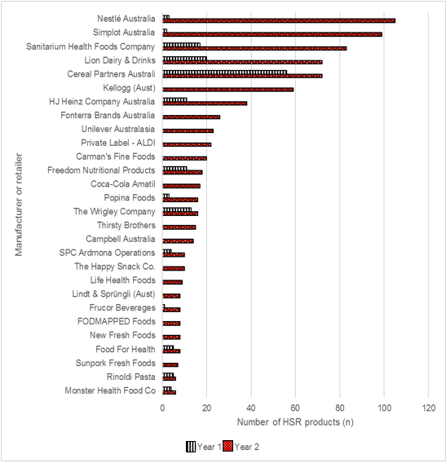

Table 1.7. Manufacturers and retailers that had more than five Health Star Rating (HSR) products in Year 2

| Manufacturer or retailer | Number of HSR products (n) in Year 2 | Proportion (%) of each manufacturer’s or retailer’s products that are HSR products, in Year 2 |
| --- | --- | --- |
| Food For Health | 8 | 100 |
| Monster Health Food Co | 6 | 100 |
| New Fresh Foods | 8 | 100 |
| Sunpork Fresh Foods | 7 | 100 |
| The Happy Snack Co. | 10 | 100 |
| The Wrigley Company | 16 | 100 |
| Cereal Partners Australia | 72 | 95 |
| Popina Foods | 16 | 94 |
| Thirsty Brothers | 15 | 94 |
| FODMAPPED Foods | 8 | 89 |
| Sanitarium Health Foods Company | 83 | 88 |
| Kellogg (Aust) | 59 | 58 |
| Carman’s Fine Foods | 20 | 57 |
| Rinoldi Pasta | 6 | 55 |
| Freedom Nutritional Products | 18 | 47 |
| Nestlé Australia | 105 | 39 |
| Private label – Coles | 606 | 36 |
| Life Health Foods | 9 | 33 |
| Simplot Australia | 99 | 28 |
| Private label – Woolworths | 545 | 27 |
| Frucor Beverages | 8 | 24 |
| Lion Dairy & Drinks | 72 | 23 |
| Fonterra Brands Australia | 26 | 16 |
| Campbell Australia | 14 | 16 |
| HJ Heinz Company Australia | 38 | 15 |
| Lindt & Sprüngli (Aust) | 8 | 12 |
| Coca-Cola Amatil | 17 | 12 |
| Unilever Australasia | 23 | 11 |
| SPC Ardmona Operations | 10 | 9 |
| Private label – ALDI | 22 | 6 |

Table 1.8 below outlines, for each manufacturer and retailer, the proportion of their products in FoodTrackTM that were HSR products, in descending order, for comparison of changes over time.

All but six manufacturers and retailers had an increase in the proportion of their HSR products in Year 2 compared with Year 1 (Table 1.8). For three manufacturers (The Wrigley Company, Betta Foods Australia, Spreyton Fresh Tasmania) 100% of their products in FoodTrackTM in both Year 1 and Year 2 were HSR products. Two manufacturers (Chris’ Dips and Emma & Tom Foods) had a decline in the proportion of HSR products from Year 1 to Year 2, with one manufacturer (Emma & Tom Foods) declining from 88% to 0% in Year 2 (Table 1.8).

In Year 2, nearly one-quarter of manufacturers and retailers (15/63) had HSR products representing 100% of their products in FoodTrackTM. Of these, two-thirds (n = 10) had no HSR products in Year 1. A further five manufacturers had HSR products representing more than 80% of their products in FoodTrackTM in Year 2; in all of these cases this was an increase from Year 1 (Table 1.8).

Nearly two-thirds of manufacturers and retailers (40/62,[13] 65%) in Year 1 did not have any HSR products in FoodTrackTM, but did have such products in Year 2, with coverage in Year 2 ranging from 3% for two manufacturers (Symington’s Australia, Arnott’s Biscuits) to 100% for 10 manufacturers (Table 1.8).

Table 1.8. Comparison of the proportion of Health Star Rating (HSR) products for each manufacturer and retailer, in Year 1 and Year 2[14]

| Manufacturer or retailer | Proportion (%) of each manufacturer’s or retailer’s products that are HSR products, in Year 1 | Proportion (%) of each manufacturer’s or retailer’s products that are HSR products, in Year 2 | Change from Year 1 |
| --- | --- | --- | --- |
| Food For Health | 56 | 100 | ↑ |
| Monster Health Food Co | 80 | 100 | ↑ |
| The Wrigley Company | 100 | 100 | ↔ |
| Betta Foods Australia | 100 | 100 | ↔ |
| Spreyton Fresh Tasmania | 100 | 100 | ↔ |
| The Happy Snack Co. | 0 | 100 | ↑ |
| New Fresh Foods | 0 | 100 | ↑ |
| Sunpork Fresh Foods | 0 | 100 | ↑ |
| Think Products | 0 | 100 | ↑ |
| Norco Foods | 0 | 100 | ↑ |
| Parilla Fresh | 0 | 100 | ↑ |
| Flavour Creations | 0 | 100 | ↑ |
| Wallaby Foods | 0 | 100 | ↑ |
| Picot Productions | 0 | 100 | ↑ |
| Teys Australia | 0 | 100 | ↑ |
| Cereal Partners Australia | 79 | 95 | ↑ |
| Popina Foods | 38 | 94 | ↑ |
| Thirsty Brothers | 0 | 94 | ↑ |
| FODMAPPED Foods | 0 | 89 | ↑ |
| Sanitarium Health Foods Company | 18 | 88 | ↑ |
| Grove Fruit Juice | 0 | 75 | ↑ |
| Australian Whole Foods | 0 | 67 | ↑ |
| Kellogg (Aust) | 0 | 58 | ↑ |
| Mayvers Health Time | 17 | 57 | ↑ |
| Carman’s Fine Foods | 0 | 57 | ↑ |
| Rinoldi Pasta | 31 | 55 | ↑ |
| The Yoghurt Co | 0 | 50 | ↑ |
| Freedom Nutritional Products | 31 | 47 | ↑ |
| Nestlé Australia | 1 | 39 | ↑ |
| Private label – Coles | 8 | 36 | ↑ |
| Life Health Foods | 0 | 33 | ↑ |
| Primo Moraitis Fresh | 0 | 29 | ↑ |
| Simplot Australia | 1 | 28 | ↑ |
| Private label – Woolworths | 3 | 27 | ↑ |
| Slim Secrets | 0 | 27 | ↑ |
| Go Natural | 0 | 27 | ↑ |
| Vitality Brands Worldwide | 19 | 26 | ↑ |
| Kalfresh | 0 | 25 | ↑ |
| Frucor Beverages | 3 | 24 | ↑ |
| Lion Dairy & Drinks | 7 | 23 | ↑ |
| Kez’s Kitchen | 0 | 20 | ↑ |
| Sunfresh Salads | 0 | 20 | ↑ |
| Tuckers Natural | 0 | 20 | ↑ |
| Annex Foods | 0 | 18 | ↑ |
| Sargents | 0 | 18 | ↑ |
| Sunraysia Natural Beverage Company | 0 | 17 | ↑ |
| PureBred Bakery | 0 | 17 | ↑ |
| Fonterra Brands Australia | 0 | 16 | ↑ |
| Campbell Australia | 0 | 16 | ↑ |
| Club Trading and Distribution | 0 | 15 | ↑ |
| HJ Heinz Company Australia | 4 | 15 | ↑ |
| Soulfresh | 0 | 13 | ↑ |
| Lindt & Sprüngli (Aust) | 0 | 12 | ↑ |
| Coca-Cola Amatil | 0 | 12 | ↑ |
| Unilever Australasia | 0 | 11 | ↑ |
| Sunbeam Foods | 0 | 10 | ↑ |
| SPC Ardmona Operations | 3 | 9 | ↑ |
| Chris' Dips | 25 | 8 | ↓ |
| Red Bull Australia | 0 | 7 | ↑ |
| Private label – ALDI | N/A | 6 | N/A |
| Symingtons Australia | 0 | 3 | ↑ |
| Arnotts Biscuits | 0 | 3 | ↑ |
| Greens General Foods | 1 | 3 | ↑ |
| Emma & Tom Foods | 88 | 0 | ↓ |

### Uptake of products displaying Option 5 of the Health Star Rating system graphic, by manufacturers and retailers

In Year 2, nine manufacturers and retailers had products displaying Option 5 (Energy icon only) of the HSR system graphic; these are summarised in Table 1.9 below. Six of these manufacturers and retailers in Year 2 displayed Option 5 on 100% of their HSR products, and three of these six also displayed Option 5 on 100% of their HSR products in Year 1.

Although Nestlé Australia had the greatest absolute number of products in Year 2 displaying Option 5 (n = 44), this represented less than half of their total number of HSR products (42%) in FoodTrackTM. The retailer Private label – Coles had such a large number of products displaying Options 1–4 in Year 2 (n = 593) that those displaying Option 5 represented only 2% of their total number of HSR products in FoodTrackTM – a decline from 8% in Year 1.

In Year 1, three of these nine manufacturers did not have any HSR products: Coca-Cola Amatil, Red Bull Australia and Lindt & Sprüngli (Aust). A further two manufacturers only had HSR products that displayed Options 1–4 in Year 1 (Nestlé Australia and Unilever Australia), as shown in Table 1.9.

Table 1.9. Comparison of the number of Health Star Rating (HSR) products displaying Option 5, by manufacturer and retailer, in Year 1 and Year 2

| Manufacturers and retailers | Number of HSR products (n) displaying Option 5 in Year 1 | Total number of HSR products (n) in Year 1 | Proportion of HSR products (%) displaying Option 5 in Year 1 | Number of HSR products (n) displaying Option 5 in Year 2 | Total number of HSR products (n) in Year 2 | Proportion of HSR products (%) displaying Option 5 in Year 2 |
| --- | --- | --- | --- | --- | --- | --- |
| Coca-Cola Amatil | 0 | 0 | 0 | 17 | 17 | 100 |
| The Wrigley Company | 13 | 13 | 100 | 16 | 16 | 100 |
| Frucor Beverages | 1 | 1 | 100 | 8 | 8 | 100 |
| Lindt & Sprüngli (Aust) | 0 | 0 | 0 | 8 | 8 | 100 |
| Betta Foods Australia | 8 | 8 | 100 | 3 | 3 | 100 |
| Red Bull Australia | 0 | 0 | 0 | 1 | 1 | 100 |
| Nestlé Australia | 0 | 3 | 0 | 44 | 105 | 42 |
| Unilever Australasia | 0 | 3 | 0 | 3 | 23 | 13 |
| Private label – Coles | 10 | 132 | 8 | 13 | 606 | 2 |
| TOTAL | **32** |  |  | **113** |  |  |

### Comparison of uptake of the Health Star Rating system to the top-selling food and beverage categories

Table 1.10below outlines the top-10 selling categories by value ($) according to the Retail World Annual Report December 2015 (8), and their corresponding HSR category(ies). The equivalent categories in Retail World are referred to as RW category/ies.

Table 1.10. Top-selling Retail World (RW) categories, and their equivalent Health Star Rating (HSR) categories

| HSR category or categories | RW category | Value ($ billion) | Ranking |
| --- | --- | --- | --- |
| Sugar (or artificially) sweetened beverages | Soft drinks, Energy drinks, Cordials, Mixers, Sports drinks, Flavoured mineral water, Iced tea (subcategories of Cold beverages) | 2.61 | 1 |
| Confectionery | Confectionery | 2.53 | 2 |
| Cheese – hard and processed, Cheese – soft | Cheese | 2.53 | 2 |
| Dairy milks – plain, Dairy milks – flavoured | Milk (dairy) | 2.00 | 3 |
| Yoghurt, Custards and dairy desserts (non-frozen) | Yoghurt, Desserts (subcategories of Chilled dairy) | 1.83 | 4 |
| Bread | Bread | 1.67 | 5 |
| Biscuits – savoury, Biscuits – sweet | Biscuits | 1.57 | 6 |
| Ready-to-eat breakfast cereals, Mueslis, Hot cereals – flavoured, Hot cereals – plain | Breakfast cereals | 1.12 | 7 |
| Frozen dairy (and soy) desserts, Frozen desserts (fruit-based only) | Ice-cream | 1.06 | 8 |
| Crisps and similar snacks | Crisps and similar snacks | 0.90 | 9 |

Figure 1.3displays the proportion of HSR products in each of these top-selling RW Categories in Year 1 and Year 2, in descending order by market share. Five of the HSR categories that are in the top-selling RW Categories listed in Table 1.10 did not have any HSR products in Year 1.

The ‘Breakfast cereals’ RW category had by far the greatest proportion of HSR products in both Year 1 (34%) and Year 2 (65%), and this was the seventh highest selling category. The top-selling RW category, ‘Cold beverages (subcategories)’ had HSR products on only 6.3% of products in Year 2 – an increase from 0.9% in Year 1 (Figure 1.3). The RW Categories ‘Confectionery’ and ‘Cheese’ both ranked as second highest selling, and in both of these categories the proportion of HSR products increased from Year 1 to Year 2. However, the greater representation of products in Year 2 was in the ‘Confectionery’ RW category (17.4% of category vs 2.5%).

Figure 1.3. Proportion of Health Star Rating (HSR) products in each Retail World category, in Year 1 and Year 2  
Click to view text version

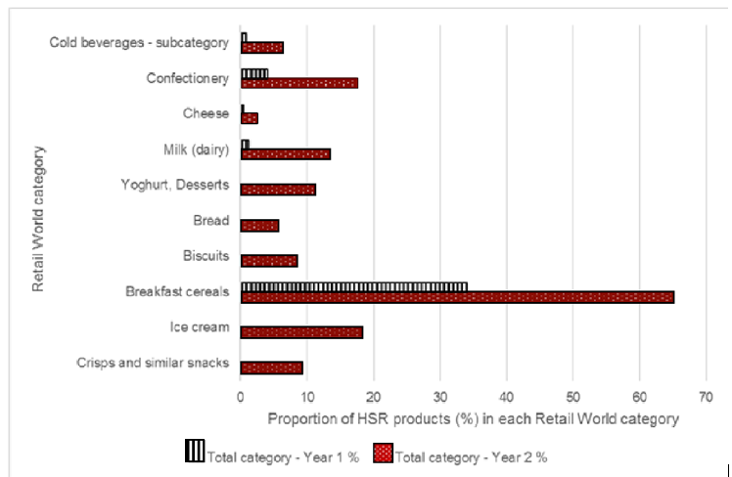

### Comparison of Health Star Rating products to those products on which displaying the Health Star Rating system graphic is perceived important by consumers

Under AoE 2, survey participants were asked on which foods or beverages they believe it is important to display the HSR system (see Chapter 2 for results). Table 1.11below outlines the top-10 ranking categories according to percentage of respondents, and their equivalent HSR category(ies).

Table 1.11. Top-ranking survey categories, and their equivalent Health Star Rating (HSR) categories

| HSR category or categories | Survey category | Percentage (%) of respondents | Ranking |
| --- | --- | --- | --- |
| Ready-to-eat breakfast cereals, Mueslis, Hot cereals – flavoured, Hot cereals – plain | Breakfast cereals | 69 | 1 |
| Cereal-based bars, Nut and seed bars, Fruit bars | Cereal bars, nut/seed bars, fruit bars | 63 | 2 |
| Yoghurt, Custards and dairy desserts (non-frozen) | Yoghurt and dairy desserts | 62 | 3 |
| Ready meals, Meal kits | Ready meals, meal kits | 60 | 4 |
| Biscuits – sweet, Cakes, muffins and other baked products | Sweet biscuits, cakes and muffins | 59 | 5 |
| Breakfast spreads, Nut and seed spreads | Spreads (e.g. peanut butter, jam) | 57 | 6 |
| Biscuits – savoury | Savoury biscuits, crackers and crispbreads | 56 | 7 |
| Edible oil spreads, Butter | Margarines and spreads (including butter) | 55 | 8 |
| Cooking sauces | Cooking sauces (pasta & other) | 54 | 9 |
| Crisps and similar snacks | Crisps and similar snacks | 53 | 10 |

Figure 1.4displays the proportion of products in each of the top-10 ranked survey categories on which survey respondents would like to see the HSR system displayed in Year 1 and Year 2, in descending order by percentage of respondents.

There was good correlation between the ‘Breakfast cereals’ survey category, which was ranked as the top category in which survey respondents would like to see HSR products, and the equivalent four HSR categories, which featured in the top-five HSR categories with the greatest proportion of HSR products in Year 2 (see Section 2.6.9), as shown in Figure 1.4.

The second highest survey category was ‘Cereal bars, nut/seed bars, fruit bars’, which had more than 20% of HSR products, nearly 10 times that of Year 1 (2.4%). ‘Yoghurt and dairy desserts’, although ranked the third highest respondent survey category, had a low presence of HSR products in Year 2 (11.1% of the survey category). The survey categories that were ranked fourth, sixth and 10th all had representation of HSR products on more than 20% of their products in FoodTrackTM. The top-10 ranked survey categories that had the least proportion of HSR products in Year 2 were ‘Margarines and spreads (including butter)’ and ‘Biscuits – savoury’. Although both these categories increased from Year 1, they had representation of HSR products on less than 10% of products in their respective category(ies) in Year 2 (5.6% and 7.1% respectively).

Figure 1.4. Proportion of Health Star Rating (HSR) products (%) in each survey category, in Year 1 and Year 2   
Click to view text version

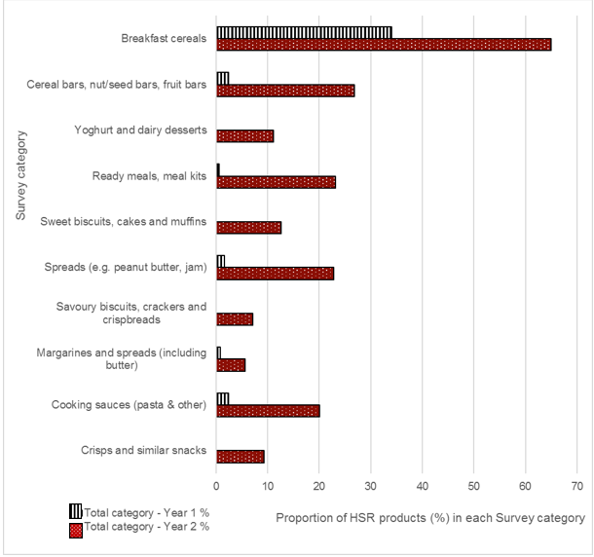

### Results from Waves 1–4 of point-in-time monitoring of uptake of the Health Star Rating system

Since September 2015, the Heart Foundation has conducted four additional waves of data collection to identify the number of HSR products at a given time point. The time points were as follows: Wave 1 – September 2015, Wave 2 – January 2016, Wave 3 – May 2016 and Wave 4 – August to September 2016.

These additional data collection waves were conducted in metropolitan Victorian Coles, Woolworths and ALDI supermarkets.[15] They were supplemented with files provided by retailers where available, as well as additional desktop research for products found in-store displaying the HSR system (see Appendix 1 for the Wave 4 report).

A total of 5,560 products were recorded at Wave 4 (months 26–27, see Figure 1.5 below), including 63 multipacks that displayed more than one HSR system graphic on the pack to reflect the different flavour or product variants. This represented just over 3.5 times more HSR products than in September 2015 (Wave 1) (n = 1,526).

### Comparison of uptake of the Health Star Rating system to uptake of the DIG

When comparing uptake of the HSR system to that of the DIG[16] over time, there was a greater number of HSR products at each time point, including the most recent wave in August to September 2016 (Wave 4, equivalent to months 26–27 post implementation). At Wave 4, uptake of the DIG was 1,167 products, compared with 5,560 products for the HSR system – this represented a nearly five times greater presence of HSR products than those displaying the DIG for the corresponding time point, on products in Australian supermarkets.

Figure 1.5. Comparison of uptake of the Health Star Rating (HSR) system to the uptake of the Daily Intake Guide (DIG), over time  
Click to view text version

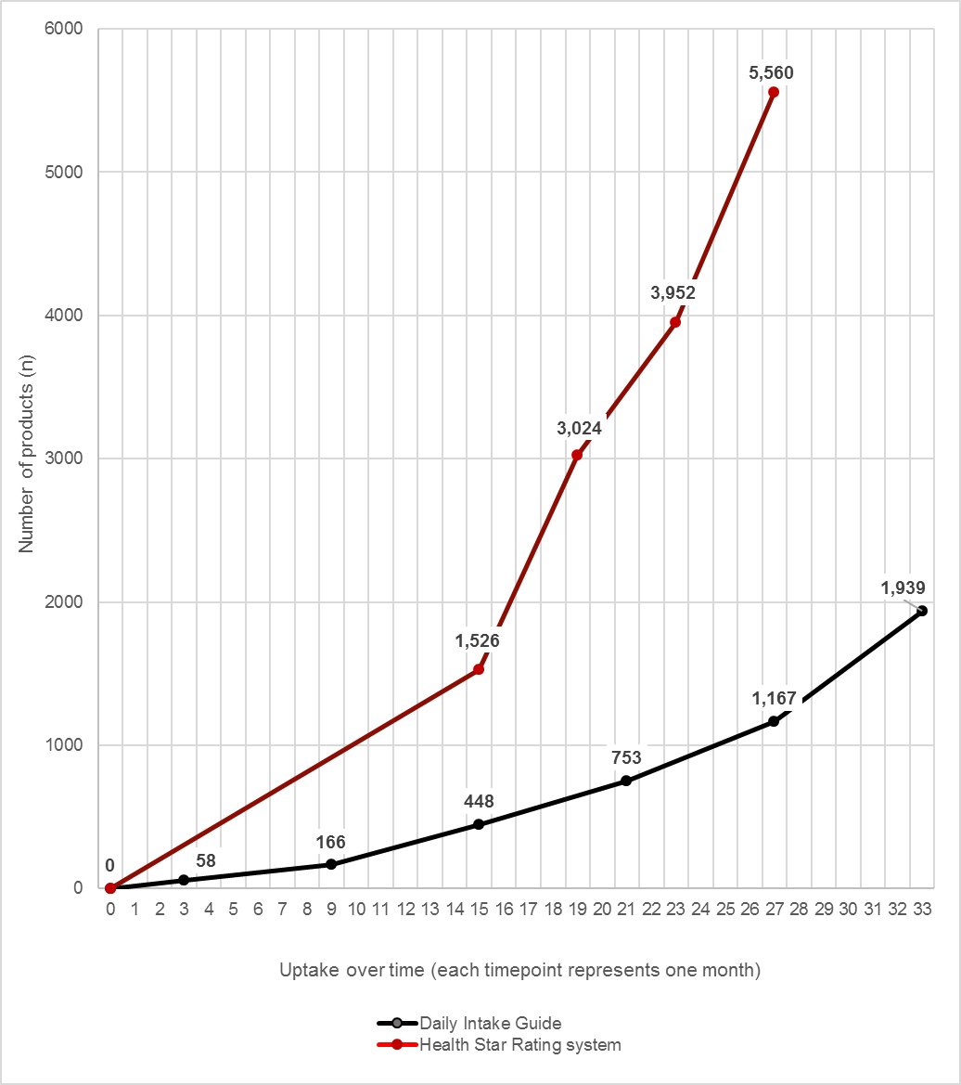

### Summary of Health Star Rating options displayed on pack

From Year 1 to Year 2, the total number of HSR products increased from 363 to 2,031 products – an additional 1,668 HSR products. Table 1.12 below compares the number of HSR products displaying each HSR option of the HSR system graphic between Year 1 and Year 2.

In Year 2, 59 HSR products (3%) displayed a combined version of the HSR system graphic. Most of these products (n = 58) displayed Option 3 and Option 5 of the HSR system graphic (i.e. two HSR system graphics). The remaining HSR product displayed Option 5 plus an additional optional nutrient, and was recorded as displaying only one HSR system graphic because the optional nutrient is not considered its own graphic. These combined HSR products have been reported separately in Table 1.12 below and do not contribute to the individual totals for Option 3 or Option 5 only.

In Year 1, 21 HSR products (6%) displayed a combined version of the HSR system graphic, 20 displayed Option 3 and Option 5, and one displayed Option 5 plus an additional optional nutrient. Of these 21 HSR products in Year 1, 20 were also identified in Year 2. These HSR products have been reported in the same way as Year 1. In Year 1, all other HSR products (n = 342) displayed only one version of the HSR system graphic on the FoP.

In Year 2, both Option 2 and Option 4 were displayed on the greatest proportion of HSR products, making up nearly two-thirds of the HSR options displayed (64%). The smallest proportions of HSR products were observed for Option 5 (6%) and the combined versions (3%) of the HSR system graphic. In Year 1, Option 1 was the most common HSR option displayed on pack (33%); as with Year 2, Option 5 and the combined versions were also present on the least number of HSR products (9% and 6%, respectively).

The biggest differences in the proportion of HSR products displaying each HSR option between Year 1 and Year 2 were found in Options 1, 2 and 4. In Year 2, the proportion of HSR products displaying Option 1 more than halved, decreasing from 33% in Year 1 to 15% in Year 2. Conversely the proportion of HSR products displaying Option 2 increased from 13% to 31%, and those displaying Option 4 increased from 25% to 33%.

The proportion of HSR products displaying Option 3, Option 5 and the combined version remained relatively similar between Year 1 and Year 2, as shown in Table 1.12.

Table 1.12. Comparison of the number and proportion of Health Star Rating (HSR) products, by HSR option, in Year 1 and Year 2[17]

| HSR option | Number of HSR products (n) in Year 1 | Proportion of total HSR products (%) in Year 1 | Total number of HSR products (n) in Year 2 | Proportion of total HSR products (%) in Year 12 | Change from Year 1 to Year 2 |
| --- | --- | --- | --- | --- | --- |
| Option 1 | 121 | 33 | 314 | 15 | ↓ |
| Option 2 | 49 | 13 | 628 | 31 | ↑ |
| Option 3 only | 51 | 14 | 250 | 12 | ↓ |
| Option 4 | 90 | 25 | 668 | 33 | ↑ |
| Option 5 only | 31 | 9 | 112 | 6 | ↓ |
| combined | 21 | 6 | 59 | 3 | ↓ |
| **Total** | **363** |  | **2,031** |  |  |

Some HSR products displayed more than one HSR system graphic on the FoP; hence, the total number of HSR system graphics assessed in this section was greater than the total number of HSR products. The products that displayed more than one HSR system graphic on the FoP were either part of the combined version outlined in Table 1.12 above,[18] or were a multipack that displayed an HSR system graphic for each flavour or product variant on the FoP (i.e. from two to four HSR system graphics).

In Year 2, the 2,031 HSR products displayed a total of 2,115 HSR system graphics on the FoP, all of which were assessed against the Style Guide for consistency in implementation. In contrast, in Year 1, some 363 HSR products, displaying a total of 383 HSR system graphics, were assessed. Thus, compared with Year 1, in Year 2 there were an additional 1,668 HSR products and an additional 1,732 HSR system graphics.

In Year 2, it was most common for HSR products to display only one HSR system graphic on the FoP (n = 1,959, 96%); however, 72 products (4%) out of the 2,031 HSR products displayed between two and four HSR system graphics on the FoP. Of these 72 HSR products, most displayed two HSR system graphics (n = 61), 58 HSR product displayed a combined version of the HSR system graphic (Option 3 and Option 5), and the remaining 14 were multipacks that displayed more than one HSR system graphic on the pack (i.e. one graphic per product or flavour variant).

Figure 1.6below outlines the number of HSR products and HSR system graphics for each HSR option in Year 2. Options 2, 3 and 5 and the combined version all had HSR products displaying more than one HSR system graphic on the FoP, with 632, 270, 114 and 117 HSR system graphics, respectively. No products displaying Option 1 and Option 4 in Year 2 had more than one HSR system graphic on the FoP. In Year 1, only the combined HSR products displayed more than one HSR system graphic on the FoP, with a total of 41 HSR system graphics from the 21 combined HSR products.

Figure 1.6. Number of Health Star Rating (HSR) products and number of HSR system graphics assessed, by HSR option, in Year 2  
Click to view text version

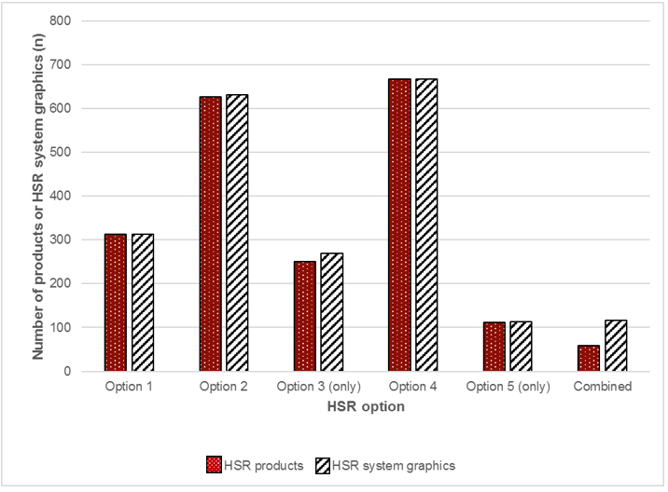

### Assessment of Health Star Rating options, by manufacturer and retailer

In Year 2, 63 manufacturers and retailers in FoodTrackTM had one or more HSR products. These are displayed in Figures 1.7–1.9 below, along with a comparison of the HSR options that each displayed.

Of these 63 manufacturers and retailers, Private label – Coles and Private label – Woolworths had the largest number of HSR products, with 606 and 545, respectively. Together, these retailers accounted for 57% of the total number of HSR products and, in both cases, Option 2 was the HSR option displayed on the largest proportion of their HSR products, as shown in Figure 1.7.

There was a notable difference between these two retailers and the manufacturer who had the third largest number of HSR products, which was Nestlé Australia, with 105 products (5% of HSR products) in Year 2. Manufacturers and retailers with 20 or more HSR products, excluding Private label – Coles and Private label – Woolworths, are listed in Figure 1.8. The remaining manufacturers and retailers with fewer than 20 HSR products each in Year 2 have been displayed in Figure 1.9. In Year 2, Private label – Coles and Nestlé Australia were the only two manufacturers and retailers to have products displaying each of the five HSR options.

Option 4 was displayed by the largest number of manufacturers and retailers (n = 41) in Year 2. This was followed by Option 1 (n = 17), Option 3 (n = 13), Option 2 (n = 11), Option 5 (n = 9) and combined (n = 2). Lion Dairy & Drinks and Frucor Beverages had HSR products that displayed a combined version of the HSR system graphic (n = 59), and these were the same manufacturers reported in Year 1 (n = 21). These combined HSR products have been excluded from Figures 1.7-1.9, for simplicity.

Most manufacturers and retailers displayed only one HSR option (43/63), with Option 4 being the most common graphic (28/43) to be displayed. This was followed by Option 1 (7/43), Option 5 (5/43), Option 2 (3/43) and Option 3 (2/43). Of the 43 manufacturers and retailers with HSR products displaying only one HSR option, nine had only one HSR product displaying the HSR system graphic. Twelve manufacturers displayed two HSR options on their HSR products (excluding those displaying a combined version);‌‌ however, no obvious trends were observed with the combined HSR options.

Figure 1.7. Number of Health Star Rating (HSR) products (n) displayed by Private label – Coles and Private label – Woolworths, by HSR option, in Year 2  
Click to view text version

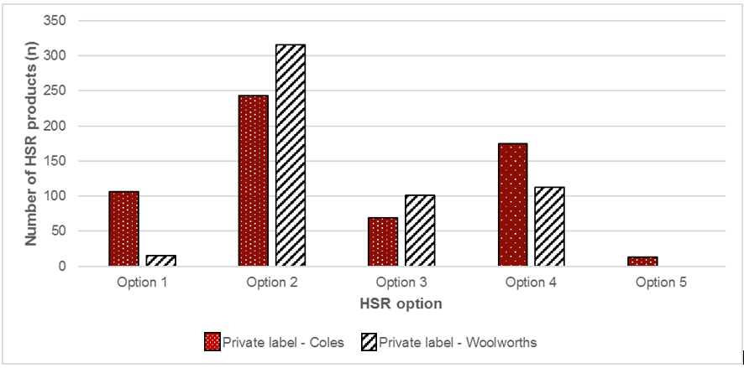

Figure 1.8. Number of Health Star Rating (HSR) products (n), by manufacturers and retailers (> 20 HSR products), by HSR option, in Year 2  
Click to view text version  
  
 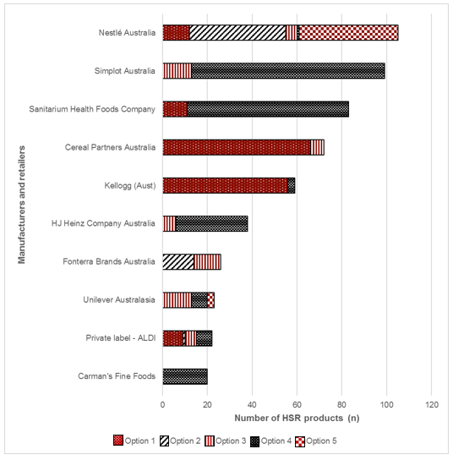

Figure 1.9. Number of Health Star Rating (HSR) products (n), by manufacturers and retailers (< 20 HSR products), by HSR option, in Year 2

Click to view text version  
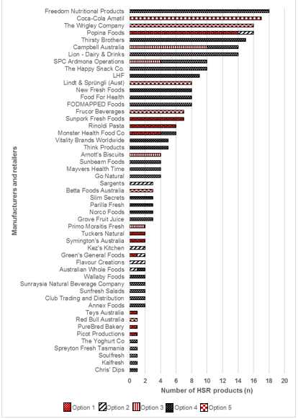

In Year 1, 23 different manufacturers and retailers had HSR products in FoodTrackTM; that is, there were 40 new manufacturers and retailers with HSR products in Year 2. In Figure 1.10 below, all manufacturers and retailers with HSR products, excluding combined (n = 2), have been displayed (n = 21). As with Year 2, in Year 1 Private label – Coles had the largest number of HSR products (132/363, 36%); however, this was then followed by Cereal Partners Australia (n = 56) and Private label – Woolworths (n = 51).

Private label – Coles was the only manufacturer or retailer to have HSR products with all five HSR options in Year 1; most manufacturers and retailers chose to display a single HSR option on their products (14/20, 70%), as was the case in Year 2. Similarly, Option 4 was the most popular when a single HSR option was used in Year 1 (9/14, 64%), and this was the same for Year 2 (27/44, 61%).

Figure 1.10. Number of Health Star Rating (HSR) products (n), by manufacturers and retailers, by HSR option, in Year 1

Click to view text version  
  
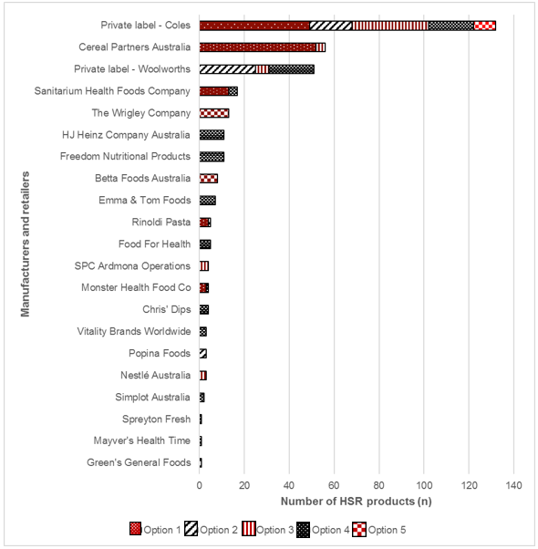

### Assessment of Health Star Rating options, by Health Star Rating category

HSR products were present in 74 different HSR categories in Year 2. HSR products displaying Option 2 and Option 4 were in the largest number of HSR categories (Option 2, n = 57; Option 1, n = 58), and Option 5 was present in the least number of HSR categories in Year 2 (n = 2). These are outlined in Figure 1.11 below for HSR categories with at least 30 HSR products, along with a comparison of the HSR options that each displayed. In Year 2, HSR products displaying a combined version of the HSR system graphic were present in seven different HSR categories – such HSR products have been excluded from these counts for simplicity.

In Year 2, most HSR categories had HSR products that used three HSR options of the HSR system graphic (26/74), followed by two HSR options (18/74) and one HSR option (15/74). Fourteen HSR categories used four HSR options, one HSR category used five HSR options and no HSR categories used all identified HSR options (including the combined version). Of the 15 HSR categories that used only one HSR option, the two most commonly used options were Option 2 (8/15) and Option 4 (7/15).

In Year 2, ‘Confectionery’ was the only HSR category to have HSR products displaying Options 1–5 of the HSR system graphic, most commonly Option 5 (52%) and Option 2 (32%). Eleven different HSR categories had HSR products displaying only one HSR option: Option 2 was the only option displayed on five of these products (‘Biscuits – sweet’; ‘Fruit – shelf-stable’; ‘Savoury snack combinations’; ‘Seasonings, herbs and spices’; ‘Tea and coffee’), Option 4 was the only option displayed on another five products (‘Breakfast drinks’; ‘Dessert toppings and baking syrups’; ‘Formulated foods’; ‘Mayonnaise and aioli products’; ‘Meat – processed’) and Option 3 was the only option displayed on the remaining product (‘Poultry – canned’), as shown in Figures 1.11 and 1.12.

Figure 1.11. Number of Health Star Rating (HSR) products (n), by HSR category (≥ 30 HSR products), by HSR option, in Year 2

Click to view text version

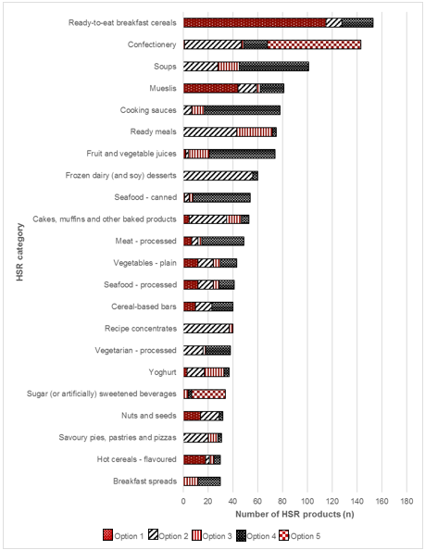

Figure 1.12. Number of Health Star Rating (HSR) products (n), by HSR category (< 30 HSR products), by HSR option, In Year 2

Click to view text version

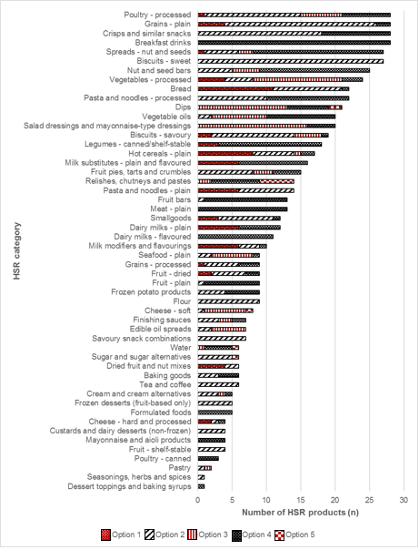

In Year 1, HSR products were present in 37 different HSR categories. Just under half of these HSR categories (18/37) exclusively used one HSR option of the HSR system graphic, most commonly Option 4 (n = 6 HSR categories). This changed from Year 1 to Year 2, with it becoming more common for HSR categories to use two or three different HSR options in Year 2. As shown in Figure 1.13 below, in Year 1, eight HSR categories used two HSR options, 10 categories used three HSR options, one HSR category used four HSR options and no categories used five HSR options.

Figure 1.13. Number of Health Star Rating (HSR) products (n), by HSR category, by HSR option, in Year 1

Click to view text version

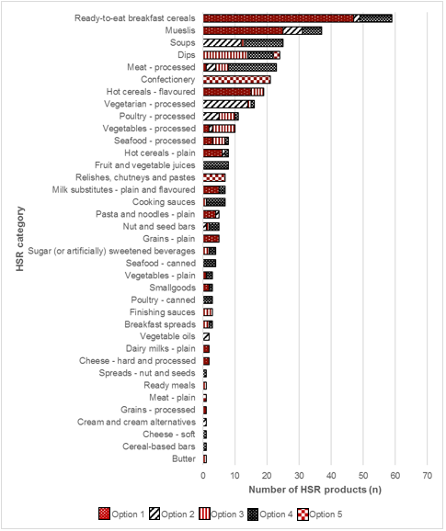

### Option 1 of the Health Star Rating system graphic

In Year 2, 15% of HSR products (314/2,031) displayed Option 1 of the HSR system graphic, compared with 33% (121/363) in Year 1. Also, in Year 2, nearly half (30/63) of the manufacturers and retailers displayed Option 1, compared with only five manufacturers and retailers in Year 1, as shown in Figure 1.14 below. The manufacturers and retailers that displayed Option 1 in Year 1 all still displayed products with Option 1 in Year 2.

In Year 2, Private label – Coles made up one-third (34%) of the total number of HSR products displaying Option 1 (n = 106), followed by Cereal Partners Australia with 21% and Kellogg (Aust) with 18%. All other manufacturers and retailers each made up 5% or less of the total number of Option 1 HSR products.

Figure 1.14. Number of Health Star Rating (HSR) products (n) displaying Option 1 of the HSR system graphic, by manufacturers and retailers, in Year 1 and Year 2[19]

Click to view text version

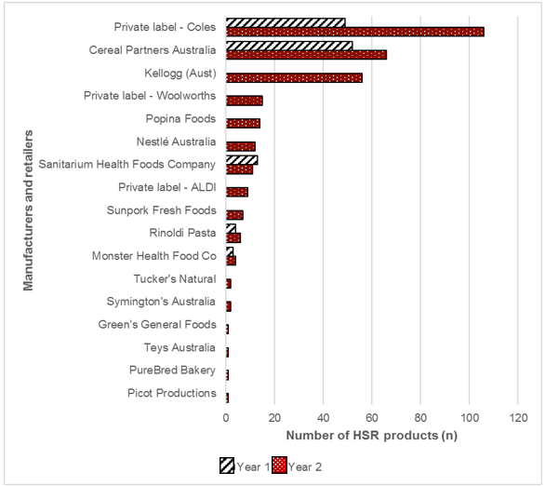

In Year 2, the 314 HSR products that displayed Option 1 of the HSR system graphic were distributed across 30 different HSR categories, as displayed in Figure 1.15 below. In Year 2, ‘Ready-to-eat breakfast cereals’ was the HSR category that had the largest proportion of HSR products within this HSR option (37%, 115/314), followed by ‘Mueslis’ (14%, 44/314) and ‘Hot cereals – flavoured’ (6%, 18/314). Five HSR categories – ‘Confectionery’, ‘Grains – processed’, ‘Poultry – processed’, ‘Seafood – canned’ and ‘Spreads – nuts and seeds’ – each had only one HSR product displaying Option 1 of the HSR system graphic.

In Year 1, HSR products displaying Option 1 of the HSR system graphic were identified in 15 different HSR categories. The three HSR categories with the largest number of HSR products displaying Option 1 in Year 1 were the same as in Year 2 (‘Ready-to-eat breakfast cereals’, ‘Mueslis’ and ‘Hot cereals – flavoured’): From Year 1 to Year 2, ‘Ready-to-eat breakfast cereals’ increased from 47 to 115 products, ‘Mueslis’ from 25 to 44 products and ‘Hot cereals – flavoured’ from 15 to 18 products.

Figure 1.15. Number of Health Star Rating (HSR) products (n) displaying Option 1 of the HSR system graphic, by HSR category, in Year 1 and Year 2

Click to view text version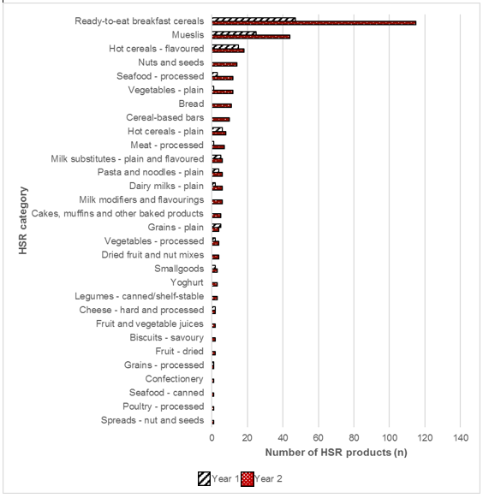

### Optional nutrient

In Year 2, there were 12 different optional nutrients displayed within HSR products displaying Option 1 of the HSR system graphic, compared with 10 optional nutrients in Year 1, as shown inFigure 1.16 below**.** In general, the order of ‘most common’ to ‘least common’ optional nutrient used, remained the same between the two years for the top-six most common optional nutrients used. The two optional nutrients that were present in Year 2 but not Year 1 were selenium and manganese (n = 7, combined).

Fibre remained the most common optional nutrient in Year 1 and Year 2, representing half or more of this sample in both years (Year 1, 50%; Year 2, 54%). This was followed in both years by protein (Year 1, 17%; Year 2, 17%) and iron (Year 1, 10%; Year 2, 8%).

Figure 1.16. Number of Health Star Rating (HSR) products displaying Option 1 of the HSR system graphic (n), by optional nutrient, in Year 1 and Year 2

Click to view text version

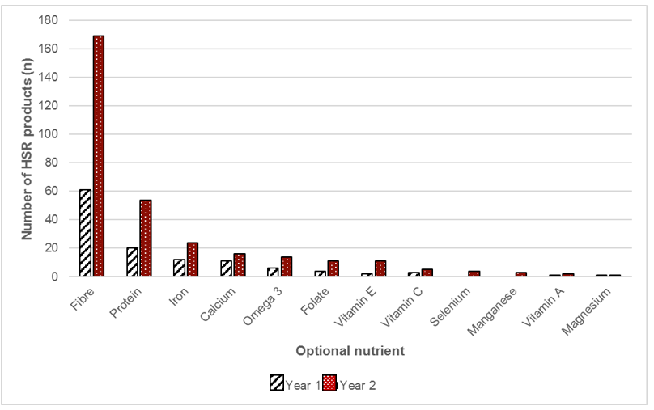

For fibre, protein and iron, the top-three manufacturers and retailers and HSR categories that had HSR products with this optional nutrient are outlined in Tables 1.13 and 1.14 below.

In Year 2, of those HSR categories with HSR products displaying fibre as the optional nutrient, ‘Ready-to-eat breakfast cereals’ had the largest number of HSR products (33%), followed by ‘Mueslis’ (17%) and ‘Hot cereals – flavoured’ (11%). Cereal Partners Australia and Private label – Coles were the manufacturers and retailers with the largest number of HSR products displaying fibre as the optional nutrient (61% combined) for Option 1 HSR products.

As with Year 2, fibre was most commonly displayed in the same three HSR categories in Year 1: ‘Ready-to-eat breakfast cereals’ (19/61), ‘Mueslis’ (18/61) and ‘Hot cereals – flavoured’ (15/61). In Year 1, Cereal Partners Australia and Private label – Coles together accounted for 93% of the total HSR products displaying fibre as the optional nutrient.

In Year 2, among HSR categories with HSR products displaying protein as the optional nutrient, protein was most commonly observed in the ‘Ready-to-eat breakfast cereals’ and ‘Mueslis’ HSR categories, which combined made up half (50%) of this sample. Kellogg (Aust) was the manufacturer with the largest number of HSR products displaying protein as the optional nutrient (24%).

In Year 1, ‘Ready-to-eat breakfast cereals’, ‘Mueslis’ and ‘Hot cereals – plain’, combined, accounted for three-quarters of the Option 1 HSR products displaying protein as their optional nutrient. Most Option 1 HSR products in Year 1 were displayed by Cereal Partners Australia and Private label – Coles (75% combined).

In Year 2, the iron optional nutrient featured exclusively on HSR products in the ‘Ready-to-eat breakfast cereals’ HSR category (n = 24). These were most commonly from Kellogg (Aust) and Sanitarium Health Foods Company, making up more than three-quarters (84%) of the total HSR products displaying iron as the optional nutrient, within Option 1 of the HSR system graphic.

As in Year 2, in Year 1, iron was also exclusive to the ‘Ready-to-eat breakfast cereals’ HSR category (n = 12) and was predominantly displayed by Sanitarium Health Foods Company (10/12).

Table 1.13. Number of Health Star Rating (HSR) products displaying the top-three optional nutrients, by HSR category, in Year 1 and Year 2

|  | HSR categories | HSR categories |
| --- | --- | --- |
|  | Year 1 | Year 2 |
| Fibre  Year 1 (n = 61)  Year 2 (n = 169) | Ready-to-eat breakfast cereals (n = 19)  Mueslis (n = 18)  Hot cereals – flavoured (n = 15) | Ready-to-eat breakfast cereals (n = 55)  Mueslis (n = 29)  Hot cereals – flavoured (n = 18) |
| Protein  Year 1 (n = 20)  Year 2 (n = 54) | Ready-to-eat breakfast cereals (n = 5)  Mueslis (n = 5)  Hot cereals – plain (n = 5) | Ready-to-eat breakfast cereals (n = 15)  Mueslis (n = 12)  Meat – processed (n = 7) |
| Iron  Year 1 (n = 12)  Year 2 (n = 24) | Ready-to-eat breakfast cereals (n = 12) | Ready-to-eat breakfast cereals (n = 24) |

Table 1.14. Number of Health Star Rating (HSR) products displaying the top-three optional nutrients, by manufacturers and retailers, in Year 1 and Year 2

|  | Manufacturers and retailers | Manufacturers and retailers |
| --- | --- | --- |
|  | Year 1 | Year 2 |
| Fibre  Year 1 (n = 61)  Year 2 (n = 169) | Cereal Partners Australia (n = 35)  Private label – Coles (n = 22)  Rinoldi Pasta (n = 2)  Monster Health Food Co (n = 2) | Private label – Coles (n = 52)  Cereal Partners Australia (n = 51)  Kellogg (Aust) (n = 26) |
| Protein  Year 1 (n = 20)  Year 2 (n = 54) | Cereal Partners Australia (n = 9)  Private label – Coles (n = 6)  Sanitarium Health Foods Company (n = 2)  Rinoldi Pasta (n = 2) | Kellogg (Aust) (n = 13)  Cereal Partners Australia (n = 7)  Private label – Woolworths (n = 7)  Sunpork Fresh Foods (n = 7) |
| Iron  Year 1 (n = 12)  Year 2 (n = 24) | Sanitarium Health Foods Company (n = 10)  Cereal Partners Australia (n = 2) | Kellogg (Aust) (n = 11)  Sanitarium Health Foods Company (n = 9)  Cereal Partners Australia (n = 2)  Private label – Woolworths (n = 2) |

### Option 2 of the Health Star Rating system graphic

In Year 2, 31% of HSR products (628/2,031) displayed Option 2, compared with 13% (49/363) in Year 1. The manufacturers and retailers displaying Option 2 of the HSR system graphic are displayed in Table 1.15below.

In Year 2, 17% (11/63) manufacturers and retailers with HSR products had products displaying Option 2 of the HSR system graphic, compared with 25% in Year 1 (5/20). Four of the five manufacturers and retailers with HSR products that displayed Option 2 in Year 1 were also identified in Year 2.

In both Year 1 and Year 2, the display of Option 2 was dominated by the two retailers – Private label – Coles, and Private label – Woolworths – who collectively displayed Option 2 on 92% and 89% of this sample, respectively. In Year 2, the third highest manufacturer displaying Option 2 was Nestlé Australia (7%), while all other manufacturers and retailers each made up 2% or less of the total number of HSR products displaying Option 2 of the HSR system graphic.

Table 1.15. Number of Health Star Rating (HSR) products displaying Option 2 of the HSR system graphic, by manufacturer or retailer, in Year 1 and Year 2

| Manufacturer or retailer | Number of HSR products (n) displaying Option 2 of the HSR system graphic, in Year 1 | Number of HSR products (n) displaying Option 2 of the HSR system graphic, in Year 2 |
| --- | --- | --- |
| Private label – Woolworths | 26 | 316 |
| Private label – Coles | 19 | 243 |
| Nestlé Australia | 0 | 43 |
| Fonterra Brands Australia | 0 | 14 |
| Sargents | 0 | 3 |
| Flavour Creations | 0 | 2 |
| Kez’s Kitchen | 0 | 2 |
| Popina Foods | 3 | 2 |
| Australian Whole Foods | 0 | 1 |
| Green’s General Foods | 1 | 1 |
| Private label – ALDI | 0 | 1 |
| Rinoldi Pasta | 1 | 0 |
| **TOTAL** | **49** | **628** |

In Year 2, Option 2 of the HSR system graphic was observed in 57 different HSR categories, as shown in Figure 1.17**.** In Year 2, the top-four HSR categories displaying Option 2 were: ‘Frozen dairy (and soy) desserts’ (56/628, 9%), ‘Confectionery’ (46/628, 7%), ‘Ready meals’ (43/628, 7%) and ‘Recipe concentrates’ (37/628, 6%). This differed from Year 1 where HSR products displaying Option 2 were identified in only 12 different HSR categories.

There was an increase of 45 HSR categories from Year 1 to Year 2, which also reflects the dramatic increase in the total HSR product count for Option 2, increasing from 49 to 628 products. Unlike Year 2, the two most common HSR categories in Year 1 to display Option 2 of the HSR system graphic were ‘Vegetarian – processed’ and ‘Soups’; combined, these accounted for over half of the products displaying Option 2 (26/49, 53%).

Figure 1.17. Number of Health Star Rating (HSR) products (n) displaying Option 2 of the HSR system graphic, by HSR category, in Year 1 and Year 2

Click to view text version

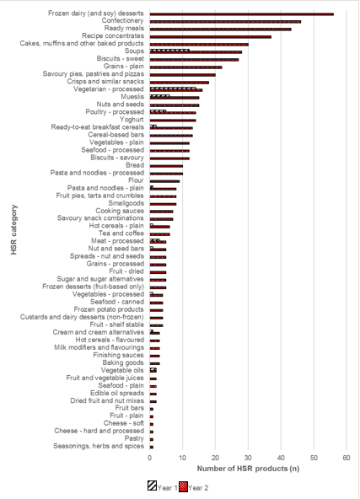

### Option 3 of the Health Star Rating system graphic

In Year 2, 12% of HSR products (250/2,031) displayed Option 3 of the HSR system graphic, compared with 14% (51/363) in Year 1. Any products that displayed the combined version of Option 3 and another HSR option on pack have been reported in the combined section of this report (Section 1.3.18).

In Year 2, there were 13 manufacturers and retailers displaying Option 3 only of the HSR system graphic, compared with five in Year 1, as shown in Figure 1.18 below. In Year 2, two retailers had the greatest proportion of HSR products displaying Option 3 only of the HSR system graphic: Private label – Woolworths (101/250, 40%) and Private label – Coles (69/250, 28%). In Year 1, the largest proportion was displayed by Private label – Coles (34/51, 67%).

Figure 1.18. Number of Health Star Rating (HSR) products (n) displaying Option 3 of the HSR system graphic, by manufacturers and retailers, in Year 1 and Year 2

Click to view text version

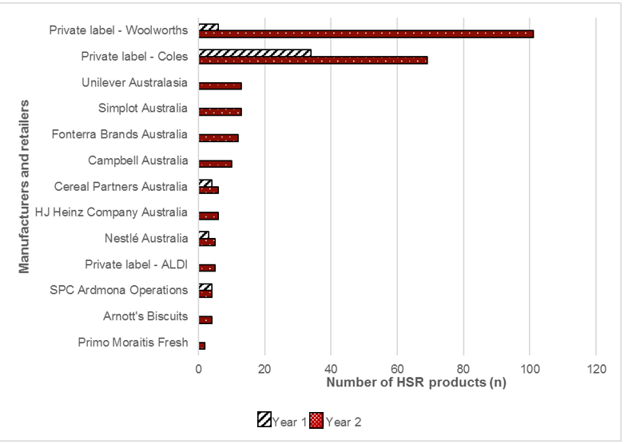

In Year 2, Option 3 of the HSR system graphic was observed in 36 different HSR categories, as shown in Figure 1.19 below.The HSR category with the largest proportion of products displaying Option 3 was ‘Ready meals’ (29/250, 12%). ‘Fruit and vegetable juices’ (17/250) and ‘Soups’ (17/250) each made up 7% of this sample, and ‘Salad dressings and mayonnaise’ (16/250) and ‘Yoghurt’ (16/250) each made up 6%. The remaining 31 HSR categories each contributed 5% or less.

From Year 1 to Year 2, an additional 21 HSR categories with HSR products displayed Option 3 only products. Out of the 15 HSR categories in Year 1, the top-three contributors to the 51 HSR products displaying Option 3 only were: ‘Dips’ (14/51, 27%), ‘Vegetables – processed’ (7/51, 14%) and ‘Poultry – processed’ (5/51, 10%). These HSR categories that had the highest number of Option 3 only HSR products in Year 1 were not the largest contributors in Year 2.

Figure 1.19. Number of Health Star Rating (HSR) products (n) displaying Option 3 of the HSR system graphic, by HSR category, in Year 1 and Year 2

Click to view text version

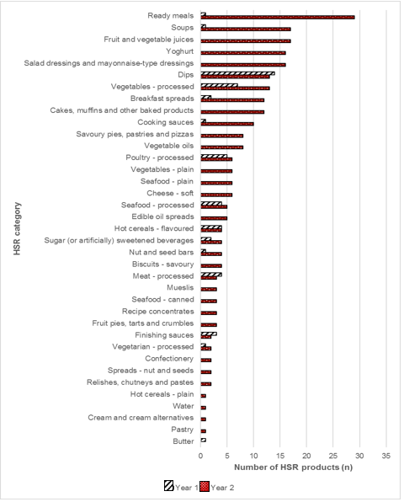

### Option 4 of the Health Star Rating system graphic

In Year 2, 33% of HSR products (668/2,031) displayed Option 4 of the HSR system graphic, compared with 25% (90/363) in Year 1. In Year 2, Option 4 was the most popular HSR option displayed on pack, with 41 manufacturers and retailers displaying Option 4 in Year 2 compared with 13 in Year 1. The retailers with the largest proportion of HSR products displaying Option 4 were Private label – Coles (175/668, 26%) and Private label – Woolworths (113/668, 17%), as in Year 1, when each of these retailers had 20 HSR products displaying Option 4 (combined 40/90, 44%).

Figure 1.20 below shows the manufacturers and retailers with products displaying Option 4 of the HSR system graphic for Year 1 and Year 2, excluding Private label – Coles and Private label – Woolworths. In Year 2, Simplot Australia had the third highest number of HSR products displaying Option 4 (86/668, 13%), followed by Sanitarium Health Foods Company (72/668, 11%). The remaining manufacturers and retailers each made up 5% or less of the total number of HSR products displaying Option 4.

In Year 1, HJ Heinz Company Australia and Freedom Nutritional Products had the third and fourth-highest number of HSR products displaying Option 4 (n = 11, both).

Figure 1.20. Number of Health Star Rating (HSR) products (n) displaying Option 4 of the HSR system graphic, by manufacturers and retailers (excluding top 2), in Year 1 and Year 2

Click to view text version

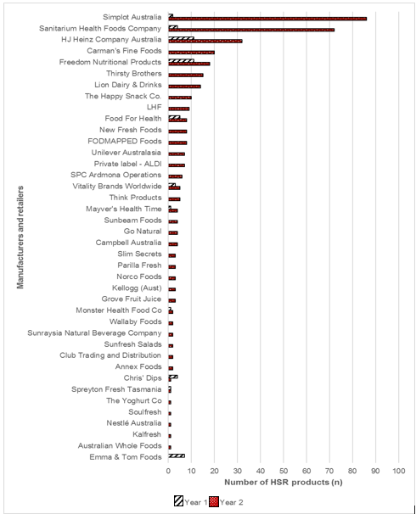

In Year 2, Option 4 of the HSR system graphic was observed in 59 different HSR categories, compared with 22 in Year 1. In Year 2, the top-four HSR categories displaying Option 4 all had similar representation: ‘Cooking sauces’ (61/668, 9%), ‘Soups’ (56/668, 8%), ‘Fruit and vegetable juices’ (53/668, 8%) and ‘Seafood – canned’ (46/668, 7%). In Year 1, ‘Soups’ was also the second highest HSR category in which Option 4 was displayed (12/90, 13%), but the highest HSR category in that year was ‘Meat – processed’ (15/90, 17%).

Figure 1.21 below displays the HSR categories for which at least 10 products displaying the HSR system graphic were identified in Year 2; it also shows the HSR product counts for Year 1. An additional 35 HSR categories in Year 2 are not featured in Figure 1.21, all of these additional categories had fewer than 10 products displaying Option 4; seven HSR categories in Year 1 had eight or fewer products displaying Option 4 (data not shown).

Figure 1.21. Number of Health Star Rating (HSR) products (n) displaying Option 4 of the HSR system graphic, by HSR category (≥ 10 HSR products), in Year 1 and Year 2

Click to view text version

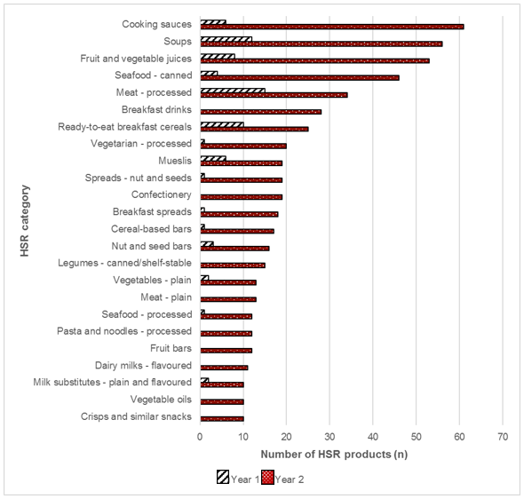

### Option 5 of the Health Star Rating system graphic

In Year 2, 6% of HSR products (112/2,031) displayed Option 5, compared with 9% (31/363) in Year 1. Any products that displayed the combined version of Option 5 and another option or optional nutrient on the pack have been reported in the combined section of this report (Section 1.3.18).

In Year 2, only nine manufacturers and retailers had HSR products displaying Option 5 of the HSR system graphic, as displayed in Figure 1.22 below.Nestlé Australia accounted for most of these products in Year 2 (44/112, 39%), followed by Coca-Cola Amatil (17/112, 15%) and The Wrigley Company (16/112, 14%). This differed from Year 1, where The Wrigley Company accounted for the highest number of HSR products displaying Option 5 (13/31, 42%). In Year 1, there were only two other manufacturers and retailers with products displaying Option 5; they included Private label – Coles (10/31, 32%) and Betta Foods Australia (8/31, 26%).

Figure 1.22. Number of Health Star Rating (HSR) products (n) displaying Option 5 of the HSR system graphic, by manufacturers and retailers, in Year 1 and Year 2

Click to view text version

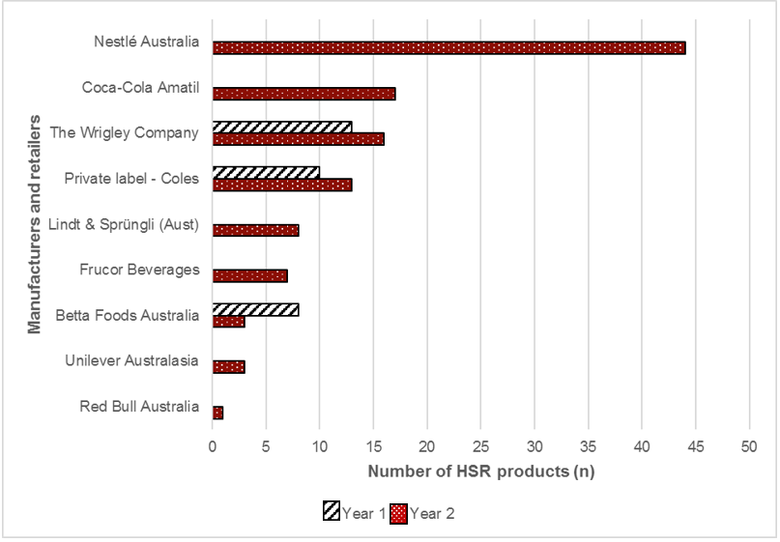

HSR products displaying Option 5 of the HSR system graphic were identified in seven different HSR categories in Year 2, compared with four in Year 1, as shown in Figure 1.23 below. In both Year 1 and Year 2, the largest proportion of HSR products displaying Option 5 was in the ‘Confectionery’ HSR category, representing 67% of this sample in Year 1 and 68% in Year 2. The second largest proportion in Year 2 was ‘Sugar (or artificially) sweetened beverages’, with Option 5 was displayed on 24% of this sample, whereas in Year 1, the second highest HSR category with HSR products displaying Option 5 was ‘Relishes, chutneys and pastes’ (n = 7, 23%).

Figure 1.23. Number of Health Star Rating (HSR) products (n) displaying Option 5 of the HSR system graphic, by HSR category, in Year 1 and Year 2[20]

Click to view text version

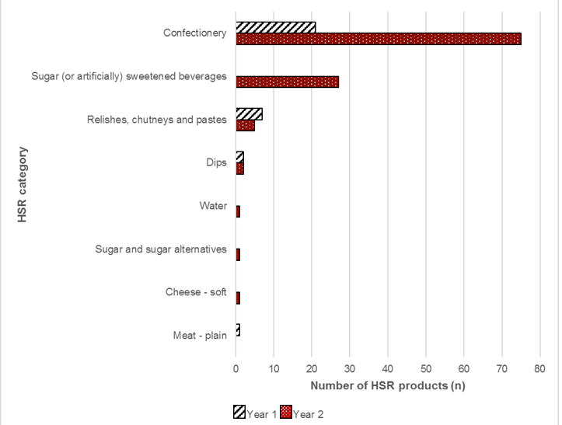

### Combined versions of the Health Star Rating system graphic

In Year 2, 59 HSR products displayed a combined version of the HSR system graphic (i.e. more than one HSR option), compared with 21 HSR products in Year 1. Additional information on these products is summarised in Table 1.16 below.

In both years, most HSR products in this sample (Year, 1 95%; Year 2, 98%) displayed Option 3 in combination with Option 5, and one HSR product in each year displayed Option 5 with an additional optional nutrient, vitamin C. Of the 21 combined products identified in Year 1, 20 were also identified in Year 2. In Year 2, 58/59 HSR products displaying a combined version of Option 3 and Option 5 of the HSR system graphic were from one manufacturer, Lion Dairy & Drinks. One Frucor Beverages HSR product displayed Option 5 plus an additional optional nutrient (vitamin C). The same two manufacturers were identified in Year 1 for the same HSR products.

In Year 2, almost half of the HSR products in this sample were in the ‘Fruit and vegetable juices’ HSR category (27/59, 46%), compared with100% in Year 1, as shown in Table 1.16.

Table 1.16. Number of Health Star Rating (HSR) products displaying a combined version of the HSR system graphic, by HSR category, in Year 1 and Year 2

|  | Year 1 | Year 2 |
| --- | --- | --- |
| Number of HSR products (n) | 21 | 59 |
| Combinations | Option 3 + Option 5 (n = 20)  Option 5 + Vitamin C (n = 1) | Option 3 + Option 5 (n = 58)  Option 5 + Vitamin C (n = 1) |
| Manufacturers | Lion Dairy & Drinks, 3 + 5 (n = 20)  Frucor Beverages, 5 + Vitamin C (n = 1) | Lion Dairy & Drinks, 3 + 5 (n = 58)  Frucor Beverages, 5 + Vitamin C (n = 1) |
| HSR categories | Fruit and vegetable juices (n = 21) | Fruit and vegetable juices (n = 27)  Yoghurt (n = 10)  Milk substitutes – plain and flavoured (n = 10)  Frozen desserts (fruit-based only) (n = 5)  Dairy milks – flavoured (n = 3)  Cheese – hard and processed (n = 2)  Dairy milks – plain (n = 1)  Custards and dairy desserts (non-frozen) (n = 1) |

### Multipacks

In Year 2, there were 282 HSR products that were multipacks (i.e. packs that contain individual prepacked units that are intended for consumption as single portions and not intended for individual sale), compared with 18 in Year 1. For these HSR products, the HSR system graphic was displayed on the FoP in three different ways:

* Variation 1: one HSR system graphic reflecting a single variant multipack (Year 1, n = 13; Year 2, n = 238)
* Variation 2: one HSR system graphic that is an average of all flavour or product variants (Year 1, n = 5; Year 2, n = 30)
* Variation 3: multiple HSR system graphics for all flavour or product variants (Year 1, n = 0; Year 2, n = 14).

The distribution of multipacks across different HSR options and multipack variations is summarised in Figure 1.24 below. Over 80% of multipacks in Year 2 displayed Variation 1 (238/282). In Year 2, Option 2 and Option 4 of the HSR system graphic was displayed on the largest proportion of this sample (combined 190/282, 67%). For the 14 multipacks that displayed Variation 3, each HSR system graphic displayed on the FoP was assessed individually.

Figure 1.24. Number of multipacks, by Health Star Rating (HSR) option, by display method, in Year 2

Click to view text version

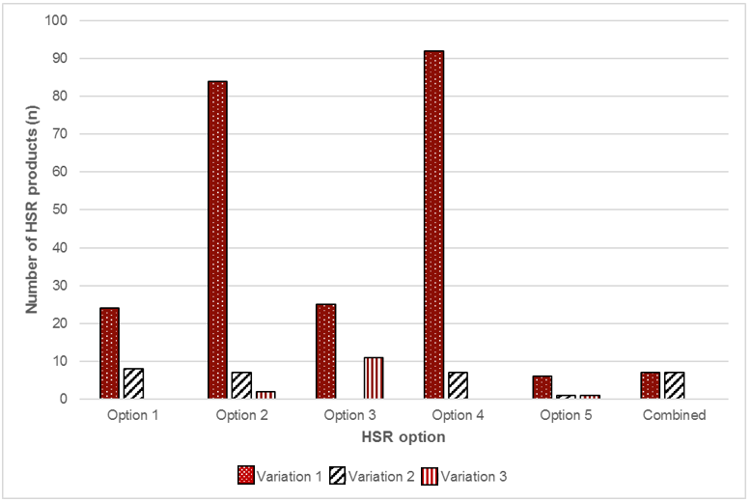

In Year 2, multipacks were identified in 37 HSR categories, compared with four HSR categories in Year 1, as shown in Table 1.17 below. In Year 2, the top-five HSR categories in this sample (‘Cereal-based bars’, ‘Frozen dairy (and soy) desserts’, ‘Hot cereals – flavoured’, ‘Breakfast drinks’ and ‘Yoghurt’) collectively made up 48% of the multipacks sample (136/282). In Year 1, most multipacks were in the ‘Hot cereals – flavoured’ HSR category (15/18, 83%).

Table 1.17. Number of multipacks, by Health Star Rating (HSR) category, in Year 1 and Year 2

| HSR category | Number of multipacks (n) in Year 1 | Number of multipacks (n) in Year 2 |
| --- | --- | --- |
| Cereal-based bars | 1 | 40 |
| Frozen dairy (and soy) desserts | 0 | 27 |
| Hot cereals – flavoured | 15 | 27 |
| Breakfast drinks | 0 | 24 |
| Yoghurt | 0 | 18 |
| Fruit and vegetable juices | 0 | 13 |
| Crisps and similar snacks | 0 | 11 |
| Soups | 0 | 10 |
| Frozen desserts (fruit-based only) | 0 | 9 |
| Nut and seed bars | 1 | 9 |
| Confectionery | 0 | 7 |
| Fruit bars | 0 | 7 |
| Savoury pies, pastries and pizzas | 0 | 7 |
| Vegetables – plain | 0 | 7 |
| Tea and coffee | 0 | 6 |
| Cooking sauces | 0 | 5 |
| Pasta and noodles – processed | 0 | 5 |
| Ready-to-eat breakfast cereals | 0 | 5 |
| Savoury snack combinations | 0 | 5 |
| Sugar (or artificially) sweetened beverages | 0 | 5 |
| Biscuits – sweet | 0 | 3 |
| Custards and dairy desserts (non-frozen) | 0 | 3 |
| Dairy milks – flavoured | 0 | 3 |
| Hot cereals – plain | 1 | 3 |
| Legumes – canned/shelf-stable | 0 | 3 |
| Milk modifiers and flavourings | 0 | 3 |
| Water | 0 | 3 |
| Dips | 0 | 2 |
| Finishing sauces | 0 | 2 |
| Formulated foods | 0 | 2 |
| Fruit – shelf-stable | 0 | 2 |
| Cakes, muffins and other baked products | 0 | 1 |
| Cheese – hard and processed | 0 | 1 |
| Milk substitutes – plain and flavoured | 0 | 1 |
| Mueslis | 0 | 1 |
| Seafood – plain | 0 | 1 |
| Seafood – processed | 0 | 1 |

### Consistency in implementation of the Health Star Rating system graphic with the Health Star Rating Style Guide

The total number of HSR products in Year 2 was 2,031 in Year 2 and 363 in Year 1. The total number of HSR system graphics displayed on these HSR products was 2,115 in Year 2 and 363 in Year 1.[21]

The Style Guide provides guidance for what products are permitted to display the HSR system graphic (10), and all products in FoodTrackTM that displayed the HSR system graphic in Year 1 and Year 2 were permitted to display it[22]. In Year 1, only 1% of HSR products were not intended to display the HSR system graphic (4/363), and in Year 2 this increased to 4% (72/2,031). A summary of these HSR products is displayed in Table 1.18below.

In Year 2, most of the 72 HSR products that were not intended to display the HSR system graphic displayed Option 4 (31/72, 43%); however, each of the five HSR options had at least one HSR product not intended to carry the HSR system. When assessing by HSR category, in Year 2, most of these HSR products were present in the ‘Vegetables – plain’ HSR category (43/72, 60%) followed by ‘Meat – plain’ (13/72, 18%).

Table 1.18. Number of Health Star Rating (HSR) products not intended to display the HSR system graphic, by HSR option, in Year 1 and Year 2[23]

| HSR option | HSR categories (Year 1) | HSR categories (Year 2) |
| --- | --- | --- |
| Option 1 | Vegetables – plain (n = 1) | Vegetables – plain (n = 12) |
| Option 2 |  | Vegetables – plain (n = 12)  Seafood – plain (n = 2)  Fruit – plain (n = 1) |
| Option 3 |  | Seafood – plain (n = 6)  Vegetables – plain (n = 6)  Water (n = 1) |
| Option 4 | Vegetables – plain (n = 2) | Meat – plain (n = 13)  Vegetables – plain (n = 13)  Water (n = 4)  Seafood – plain (n = 1) |
| Option 5 | Mezat – plain (n = 1) | Water (n = 1) |

### General Variations from the Style Guide

In Year 2, out of a total of 2,115 HSR system graphics that were assessed against the Style Guide (see Section 1.3.20), 94% were consistent with the Style Guide (n = 1,997); thus, only 6% (118/2,115) of HSR system graphics displayed a variation to the Style Guide. In Year 1, a similar proportion (93% of the HSR system graphics assessed) were consistent with the Style Guide (355/383). Figure 1.25below compares the levels of consistency with the Style Guide between Year 1 and Year 2 across the five HSR options displayed on pack.

Figure 1.25. Proportion of Health Star Rating (HSR) system graphics (%), by HSR option, that were consistent with the Style Guide, in Year 1 and Year 2

Click to view text version

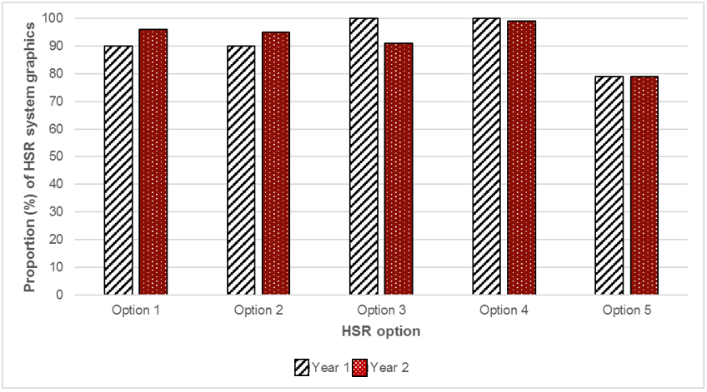

Although the total proportion of HSR system graphics that were consistent with the Style Guide remained similar between Year 1 and Year 2, some differences were observed within each of the HSR options. In Year 1, no inconsistencies were identified in Option 3 and Option 4; however, the proportion of consistent HSR system graphics decreased from 100% to 91% for Option 3, and decreased marginally (from 100% to 99%) in Option 4. The lowest level of consistency in both years was Option 5, with a 79% consistency rate. All other options in both years had consistency rates of 90% or more.

### Technical variations from the Style Guide

In Year 2, 148 technical variations were identified, an increase from 31 in Year 1. These variations are outlined in Table 1.19below.The variations could be grouped into three key themes:

* Theme 1: Nominated reference measure (NRM) differs from the recommendations in the guidelines
* Theme 2: Percentage dietary intake (%DI) is implemented differently to recommend guidelines
* Theme 3: HSR system graphic is not on the FoP.

Table 1.19. Number of technical variations from the Style Guide, in Year 1 and Year 2

| Type of technical variation | Count (n) Year 1 | Count (n) Year 2 |
| --- | --- | --- |
| ***Health Star Rating (HSR) system graphic*** |  |  |
| HSR system graphic is not on the front of pack (Theme 3) | 0 | 29 |
| Incomplete five-star rating scale | 0 | 6 |
| Mismatch of the HSR system graphic value to the numerical rating value | 0 | 3 |
| ***Energy and nutrient icons, including % dietary intake (%DI)*** |  |  |
| Use of prescribed nutrients differs to the guidelines | 0 | 1 |
| Nutrient order and/or display varies to recommended guidelines | 1 | 4 |
| Mismatch of energy and/or nutrient values to those stated in the nutrition information panel | 2 | 4 |
| Nutrient(s) values displayed with units different to guidelines | 1 | 1 |
| Nutrient(s) values displayed with decimal place different to guidelines | 3 | 0 |
| %DI implemented differently to recommend guidelines (Theme 2) | 3 | 34 |
| DIG implemented with the HSR system graphic differently to recommendations in the guidelines | 0 | 8 |
| Nutrient(s) do not meet the conditions to use the terms 'high' or 'low' | 1 | 5 |
| ***Nominated reference measure*** |  |  |
| Nominated reference measure differs to the recommendations in the guidelines (Theme 1) | 20 | 53 |
| **TOTAL** | **31** | **148** |

In Year 2, the most common type of technical variation identified was that the NRM differed to the recommendations in the Style Guide (Theme 1). This was identified on 53 products (36% of the total number of technical variations). This technical variation was also the most common error in Year 1, where it was identified on 20/31 different HSR system graphics with a technical variation.

In Year 2, there were 32 instances of a product with an industry agreed standard serve size using an NRM that did not equate to the industry-agreed standard serve size as outlined in the Style Guide.[24] Some examples include:

* NRM is ‘per 2 pieces’, which equates to a 15 g serve size; however, the ‘Confectionery’ product has an industry agreed standard serve size, which is 25 g ±5 g
* NRM is ‘per 200 mL glass’, but the beverage product has a total pack size > 600 mL; therefore, the industry agreed standard serve size should be 250 mL

In Year 2, Theme 1 was observed on 17 of 53 products that used the term ‘serve’ and a value when the product did not have an industry agreed standard serve size. For example:

* NRM is ‘per 25 g serve’, but the product does not have an industry-agreed standard serve size.

In Year 2, Theme 1 was observed with seven different manufacturers and retailers, three of which accounted for 86% of the total HSR system graphics displaying this error (45/53). Theme 1 was also observed on products in 11 different HSR categories; however, it was most common in ‘Confectionery’ (17/53, 32%) and ‘Fruit and vegetable juices’ (16/53, 30%) (data not shown).

Another common technical variation identified in Year 2 was %DI implemented differently to the recommended guidelines (Theme 2), which increased from Year 1 (Year 2, n = 34; Year 1, n= 3). In Year 2, 94% (32/34) of these cases involved the use of %DI when the nominated reference measure was ‘per 100 g’; however, %DI can only be used for ‘per pack’ or ‘per serve’, not ‘per 100 g’ or ‘per 100 mL’, as outlined in the Style Guide.[25] An example of this is a product with a NRM of ‘per 100 g’ and a serve size of 150 g that uses %DI on the energy icon only. Theme 2 in Year 2 was observed with four different manufacturers; however, one accounted for 85% of the occurrences (29/34), all of which were in the ‘Yoghurt’ HSR category, as shown in Table 1.19.

The third most common technical variation identified in Year 2 was that 29 HSR products did not display the HSR system graphic on the FoP (Theme 3).[26] These HSR products either displayed the HSR system graphic on the top, side or back of the pack. Although this theme accounted for 20% of the total number of technical variations identified in Year 2, there were no instances of this in Year 1.

Theme 3 was observed with three different manufacturers and retailers; however, one manufacturer accounted for 72% of the occurrences, all of which were identified in the ‘Yoghurt’ HSR category (21/29).

Figure 1.26 below summarises the number of HSR system graphics displaying the top-three technical variation themes by HSR category, with the ‘Yoghurt’ HSR category clearly displaying the highest number of technical variations overall.

Figure 1.26. Number of Health Star Rating (HSR) system graphics (n) displaying the top-three technical variation themes, by HSR category, in Year 2

Click to view text version

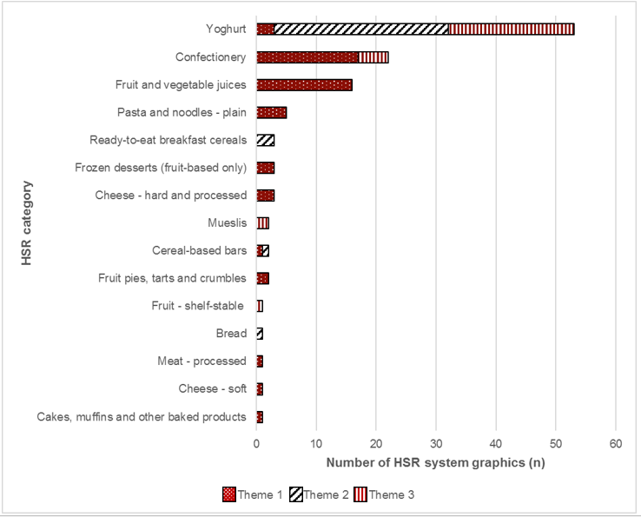

### Design variations from the Style Guide

In Year 2, a total of 190 design variations were identified out of the 2,115 HSR system graphics that were assessed. This was an increase from the 29 design variations identified in Year 1. These variations are summarised in Table 1.20 below. Again, the variations could be grouped into three key themes:

* Theme 4: Nutrient value is expressed to decimal place other than what is suggested in the HSR Style Guide[27]
* Theme 5: One HSR option is displayed on the FoP and a different HSR option is on the back or top of pack; or the ‘snail’ (prescribed nutrient icons) is on the BoP
* Theme 6: Nutrient or energy icons display the older version of the HSR system graphic

Table 1.20. Number of design variations from the Style Guide, in Year 1 and Year 2

| Type of design variation | Count (n) Year 1 | Count (n) Year 2 |
| --- | --- | --- |
| *Health Star Rating (HSR) system graphic* |  |  |
| Product displays a combination of HSR system graphics on the front of pack (FoP) | 21 | 59 |
| HSR element is on the FoP and the ‘snail’ wraps around the side of the pack, still joined | 0 | 4 |
| One HSR option is displayed on the FoP and a different HSR option is on the back of pack (BoP) or top of pack; or the ‘snail’ is on the BoP (Theme 5) | 0 | 32 |
| HSR system graphic is displayed on the box not the actual product | 0 | 2 |
| HSR value is not a valid number | 0 | 1 |
| Manufacturer has placed a sticker over one nutrient value in the HSR system graphic with correct information | 2 | 0 |
| *Energy and nutrient icons, including % dietary intake (%DI)* |  |  |
| Nutrient or energy icons display the older version of the HSR system graphic (Theme 6) | 3 | 22 |
| Use of optional nutrient differs to the recommendations in the guidelines | 0 | 1 |
| Nutrient value is expressed to decimal place other than what is suggested in the HSR Style Guide (Theme 4) | 0 | 34 |
| Sugar-free beverages display energy values to one decimal place, however, match the nutrition information panel (NIP) | 0 | 3 |
| *Nominated reference measure (NRM)* |  |  |
| NRM is in a different position to what is suggested in the HSR Style Guide | 0 | 10 |
| NRM is per 100 g, which matches the serve size; however, potentially confusing because it uses %DI | 0 | 9 |
| NRM is a different variation to the Style Guide but still appropriate | 0 | 7 |
| NRM is 'per row', which is implied to be the same as the serve size in the NIP; however, not stated | 0 | 6 |
| **TOTAL** | **26** | **190** |

In this section, HSR products that displayed a combined version of the HSR system graphic were identified as a design variation. This was the most common design variation in both Year 2 (59/190, 31%) and Year 1 (21/26, 81%). For more information on this design variation, see Section 1.3.18 for HSR products displaying a combined version of the HSR system graphic.

Another common design variation observed in Year 2 was the display of a nutrient value to a different number of decimal places to what was suggested in the Style Guide (Theme 4). This variation was identified with 34 different HSR system graphics in Year 2. Although these values differed from what was suggested in the Style Guide, they matched the value specified in the NIP for the respective nutrient. This design variation was not identified in Year 1. Six different manufacturers and retailers displayed this design variation in six different HSR categories; most of these were in the ‘Ready-to-eat breakfast cereals’ HSR category (27/34, 79%) (data not shown).

Another design variation identified on 32 products was an HSR product displaying one HSR option on the FoP and a different HSR option on the BoP (Theme 5). For example, one HSR product in the ‘Ready meal’ category displayed Option 4 on the FoP and Option 2 on the BoP. Another HSR product in the ‘Savoury pies, pastries and pizza’ category displayed Option 4 on the FoP (which represented an average of all the flavour variants in the multipack), and individual Option 2 HSR system graphics for each flavour variant on the BoP. Five different manufacturers and retailers displayed this design variation, with 75% of the occurrences being accounted for by two manufacturers (24/32) in the ‘Ready-to-eat breakfast cereals’, and ‘Crisps and similar snacks’ HSR categories. The remaining four HSR categories had three or fewer HSR system graphics each with this design variation. This design variation was not identified in Year 1 (data not shown).

Twenty-two products displayed an older version of the HSR system graphic (Theme 6), 86% of which were in the ‘Confectionery’ HSR category, with the remaining 14% in the ‘Mueslis’ HSR category. Three different manufacturers displayed this design variation; however, 73% were from one manufacturer (16/22). Although these products display an older version of the HSR system graphic and differed from the current version of the Style Guide, they are in line with an earlier version of the Style Guide. In Year 1, this design variation was identified on three HSR system graphics.

One retailer with HSR products in various HSR categories (n = 555 individual HSR system graphics) displayed a design that varied from the recommended HSR system graphic. This has not been listed in Table 1.20 above because it is unique to this retailer. This variation was also identified in Year 1, with a total of 35 HSR system graphics by the same retailer.

Figure 1.27 below summarises the number of HSR system graphics displaying the top-three design variation themes by HSR category. The figure does not include the most common design variation – a combined version of the HSR system graphic – because this is reported elsewhere. The ‘Ready-to-eat breakfast cereals’ and ‘Confectionery’ HSR categories clearly displayed the highest number of design variations overall.

Figure 1.27. Number of Health Star Rating (HSR) system graphics (n) displaying the top-three design variation themes, by HSR category, in Year 2

Click to view text version

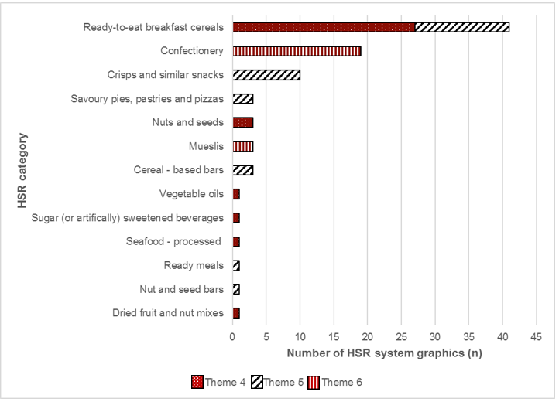

### Assessment of the Health Star Rating displayed on pack against the calculated Health Star Rating

In Year 2, there were 2,031 HSR products in FoodTrackTM, of which 113 displayed Option 5 (Energy icon only); the remaining 1,918 products displayed one of the HSR Options 1–4. Table 1.21 below outlines the total number of HSR products in Year 2 and Year 1 that had sufficient data on pack to be able to determine the HSR (see Section 2.2: Methodology for more information) by using the FoodTrackTM HSRC, supplemented with the Excel HSRC, where required.

These HSR products were divided into two groups, depending on whether they were a single HSR product displaying one NIP on the pack, or a multipack that contained a variety of flavour or products variants and displayed one NIP on the pack per variant, with or without also displaying an average HSR. There were five HSR products in the ‘Water’ category that displayed Option 4 of the HSR system. These products were excluded from analysis because ‘Water’ automatically receives a five-star rating.[28]

In Year 2, for those eligible individual HSR products on pack (Options 1–4), 97% (1,755/1,804) displayed an HSR on the pack that matched the calculated HSR. In comparison, in Year 1, 98% (309/315) eligible individual HSR products displayed an HSR that matched the calculated HSR.

Table 1.21. Summary of Health Star Rating (HSR) products that were eligible for assessment, in Year 1 and Year 2

|  | Year 2 (June 2015 to June 2016) | Year 1 (June 2014 to June 2015) |
| --- | --- | --- |
| Total number of HSR products | 2,031 | 363 |
| Number of HSR products displaying the Energy icon only (Option 5) | 113 (5.6%) | 32 (8.8%) |
| Number of HSR products displaying Options 1–4 | **1,918** | **331** |
| Number of individual HSR products | 1,896/1,918 | 326/331 |
| Number of multipack HSR products | 22/1,918 | 5/331 |
| Number of HSR products in the ‘Water’ HSR category displaying Options 1–4 | 5/1,896 | N/A  (not collected in Year 1) |
| Number of individual HSR products with incomplete data | 87/1,896 | 11/326 |
| Number eligible for assessment | 1,804 individual products  22 multipacks | 315 individual products  5 multipacks |
| Number of individual HSR products matching (multipacks addressed in section below) | 1,755 individual products (97%) | 309 individual products (98%) |
| Number of individual HSR products mismatching  Number overstated  Number understated | 49 individual products  19  30 | 6 individual products  0  6 |

In Year 2, a total of 49 individual HSR products for which the calculated HSR did not match that displayed on pack; Table 1.22below outlines the breakdown for these 49 HSR products by HSR category.

Among 30 of these 49 HSR products, 27 displayed an HSR on the pack that was half a star lower than that the calculated HSR, and three displayed an HSR that was one star lower than the calculated HSR. The four HSR products in Year 1 that also displayed an HSR on the pack half a star lower than the calculated HSR were also present in Year 2 as part of the 27 HSR products. In Year 2, 15 of the 19 HSR products that overstated the HSR on pack (compared with the calculated HSR) displayed an HSR on the pack half a star higher than the calculated HSR, three displayed an HSR that was one star higher and one displayed an HSR that was one and a half stars higher.

In Year 2, the 49 individual HSR products for which the calculated HSR did not match that displayed on the pack were split over 24 different HSR categories. ‘Confectionery’ was the main category, with nearly 20% of the representation in this sample (10/49), followed by ‘Fruit and vegetable juices’ (6/49), as shown in Table 1.22.

Table 1.22. Health Star Rating (HSR) categories in which the calculated HSR did not match that displayed on pack

| HSR category | Number of HSR products (n) with an overstated HSR in Year 2 | Number of HSR products (n) with an understated HSR in Year 2 | Total number of HSR products (n) that did not match the calculated HSR in Year 2 |
| --- | --- | --- | --- |
| Confectionery | 1 | 9 | 10 |
| Fruit and vegetable juices | 6 | 0 | 6 |
| Frozen dairy (and soy) desserts | 2 | 1 | 3 |
| Mueslis | 1 | 2 | 3 |
| Cereal-based bars | 1 | 1 | 2 |
| Formulated foods | 0 | 2 | 2 |
| Frozen desserts (fruit-based only) | 2 | 0 | 2 |
| Fruit bars | 0 | 2 | 2 |
| Nut and seed bars | 0 | 2 | 2 |
| Soups | 0 | 2 | 2 |
| Vegetarian – processed | 1 | 1 | 2 |
| Baking goods | 0 | 1 | 1 |
| Biscuits – savoury | 1 | 0 | 1 |
| Biscuits – sweet | 0 | 1 | 1 |
| Bread | 1 | 0 | 1 |
| Breakfast spreads | 0 | 1 | 1 |
| Cooking sauces | 0 | 1 | 1 |
| Dips | 0 | 1 | 1 |
| Fruit pies, tarts and crumbles | 0 | 1 | 1 |
| Hot cereals – flavoured | 1 | 0 | 1 |
| Legumes – canned/shelf-stable | 1 | 0 | 1 |
| Poultry – processed | 0 | 1 | 1 |
| Ready-to-eat breakfast cereals | 0 | 1 | 1 |
| Vegetables – processed | 1 | 0 | 1 |
| **Total** | **19** | **30** | **49** |

### Assessment of the Health Star Rating displayed on pack against the calculated Health Star Rating: multipack assessment

In Year 2, there were 22 multipacks that contained a variety of flavour or product variants. Nine of these HSR products displayed an average HSR on the FoP, along with a single HSR for each product or flavour variant. Of these nine HSR products, one had missing data and was therefore excluded from further assessment. Of the remaining eight HSR products, four displayed an HSR that matched the calculated HSR, three displayed an average HSR on the pack that was half a star higher than the calculated HSR, and one displayed an average HSR that was half a star lower than the calculated HSR. Of the four HSR products for which the displayed HSR did not match the calculated HSR, two were in the ‘Savoury pies, pastries and pizzas’ HSR category, and two were in ‘Cereal-based bars’ HSR category.

The remaining 13 of the 22 HSR products had a total of 63 individual flavour or product variants, each with their own nutritional information, three of which had missing data and were therefore excluded from further assessment. Of the remaining 60 product or flavour variants, most (58/60, 97%) displayed an HSR on the pack that matched the calculated HSR, leaving only two product or flavour variants that did not match. These two product or flavour variants were the same as those present in two different multipacks in the ‘Yoghurt’ category, and the HSR on pack was understated by half a star.

In Year 1, there were five multipacks that contained a variety of flavour or product variants. All five of these displayed an average HSR on the FoP and an average NIP on the BoP. The average HSR displayed on the pack matched the calculated HSR for all five of these HSR products.

# Consumer awareness and ability to use the Health Star Rating system correctly

Chapter 2: Consumer awareness and ability to use the Health Star Rating system correctly 106

2.1 Chapter summary 115

2.1.1 Awareness of the Health Star Rating system 115

2.1.2 Understanding of what the Health Star Rating system represents 115

2.1.3 Use of the Health Star Rating system 115

2.1.4 Advertising awareness 115

2.1.5 Perceptions and attitudes towards the Health Star Rating system 116

Health Star Rating system graphics 117

2.2 Methodology 118

2.2.1 Survey design and sample 118

2.2.2 Online panel partner 118

2.2.3 Survey questionnaire 119

2.2.4 Data analysis and reporting 120

2.2.5 Accuracy of results 120

2.2.6 Sample characteristics 120

2.3 Results – Section A: General supermarket shopping 122

2.3.1 Main influence when choosing between two products 122

2.3.2 Frequency of visits to the supermarket 122

2.3.3 Supermarkets visited in the past month 123

2.3.4 Average spend per visit to the supermarket 124

2.3.5 Comparing the healthiness of products 124

2.3.6 Use of the nutrition information panel 125

2.4 Results – Section B: Awareness of food logos 126

2.4.1 Unprompted awareness of food logos 126

2.4.2 Unprompted awareness of the Health Star Rating system 127

Age group 127

Gender 127

Household income 128

Body mass index 128

Indigenous status 128

Language spoken at home 129

Location – metropolitan versus regional/rural 129

Household structure – children 129

2.4.3 Prompted awareness of food logos 130

2.4.4 Prompted awareness of the Health Star Rating system 131

Age group 131

Gender 132

Household income 132

Body mass index 132

Indigenous status 133

Language spoken at home 133

Location – metropolitan versus regional/rural 133

Household structure – children 133

2.5 Results – Section C: Knowledge and understanding of the Health Star Rating system 135

2.5.1 Understanding of what the Health Star Rating system means 135

2.5.2 Understanding of how the Health Star Rating on a product is determined 135

2.5.3 Statements about the Health Star Rating system 136

2.5.4 Using the Health Star Rating system 137

2.5.5 Understanding what one star or five stars means 138

2.5.6 Statements about the Health Star Rating system – a product with more stars… 139

2.5.7 Easiest to understand 140

2.5.8 Easiest to recognise 140

2.5.9 Provides sufficient information 141

2.5.10 Preferred option 142

2.6 Results – Section D: Purchasing behaviours 143

2.6.1 Purchased a product displaying the Health Star Rating system graphic (a Health Star Rating product) 143

2.6.2 The Health Star Rating system influenced choice 144

2.6.3 How the Health Star Rating system influenced choice 145

2.6.4 Reasons why the Health Star Rating system did not influence choice 145

2.6.5 Continue to buy the product 146

2.6.6 Likelihood of the Health Star Rating system influencing choices in the future 146

2.6.7 Health Star Rating system graphic comparison – which is the healthier option? 147

2.6.8 Foods and/or beverages purchased in the supermarket displaying the Health Star Rating system graphic (a Health Star Rating product) 149

2.6.9 Foods and/or beverages on which it is important to display the Health Star Rating system graphic 151

2.7 Results – Section E: Advertising awareness 153

2.7.1 Awareness and source of Health Star Rating system advertising 153

2.7.2 Product advertised or promoted 155

2.7.3 Influence advertising had on purchasing a product displaying the Health Star Rating system graphic (a Health Star Rating product) 156

2.8 Results – Section F: Attitudes and perceptions about the Health Star Rating system 157

2.8.1 Statements about the Health Star Rating system – perceptions and attitudes 157

2.8.2 Trust in the Health Star Rating system 158

Age group 158

Gender 158

Household income 159

BMI 159

Language spoken at home 159

Location – metropolitan versus regional/rural 159

Household structure – children 160

2.8.3 Level of confidence in the Health Star Rating system 160

2.9 Results – Section G: Health attitudes and behaviours 161

2.9.1 Concern about the healthiness of food purchased 161

2.9.2 Perceived healthiness of diet 161

2.9.3 Changes to diet 162

2.9.4 Type of changes made to diet 162

2.9.5 Type of changes made to diet 163

## Chapter summary

### Awareness of the Health Star Rating system

* Excluding brand names, the HSR system was the third most recognised food logo in the supermarket.
* Unprompted awareness of the HSR system increased from 3% in April 2015 to 13% in July 2016. Unprompted awareness continued to remain higher among females, persons aged under 35, those with an annual household income of more than $50,000 or those with a body mass index (BMI) in the healthy weight range.
* Prompted awareness of the HSR system rose significantly, to 67% in July 2016 – a 26% increase compared with the September 2015 result.

### Understanding of what the Health Star Rating system represents

* Among respondents who were aware of the HSR system, most had a broad understanding of what the HSR system represents on food packaging.
* There was an increase in the latest survey results (July 2016, compared with February 2016) in the proportion of respondents who reported that the HSR system makes it easier to identify healthier options. However, a large proportion of respondents still lacked knowledge of the correct meaning of the HSR system.

### Use of the Health Star Rating system

* In line with an increase in awareness, a significantly higher proportion of respondents in the latest survey (July 2016) reported that they had purchased an HSR product. However, relative to the awareness of the HSR system, the increase in the number of respondents who reported buying HSR products was small.
* The recall among respondents of having purchased an HSR product was higher across all age groups, gender, location, language spoken at home and household structure. The only key demographic groups not to have an increase was respondents who were classified as having a BMI of less than 25 and those in the lowest household income group (< $50,000).
* Close to three in five respondents who reported purchasing a HSR product reported that the rating scale had influenced their purchasing decision, with more than half of those influenced purchasing a different product to what they would normally purchase.

### Advertising awareness

* Despite the significant increase in awareness of the HSR system, there was only a slight increase in the proportion of respondents who could recall hearing or seeing any advertising featuring the HSR system.
* The increased awareness was driven by product coverage (i.e. seeing products in the supermarket or in a catalogue) rather than by direct promotion and/or advertising of the HSR system.

### Perceptions and attitudes towards the Health Star Rating system

* Along with the increased awareness of the HSR system and the proportion of respondents who reported having purchased an HSR product, positive perceptions towards the system in July 2016 increased significantly compared with the previous surveys.
* Significantly more respondents (compared with the February 2016 survey) reported that they viewed the HSR system as trustworthy, easy to understand, credible and reliable. As with previous surveys, almost three in five of those surveyed agreed that the HSR system was personally relevant and relevant to their family.

Health Star Rating system graphics

| Health Star Rating system graphics |
| --- |
| Option 1  HSR + energy icon + 3 prescribed nutrient icons + optional nutrient |
| Option 2  HSR + energy icon + 3 prescribed nutrient icons  The Option 2 graphic showing the Health Star Rating, the Energy icon and 3 prescribed nutrients. |
| Option 3  HSR + energy icon  The Option 3 graphic showing the Health Star Rating and the Energy icon. |
| Option 4  HSR only  The Option 4 graphic showing the Health Star Rating only. |
| Option 5  Energy icon only  The Option 5 graphic showing the Energy icon only. |

## Methodology

Outcomes for AoE 2 were specifically divided into four key areas, as per the framework:

* awareness (unprompted and prompted) of the HSR system
* consumer knowledge and understanding of the HSR system, including what the HSR represents and what it means on product packaging
* whether consumers are using the HSR system accurately and effectively
* the level of trust, reliability and credibility consumers have in the HSR system.

These four key areas were measured at the total population level, and by agreed select population groups. This included measurement by selected age groups, household income, BMI, gender and language spoken at home.

### Survey design and sample

The online survey was conducted in three waves, during September 2015 (Wave 1), February 2016 (Wave 2) and July 2016 (Wave 3), with more than 2,000 respondents per wave. The survey questionnaire is provided in Appendix 4.

To be eligible to participate in the survey, participants were required to be the main or shared grocery buyer in their household and to be 18 years of age or over.

The sample of consumers was based on a cross-section of Australian adults. The sample was stratified to include sufficient sample sizes by:

* age group (under 35 years of age, 35–54 years of age and 55 years of age and over)
* household income per annum (less than $50,000, between $50,000 and $99,000, and $100,000 or greater)
* gender (male / female)
* BMI (underweight/normal weight, overweight or obese)
* language spoken at home (English spoken only at home or language other than English spoken at home)
* location (respondent residing in metropolitan area or in regional/rural area).

### Online panel partner

For each wave, data collection was undertaken in conjunction with a well-known market research company – Research Now. The sample was obtained through Research Now’s online research panel.

Research Now operates in 38 countries and has more than 6 million panellists internationally. It is one of the leading online sampling and data collection organisations in Australia and worldwide.

### Survey questionnaire

The initial two consumer surveys of the HSR system, conducted in September 2014 and April 2015 were undertaken by Pollinate. The surveys evaluated the roll-out of the HSR system and its impact on consumers (13, 14).

For the latest three surveys (September 2015, February 2016, July 2016), changes were made to the questionnaire used in the first two surveys conducted by Pollinate. The overall length and the breadth of the questionnaire used in the current survey was expanded, with changes including:

* broadening the questions on unprompted logos or labels
* increasing the number of other food logos or labels included for testing of prompted awareness
* increasing the number of factors influencing purchasing decision
* including new questions relating to what consumers believe the HSR system represents, how it is calculated and what the rating means on a product
* including new questions for those who have used the HSR system, with particular focus on actual and intended behaviours
* including new questions on the level of importance consumers place on the HSR across food products
* broadening the number of questions on trust, reliability and credibility of the HSR system
* including questions on whether the HSR system is meeting the needs of consumers.

The changes to the questionnaire limit the direct comparability of the current surveys with the two previous surveys conducted by Pollinate; however, where directly comparable, time series data and/or analysis is included in this report.

The questionnaire used in these surveys consisted of seven main sections, including:

* demographics:
  + gender, age, household income, household structure, educational attainment, activity status, Indigenous status and language spoken at home
* awareness of food logos:
  + unprompted and prompted awareness of the HSR system and other food logos
* purchasing behaviours:
  + main influencing factor when purchasing products at the supermarket, frequency of visits to the supermarket and average spend, supermarkets visited
* understanding of the HSR system:
  + what the HSR on a product means, how the number of stars is determined, comparison of a product with one and five stars
* use of the HSR system:
  + purchased a particular food displaying the HSR system graphic, whether the HSR system influenced the purchasing decision
* perceptions towards the HSR system:
  + whether the HSR system is credible, trusted, easy to use and easy to understand, and overall confidence in the HSR system
* general health and food attitudes and behaviours:
  + concern about healthiness of food and diet, change in dieting behaviour, daily intake of fruit and vegetables, and physical activity levels.

### Data analysis and reporting

For AoE 2, data were analysed using the statistical software package, SPSS (version 23), with independent sample t-tests used to determine whether the means of two groups were statistically different from each other (significance level set at *p <*0.05). Where relevant, for analysis the survey population was grouped by gender, age, BMI, annual household income, place of residence, Indigenous status and language spoken at home.

### Accuracy of results

The surveys conducted for AoE 2 were based on a sample of Australian adults. As it is not a census population, some level of error was inherent in the results. This margin of error was quantified statistically such that, with 95% confidence, a given range contains the true result at a population level; the error margin was 2.2%, meaning that, with 95% confidence, a result, plus or minus the error margin (e.g. 50% ±2.2), contains the true result at the population level.

### Sample characteristics

Table 2.1 outlines the sample characteristics of the populations surveyed for Waves 1–3.

Table 2.1. Sample characteristics of the populations surveyed for Waves 1–3 of AoE 2

| Characteristics | Sep-15 | Feb-16 | Jul-16 |
| --- | --- | --- | --- |
| **Total** | **n** | **n** | **n** |
|  | 2,036 | 2,005 | 2,003 |
| **Gender** | **%** | **%** | **%** |
| Male | 51 | 49 | 48 |
| Female | 49 | 51 | 52 |
| **Age group** | **%** | **%** | **%** |
| Under 35 | 30 | 30 | 32 |
| 35–54 | 32 | 35 | 35 |
| 55 or over | 38 | 34 | 33 |
| **Location** | **%** | **%** | **%** |
| Metropolitan | 72 | 71 | 72 |
| Regional/rural | 28 | 29 | 28 |
| **Annual household income** | **%** | **%** | **%** |
| Below $50,000 | 36 | 30 | 33 |
| Between $50,000 to $99,999 | 37 | 34 | 35 |
| $100,0000 or higher | 27 | 36 | 33 |
| **Speak language other than English** | **%** | **%** | **%** |
| Yes | 18 | 16 | 18 |
| No | 81 | 84 | 82 |
| **Household structure** | **%** | **%** | **%** |
| Children in the household | 32 | 34 | 64 |
| No children in the household | 68 | 66 | 36 |
| **Indigenous status** | **%** | **%** | **%** |
| Indigenous | 2 | 1 | 2 |
| Non-Indigenous | 98 | 99 | 98 |

## Results – Section A: General supermarket shopping

### Main influence when choosing between two products

When purchasing food at the supermarket and choosing between two similar products, price remained the most common factor that influenced purchasing decisions, being 41% in July 2016. However, the latest results showed that a significantly lower proportion of respondents reported that they focus on product quality, decreasing from 17% in February 2016 to 14% in July 2016 (*p =*0*.*009). Personal preference, the healthiness of a product, product taste and nutritional value also remained on par with the previous wave as the main influencing factor when deciding between two like products.

Figure 2A1. When buying food at the supermarket, what is the main thing that influences your choice between two similar products?

Click to view text version

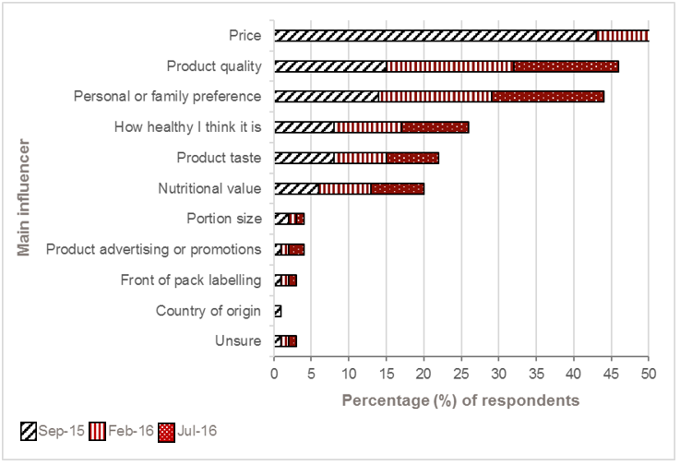

Sample: September 2015, n = 2,036; February 2016, n = 2,005; July 2016, n = 2,003

### Frequency of visits to the supermarket

The latest results revealed that more than half of respondents reported visiting a supermarket more than once a week. There was a trend emerging in the frequency of respondents visiting a supermarket. The latest results showed respondents moving towards visiting a supermarket more than once a week (significantly higher than the result from September 2015, *p* = 0.01) rather than doing a weekly supermarket shop.

Table 2A1. On average, how often do you visit a supermarket to do your grocery shopping?

|  | Sep-15 (%) | Feb-16 (%) | Jul-16 (%) |
| --- | --- | --- | --- |
| Every day | 3 | 5 | 5 |
| Several times a week | 47 | 48 | 49 |
| Once a week | 42 | 40 | 39 |
| Once a fortnight | 7 | 6 | 6 |
| Once a month | 1 | 1 | 1 |

Sample: September 2015, n = 2,036; February 2016, n = 2,005; July 2016, n = 2,003

### Supermarkets visited in the past month

The latest results showed a reported significant increase in the frequency of visits to a supermarket for two major supermarket chains – ALDI and IGA. Compared with the two previous waves, the latest results showed a significant rise in the proportion of respondents who had visited ALDI in the past month (43% vs 47%, *p =*0*.*01). Similarly, compared with September 2015, the proportion of respondents who had visited IGA in the past month increased significantly (33% vs 36%, *p =*0*.*05).

Results for consumers who had visited Woolworths and Coles in the past month were similar to those of previous waves.

Figure 2A2. Which supermarkets have you visited in the past month?

Click to view text version

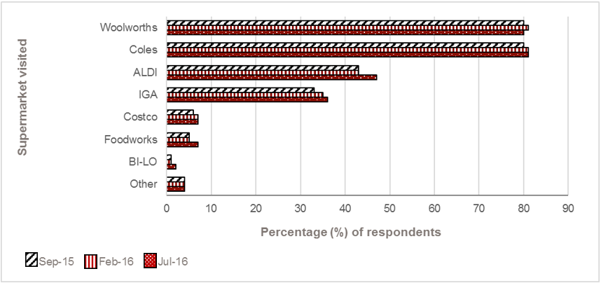

Sample: September 2015, n = 2,036; February 2016, n = 2,005; July 2016, n = 2,003

### Average spend per visit to the supermarket

The average expenditure per visit to the supermarket varied greatly. Respondents with an annual household income of more than $100,000 were significantly more likely to spend at least $100 per visit to the supermarket compared with those with an annual household income of less than $100,000 (45% vs 36%, *p =*0*.*0007).

Spending at least $100 per visit to the supermarket increased with increasing BMI. Those with a BMI in the overweight and obese range were significantly more likely to spend at least $100 per visit to the supermarket than those in the normal weight range (40% vs 33%, *p =*0*.*003).

Table 2A2. On average, how much do you spend in one visit to the supermarket?

|  | Sep-15 (%) | Feb-16 (%) | Jul-16 (%) |
| --- | --- | --- | --- |
| Under $20 | 3 | 3 | 3 |
| $20 to $49 | 27 | 23 | 22 |
| $50 to $99 | 31 | 36 | 33 |
| $100 to $149 | 22 | 21 | 23 |
| $150 to $199 | 8 | 9 | 9 |
| $200 or more | 5 | 4 | 6 |
| It varies | 4 | 4 | 4 |

Sample: September 2015, n = 2,036; February 2016, n = 2,005; July 2016, n = 2,003

### Comparing the healthiness of products

In the latest results, close to three in five respondents (57%) stated that they ‘always’ or ‘most of the time’ compare how healthy products are when grocery shopping, with an additional 28% reporting that they ‘sometimes’ compare the healthiness of products. This remained relatively consistent across all three waves.

More than three in five (61%) females reported that they ‘always’ or ‘most of the time’ compare how healthy products are; this was significantly higher than males, at 52% (*p =*0*.*001). Similarly, respondents with a BMI of less than 25 (normal weight) were more likely to ‘always’ or ‘most of the time’ compare how healthy products are than respondents with a BMI of 30 or higher (63% vs 52%, *p <*0.0001).

Figure 2A3. When choosing a new food during grocery shopping, how often do you compare how healthy products are?

Click to view text version

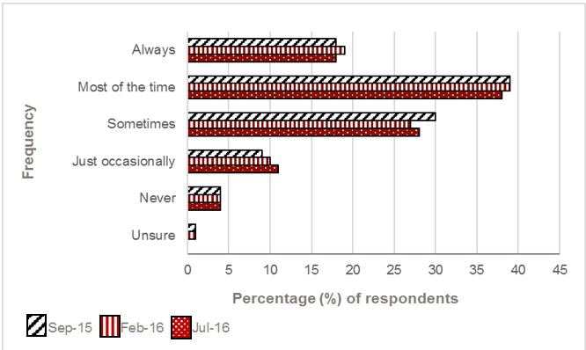

Sample: September 2015, n = 2,036; February 2016, n = 2,005; July 2016, n = 2,003

### Use of the nutrition information panel

More than two in five respondents (43%) reported that they look at the nutrition information panel (NIP) on ‘all’ or ‘most’ food products, when at the supermarket. Significantly more females than males stated that they look at the NIP on ‘all’ or ‘most’ food products, when at the supermarket (46% vs 40%; *p =*0*.*05). Similarly, respondents with a BMI of less than 25 were more likely to look at the NIP on ‘all’ or ‘most’ food products than respondents with a BMI of 30 or higher (48% vs 38%, *p <*0.0001).

Figure 2A4. On average, when at the supermarket, do you look at the nutrition information panel on…?

Click to view text version

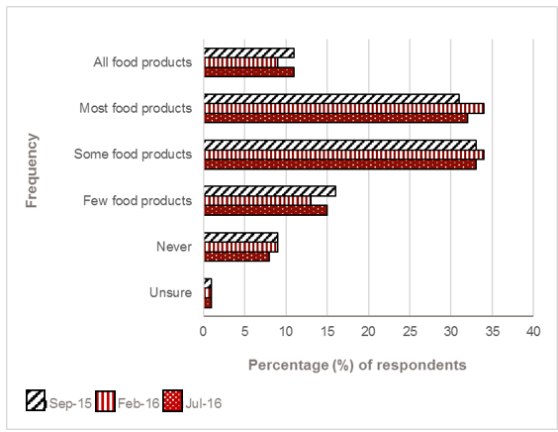

Sample: September 2015, n = 2,036; February 2016, n = 2,005; July 2016, n = 2,003

## Results – Section B: Awareness of food logos

### Unprompted awareness of food logos

Respondents were asked about their awareness of different logos that help customers choose the food they buy in the supermarket.

In April 2015, just 3% of respondents, when unprompted, were aware of the HSR system. In just over 12 months, unprompted awareness increased more than fourfold to 13% of respondents. However, since February 2016, unprompted awareness of the HSR system remained consistent.

Excluding brand names, the HSR system was the third most recognised food logo in the supermarket.

Figure 2B1. Apart from brand names, thinking about different logos that help customers choose the food they buy in the supermarket, which ones are you aware of?

Click to view text version

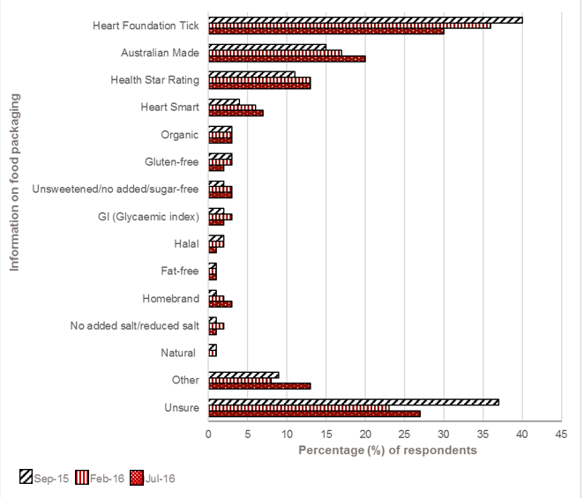

Sample: September 2015, n = 2,036; February 2016, n = 2,005; July 2016, n = 2,003

### Unprompted awareness of the Health Star Rating system[29]

Age group

As with previous findings, unprompted awareness of the HSR system was significantly higher among respondents under the age of 35, who were nearly twice as likely to mention the HSR system as those aged 35 and over (*p =*0*.*0001).

Table 2B1. Age group

|  | Sep-15 (%) | Feb-16 (%) | Jul-16 (%) |
| --- | --- | --- | --- |
| Under 35 | 16 | 18 | 19 |
| Between 35 and 54 | 11 | 11 | 13 |
| 55 or over | 9 | 10 | 6 |

Gender

Unprompted awareness of the HSR system continued to be significantly higher among females than males (*p =*0*.*0004).

Table 2B2. Gender

|  | Sep-15 (%) | Feb-16 (%) | Jul-16 (%) |
| --- | --- | --- | --- |
| Female | 15 | 15 | 15 |
| Male | 8 | 11 | 10 |

Household income

The latest findings revealed a significant rise in unprompted awareness among respondents with a household income of more than $100,000 per annum, at 17% (*p =*0*.*0002). This was 1.6 times higher than those with a household income of less than $100,000 per annum.

Table 2B3. Household income

|  | Sep-15 (%) | Feb-16 (%) | Jul-16 (%) |
| --- | --- | --- | --- |
| < $50,000 | 7 | 10 | 10 |
| $50,000 to $99,999 | 14 | 14 | 12 |
| $100,000 or more | 13 | 14 | 17 |

Body mass index

Unprompted awareness of the HSR system was negatively correlated with BMI. Comparing the latest result to September 2015, there was a slight increase in awareness of the HSR system among respondents with a BMI in the normal weight range and those with a BMI in the obese range.

Table 2B4. Body mass index

|  | Sep-15 (%) | Feb-16 (%) | Jul-16 (%) |
| --- | --- | --- | --- |
| < 25.0 | 14 | 16 | 16 |
| 25.0–29.9 | 10 | 14 | 10 |
| ≥ 30.0 | 8 | 9 | 10 |

Indigenous status[30]

Unprompted awareness among respondents of Aboriginal and/or Torres Strait Islander background remained lower than among non-Indigenous respondents.

Table 2B5. Indigenous status

|  | Sep-15 (%) | Feb-16 (%) | Jul-16 (%) |
| --- | --- | --- | --- |
| Indigenous | 4 | 7 | 4 |
| Non-Indigenous | 12 | 13 | 13 |

Language spoken at home

Although the difference was not significant, those who spoke only English at home were more likely to be aware of the HSR system than those who spoke a language other than English.

Table 2B6. Language spoken at home

|  | Sep-15 (%) | Feb-16 (%) | Jul-16 (%) |
| --- | --- | --- | --- |
| English only | 11 | 13 | 13 |
| Other than English | 11 | 14 | 10 |

Location – metropolitan versus regional/rural

As with previous findings, the latest results showed that respondents living in metropolitan areas were significantly more likely to nominate the HSR system as a food logo than those living in regional or rural areas of Australia (*p =*0*.*002).

Table 2B7. Location

|  | Sep-15 (%) | Feb-16 (%) | Jul-16 (%) |
| --- | --- | --- | --- |
| Metropolitan | 13 | 14 | 14 |
| Regional/rural | 9 | 11 | 9 |

Household structure – children

Even though not significant, the latest findings showed that households with children were more likely to be aware of the HSR system than those without children.

Table 2B8. Children at home

|  | Sep-15 (%) | Feb-16 (%) | Jul-16 (%) |
| --- | --- | --- | --- |
| With children | 13 | 13 | 15 |
| No children | 11 | 13 | 12 |

### Prompted awareness of food logos[31]

The latest findings revealed prompted awareness of the HSR system rose significantly, to 67% in July 2016 – a 26% increase compared with the September 2015 result.

Figure 2B2. Which of the following are you aware of on food packaging?

Click to view text version

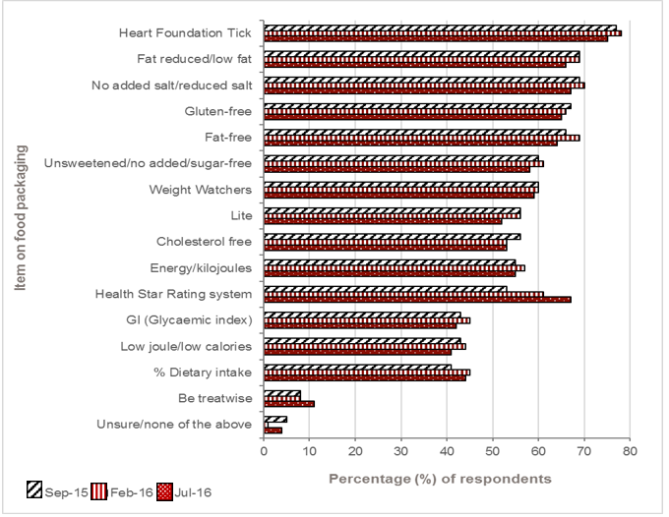

Sample: September 2015, n = 2,036; February 2016, n = 2,005; July 2016, n = 2,003

### Prompted awareness of the Health Star Rating system

In just over 12 months, prompted awareness of the HSR system more than doubled, from 33% of respondents in April 2015 to 67% in July 2016.

Figure 2B3. Prompted awareness of the Health Star Rating system over time

Click to view text version

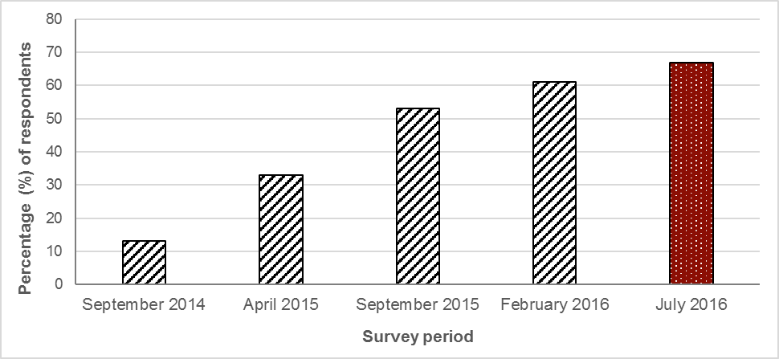

Sample: September 2014, n = 1,000; April 2015, n = 1,011; September 2015, n = 2,036; February 2016, n = 2,005; July 2016, n = 2,003

Age group

In line with unprompted awareness, prompted awareness of the HSR system remained higher among respondents aged under 35 (*p <*0.0001).

Table 2B9. Age group

|  | Sep-15 (%) | Feb-16 (%) | Jul-16 (%) |
| --- | --- | --- | --- |
| Under 35 | 64 | 66 | 78 |
| Between 35 to 54 | 51 | 61 | 66 |
| 55 or over | 47 | 55 | 56 |

Gender

Both unprompted and prompted awareness of the HSR system was significantly higher among females than males (*p =*0*.*0009).

Table 2B10. Gender

|  | Sep-15 (%) | Feb-16 (%) | Jul-16 (%) |
| --- | --- | --- | --- |
| Female | 55 | 64 | 70 |
| Male | 51 | 57 | 63 |

Household income

Prompted awareness of the HSR system was highest among respondents with a household income of $50,000 or more (*p =*0*.*003).

Table 2B11. Household Income

|  | Sep-15 (%) | Feb-16 (%) | Jul-16 (%) |
| --- | --- | --- | --- |
| < $50,000 | 49 | 58 | 63 |
| $50,000 to $99,999 | 59 | 63 | 70 |
| $100,000 or more | 54 | 60 | 70 |

Body mass index

As with unprompted awareness, prompted awareness of the HSR system was negatively correlated with increasing BMI.

Prompted awareness was significantly higher among those with a BMI in the normal weight range than those in the overweight/obese range (*p* < 0.0001). It was also significantly higher among those with a BMI in the normal weight range (< 25.0) than those in the overweight weight range (25.0–29.9) (*p* = 0.003).

Table 2B12. Body mass index

|  | Sep-15 (%) | Feb-16 (%) | Jul-16 (%) |
| --- | --- | --- | --- |
| < 25.0 | 57 | 65 | 71 |
| 25.0 to 29.9 | 51 | 58 | 63 |
| ≥ 30.0 | 49 | 56 | 60 |

Indigenous status[32]

Prompted awareness among respondents of Aboriginal and/or Torres Strait Islander background increased in July 2016, compared with the February 2016 results.

Table 2B13. Indigenous status

|  | Sep-15 (%) | Feb-16 (%) | Jul-16 (%) |
| --- | --- | --- | --- |
| Indigenous | 62 | 57 | 65 |
| Non-Indigenous | 53 | 60 | 67 |

Language spoken at home

The language spoken at home was not a deciding factor in prompted awareness of the HSR system among respondents.

Table 2B14. Language spoken at home

|  | Sep-15 (%) | Feb-16 (%) | Jul-16 (%) |
| --- | --- | --- | --- |
| English only | 53 | 60 | 67 |
| Other than English | 55 | 66 | 67 |

Location – metropolitan versus regional/rural

Respondents living in metropolitan areas were more likely to be aware of the HSR system than those living in regional or rural areas of Australia.

Table 2B15. Location

|  | Sep-15 (%) | Feb-16 (%) | Jul-16 (%) |
| --- | --- | --- | --- |
| Metropolitan | 54 | 61 | 67 |
| Regional/rural | 50 | 60 | 65 |

Household structure – children

Compared with February 2016, respondents with children living at home recorded a significant increase in awareness. There was only a marginal difference for those without children living at home during the same period (*p <*0.0001).

Table 2B16. Children at home

|  | Sep-15 (%) | Feb-16 (%) | Jul-16 (%) |
| --- | --- | --- | --- |
| With children | 58 | 60 | 72 |
| No children | 51 | 63 | 64 |

## Results – Section C: Knowledge and understanding of the Health Star Rating system

### Understanding of what the Health Star Rating system means

For respondents who were aware of the HSR system, more than half (54%) were aware that the HSR system is a rating scale of the healthiness of a food product, with an additional 3% stating that it is a comparison between two products in the same category. The latest results (July 2016) were on a par with the previous results. Respondents were generally aware that the HSR system means a comparative rating between products, identification of which products are healthier or provision of information on nutritional profile.

Figure 2C1. When the Health Star Rating system is on the packaging of food, what do you think it means?

Click to view text version

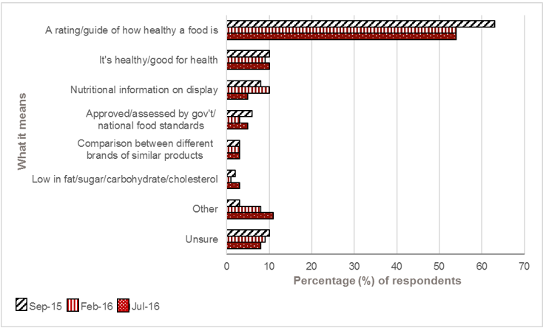

Sample: September 2015, n = 1,084; February 2016, n = 1,213; July 2016, n = 1,335

### Understanding of how the Health Star Rating on a product is determined

Respondents were asked their opinion about how the number of stars on a product is determined.

Generally, most respondents were aware that the number of stars on a product is determined by the nutritional analysis of products, or is based on the healthiness of a product. Compared with February 2016, there was a decrease in the proportion of respondents aware that the number of stars on a product is determined by the nutritional analysis of products (35% vs 32%, *p =*0*.*05).

Only a small proportion of respondents believed a manufacturer can simply decide how many stars their products have.

Figure 2C2. In your opinion, how is the number of stars on a product determined?

Click to view text version

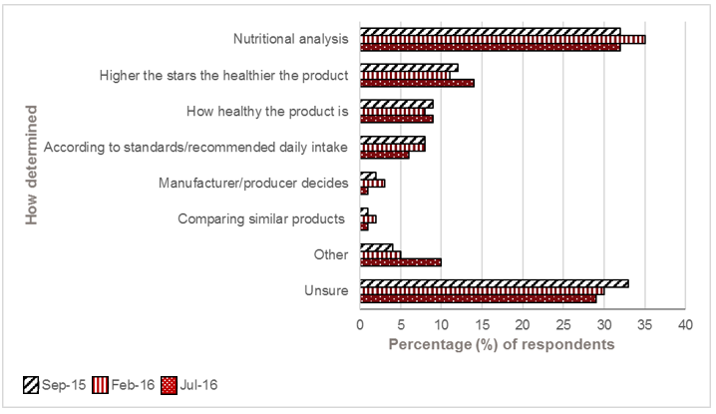

Sample: September 2015, n = 1,084; February 2016, n = 1,213; July 2016, n = 1,335

### Statements about the Health Star Rating system

The most recent results saw the highest percentage of respondents agree that the HSR system helps them to identify a healthier option. A similar percentage to the previous wave agreed that the HSR system makes it easier to compare products that are in the same category in the supermarket. Although three in five respondents believed the HSR system assisted in their decision-making process while purchasing food products, just over one in four held the view that it is just another logo on food products that adds to the confusion.

Table 2C1. How strongly do you agree or disagree that the Health Star Rating system…?

|  | Apr-15 (%) | Sep-15 (%) | Feb-16 (%) | Jul-16(%) |
| --- | --- | --- | --- | --- |
| Makes it easier for me to identify the healthier option within a category | 73 | 74 | 72 | 75 |
| Makes it easier for me to compare products that are in the same category in the supermarket | 74 | 73 | 72 | 72 |
| Helps me think about the healthiness of food | 73 | 71 | 69 | 71 |
| Makes it easier for me to identify the healthier option across all categories | n/a | 68 | 67 | 70 |
| Helps me make decisions about which foods to buy | 67 | 61 | 59 | 61 |
| Makes it easier for me to compare products that are in the different categories in the supermarket | 51 | 58 | 58 | 61 |
| Makes me want to buy healthier products | 62 | 57 | 55 | 57 |
| It's just another thing on a pack that makes shopping more confusing | 24 | 28 | 25 | 28 |

Sample: April 2015, n = 334; September 2015, n = 1,084; February 2016, n = 1,213; July 2016, n = 1,335

### Using the Health Star Rating system

Respondents were asked how they would use the HSR system.

The latest results saw a significant drop in the proportion of respondents who stated they would use the HSR system to compare products or for a better choice, compared with the February 2016 result (30% vs 26%; *p =*0*.*03). However, across all three time points, this remained the response with the greatest percentage of respondents. The proportion who stated they would not use the HSR system is marginally down compared with the February 2016 result (17% vs 15%).

Figure 2C3. How would you use the Health Star Rating (HSR) system?

Click to view text version

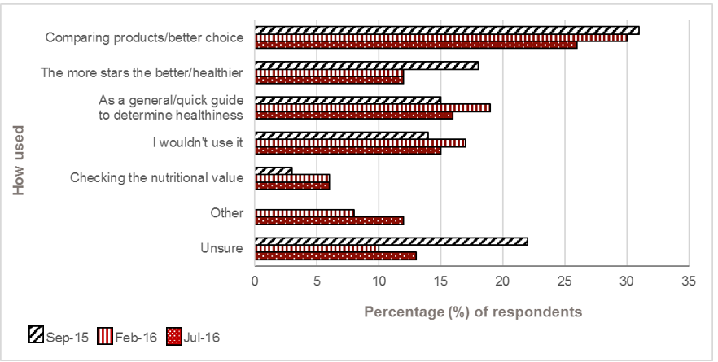

Sample: September 2015, n = 1,084; February 2016, n = 1,213; July 2016, n = 1,335

### Understanding what one star or five stars means

Respondents were asked about their understanding of the meaning of one star and five stars on a product.

Respondents who reported being aware of the HSR system were most likely to state that a food product with one star means the product is unhealthy or has little nutritious value; however, this decreased significantly over each wave, from 78% to 70% to 56% (*p <*0.0001). In contrast, an increasing proportion of respondents believed that one star means a product is less healthy than products with more stars, or that you should limit or avoid consumption of products with one star.

The clear majority of respondents stated that a food product with five stars means the product is the healthiest choice or that it is good for your health; however, this has declined significantly compared with the February 2016 result (88% vs 85%, *p =*0*.*02).

Figure 2C4. If a food product has one star, what do you think this means?

Click to view text version

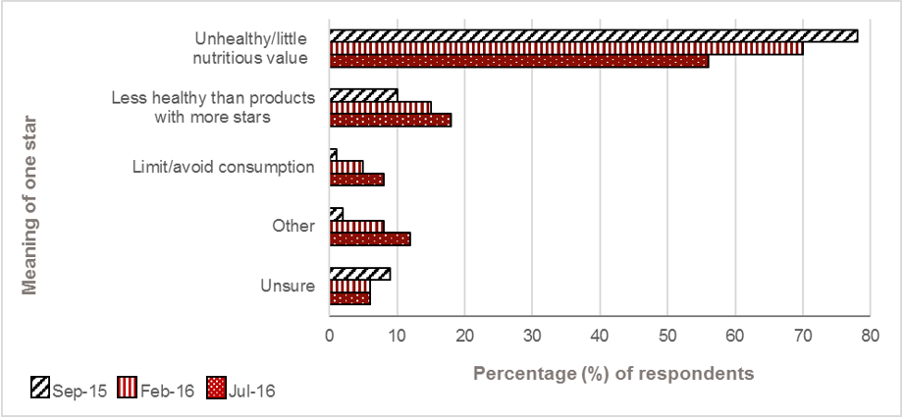

Sample: September 2015, n = 1,084; February 2016, n = 1,213; July 2016, n = 1,335

Figure 2C5. If a food product has five stars, what do you think this means?

Click to view text version

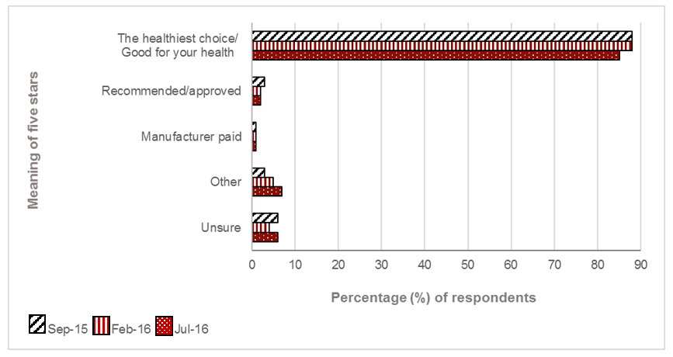

Sample: September 2015, n = 1,084; February 2016, n = 1,213; July 2016, n = 1,335

### Statements about the Health Star Rating system – a product with more stars…

Respondents were asked a series of statements about products with the HSR system.

There was marginal change in the July 2016 result compared with the previous survey relating to what a product with more stars represented. However, significantly more respondents in the latest survey felt that a product with more stars meant it was more expensive (25% vs 21%, *p =*0*.*02) and that you can eat as much as you like compared with a product with fewer stars (17% vs 13%, *p =*0*.*005).

Table 2C2. How strongly do you agree or disagree that a product with more stars means…?

|  | Sep-15 (%) | Feb-15 (%) | Jul-16 (%) |
| --- | --- | --- | --- |
| It is a healthier option compared to a similar food product with less stars | 78 | 76 | 76 |
| It is a healthier option compared to a food product with less stars | 76 | 74 | 74 |
| It is healthy | 63 | 60 | 61 |
| It is more expensive than a product with less stars | 26 | 21 | 25 |
| You can eat it as much as you like compared to a product with less stars | 17 | 13 | 17 |
| It does not taste as good as a product with less stars | 14 | 10 | 12 |

Sample: September 2015, n = 1,084; February 2016, n = 1,213; July 2016, n = 1,335

### Easiest to understand

The HSR system was displayed in the five different options available. Respondents were asked which they believe is easiest to understand and to recognise, and which provides sufficient information.

The HSR system graphic with the most detailed nutrient information remained the version that respondents view as the easiest to understand (Option 1). This was followed by the single circle HSR system graphic (Option 4), for which the proportion increased slightly compared with previous survey results.

Table 2C3. The Health Star Rating (HSR) system can be displayed in five different ways. Please select the style you believe is the easiest to understand.

| Option of the HSR system graphic | HSR system graphic | Sep-15 (%) | Feb-15 (%) | Jul-16 (%) |
| --- | --- | --- | --- | --- |
| Option 1 | HSR + energy icon + 3 prescribed nutrient icons + optional nutrient | 52 | 53 | 50 |
| Option 4 | Option 4 HSR only | 20 | 21 | 24 |
| Option 2 | Option 2 HSR + energy icon + 3 prescribed nutrient icons + optional nutrient | 21 | 21 | 21 |
| Option 3 | Option 3 HSR + energy icon | 5 | 5 | 5 |
| Option 5 | Option 5 Energy icon only | 1 | 1 | 1 |

Sample: September 2015, n = 1,084; February 2016, n = 1,213; July 2016, n = 1,335

### Easiest to recognise

The HSR system graphic with the most detailed nutrient information remained the version that respondents viewed as the easiest to recognise (Option 1). The single circle HSR system graphic (Option 4) was also seen as easy to recognise, with over a third of respondents selecting this version, a result that is on par with the February 2016 survey.

Table 2C4. The Health Star Rating (HSR) system can be displayed in five different ways. Please select the style you believe is the easiest to recognise?

| Option of the HSR system graphic | HSR system graphic | Sep-15 (%) | Feb-15 (%) | Jul-16 (%) |
| --- | --- | --- | --- | --- |
| Option 1 | Option 1 HSR + energy icon + 3 prescribed nutrient icons + optional nutrient | 45 | 43 | 42 |
| Option 4 | Option 4 HSR only | 32 | 34 | 34 |
| Option 2 | Option 2 HSR + energy icon + 3 prescribed nutrient icons | 16 | 17 | 19 |
| Option 3 | Option 3 HSR + energy icon | 7 | 5 | 4 |
| Option 5 | Option 5 Energy icon only | 1 | 1 | 1 |

Sample: September 2015, n = 1,084; February 2016, n = 1,213; July 2016, n = 1,335

### Provides sufficient information

The two HSR system graphics with additional nutritional information (Option 1 and Option 2) remained the versions that respondents are most likely believe provide sufficient information.

Table 2C5. The Health Star Rating (HSR) system can be displayed in five different ways. Please select the style you believe provides sufficient information

| Option of the HSR system graphic | HSR system graphic | Sep-15 (%) | Feb-15 (%) | Jul-16 (%) |
| --- | --- | --- | --- | --- |
| Option 1 | Option 1 HSR + energy icon + 3 prescribed nutrient icons + optional nutrient | 62 | 60 | 59 |
| Option 2 | Option 2 HSR + energy icon + 3 prescribed nutrient icons | 21 | 23 | 23 |
| Option 4 | Option 4 HSR only | 11 | 12 | 13 |
| Option 3 | Option 3 HSR + energy icon | 5 | 4 | 4 |
| Option 5 | Option 5 Energy icon only | 1 | 1 | 1 |

Sample: September 2015, n = 1,084; February 2016, n = 1,213; July 2016, n = 1,335

### Preferred option

Along with being selected as easiest to understand, easiest to recognise and providing sufficient information, the HSR system graphic with the most detailed nutrient information (Option 1) remained the preferred style.

Table 2C6. Overall, please select the style you prefer the most.

| Option of the HSR system graphic | HSR system graphic | Sep-15 (%) | Feb-15 (%) | Jul-16 (%) |
| --- | --- | --- | --- | --- |
| Option 1 | Option 1 HSR + energy icon + 3 prescribed nutrient icons + optional nutrient | 57 | 57 | 54 |
| Option 2 | Option 2 HSR + energy icon + 3 prescribed nutrient icons | 21 | 21 | 22 |
| Option 4 | Option 4 HSR only | 16 | 17 | 19 |
| Option 3 | Option 3 HSR + energy icon | 5 | 4 | 4 |
| Option 5 | Option 5 Energy icon only | 1 | 1 | 1 |

Sample: September 2015, n = 1,084; February 2016, n = 1,213; July 2016, n = 1,335

## Results – Section D: Purchasing behaviours

### Purchased a product displaying the Health Star Rating system graphic (a Health Star Rating product)[33]

In line with the increase in awareness, a significantly higher proportion (compared with the previous surveys) of respondents in the latest survey reported that they had purchased an HSR product.

The recall among respondents of having purchased a product with the stars was higher across all age groups, gender, location, language spoken at home and household structure. The only key demographic groups not to have an increase was respondents who were classified as having a BMI < 25 and those in the lowest household income group (< $50,000).

Table 2D1. In the past three months, have you purchased a product that had the Health Star Rating system?

|  | Apr-15 (%) | Sep-15 (%) | Feb-16 (%) | Jul-16 (%) |
| --- | --- | --- | --- | --- |
| Yes | 8 | 45 | 52 | 56 |
| No | 41 | 10 | 7 | 6 |
| Unsure | 51 | 45 | 42 | 38 |

Sample: April 2015, n = 334; September 2015, n = 1,084; February 2016, n = 1,213; July 2016 = 1,335

Table 2D2. Age group

|  | Sep-15 (%) | Feb-16 (%) | Jul-16 (%) |
| --- | --- | --- | --- |
| Under 35 | 47 | 57 | 60 |
| Between 35 and 54 | 49 | 50 | 57 |
| 55 or over | 40 | 48 | 50 |

Table 2D3. Gender

|  | Sep-15 (%) | Feb-16 (%) | Jul-16 (%) |
| --- | --- | --- | --- |
| Female | 41 | 50 | 55 |
| Male | 49 | 54 | 57 |

Table 2D4. Household Income

|  | Sep-15 (%) | Feb-16 (%) | Jul-16 (%) |
| --- | --- | --- | --- |
| < $50,000 | 41 | 48 | 34 |
| $50,000 to $99,999 | 48 | 57 | 58 |
| $100,000 or more | 47 | 52 | 62 |

Table 2D5. Body mass index

|  | Sep-15 (%) | Feb-16 (%) | Jul-16 (%) |
| --- | --- | --- | --- |
| < 25.0 | 49 | 65 | 60 |
| 25.0 to 29.9 | 45 | 53 | 56 |
| ≥ 30.0 | 39 | 47 | 56 |

Table 2D6. Language

|  | Sep-15 (%) | Feb-16 (%) | Jul-16 (%) |
| --- | --- | --- | --- |
| English only | 42 | 51 | 54 |
| Other than English | 56 | 55 | 66 |

Table 2D7. Location

|  | Sep-15 (%) | Feb-16 (%) | Jul-16 (%) |
| --- | --- | --- | --- |
| Metro | 46 | 55 | 57 |
| Regional/rural | 43 | 44 | 54 |

Table 2D8. Children at home

|  | Sep-15 (%) | Feb-16 (%) | Jul-16 (%) |
| --- | --- | --- | --- |
| With children | 49 | 58 | 62 |
| No children | 43 | 49 | 53 |

### The Health Star Rating system influenced choice

Almost three in five respondents of those who had reported purchasing a HSR product in the last three months stated that the HSR system graphic displayed on the product influenced their choice. In the latest survey, the proportion of respondents who had reported that the HSR system influenced their purchasing choice remained on a par with the February 2016 results. Even though women were significantly more likely to be aware of the HSR system, men were statistically more likely than women to report that the stars on a product packaging influenced their selection (63% vs 50%, *p =*0*.*07).

Table 2D9. Did the Health Star Rating system on the product influence your choice?

|  | Sep-15 (%) | Feb-16 (%) | Jul-16 (%) |
| --- | --- | --- | --- |
| Yes | 56 | 59 | 59 |
| No | 37 | 32 | 34 |
| Unsure | 7 | 9 | 7 |

Sample: September 2015, n = 489; February 2016, n = 626; July 2016, n = 749

### How the Health Star Rating system influenced choice

As with previous surveys, one in two respondents who reported having purchased an HSR product, purchased a different product than they normally would have purchased as a result of the HSR system.

Table 2D10. How did it influence your choice?

|  | Sep-15 (%) | Feb-15 (%) | Jul-16 (%) |
| --- | --- | --- | --- |
| It confirmed I should buy my usual product | 45 | 47 | 49 |
| I chose a product with more stars that I don't often buy | 37 | 33 | 32 |
| I chose a product with more stars that I've never tried before | 11 | 13 | 12 |
| I chose not to buy my usual product because it had fewer stars than other options | 7 | 7 | 6 |

Sample: September 2015, n = 273; February 2016, n = 368; July 2016, n = 444

### Reasons why the Health Star Rating system did not influence choice

For respondents who reported that their purchasing was not influenced by the HSR system, personal preference remained the main reason in July 2016, at 39%; however, this was a significant decline compared with the September 2015 result (56%, *p =*0*.*0001). The next highest reason was respondents own ability to determine which products are healthy.

Figure 2D1. Why didn’t the Health Star Rating system influence your choice?

Click to view text version

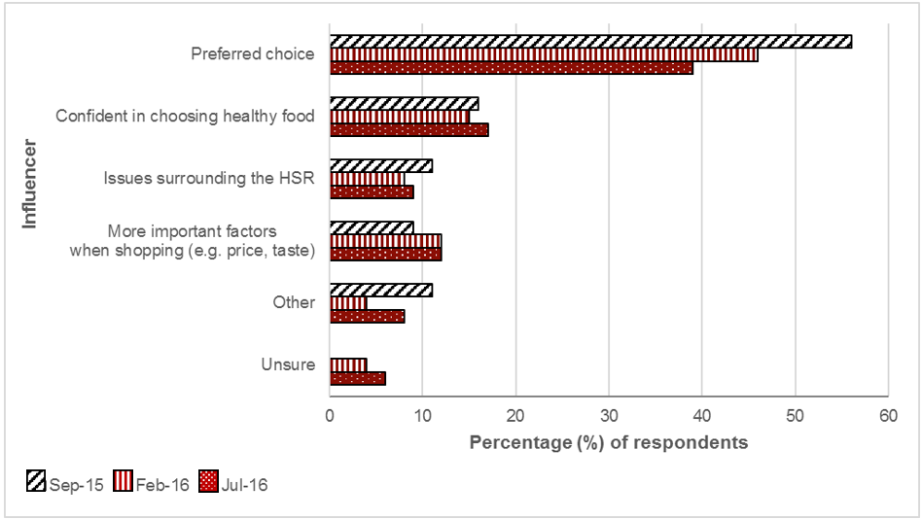

Sample: September 2015, n = 180; February 2016, n = 203; July 2016, n = 254

### Continue to buy the product

In July 2016, of those who reported being influenced in purchasing a different product due to the HSR system (subset, n = 444), nine in 10 said they would continue to purchase that product (on a par with previous results).

Table 2D11. Have you continued or will continue to buy the product?

|  | Sep-15 (%) | Feb-16 (%) | Jul-16 (%) |
| --- | --- | --- | --- |
| Yes | 90 | 90 | 90 |
| No | 2 | 2 | 1 |
| Unsure | 8 | 8 | 9 |

Sample: September 2015, n = 273; February 2016, n = 368; July 2016, n = 444

### Likelihood of the Health Star Rating system influencing choices in the future

The latest results reveal a similar proportion of respondents (compared with previous surveys) reported that they are likely to use the HSR system in the future when selecting food products. However, compared with September 2015, respondents were significantly more likely to state they were ‘very likely’ to use the HSR system in the future when selecting food products (*p =*0*.*003).

Intended usage of the HSR system was similar across key demographic profiles, including age, gender, BMI and household income.

Table 2D12. How likely or unlikely is the Health Star Rating system to influence choices you make in the future when buying food?

|  | Sep-15 (%) | Feb-16 (%) | Jul-16 (%) |
| --- | --- | --- | --- |
| Very likely | 19 | 21 | 24 |
| Likely | 53 | 50 | 48 |
| Unlikely | 14 | 15 | 14 |
| Very unlikely | 7 | 8 | 7 |
| Unsure | 7 | 7 | 7 |

Sample: September 2015, n = 1,084; February 2016, n = 1,213; July 2016, n = 1,335

### Health Star Rating system graphic comparison – which is the healthier option?

Respondents understanding and knowledge of comparing HSR system graphics to determine the healthiness of a product remained high.

Table 2D13. Please select which you think is a healthier option in each pair

| Scenario 1 | Apr-15 (%) | Sep-15 (%) | Feb-16 (%) | Jul-16 (%) |
| --- | --- | --- | --- | --- |
| A graphic showing Health Star Rating only with 1 star. | 3 | 5 | 4 | 4 |
| A graphic showing Health Star Rating only with 2 stars. | 90 | 91 | 91 | 89 |
| These are the same | 7 | 5 | 5 | 6 |

Sample: September 2015, n = 1,084; February 2016, n = 1,213; July 2016, n = 1,335

Table 2D14. Please select which you think is a healthier option in each pair

| Scenario 2 | Apr-15 (%) | Sep-15 (%) | Feb-16 (%) | Jul-16 (%) |
| --- | --- | --- | --- | --- |
| A graphic showing Health Star Rating only with 2.5 stars. | 4 | 3 | 3 | 4 |
| A graphic showing Health Star Rating only with 3.5 stars. | 89 | 93 | 93 | 91 |
| These are the same | 7 | 4 | 4 | 5 |

Sample: September 2015, n = 1,084; February 2016, n = 1,213; July 2016, n = 1,335

Table 2D15. Please select which you think is a healthier option in each pair

| Scenario 3 | Apr-15 (%) | Sep-15 (%) | Feb-16 (%) | Jul-16 (%) |
| --- | --- | --- | --- | --- |
| A graphic showing the Health Star Rating, the Energy icon, 3 prescribed nutrients and an optional nutrient. | 11 | 10 | 11 | 12 |
| A graphic showing Health Star Rating only with 2.5 stars. | 81 | 83 | 82 | 80 |
| These are the same | 8  7  711 | 7  10 | 7  7  11 | 8  12 |

Sample: September 2015, n = 1,084; February 2016, n = 1,213; July 2016, n = 1,335

Table 2D16. Please select which you think is a healthier option in each pair

| Scenario 4 | Apr-15 (%) | Sep-15 (%) | Feb-16 (%) | Jul-16 (%) |
| --- | --- | --- | --- | --- |
| HSR + energy icon + 3 prescribed nutrient icons + optional nutrient | 6 | 9 | 7 | 9 |
| HSR + energy icon + 3 prescribed nutrient icons + optional nutrient | 6 | 12 | 12 | 11 |
| These are the same | 87 | 78 | 82 | 80 |

Sample: September 2015, n = 1,084; February 2016, n = 1,213; July 2016, n = 1,335

Table 2D17. Please select which you think is a healthier option in each pair

| Scenario 5 | Apr-15 (%) | Sep-15 (%) | Feb-16 (%) | Jul-16 (%) |
| --- | --- | --- | --- | --- |
| HSR + energy icon + 3 prescribed nutrient icons | 67 | 56 | 58 | 54 |
| HSR + energy icon + 3 prescribed nutrient icons + optional nutrient | 8 | 13 | 13 | 13 |
| These are the same | 25 | 31 | 30 | 33 |

Sample: September 2015, n = 1,084; February 2016, n = 1,213; July 2016, n = 1,335

### Foods and/or beverages purchased in the supermarket displaying the Health Star Rating system graphic (a Health Star Rating product)

For respondents who reported having purchased an HSR product, ‘Breakfast cereals’ remained the main food category, followed by ‘Yoghurt and dairy desserts’ and ‘Cereal bars, nut/seed bars, fruit bars’.

Compared with the February 2016 results, the reported purchasing of ‘Rice and rice products’ displaying the HSR system graphic has increased significantly (from 12% to 16%; *p =*0*.*03).

Figure 2D2. Please select which foods and/or beverages you purchased in the supermarket had the Health Star Rating system on them

Click to view text version

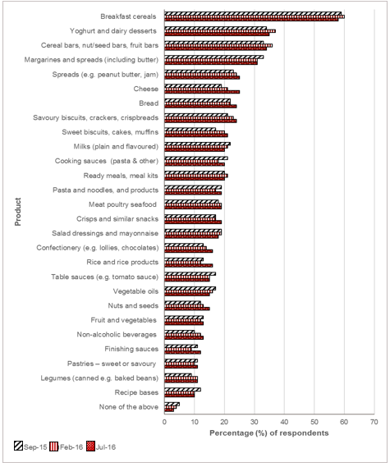

Sample: September 2015, n = 507; February 2016, n = 626; July 2016, n = 749

### Foods and/or beverages on which it is important to display the Health Star Rating system graphic

‘Breakfast cereals’ remained the most commonly mentioned category as an important food category to have products displaying the HSR system graphic, followed by ‘Cereal bars, nut/seed bars, fruit bars’, ‘Yoghurt and dairy desserts’ and ‘Ready meals, meal kits’. In the latest survey, all of these decreased compared with the February 2016 results.

Figure 2D3. Please select which foods and/or beverages you believe it is important to have the Health Star Rating system on

Click to view text version

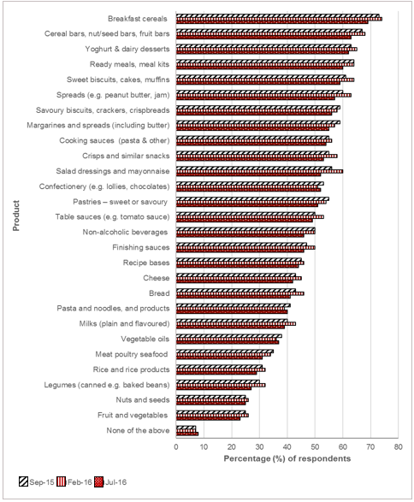

Sample: September 2015, n = 1,084; February 2016, n = 1,213; July 2016, n = 1,335

## Results – Section E: Advertising awareness

### Awareness and source of Health Star Rating system advertising

Compared with the February 2016 result, there was a slight increase in the proportion of respondents who could recall hearing or seeing any advertising featuring the HSR system, but this was still lower than in September 2015. Respondents were most likely to see advertising featuring the HSR system on TV advertisements, on food packaging and in a supermarket catalogue.

Table 2E1. In the last three months, do you remember seeing, hearing or reading any advertising or promotions about the Health Star Rating system?

|  | Sep-15 (%) | Feb-16 (%) | Jul-16 (%) |
| --- | --- | --- | --- |
| Yes | 20 | 13 | 15 |
| No | 59 | 66 | 63 |
| Unsure | 21 | 21 | 22 |

Sample: September 2015, n = 1,084; February 2016, n = 1,213; July 2016, n = 1,335

Figure 2E1. Where had you seen, or heard about the Health Star Rating system?

Click to view text version

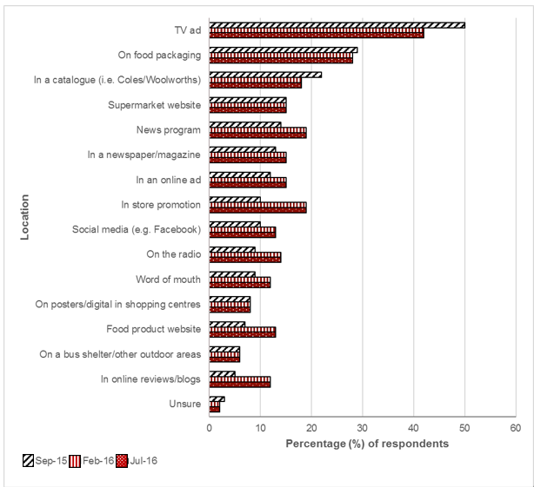

Sample: September 2015, n = 217; February 2016, n = 156; July 2016, n = 200

In July 2016, more than half of respondents reported they were ‘unsure’ who was responsible for the advertising or promotion in relation to the HSR system that they had seen or heard. The proportion of respondents who reported that it was ‘product/brand/supermarket chain specified’, remained consistent across all three survey periods, at 29%.

Table 2E2. Which organization or company did the advertising or promotion(s)?

|  | Sep-15 (%) | Feb-16 (%) | Jul-16 (%) |
| --- | --- | --- | --- |
| Product/brand/supermarket chain specified | 29 | 29 | 29 |
| Government | 6 | 8 | 5 |
| Other | 15 | 22 | 10 |
| Unsure | 51 | 41 | 58 |

Sample: September 2015, n = 217; February 2016, n = 156; July 2016, n = 200

### Product advertised or promoted

Respondents’ recall of HSR products being advertised or promoted aligned closely with their reported purchasing habits, with ‘Breakfast cereals’ and ‘Dairy foods’ at the top of the list.

Figure 2E2. What product or products were being advertised or promoted?

Click to view text version

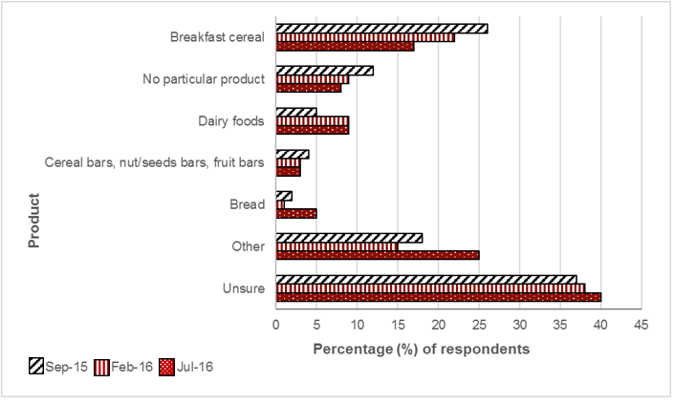

Sample: September 2015, n = 217; February 2016, n = 156; July 2016, n = 200

### Influence advertising had on purchasing a product displaying the Health Star Rating system graphic (a Health Star Rating product)

Advertising of the HSR system or HSR products continued to drive behaviours, with more than one in two respondents that had seen, heard or read advertising about the HSR reporting being influenced by the advertising when determining what product to purchase.

Table 2E3. After seeing or hearing this advertising or promotion(s) for products with a Health Star Rating system, did it influence you to buy a product or products you normally wouldn’t buy?

|  | Sep-15 (%) | Feb-16 (%) | Jul-16 (%) |
| --- | --- | --- | --- |
| Yes | 48 | 49 | 56 |
| No | 45 | 39 | 33 |
| Unsure | 7 | 13 | 12 |

Sample: September 2015, n = 217; February 2016, n = 156; July 2016, n = 200

## Results – Section F: Attitudes and perceptions about the Health Star Rating system

### Statements about the Health Star Rating system – perceptions and attitudes

Along with an increased awareness (prompted) of the HSR system and the proportion of respondents who had purchased an HSR product, positive perceptions towards the system increased compared with the previous survey.

Significantly more respondents (compared with the February 2016 survey) reported that they viewed the HSR system as trustworthy (48% vs 54%, *p =*0*.*002), easy to understand (68% vs 72%, *p =*0*.*03), credible (54% vs 58%, *p =*0*.*04) or reliable (50% vs 55%, *p =*0*.*01).

As with previous surveys, there were strong levels of relevance, with almost three in five respondents agreeing that the HSR system was personally relevant and relevant to their family. However, there was no change in the past 12 months.

Table 2F1. How strongly do you agree or disagree that the Health Star Rating system…?

| Strongly Agree / Agree | Sep-14 (%) | Apr-15 (%) | Sep-15 (%) | Feb-16 (%) | Jul-16 (%) |
| --- | --- | --- | --- | --- | --- |
| Is a system I trust | 34 | 38 | 51 | 48 | 54 |
| Is easy to understand | 67 | 59 | 72 | 69 | 72 |
| Is easy to use | n/a | 58 | 72 | 68 | 72 |

Sample: September 2015, n = 1,084; February 2016, n = 1,213; July 2016, n = 1,335

Table 2F2. How strongly do you agree or disagree that the Health Star Rating system…?

| Strongly Agree / Agree | Sep-15 (%) | Feb-16 (%) | Jul-16 (%) |
| --- | --- | --- | --- |
| Makes choosing food easier | 62 | 62 | 63 |
| Is a credible system | 57 | 54 | 58 |
| Is a reliable system | 54 | 50 | 55 |
| Is open and transparent | 50 | 48 | 52 |
| Is hard to see on the package | 26 | 22 | 24 |
| Is confusing | 19 | 18 | 18 |
| Has a poor reputation | 17 | 16 | 17 |

Sample: September 2015, n = 1,084; February 2016, n = 1,213; July 2016, n = 1,335

Table 2F3. How strongly do you agree or disagree that the Health Star Rating system…?

| Strongly Agree / Agree | Sep-15 (%) | Feb-16 (%) | Jul-16 (%) |
| --- | --- | --- | --- |
| Is relevant to my family | 60 | 58 | 59 |
| Is personally relevant to me | 58 | 58 | 58 |

Sample: September 2015, n = 1,084; February 2016, n = 1,213; July 2016, n = 1,335

### Trust in the Health Star Rating system[34]

Age group

The latest results reveal that respondents aged 35–54 were still most likely to view the HSR system as trustworthy.

Table 2F4. Age group

|  | Sep-15 (%) | Feb-16 (%) | Jul-16 (%) |
| --- | --- | --- | --- |
| Under 35 | 53 | 49 | 53 |
| Between 35 and 54 | 54 | 63 | 57 |
| 55 or over | 47 | 46 | 53 |

Gender

Slightly more males than females were likely to view the HSR system as trustworthy in July 2016.

Table 2F5. Gender

|  | Sep-15 (%) | Feb-16 (%) | Jul-16 (%) |
| --- | --- | --- | --- |
| Female | 48 | 48 | 53 |
| Male | 54 | 49 | 56 |

Household income

Even though the findings were not significant, those who earn an annual household income of $100,000 or more were most likely to view the HSR system as trustworthy.

Table 2F6. Household income

|  | Sep-15 (%) | Feb-16 (%) | Jul-16 (%) |
| --- | --- | --- | --- |
| < $50,000 | 47 | 47 | 56 |
| $50,000 to $99,999 | 59 | 50 | 54 |
| $100,000 or more | 49 | 49 | 59 |

BMI

There were no significant differences between BMI categories and viewing the HSR system as trustworthy.

Table 2F7. Body mass index

|  | Sep-15 (%) | Feb-16 (%) | Jul-16 (%) |
| --- | --- | --- | --- |
| < 25.0 | 53 | 50 | 55 |
| 25.0–29.9 | 50 | 52 | 53 |
| ≥ 30.0 | 48 | 41 | 57 |

Language spoken at home

Respondents who speak a language other than English at home were significantly more likely to view the HSR system as trustworthy.

Table 2F8. Language

|  | Sep-15 (%) | Feb-16 (%) | Jul-16 (%) |
| --- | --- | --- | --- |
| English only | 48 | 46 | 52 |
| Other than English | 66 | 61 | 64 |

Location – metropolitan versus regional/rural

Whether a respondent resides in a metropolitan area or a regional/rural area, the latest results revealed that 54% view the HSR system as trustworthy.

Table 2F9. Residential location

|  | Sep-15 (%) | Feb-16 (%) | Jul-16 (%) |
| --- | --- | --- | --- |
| Metro | 53 | 50 | 54 |
| Regional/rural | 46 | 44 | 54 |

Household structure – children

The latest results found no real difference between respondents who had children at home and those who did not and their view on whether the HSR system is trustworthy.

Table 2F10. Children at home

|  | Sep-15 (%) | Feb-16 (%) | Jul-16 (%) |
| --- | --- | --- | --- |
| With children | 55 | 50 | 55 |
| No children | 49 | 49 | 54 |

### Level of confidence in the Health Star Rating system

The proportion of respondents who reported a high level of confidence in the HSR system in July 2016 remained the same as in the previous survey (February 2016); however, there was a slight increase in those who reported a ‘somewhat’ high level of confidence in the system.

Table 2F11. What best describes your level of confidence in the Health Star Rating system…?

|  | Sep-15 (%) | Feb-16 (%) | Jul-16 (%) |
| --- | --- | --- | --- |
| High | 13 | 16 | 16 |
| Somewhat high | 49 | 44 | 47 |
| Indifferent | 27 | 27 | 26 |
| Somewhat low | 6 | 8 | 6 |
| Low | 5 | 6 | 5 |

Sample: September 2015, n = 1,084; February 2016, n = 1,213; July 2016, n = 1,335

## Results – Section G: Health attitudes and behaviours

### Concern about the healthiness of food purchased

Forty-one per cent of respondents reported that they were ‘extremely’ or ‘very’ concerned about the healthiness of the food they purchase.

Respondents aware of the HSR system were more likely to be ‘extremely’ or ‘very’ concerned about how healthy the food they buy is compared with those unaware of the HSR system (43% vs 40%). Similarly, those who purchased HSR products were more likely to report being ‘extremely’ or ‘very’ concerned about how healthy the food they buy is than those who did not purchase such products (48% vs 38%).

Table 2G1. In general, thinking about all the food you buy, how concerned are you about how healthy the food is for you…?

|  | Sep-15 (%) | Feb-16 (%) | Jul-16 (%) |
| --- | --- | --- | --- |
| Extremely concerned | 13 | 13 | 13 |
| Very concerned | 26 | 28 | 28 |
| Moderately concerned | 37 | 37 | 35 |
| A little concerned | 20 | 18 | 19 |
| Not at all concerned | 4 | 3 | 4 |
| Unsure | 1 | 1 | 1 |

Sample: September 2015, n = 2,036; February 2016, n = 2,005; July 2016, n = 2,003

### Perceived healthiness of diet

Two-thirds of respondents perceived their diet to be ‘healthy’ or ‘very healthy’.

Respondents who are aware of the HSR system were more likely to report that their diet is either ‘healthy’ or ‘very healthy’ than those who are unaware of the HSR system (74% vs 68%). Those who reported purchasing HSR products were significantly more likely to report that their diet is either ‘healthy’ or ‘very healthy’ than those who did not purchase HSR products (68% vs 61%, *p*= 0.04).

Table 2G2. Thinking about your diet, would you say that what you usually eat is…?

|  | Sep-15 (%) | Feb-16 (%) | Jul-16 (%) |
| --- | --- | --- | --- |
| Very healthy | 8 | 9 | 9 |
| Healthy | 56 | 58 | 57 |
| Neither healthy nor unhealthy | 30 | 27 | 28 |
| Unhealthy | 4 | 4 | 4 |
| Very unhealthy | 1 | 0 | 1 |
| Unsure | 1 | 1 | 1 |

Sample: September 2015, n = 2,036; February 2016, n = 2,005; July 2016, n = 2,003

### Changes to diet

Two in five respondents reported having made changes to their diet over the past six months.

Respondents who are aware of the HSR system were significantly more likely to report that they had made changes to their diet in the past six months than those who are unaware of the HSR system (42% vs 36%, *p*= 0.04). Those who reported purchasing HSR products were significantly more likely to report having made changes to their diet than those who are unaware of the HSR system (50% vs 29%; p = 0.003).

Table 2G3. Over the past six months, have you made any changes to your diet?

|  | Sep-15 (%) | Feb-16 (%) | Jul-16 (%) |
| --- | --- | --- | --- |
| Yes | 39 | 41 | 40 |
| No | 58 | 55 | 56 |
| Unsure | 4 | 4 | 4 |

Sample: September 2015, n = 2,036; February 2016, n = 2,005; July 2016, n = 2,003

### Type of changes made to diet

When asked what changes respondents made to their diet, the latest survey found that the three most common changes were changing the types of food they eat (67%), changing the amount of food they eat (55%) and excluding or cutting out types of food from their diet (42%).

Figure 2G1. Which of the following changes have you made in the past six months to your diet?

Click to view text version

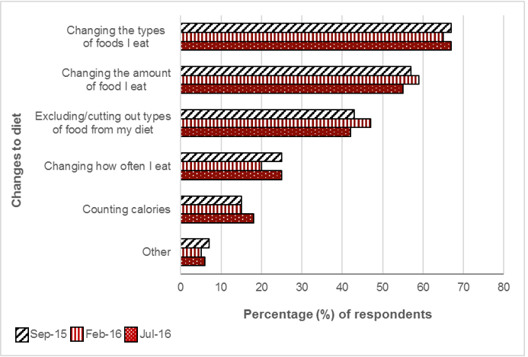

Sample: September 2015, n = 2,036; February 2016, n = 2,005; July 2016, n = 2,003

### Type of changes made to diet

The latest survey showed that almost two-thirds (64%) of respondents stated that they made changes to their diet ‘to improve their physical health’. More than half (56%) of respondents stated that they made changes to their diet ‘to lose weight’, and 44% changed their diet ‘to feel better’.

Figure 2G2. For which of the following reasons did you make changes to your diet?

Click to view text version

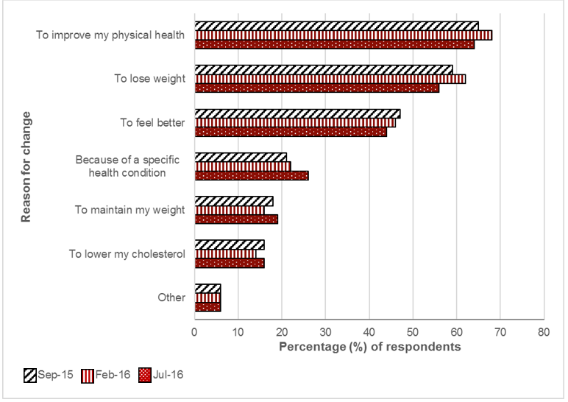

Sample: September 2015, n = 2,036; February 2016, n = 2,005; July 2016, n = 2,003

# Nutrient status of products carrying a Health Star Rating system graphic

3 Chapter 3: Nutrient status of products carrying a Health Star Rating system graphic 164

3.1 Chapter summary 166

3.1.1 Nutrient status of Health Star Rating products in Year 1 and Year 2 166

Health Star Rating system graphics 167

3.2 Methodology 168

3.2.1 Data analysis 168

3.3 Results 169

3.3.1 Distribution of the Health Star Rating on Health Star Rating products in Year 1 and Year 2. 169

3.3.2 Mean Health Star Rating of Health Star Rating products in Year 1 and Year 2 170

3.3.3 Distribution of the Health Star Rating, by Health Star Rating category class 172

3.3.4 Nutrient status of Health Star Rating products 178

3.3.5 Nutrient status of Health Star Rating products, by nutrient 179

Energy 179

Saturated fat 181

Sugars 182

Sodium 183

Protein 184

Fibre 185

3.3.6 Changes in the Health Star Rating on Health Star Rating products over time 186

## Chapter summary

### Nutrient status of Health Star Rating products in Year 1 and Year 2

* The most commonly displayed star rating on pack in Year 1 and Year 2 was 4.0, which was displayed on 29% and 25% of HSR products, respectively.
* In both Year 1 and Year 2, the lowest star ratings – 0.5 and 1.0 – were displayed on the lowest number and proportion of products (0.5 stars: Year 1, n = 2, 0.6% and Year 2, n = 62, 3%; 1.0 star: Year 1, n = 2, 0.6% and Year 2, n = 65, 3%).
* The mean star rating of HSR products was 3.81 and 3.46, in Year 1 and Year 2, respectively.
* The ‘2 – Food’ HSR category class had the most HSR products in both Year 1 (284/363, 78%) and Year 2 (1,621/2,020, 80%).
* In Year 1 and Year 2, there were 254 of the same HSR products, 96% of which displayed the same HSR in Year 1 as in Year 2.

Health Star Rating system graphics

| Health Star Rating system graphics |
| --- |
| Option 1  HSR + energy icon + 3 prescribed nutrient icons + optional nutrient |
| Option 2  HSR + energy icon + 3 prescribed nutrient icons  The Option 2 graphic showing the Health Star Rating, the Energy icon and 3 prescribed nutrients. |
| Option 3  HSR + energy icon  The Option 3 graphic showing the Health Star Rating and the Energy icon. |
| Option 4  HSR only  The Option 4 graphic showing the Health Star Rating only. |
| Option 5  Energy icon only  The Option 5 graphic showing the Energy icon only. |

## Methodology

To conduct part of this assessment, CSIRO software engineers developed automated reporting scripts in FoodTrackTM that provided reports relating to the nutrient status of products displaying the HSR system. The following parameters were used for Year 1 and Year 2:

* category and group counts
* distribution of HSR by HSR category class and overall
* mean HSR by HSR category class and overall
* mean nutrient values, by HSR category class, by HSR product.

For the automated reporting, a series of rules was created in FoodTrackTM:

* ensure all product NIP data is for the product ‘as consumed’
* report all NIP data per 100 g/100 mL (i.e. convert any data not provided in per 100 g/100 mL from ‘per serving’ to ‘per 100 g/100 mL’ before calculation)
* treat any NIP data with ‘<’ values as a whole number; for example, treat ‘< 1’ as 1
* treat any data that is missing (i.e. not available, N/A) as missing data, not zero.

HSR products in Year 1 and/or Year 2 were also monitored over time to identify any potential changes in the HSR, and divided into the following groups for reporting:

* those present in Year 1 and Year 2
  + displaying an HSR system graphic in Year 1 only
  + displaying an HSR system graphic in Year 2 only
  + displaying an HSR system graphic in both years
* those present in Year 1 only, and displaying an HSR system graphic
* those present in Year 2 only, and displaying an HSR system graphic.

The product barcode was used as the unique identifier in FoodTrackTM because previous experience indicated that this was the parameter that was best able to track the same products over time.

Some products were present in both Year 1 and Year 2 but displayed an HSR system graphic in Year 2 only. For such products, the required product data from Year 1 was run through the automated HSRC in FoodTrackTM to determine what the HSR would have been if it had been displayed on the pack; this was then compared with the actual HSR displayed on pack in Year 2.

Owing to the small sample sizes of HSR products in Year 1, when these were divided into HSR category classes, no statistical analysis comparing the groups over time (Year 1 vs Year 2) was performed. These results are therefore primarily descriptive.

### Data analysis

Unless specified, all analyses for AoE 3 were conducted in Microsoft Excel 2016. Automated reporting scripts were developed for use in the FoodTrackTM database.

## Results

### Distribution of the Health Star Rating on Health Star Rating products in Year 1 and Year 2.

The number of products displaying each HSR on the pack in Year 2 is outlined in Figure 3.1below, and compared with that of Year 1.[35] The distribution of the HSRs displayed on the pack was similar in Year 1 and Year 2. The most commonly displayed HSR in both Year 1 and Year 2 was 4.0, and it was also displayed on a similar proportion of products (Year 1 = 29%, Year 2 = 25%).

In both Year 1 and Year 2, the lowest star ratings – 0.5 and 1.0 – were displayed on the lowest number of products, both as absolute number and as a proportion of the eligible products (0.5 stars: Year 1, n = 2, 0.6% and Year 2, n = 62, 3%; 1.0 star: Year 1, n = 2, 0.6% and Year 2, n = 65, 3%).

Figure 3.1. Number of Health Star Rating (HSR) products (n) displaying each HSR on pack, in Year 1 and Year 2

Click to view text version

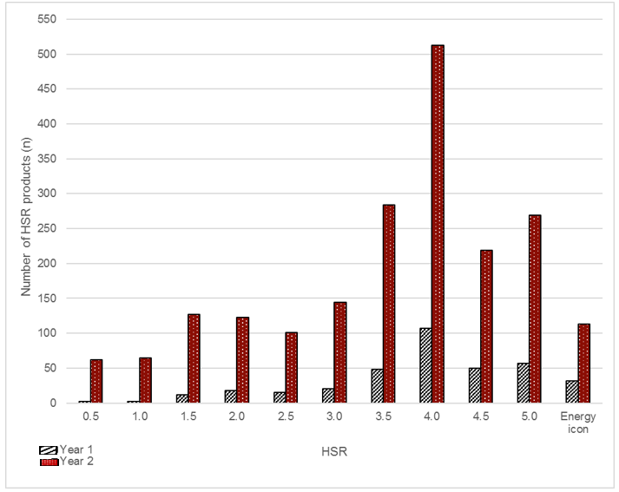

### Mean Health Star Rating of Health Star Rating products in Year 1 and Year 2[36]

The mean HSR of HSR products was 3.81 in Year 1 and 3.46 in Year 2.[37] Figure 3.2 below displays the mean HSR by HSR category class.[38]

In both years, the mean HSR was greatest for ‘1 – Beverages’ (Year 1 4.55, Year 2 4.33), followed by ‘1D – Dairy beverages’ (Year 1 4.06, Year 2 4.31). The mean HSR in three HSR category classes (‘2D – Dairy food’, ‘3 – Oils and spreads’ and ‘3D – Cheese and processed cheese’), increased from Year 1; however, the small sample sizes in Year 1 for some of these HSR category classes (see footnote), should be noted in the context of these results. There was a slight decrease in the ‘2 – Food HSR’ category class from Year 1 to Year 2 (from 3.75 to 3.35).

In Year 2, the greatest mean HSR was observed for both the ‘1 – Beverages’ (4.33) and the ‘1D – Dairy beverages’ (4.31) category classes, followed by ‘2D – Dairy food’ (3.35), ‘2 – Food’ (3.45), then ‘3 – Oils and spreads’ and (3.20) ‘3D – Cheese and processed cheese’ (2.75).

Figure 3.2. Mean Health Star Rating (HSR) displayed on pack, by HSR category class, in Year 1 and Year 2

Click to view text version

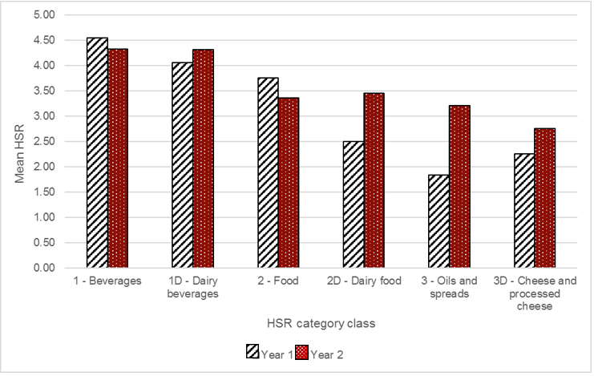

### Distribution of the Health Star Rating, by Health Star Rating category class

The number of HSR products displaying each HSR on pack across the six HSR category classes is outlined in Figures 3.3–3.8below.[39]

In the ‘1 – Beverages’ HSR category class, most HSR products in both Year 1 and Year 2 displayed 5.0 stars, representing 84% of this HSR category class in Year 1 and 78% in Year 2 (Year 1, 27/32 and Year 2, 93/120). A greater proportion of HSR products in ‘1 – Beverages’ displayed Option 5 (Energy icon only) of the HSR system graphic in Year 2 than Year 1 (24% vs 3%).

Figure 3.3. Number of Health Star Rating (HSR) products (n) displaying each HSR on pack, within the ‘1 – Beverages’ HSR category class, in Year 1 and Year 2

Click to view text version

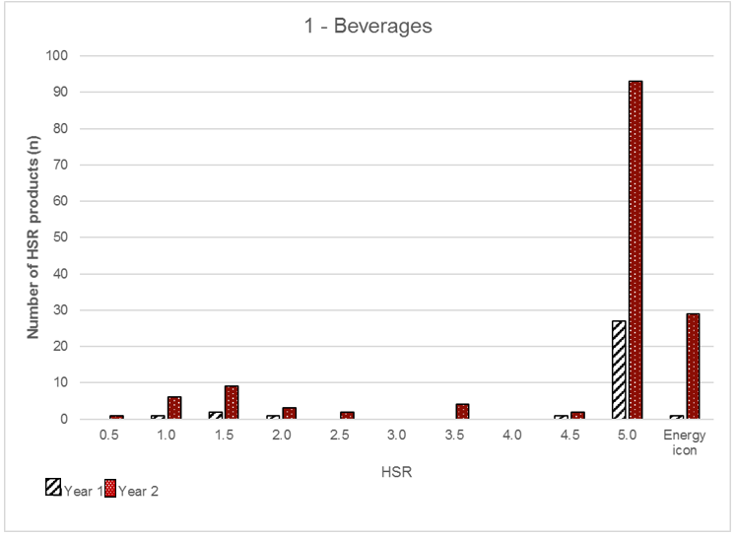

In the ‘1D – Dairy beverages’ HSR category class, in both Year 1 and Year 2, there were no HSR products with an HSR of less than 2.5 or Option 5 (Energy icon only). In Year 2, half of the HSR products in this HSR category class (45/89) displayed an HSR of 4.5, followed by a similar number of HSR products displaying 4.0 and 5.0 stars. Very few HSR products in Year 2 displayed between 2.5 and 3.5 stars (13/89).

Figure 3.4. Number of Health Star Rating (HSR) products (n) displaying each HSR on pack, within the 1D – Dairy Beverages HSR category class, in Year 1 and Year 2

Click to view text version

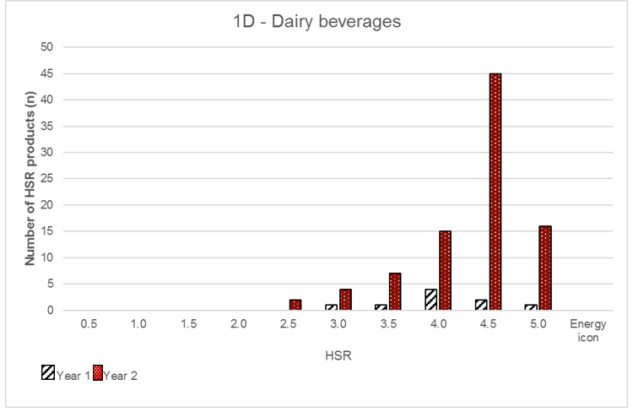

In both Year 1 and Year 2, most HSR products were part of the ‘2 – Food’ HSR category class (Year 1, 284/363, 78% and Year 2, 1621/2020,[40] 80%). A similar distribution in the range of the HSR displayed on pack was observed in Years 1 and 2, with HSR products displaying 4.0 stars remaining the largest proportion in both years (Year 1, 103/284, 36% and Year 2, 485/1621, 30%). This is the only HSR category class in which there were products displaying a range of 0.5–5.0 stars and Option 5 (Energy icon only).[41]

Figure 3.5. Number of Health Star Rating (HSR) products (n) displaying each HSR on pack, within the 2 – Food HSR category class, in Year 1 and Year 2

Click to view text version

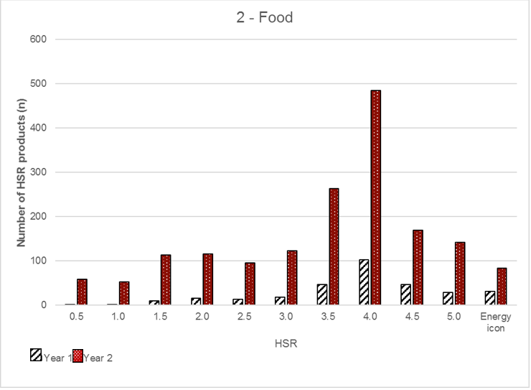

In Year 1, there was only one HSR product in the ‘2D – Dairy food’ HSR category class, and it had a value of 2.5. In Year 2, the total count in this HSR category class increased to 53, with the greatest proportion (16/53, 30%) displaying an HSR of 5.0. The remainder of the HSR products displayed a varying rate across the other value options, except for 2.0 and Option 5 (Energy icon only), which did not have any HSR products in Year 2 (and Year 1).

Figure 3.6. Number of Health Star Rating (HSR) products (n) displaying each HSR on pack, within the ‘2D – Dairy’ food HSR category class, in Year 1 and Year 2

Click to view text version  
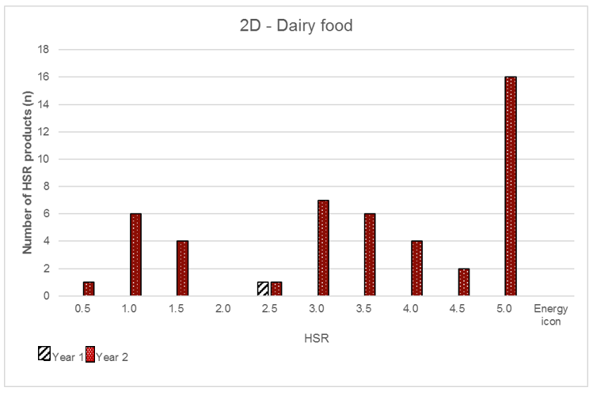

In Year 1, in the ‘3 – Oils and spreads’ HSR category class, there were only three HSR products; these products had an HSR of 0.5, 2.0 and 3.0. In Year 2, this rose to 27 HSR products, with the greatest number displaying 3.0 stars (n = 10), followed by 4.0 stars (n = 7). There were no HSR products in this HSR category class in Year 2 that displayed 1.0, 1.5 or 2.5 stars, or Option 5 (Energy icon only).

Figure 3.7. Number of Health Star Rating (HSR) products (n) displaying each HSR on pack, within the ‘3 – Oils and spreads’ HSR category class, in Year 1 and Year 2

Click to view text version  
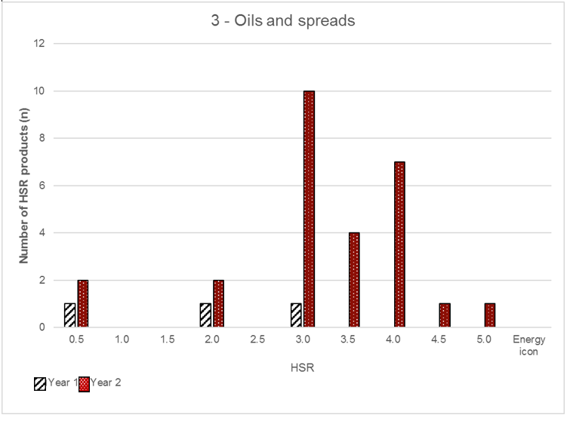

The ‘3D – Cheese and processed cheese’ HSR category class was the one in which the fewest HSR products were displayed in Year 2 (n = 9) and a very small number in Year 1 (n = 2). In Year 2 there was a fairly even distribution of HSR products across the various HSRs; however, there were no HSR products in Year 2 (and Year 1) that displayed the following ratings: 0.5, 3.0, 3.5, and 4.5.

Figure 3.8. Number of Health Star Rating (HSR) products (n) displaying each HSR on pack, within the ‘3D – Cheese and processed cheese’ HSR category class, in Year 1 and Year 2

Click to view text version

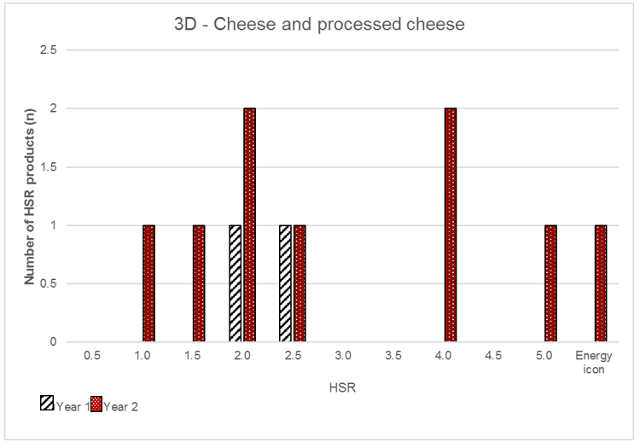

### Nutrient status of Health Star Rating products

This section compares the nutrient status of HSR products in Year 1 with Year 2, within each of the six HSR category classes. Specifically, comparisons were made among the nutrients that are incorporated into the HSRC; that is, energy, saturated fat, sugars, sodium, protein and fibre.[42] All values were expressed per 100 g or 100 mL as consumed.[43]

The sample size of some groups, particularly some of those in Year 1, was small and should be interpreted with caution. The product counts are summarised in Table 3.1. Where product counts varied across nutrients, this reflects missing data on pack. The count varied for fibre in some instances because it is not mandatory to list fibre on the NIP; therefore, the counts were generally lower for fibre than for the other nutrients listed (Table 3.1).

Table 3.1. Number of Health Star Rating (HSR) products, in each HSR category class, for each nutrient, in Year 1 and Year 2

| Year 1 | | | | | | | |
| --- | --- | --- | --- | --- | --- | --- | --- |
| **Nutrient(s) per 100 g/100 mL** | **1 – Beverages** | **1D – Dairy Beverages** | **2 – Food** | **2D – Dairy beverages** | **3 – Oils and spreads** | **3D – Cheese and processed cheese** | **TOTAL** |
| HSR count (n) | 32 | 9 | 284 | 1 | 3 | 2 | 331 |
| Energy | 32 | 9 | 256 | 1 | 3 | 2 | 303 |
| Saturated fat | 32 | 9 | 256 | 1 | 3 | 2 | 303 |
| Sugars | 32 | 9 | 256 | 1 | 3 | 2 | 303 |
| Protein | 32 | 9 | 256 | 1 | 3 | 2 | 303 |
| Sodium | 32 | 9 | 256 | 1 | 3 | 2 | 303 |
| Fibre | 27 | 9 | 218 | 1 | N/A | N/A | 255 |

| Year 2 | | | | | | | |
| --- | --- | --- | --- | --- | --- | --- | --- |
| **Nutrient(s) per 100 g/100 mL** | **1 – Beverages** | **1D – Dairy Beverages** | **2 – Food** | **2D – Dairy beverages** | **3 – Oils and spreads** | **3D – Cheese and processed cheese** | **TOTAL** |
| HSR count (n) | 120 | 89 | 1,621 | 53 | 27 | 8 | 1918 |
| Energy | 116 | 88 | 1,524 | 53 | 27 | 8 | 1,816 |
| Saturated fat | 116 | 88 | 1,524 | 53 | 27 | 8 | 1,816 |
| Sugars | 116 | 88 | 1,524 | 53 | 27 | 8 | 1,816 |
| Protein | 116 | 88 | 1,524 | 53 | 27 | 8 | 1,816 |
| Sodium | 116 | 88 | 1,524 | 53 | 27 | 8 | 1,816 |
| Fibre | 87 | 61 | 1,188 | 22 | 1 | N/A | 1,359 |

### Nutrient status of Health Star Rating products, by nutrient

This section compares the mean values of the nutrients listed in Table 3.1 by HSR category class, in Year 1 and Year 2. As noted above, results in this section should be interpreted with caution in instances where there is a small sample size (see Table 3.1).

#### Energy

There was no marked difference in the mean energy content of HSR products between Year 1 and Year 2 within each of the six HSR category classes. The HSR category classes in which HSR products had the greatest mean energy content in both years were ‘3 – Oils and spreads’, ‘3D – Cheese and processed cheese’ and ‘2 – Food’, respectively. The mean energy content of the remaining three category classes (‘1 – Beverages’, ‘1D – Dairy beverages’ and ‘2D – Dairy food’) was less than 500 kJ per 100 g/100 mL for all products.

Figure 3.9. Mean energy content of Health Star Rating (HSR) products, by HSR category class, in Year 1 and Year 2

Click to view text version

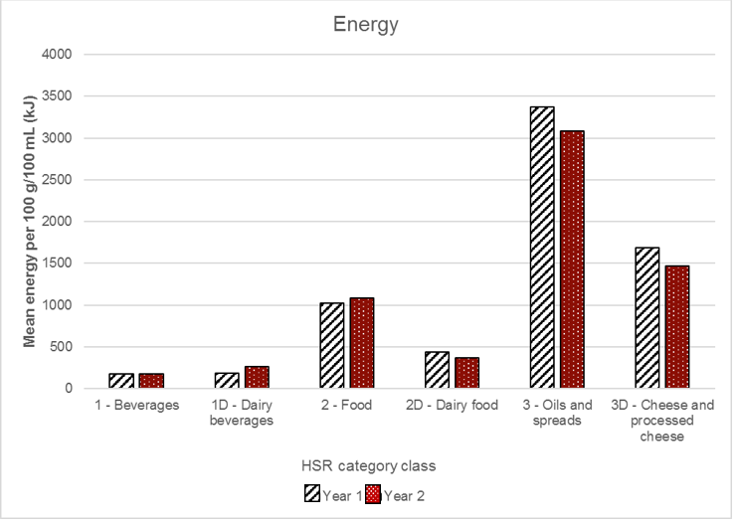

#### Saturated fat

The HSR category classes in which HSR products had the highest mean saturated fat content, in both Year 1 and Year 2, were ‘3 – Oils and spreads’ and ‘3D – Cheese and processed cheese’. The remaining four HSR category classes all had HSR products with a mean saturated fat content of less than 5.0 g per 100 g/100 mL: the ‘1 – Beverages’ category class was the lowest (0.01 g per 100 g/100 mL in Year 1 and 0.21 g per 100 g/100 mL in Year 2). Although the mean saturated fat content of HSR products in the ‘3 – Oils and spreads’ and ‘3D – Cheese and processed cheese’ HSR category classes appeared to have decreased more noticeably from Year 1 to Year 2, these should be interpreted with caution due to the small sample sizes for some of these HSR category classes, as mentioned above (see Table 3.1).

Figure 3.10. Mean saturated fat content of Health Star Rating (HSR) products, by HSR category class, in Year 1 and Year 2

Click to view text version

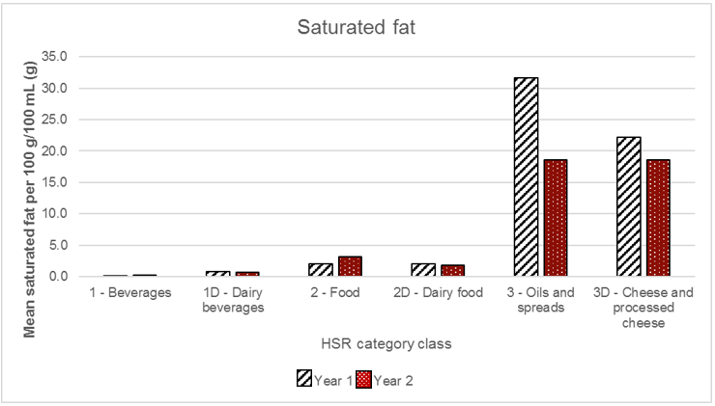

#### Sugars

The mean sugars content for HSR products in Year 1 and Year 2 was lowest in the ‘3 – Oils and spreads’ and ‘3D – Cheese and processed cheese’ HSR category classes (both < 2.0 g per 100 g/100 mL). In the ‘1 – Beverages’ HSR category class, the mean sugars content was similar between Year 1 and Year 2 (9.0 g and 8.5 g, per 100 g/100 mL, respectively). Although the mean sugars content of HSR products in the ‘1D – Dairy beverages’, ‘2 – Food’ and ‘2D – Dairy food’ HSR category classes appeared to have increased from Year 1 to Year 2, these finding should be interpreted with caution because of the small sample sizes for some HSR category classes, as outlined earlier (see Table 3.1). In Year 2, the mean sugars content of HSR products in the ‘2 – Food’ HSR category class increased from 8.9 g to 13.8 g per 100 g/100 mL.

Figure 3.11. Mean sugars content of Health Star Rating (HSR) products, by HSR category class, in Year 1 and Year 2

Click to view text version

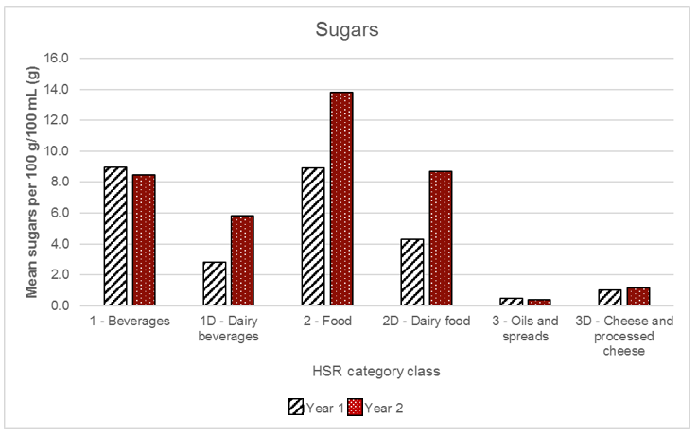

#### Sodium

The mean sodium content of HSR products in both Year 1 and Year 2 was lowest in the ‘1 – Beverages’ HSR category class, followed by the ‘1D – Dairy beverages’, with both being less than 100 mg per 100 g/100 mL. Although the mean sodium content in the ‘2D – Dairy food’ and ‘3 – Oils and spreads’ HSR category classes appeared to have decreased notably from Year 1 to Year 2, these findings should be interpreted with caution because of the small sample sizes for some HSR category classes, as outlined earlier (see Table 3.1). The mean sodium content of HSR products was greatest in the ‘3D – Cheese and processed cheese’ HSR category class in both Year 1 and Year 2, and although this value appeared to have increased in Year 2, again, this finding should be interpreted in the context of the small sample sizes for this HSR category class in both years (n = 2 in Year 1 and n = 8 in Year 2).

Figure 3.12. Mean sodium content of Health Star Rating (HSR) products, by HSR category class, in Year 1 and Year 2

Click to view text version

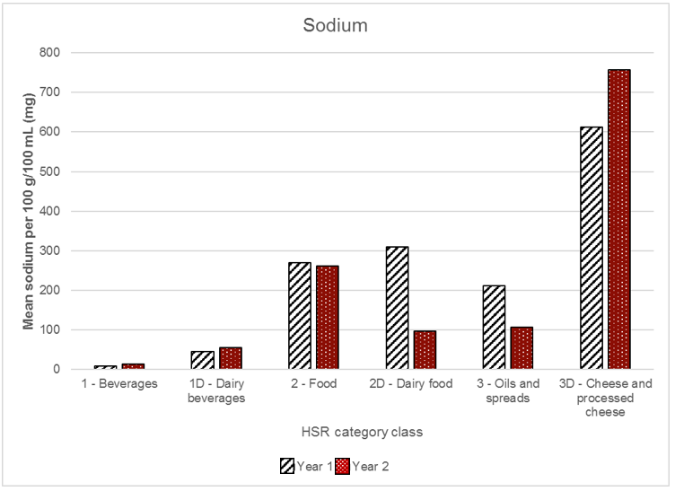

#### Protein

The mean protein content of HSR products in Year 1 and Year 2 was similar across all six HSR category classes. It was noticeably higher in the ‘3D – Cheese and processed cheese’ HSR category class than in any other category class, with an average of about 25 g per 100 g/100 mL in both years. For HSR products in all remaining five HSR category classes, the mean protein content was 10 g per 100 g/100 mL or less; it was lowest in ‘3 – Oils and spreads’, ‘1 – Beverages’, and ‘1D – Dairy beverages’, all of which were at or below 5.0 g per 100 g/100 mL.

Figure 3.13. Mean protein content of Health Star Rating (HSR) products, by HSR category class, in Year 1 and Year 2

Click to view text version

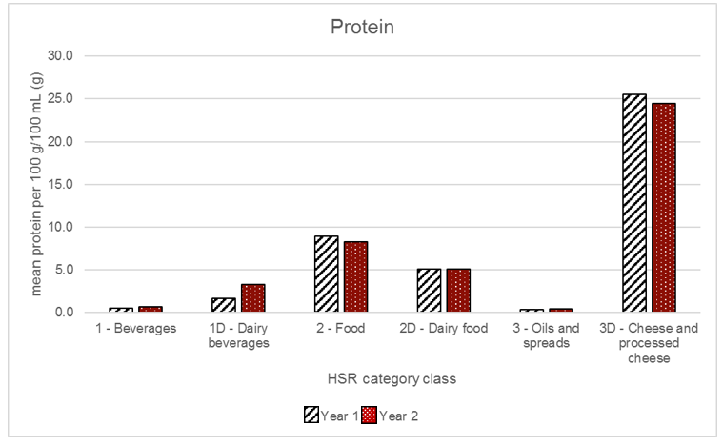

#### Fibre

In both Year 1 and Year 2, the mean fibre content of HSR products was notably highest in the ‘2 – Food’ HSR category, with a mean of more than 4.5 g per 100 g/100 mL in both years. In the ‘1 – Beverages’, ‘1D – Dairy beverages’ and the ‘2D – Dairy food’ HSR category classes, the mean fibre content of HSR products was below 1.0 g per 100 g for all three classes. Data for fibre was not available for the ‘3D – Cheese and processed cheese’ HSR category class. There was only one fibre value available in the ‘3 – Oils and spreads’ HSR category class, but the value was zero.

Figure 3.14. Mean fibre content of Health Star Rating (HSR) products, by HSR category class, in Year 1 and Year 2

Click to view text version

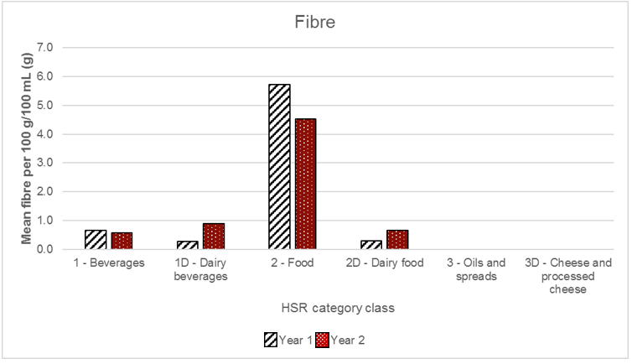

### Changes in the Health Star Rating on Health Star Rating products over time

Table 3.2 below summarises the profile of HSR products in Year 1 and Year 2.

Table 3.2. Presence (and absence) of Health Star Rating (HSR) products, in Year 1 and Year 2

| Presence (and absence) of HSR products in FoodTrackTM | Number of HSR products (n) in Year 1 | Number of HSR products (n) in Year 2 |
| --- | --- | --- |
| Present in Year 1 and Year 2 (same HSR product) | 254 | 254 |
| Present in Year 1 only | 107 | N/A |
| Present in Year 2 only | N/A | 1,131 |
| Present in Year 1 and Year 2, but a HSR product in Year 2 only | N/A | 646 |
| Present in Year 1 and Year 2, but a HSR product in Year 1 only | 2 | N/A |
| TOTAL | **363** | **2031** |

There were 254 of the same HSR products in both Year 1 and Year 2,[44] 96% of which (245/254) displayed the same HSR in Year 1 as in Year 2. For the nine HSR products that had a different HSR between years, there were mixed outcomes: five HSR products had an HSR that increased by 0.5 stars, three HSR products had an HSR that decreased by 0.5 stars and one HSR product had an HSR that decreased by 1.0 star. Table 3.3 below summarises these nine HSR products.

Table 3.3. Health Star Rating (HSR) products present in Year 1 and Year 2, for which the HSR did not match

|  | HSR category | HSR Year 1 | HSR Year 2 | Change |
| --- | --- | --- | --- | --- |
| Product 1 | Fruit and vegetable juices | 4.5 | 5.0 | +0.5 |
| Product 2 | Vegetables – processed | 3.5 | 4.0 | +0.5 |
| Product 3 | Mueslis | 4.5 | 4.0 | -0.5 |
| Product 4 | Mueslis | 5.0 | 4.0 | -1.0 |
| Product 5 | Mueslis | 5.0 | 4.5 | -0.5 |
| Product 6 | Mueslis | 4.5 | 4.0 | -0.5 |
| Product 7 | Mueslis | 4.5 | 5.0 | +0.5 |
| Product 8 | Ready-to-eat breakfast cereals | 3.5 | 4.0 | +0.5 |
| Product 9 | Ready-to-eat breakfast cereals | 3.5 | 4.0 | +0.5 |

The profile of the 245 HSR products that displayed the same HSR in both Year 1 and Year 2 is outlined in Figure 3.15 below. The greatest number of HSR products in this sample displayed an HSR of 4.0 on pack (n = 77), followed by ratings of 5.0, 4.5 and 3.5, respectively. The HSR products in which the HSR system graphic was displayed on the lowest number were those with 3.0 stars or less (in particular, 0.5–1.5 stars).

Figure 3.15. Number of Health Star Rating (HSR) products (n) displaying each HSR on pack, for products displaying the same HSR in Year 1 and Year 2

Click to view text version

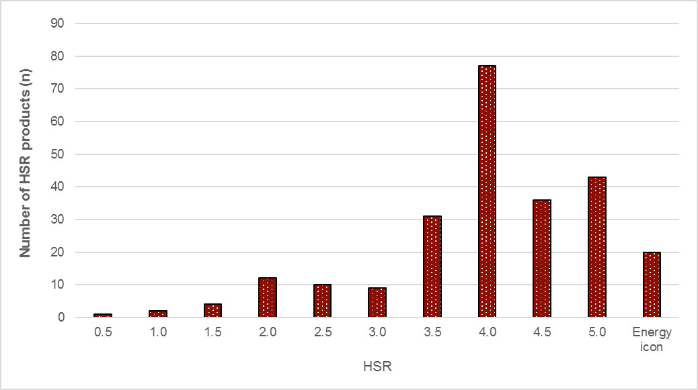

The 245 HSR products that displayed the same HSR in both Year 1 and Year 2 were spread across 32 HSR categories. The number of these products in each HSR category is displayed in Figure 3.16below. Four of these HSR categories had only one HSR product: ‘Cream and cream alternatives’, ‘Grains – processed’, ‘Spreads – nut and seeds’, ‘Vegetable oils’. These four categories are excluded from Figure 3.16.

The ‘Ready-to-eat breakfast cereals’ HSR category had by far the highest number of HSR products (n = 53) –more than double the second highest HSR category, which was also a breakfast cereals category, ‘Mueslis’ (n = 21). Of the 32 HSR categories, 24 had 10 or fewer HSR products (including the four HSR categories with only one HSR product mentioned in the previous paragraph).

Figure 3.16. Number of Health Star Rating (HSR) products (n) in each HSR category, for products displaying the same HSR in Year 1 and Year 2

Click to view text version

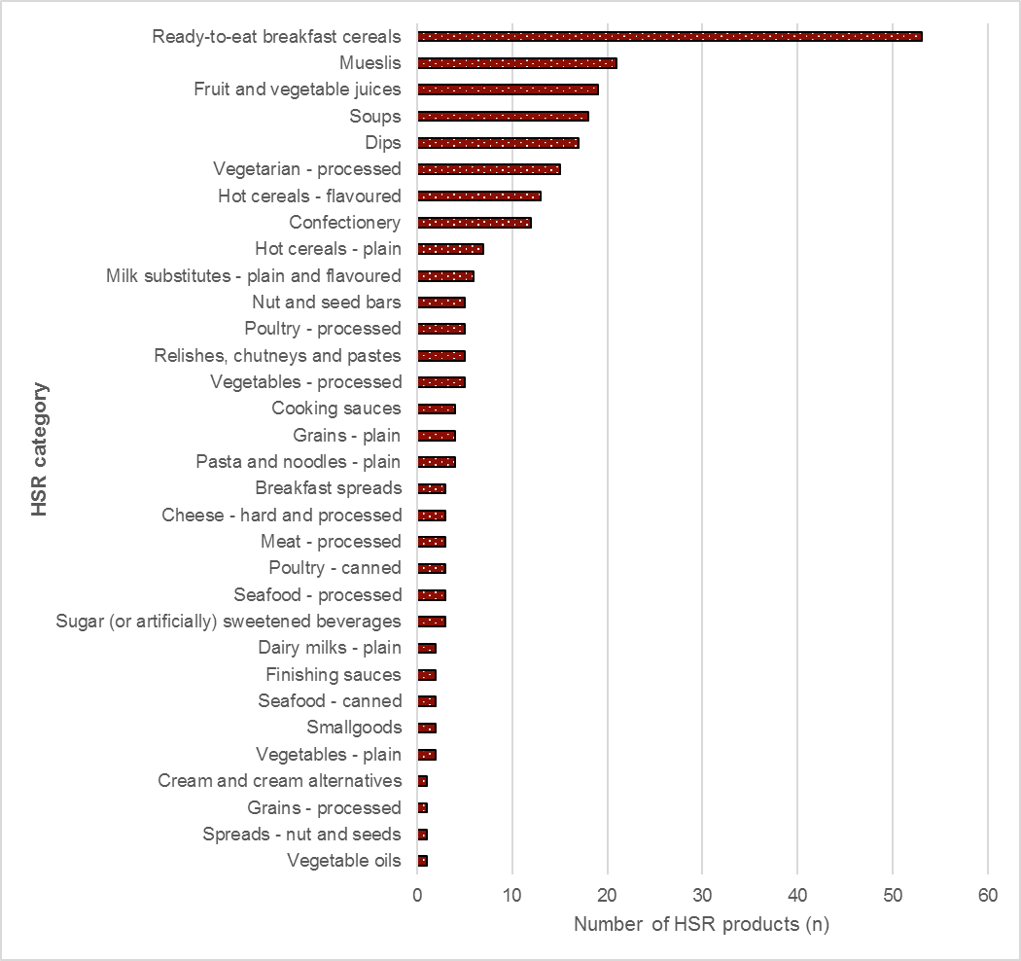

Of the remaining 1,777 HSR products in Year 2, 65% (n = 1,131) were not in FoodTrackTM in Year 1; that is, there was a unique record of these products in Year 2 only. Conversely, there were 107 HSR products in FoodTrackTM in Year 1 that were not in FoodTrackTM in Year 2.

The distribution of the 1,131 HSR products that were new in FoodTrackTM in Year 2 is shown in Figure 3.17 below. The distribution of these products followed a similar pattern to that of the 245 products present in both years (displaying the same HSR on pack), being greatest at a rating of 4.0 stars, followed by other HSR products with 3.5 stars or higher. The HSR products displaying the least number of HSRs were those displaying 0.5 stars or 1.0 star, followed by Option 5 (Energy icon only) of the HSR system graphic.

Figure 3.17. Number of Health Star Rating (HSR) products (n) displaying each HSR on pack, for HSR products that were new in Year 2

Click to view text version

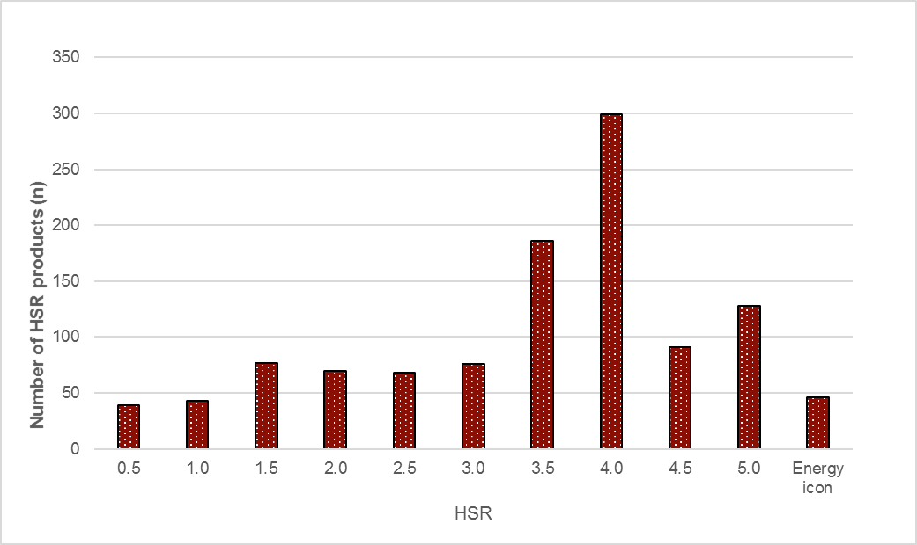

There were 646 HSR products in Year 2 for which there was also a record in FoodTrackTM in Year 1 but the product did not display the HSR system graphic in the Year 1 record. Conversely, there were two HSR products that were in the Year 1 record, but not in the Year 2 record.

Of these 646 products, 47 displayed Option 5 (Energy icon only) in Year 2 and were therefore excluded from further analysis. The analysis also excluded three products that did not have NIP information available in Year 1 or Year 2 and thus for which the calculated HSR could not be determined.

Of the remaining 596 HSR products, there were 217 individual HSR products (36%) that had complete data available in both Year 1 and Year 2 for assessment using the HSRC (FoodTrackTM or Excel), and an additional six multipacks. The remaining HSR products had missing data and were therefore excluded from further analysis (see Methodology, Section 3.2, for definition of missing data). For simplicity, the six multipacks have also been excluded from further analysis.

Most of these 217 HSR products (n = 186, 86%) had a calculated HSR that matched the HSR displayed on the pack in Year 2. There were only 31 HSR products for which the calculated HSR in Year 1 differed from that displayed on the pack in Year 2. These products are summarised in Table 3.4 below.

The variance from the calculated HSR in Year 1 to that displayed on the pack in Year 2 ranged from +2.0 to  
–1.0. Of these 31 products, 22 had an HSR in Year 2 that was greater than the calculated HSR in Year 1, and the remaining nine HSR products had an HSR in Year 2 that was less than in Year 1. Of these nine products, three were in the ‘Vegetables – plain’ HSR category (and were 100% vegetables) and two were in the ‘Grains – plain’ and ‘Hot cereals – plain’ HSR categories (one in each category), both of which comprised 100% single ingredients.

Table 3.4. Number of Health Star Rating (HSR) products in each HSR category with a calculated HSR in Year 1 that differed to that displayed on pack in Year 2

| HSR category | Number of HSR products (n) | Difference from Year 1 to Year 2 |
| --- | --- | --- |
| Bread | 1 | +0.5 |
| Breakfast spreads | 1 | –0.5 |
| Cereal-based bars | 3 | +0.5 (2 products)  –0.5 (1 product) |
| Crisps and similar snacks | 1 | +2.0 |
| Dried fruit and nut mixes | 1 | –0.5 |
| Formulated foods | 2 | +1.5 (2 products) |
| Frozen desserts (fruit-based only) | 1 | +0.5 |
| Fruit and vegetable juices | 1 | +0.5 |
| Grains – plain | 1 | +1.0 |
| Hot cereals – flavoured | 1 | –1.0 |
| Hot cereals – plain | 1 | +0.5 |
| Mueslis | 1 | +0.5 |
| Nut and seed bars | 2 | +0.5 (1 product)  +1.5 (1 product) |
| Nuts and seeds | 3 | +1.0 (2 products)  –1.0 (1 product) |
| Ready-to-eat breakfast cereals | 6 | +0.5 (2 products)  +1.0 (1 product)  +2.0 (3 products) |
| Savoury snack combinations | 1 | +0.5 |
| Vegetables – plain | 3 | –0.5 (3 products) |
| Vegetarian – processed | 1 | –0.5 |
| TOTALS | 31 | +2.0 to –1.0 |

# Industry’s experience with the Health Star Rating system

4 Chapter 4: Industry’s experience with the Health Star Rating system 191

4.1 Chapter summary 193

Health Star Rating system graphics 195

4.2 Methodology 196

4.2.1 Interview design and sample 196

4.2.2 Interviewees 196

Company size 196

Health Star Rating 197

4.2.3 Discussion guide 198

4.3 Results: Insights 199

4.3.1 Motivators for implementing the Health Star Rating system 199

Internal motivations 199

App motivations 200

4.3.2 Rationale for product coverage and Health Star Rating graphic selection 200

Rationale for product coverage 200

Rationale for selecting version of HSR system graphic (Options 1–5) 203

4.3.3 Implementing the Health Star Rating system 203

4.3.4 Impact of the Health Star Rating system 204

Changes in sales 204

Changes in brand perception and reputation 204

Changes to formulation and reformulation of products 205

4.3.5 Areas for improvement 206

Consumer awareness and understanding of the HSR system 206

The HSR Calculator 206

The HSR system 207

4.3.6 Future intentions 207

Expansion of HSR product coverage 207

HSR benchmarking to guide product formulation and reformulation 208

## Chapter summary

* Manufacturers and retailers (companies) were motivated to implement the HSR system on their products for a range of reasons, including:
  + demonstrating the company’s commitment to health and nutrition, and transparency
  + improving the company’s competitive advantage by creating a point of difference, improving brand awareness and reputation, and/or meeting [perceived] consumer demand for the HSR system
  + meeting retailer requirements.
* Of the companies interviewed, most (61%) had implemented the HSR system across a subset of their products; however, some of these companies reported intending to expand the number of their products displaying the HSR system.
* There are five different options for the HSR system that can be displayed on packaging (Options 1–5). Size of a product’s package and available space was the most important consideration when choosing the HSR system graphic. Other important considerations were the appropriateness of the graphic to the product, and the simplicity of the graphic.
* The ease, or otherwise, of making the decision to implement the HSR system depended largely on the structure and size of the company. The decision to implement the HSR system in small companies was typically made by the leader of the company, and was therefore relatively streamlined. In contrast, medium and large sized companies tended to have more layers of approval for making the decision.
* There was a range of experiences reported about the implementation of the HSR system for companies interviewed.
  + Some interviewees found the government’s materials and workshops useful and easy to use, and felt supported throughout the implementation process. Other interviewees reported issues with the resources provided, noting the delay in the release of the Style Guide, (a perceived) lack of clarity in the Style Guide, the HSRC not working on occasions, and difficulty in determining which figures to input into the HSRC.
  + Large companies also reported difficulties with implementation in relation to their internal processes, and in the time taken to reach decisions and build consensus around decisions.
  + Some companies (particularly small and medium sized ones) reported that they found the implementation process challenging because of their lack of nutrition expertise; they also reported difficulties in calculating FVNL and fibre contents.
  + Companies also highlighted that the implementation process created additional costs for their business in terms of packaging and resources (e.g. staff).
* Views of the impact of HSR system were mixed. Although most companies stated that they had not experienced any change since implementing the HSR system, some reported significant changes.
  + Several companies reported increasing sales, particularly for those products with ‘higher’ HSRs, or for specific product lines displaying the HSR system graphic. However, most companies reported no change to sales.
  + A couple of companies reported that implementation of the HSR system had positively influenced how their brand and/or product is perceived. However, other companies felt that implementation of the HSR system had negatively affected their brand and reputation because of the negative perceptions and criticism of the HSR system.
  + Several companies reported having used the HSR system to guide the formulation and reformulation of their products, to guide nutrient targets and/or increase the HSR system rating of their products.
* The consultation with companies has highlighted some areas for improvement.
  + Many companies reported that they would like to see more consumer education around the HSR system and how to use it correctly. Interviewees agreed that government was best placed to deliver education and awareness because this would add credibility and ensure that consumers are aware that this is a government-led scheme.
  + Although many companies reported that their products were accurately reflected by the HSR they receive, issues were raised about the ability of the HSRC to accurately reflect the perceived ‘healthiness’ of a product or how ‘processed’ the product is. Some companies highlighted that these ‘inconsistencies’ were reducing consumers’ trust in the system.
  + Some companies thought that the HSR system should be applied to a limited set of products (e.g. ‘core foods’), whereas others thought it should be expanded to cover all supermarket products.
  + There was also the suggestion of shifting the focus of the HSR system from nutrients to have a greater focus on whole foods and dietary patterns. However, if the existing focus on nutrients were to stay, companies reported that they would like to see greater clarity on definitions. Specifically, several companies requested greater clarity as to the inclusion and exclusion criteria as to what constitutes FVNL.
* Many of the companies interviewed were happy with how the HSR system is currently functioning. Consequently, many companies reported that they were looking to expand the coverage of the HSR system across more of their products. To support this process, many companies reported having introduced internal goals and benchmarks. However, some companies reported that the [perceived] anomalies in the HSRC would need to be addressed before they would implement the HSR system across all of their products.

Health Star Rating system graphics

| Health Star Rating system graphics |
| --- |
| Option 1  HSR + energy icon + 3 prescribed nutrient icons + optional nutrient |
| Option 2  HSR + energy icon + 3 prescribed nutrient icons  The Option 2 graphic showing the Health Star Rating, the Energy icon and 3 prescribed nutrients. |
| Option 3  HSR + energy icon  The Option 3 graphic showing the Health Star Rating and the Energy icon. |
| Option 4  HSR only  The Option 4 graphic showing the Health Star Rating only. |
| Option 5  Energy icon only  The Option 5 graphic showing the Energy icon only. |

## Methodology

This chapter is supplementary to the current areas of enquiry, and therefore does not map directly to key areas of the framework. However, the analysis of consultation with manufacturers and retailers (companies) presented in this chapter contributes the following:

* understanding of the motivations behind implementation of the HSR system by companies
* experience of implementing the HSR system by companies
* impact of the HSR system, both positive and negative
* understanding of areas for improvement to support the long-term uptake of the HSR system
* intentions of companies around their ongoing participation in the HSR system.

Industry insights were gathered through structured interviews of those willing to participate.

### Interview design and sample

In June 2016, the Heart Foundation conducted telephone interviews with 36 representatives from Australian food and beverage companies that have products displaying the HSR system.

All companies with HSR products, identified in FoodTrackTM and the point-in-time data collections, were invited by the Department to participate in the consultation process. A total of 72 companies were invited to participate, of whom 50 agreed to do so. When subsequently approached by the Heart Foundation, 36 of these 50 companies agreed to be interviewed.

The sample of companies interviewed is not necessarily representative. However, to provide context to the companies’ responses, characteristics of those interviewed are provided.

### Interviewees

#### Company size

Companies interviewed were classified according to business size, based on the number of employees. Using the definition provided by the Australian Bureau of Statistics (ABS), ‘small companies’ those with fewer than 20 employees, ‘medium companies’ as those with between 20 and 200 employees, and ‘large companies’ as those with more than 200 employees (15). As illustrated in Figure 4.1 a good spread of small, medium and large companies was captured in the consultation. This was important in terms of providing insight into whether and how the experience of companies varied by size.

Figure 4.1. Distribution of interviewees by company size

Click to view text version

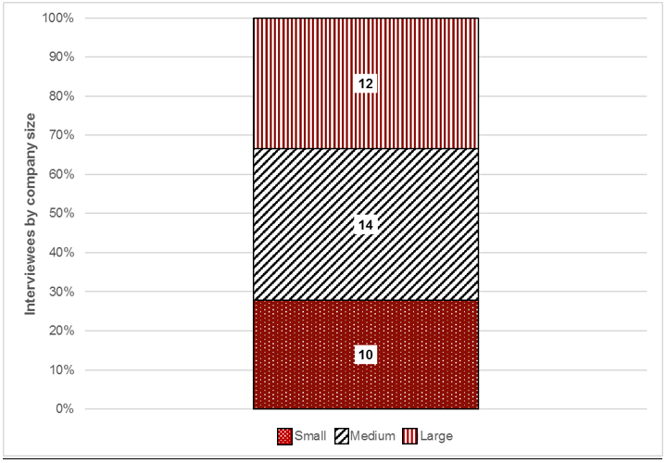

#### Health Star Rating

For each of the companies interviewed, information was collated on the HSR of their product(s) in Year 2. Figure 4.2 presents the range of HSRs, by company size. It shows that the larger companies tended to have a greater range in their HSRs, primarily driven by the fact that when a company implemented the HSR system on their products, they often committed to implementing it across the whole product suite.

Figure 4.2. Range of Health Star Rating (HSR) system rating, by company size

Click to view text version

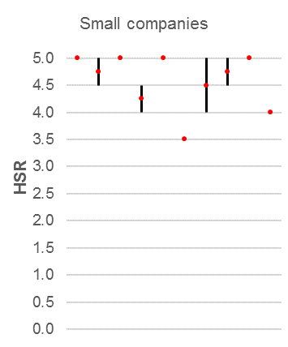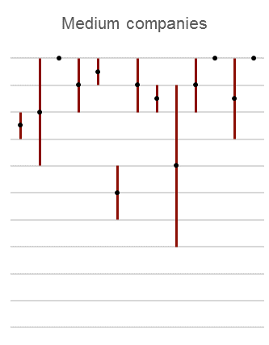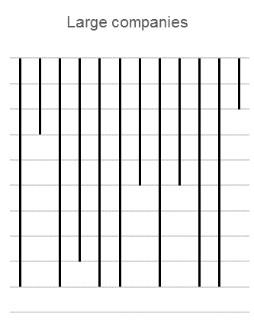

### Discussion guide

A discussion guide was used to ensure that each interview canvassed the same areas. Questions were open ended to facilitate discussion and capture the full experience of participating companies.

The discussion guide canvassed seven key areas:

* the rationale for implementing the HSR system, and the process undertaken to make this decision and what products to apply it to
* their expectations of the HSR system, before and after implementation
* the process of implementing the HSR system, including any barriers or challenges
* the rationale for selecting a HSR system graphic (i.e. Options 1–5 of the HSR system graphic)
* the relevance of the HSR system in accurately reflecting the nutritional value of their product(s)
* the impact of the HSR system, such as consumer feedback or changes to (re)formulation
* their views on the future of the HSR system.

The discussion guide is provided in Appendix 5.

## Results: Insights

Industry insights are structured into six sections:

* motivation for participating in the HSR system
* rationale for product coverage and graphic selection
* experience in implementing the HSR system
* impact of the HSR system
* areas for improvement
* future intentions.

### Motivators for implementing the Health Star Rating system

The motivations for adopting the HSR system can be broadly categorised into two groups: internal motivations and external motivations. Internal motivations were driven by the companies’ own beliefs, values and how they wanted to position themselves in the market. External motivations were driven by factors outside of the business, to which a business may respond reactively or proactively. These two types of motivation are discussed below.

#### Internal motivations

Most of the companies interviewed were at least partially motivated to implement the HSR system because of a desire to provide additional information to customers, supporting them to compare products and make more informed choices.

For many companies, particularly large ones, the decision to implement the HSR system was driven by a desire to reflect the values of the company. At a general level, implementing the HSR system is believed to provide transparency to the consumer, which several companies stated was important. More specifically, some companies stated that implementing the HSR system reflected the company’s commitment to health and nutrition, with several companies interviewed stating that they have established nutrition and health policies with which the HSR system aligns. One company interviewed was already scoping the potential for a FoP labelling (FoPL) scheme to implement across their product range. Implementation of the HSR system became an obvious choice for this company, because it facilitates broader comparison of products.

With the HSR system being relatively new, some companies also stated that their participation was about being a market leader and encouraging industry uptake.

#### External motivations

Small and medium sized companies tended to report being more motivated to implement the HSR system to improve or maintain the company’s competitive advantage. Many companies mentioned that they had considered the participation of their competitors in the HSR system when making their own decision to use the HSR system.

Those companies that had products that rated highly felt that the HSR system would provide a point of difference for them and promote a positive nutrition story. Several small and medium sized companies expected this to raise the brand awareness of their products. Larger companies, which may already have strong brand awareness, were more interested in the potential uplift to reputation and brand perception of the product and/or company.

A couple of large companies stated they had internal research that showed consumer demand for a system like the HSR system, which formed part of their decision for participating. Conversely, a few interviewees reported that their company perceived a lack of consumer demand of the system.

Several companies reported choosing to participate in the HSR system because it was a retailer requirement.

### Rationale for product coverage and Health Star Rating graphic selection

#### Rationale for product coverage

Of the companies interviewed, most (61%) have only implemented the HSR system across a subset of their products. This is illustrated in Figure 4.3 (Panel A), which also shows (Panel B) that larger companies were more likely than small companies to have partial coverage of their products. Some companies with the HSR system on some of their product range are in the process of expanding their coverage, with the aim of having the HSR system on their whole product range.

Figure 4.3. Coverage of HSR products by company size

Click to view text version

Figure 4.3A is a stacked bar graph illustrating the coverage of Health Star Rating (HSR) products by company size. This figure shows partial count at 5 for small business, 9 for medium businesses and 8 for large businesses. The second shows the full count at 5 for small business, 5 for medium business and 4 for large business.
Please refer to the text version in the link above figure 4.3 

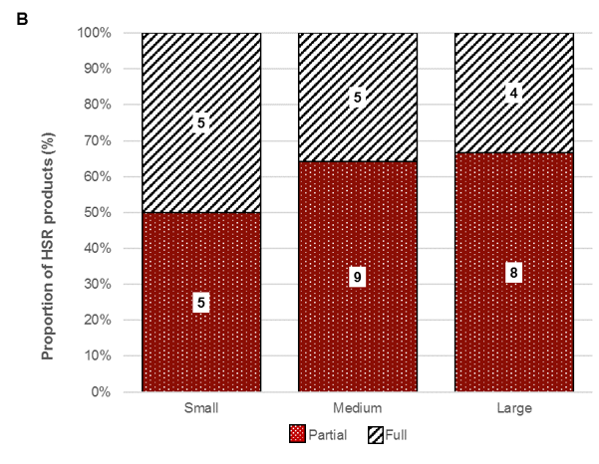

Larger companies were more likely to have multiple products, and products that fell into multiple food and beverage categories. Although this is not necessarily an issue, it can increase the complexity of implementation.

Some of the companies that did not implement the HSR system across all their products expressed concern about the HSR that some of their products would receive, were they to implement the HSR system on their whole product suite.

Implementing the HSR system on all products was also reported to increase the overall cost of implementation, due to the need to rework packaging. This concern was reported most frequently by small and medium sized companies, who stated that it was too costly to have new packaging printed if it had been completed recently.

Despite these concerns, a large proportion of companies (39%) implemented the HSR system across all their products. These companies believed that applying the HSR system consistently across their whole product suite was an important demonstration of their companies’ commitment to transparency, and helped to ensure that consumers were genuinely able to compare the nutritional value of products.

“Consumers are more curious about you not explaining information, then actually you having information readily available for them.”

“I think if you put it on some, and not others because they may not look goods [sic] it defeat’s [sic] the purpose of the system.”

#### Rationale for selecting version of HSR system graphic (Options 1–5)

Among the five different options for the HSR system that can be displayed on packaging (Options 1–5), companies are free to choose the HSR option they consider to be the most appropriate.

According to those interviewed, the most important factor when deciding on the HSR system graphic was the size of the package and the available space on the packaging. Large companies tended to prefer Option 1, which provides the most detail, but would scale down as appropriate for smaller packages. When space was limited, Option 4 was the preferred option for companies.

Other companies selected the HSR graphic based on its appropriateness for the product. For example, one interviewee wanted to highlight the protein content for meat products, and another the vitamin E content for nuts. These companies consequently selected the HSR system graphic that would enable the company to highlight that detail.

Another important consideration for companies was the simplicity of the design, which most often led them to choose Option 4. In recognition that FoP ‘real estate’ is limited, and that too much information can overwhelm customers and dilute the message, many companies highlighted that ‘simple was better’.

“If you put too much on there, it’s only going to make people… more confused… The whole concept of the HSR [system] is to make it simple.”

### Implementing the Health Star Rating system

The ease, or otherwise, of making the decision to implement the HSR system depended largely on the structure and size of the company. In smaller companies, often the company leader, such as the managing director, owner or chief executive officer (CEO), was responsible for making the decision to implement the HSR system, and therefore the decision process was streamlined. In contrast, medium and larger companies had more layers of approval for making the decision. In these larger companies, a variety of teams was involved in making the decision, including nutrition, regulatory affairs, and marketing and corporate affairs teams. The process was further complicated for companies with a global parent, to ensure that global management understood and supported the HSR system for Australian products.

Once the decision to participate in the HSR system had been taken, there was a range of experiences reported on the implementation itself.

Some interviewees felt supported with the implementation process because of the government’s materials and workshops. These companies highlighted that the resources provided by the government, such as the online HSRC and Style Guide, were straight forward and easy to use. A few interviewees also commented that the workshops held by the government were helpful in providing additional support, as was the hotline provided by the government.

“There was plenty of information out there like the style guide, online calculator, plenty of information to tell you about the scoring and what category your food falls under. I’ve rung the hotline a couple of times … and there’s always been someone there.”

However, other interviewees reported issues with the resources provided. Two companies reported that the HSRC was not operating correctly at times, or that they had difficulty in determining the figures to input into the HSRC. Several companies also found the Style Guide to be unclear, and one interviewee stated that greater clarity was required for single-ingredient products. One large company reported that the delay in releasing the Style Guide meant that some decisions were made without its guidance.

Large companies also reported difficulties with implementation in relation to their internal processes. As discussed earlier, larger companies typically have a more complex approval process for decision-making, which can slow the process of implementation. Such companies also found it challenging to decide whether to implement the HSR system across all their products, particularly when some of their products had a ‘low’ HSR.

Some small and medium sized companies were challenged in the implementation process due to their lack of nutrition expertise, and experienced difficulties in calculating FVNL and fibre contents. These companies felt that more clarity is required on what contributes to the FVNL values, and suggested that definitions should be made clearer.

Companies also highlighted that the implementation process created additional costs for their business in terms of packaging and resources (e.g. staff). To accommodate the new FoPL, changes were made to packaging, creating additional costs. In fact, some interviewees commented that they would expand the HSR system to more of their products in line with scheduled updates to their packaging, such that participation did not increase their packaging costs. Additional resources were required to support the implementation process, such as updating systems for automated HSR calculations, artwork changes and internal education.

### Impact of the Health Star Rating system

Views of the impact of the HSR system were mixed. Although most companies stated that they have not experienced any change since implementing the HSR system, some reported significant changes. The types of impacts included:

* changes in sales, attributable to participation in the HSR system
* changes to product and company reputation, both positive and negative, from affiliation with the HSR system
* changes to formulation of new products and reformulation of existing products to improve the HSR of their products.

#### Changes in sales

Several companies reported increasing sales, particularly for those products with ‘higher’ HSRs, or on specific lines displaying the HSR system graphic. One company reported that sales in a line of breakfast cereals displaying the HSR system increased by 50% in the first year.

However, improvement in sales was not the norm. Most companies reported no change to sales. Some companies highlighted that this could be because it is too soon to see changes.

#### Changes in brand perception and reputation

Two companies reported that implementation of the HSR system has positively influenced how their brand and/or product is perceived. This was primarily reported by small and medium sized companies, who felt that having a ‘high’ HSR on their products increased their credibility, and had received positive feedback from customers.

“… since we’ve included [HSR system rating] on our packaging a few customers have made contact with us about the fact that they really like … that we have the HSR on pack, and it definitely puts a spotlight on our products in terms of its nutritional benefits”

However, other companies felt that implementation of the HSR system had negatively impacted on their brand and reputation. This was generally reported by large companies who reported that the negative perceptions and criticism of the HSR system had damaged their product and/or company through association.

Companies reported that the HSR system had been criticised as being developed by the food industry, despite being a government-led initiative. The HSR system has also been criticised for perceived inconsistencies in HSRs, for example, the HSR of dairy products, treatment of mixed foods (e.g. cheese and biscuit combinations), and plain vegetables scoring an HSR of less than 5.0.

#### Changes to formulation and reformulation of products

Several companies developed new products in line with the HSR system, including flavoured milk, chia bars, muesli, pasta, savoury pastry products, salads, savoury biscuits and cereal bars. The HSR system was reported to guide nutrient targets for the new products, and companies reported using the HSR system to work backwards and adjust their recipes to ensure that they met the desired HSR for these products.

Some companies reported also having reformulated existing products to increase the HSR of their products. In addition, some companies who reported no product reformulation to date have future intentions to reformulate their products to improve their HSR. Table 4.1 summarises the products and reported change(s) made to the product.

Table 4.1. Reformulation of products

| Product | Change made |
| --- | --- |
| Muesli | Sultanas and ingredients blend adjusted  Lupin and chia ingredient adjusted |
| Breakfast cereals | Sugar and sodium decreased  Fibre increased |
| Ready meals | Oil and sodium reduced |
| Pastry | Sodium and fat reduced |
| Savoury biscuits | Sodium reduced |
| Fudge bar | Fibre increased  Fat decreased |
| Fruit/vegetable snacks | Sodium reduced |
| Yoghurt | Sugar reduced |

### Areas for improvement

#### Consumer awareness and understanding of the HSR system

Many companies reported that they would like to see more consumer education around the HSR system and how to use it correctly. Companies reported that they would like to increase awareness among consumers and the general public that the HSR system is government led, not industry developed, particularly because of the commentary in the media about the industry’s perceived involvement in its design. Interviewees agreed that the government is best placed to provide education and awareness because this would add credibility and ensure that consumers are aware that this is a government-led scheme.

“The education behind the system needs to be stronger, particularly in terms of … [demonstrating] that this is a government initiative that has been done in consultation with industry.”

Companies reported that they would also like consumers to have greater awareness about how to use the HSR system appropriately, and ensure that consumers are aware that it is for within category comparison, not across category.

“Consumers only see the stars and they don’t put the other level of interpretation around that it’s restricted to categories, which is a challenge.”

#### The HSR Calculator

Many companies reported that their products were accurately reflected by the HSR; however, several issues were raised in relation to:

* the HSR(s) of dairy products
* how mixed foods are treated, such as cheese and biscuit combinations
* vegetables scoring an HSR of less than 5.0
* natural fish products penalised due to their naturally high fat content
* edible oil spreads not sufficiently represented, considering their ‘healthy’ fat content.

Fundamentally, these comments reflect a more general concern that the HSRC does not always accurately reflect the perceived ‘healthiness’ of a product. For example, a concern was raised about the potential for companies to manipulate products to get a higher HSR, but not actually make the product ‘healthier’.

Concerns were also raised about the ability to distinguish how ‘processed’ a product is. A few companies felt that products that have less ‘processing’, such as wholegrain products or products that have no ‘additives’ or ‘chemicals’, should have this recognised in their HSR. In a similar vein, another company thought a distinction should be made between natural and added sugars.

For some large companies that have applied the HSR system to only some of their products, they would only expand coverage to additional products if these ‘anomalies’ are addressed.

Some companies also highlighted that these ‘inconsistencies’ in the HSR are reducing consumers’ trust in the system.

“There is a lot of concern about consumer scepticism about the healthy star rating.”

#### The HSR system

Companies had a range of suggestions for improving the HSR system, some of which were conflicting. Some companies proposed that the HSR system be applied only to ‘core foods’ (i.e. not ‘discretionary foods’). Some companies went further, suggesting that it be applied only to products with a ‘high’ HSR, thereby making the HSR an indicator of ‘healthy’ food. In contrast, one company suggested that it be applied to all products in the supermarket.

There was also the suggestion of shifting the focus of the HSR system from nutrients to have a greater focus on whole foods and dietary patterns; however, if the existing focus on nutrients were to stay, companies would like greater clarity on definitions. Specifically, several companies requested greater clarity about the inclusion and exclusion criteria of what constitutes FVNL.

### Future intentions

Many of the companies interviewed were happy with how the HSR system is currently functioning.

“Think it’s a really good system… every product sold in Australia should have it.”

Although the companies interviewed raised issues and concerns, many expressed their commitment to the integration of the HSR system into their business and product development.

#### Expansion of HSR product coverage

As outlined above, most of the companies interviewed have not currently implemented the HSR system on all their products. However, many of the companies, particularly those of medium and large size, reported intending to expand the number of products (see Figure 4.4). Furthermore, these companies often set specific time frames for when this objective should be reached.

Figure 4.4. Intentions to expand coverage of Health Star Rating system by company size

Click to view text version

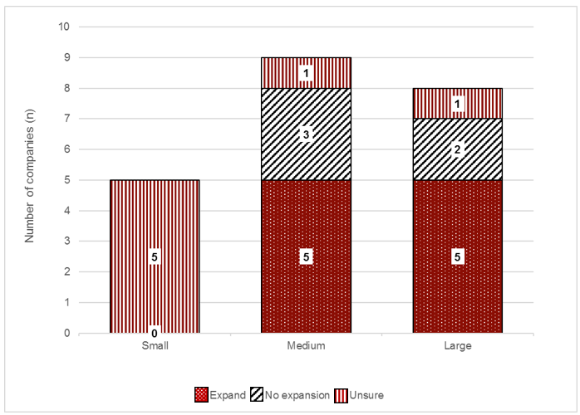

However, the intention to expand coverage of the HSR system was conditional for several of the companies. Many of the companies that had implemented the HSR system on some of their products had also expressed concerns about the HSRC and the relevance of the HSR system to their products. Some of these companies stated that the perceived ‘anomalies’ need to be addressed before they would consider implementing the HSR system on their additional products.

For those companies that expressed concern about the cost of printing new packaging with the HSR system graphic, many conceded that they would probably expand their range of HSR products as they updated their packages and undertook new printing batches.

#### HSR benchmarking to guide product formulation and reformulation

Many companies reported having already used the HSR system to guide product formulation and reformulation. Many have created internal benchmarks for future product formulation and reformulation; for example, a minimum HSR benchmark for a given product, category or product range, and a longer term goal to improve their product ratings. To achieve these benchmarks, companies reported working to incorporate the HSR system into their nutritional standards or to guide product development less formally.

Appendix 1. Wave 4 uptake report

Report for Wave 4 of point-in-time uptake monitoring of the Health Star Rating system, in Australian supermarkets in August to September 2016

Background

The Australian Government Department of Health (Department) has previously requested more regular monitoring of uptake of the Health Star Rating (HSR) system across products stocked in the two major retailers (Coles and Woolworths). In late 2015, it was decided that uptake of the HSR system across products stocked in ALDI supermarkets would also be captured.

The National Heart Foundation of Australia (Heart Foundation) previously submitted proposals in July 2015 and July 2016 to conduct an additional four waves of data collection to monitor the uptake of the HSR system in-store. The time frames for these four waves were:

* Wave 1 – September 2015
* Wave 2 – January 2016
* Wave 3 – May 2016
* **Wave 4 – August to September 2016.**

This report provides the results for **Wave 4** of this collection.

Methodology

The Heart Foundation is using the joint Heart Foundation and Commonwealth Scientific and Industrial Organisation (CSIRO) FoodTrackTM database to monitor the implementation of the HSR system for a two-year period (retrospective June 2014 to June 2016). The data collection method used to populate this database is an annual rolling process whereby the more than 80 categories are collected progressively throughout the year, across Coles and Woolworths. As of 2016, data is also collected from ALDI supermarkets.

The Heart Foundation currently has a team of trained data collection field officers (qualified in nutrition and/or dietetics) who populate the FoodTrackTM database on an ongoing basis, by collecting data in-store using smartphone technology.

This collection methodology does not capture the roll-out of the HSR system at a given point in time. The Health Star Rating Advisory Committee (HSRAC) and the Department regularly receive requests for an update on the number of products carrying the HSR system at a given point in time, and currently have no methodology in place to capture this on a regular basis. To address the request for the additional uptake monitoring, one of the Heart Foundation’s trained data collection officers was recruited specifically for this piece of work.

The activities conducted were as follows:

1. Heart Foundation staff developed a template for collection of the required data in-store, and an additional standard operating procedure (SOP) to ensure a standardised collection methodology.
2. The data collection officer was trained for this work using the developed SOP. Training was conducted by Heart Foundation staff, and the officer was provided with instructions regarding the data he or she was required to collect.
3. Data was collected according to the SOP during four consecutive weeks in August to September 2016, and transcribed directly into an existing Microsoft Excel template; data from Wave 3 was used as the template.
4. Data collected was audited by Heart Foundation staff, and supplemented with products from the FoodTrackTM database that display the HSR system, that were not captured in-store, for the related time frame.
5. Data was also supplemented with files provided by ALDI and Woolworths that list those retailers’ private label branded products displaying the HSR system.[45]
6. Data was then supplemented with additional desktop research of each manufacturer’s website for products found in-store displaying the HSR system. This was completed to identify any product lines not found in the store visits that display the HSR system graphic or any state-specific products not found in Victoria. This exercise was also completed for Woolworths and Coles online store websites. **Appendix 2** lists the websites visited.

#### What *was* collected

* Barcode, manufacturer, brand, item description (including pack size).
* Presence of the HSR system graphic, and the HSR displayed on pack.

#### What *was not* collected

* No additional product information; that is, images, star-type, use of ‘snail’ or not, nutrition information panel (NIP) data, ingredients, position on packaging, etc.

#### Scope of products

* The data collection officer visited two major Coles, two major Woolworths and two ALDI stores in metropolitan Victoria during the months of August to September.
* All private label and branded products were reviewed, for all FoodTrackTM categories.
* Multipacks and variety packs were included, as were products with multiple pack sizes, with one record per pack size.

#### Supplementary material

Woolworths and ALDI supermarkets agreed to also provide the Heart Foundation with a list of their private label products, currently stocked in their stores, that display the HSR system graphic, as well those currently on artwork but not yet stocked. This list was used to supplement the data that was collected in-store. Once the product list with data from in-store collection, and from ALDI and Woolworths, had been completed, additional desktop research was conducted by visiting every available manufacturer’s website that was on the product list, and also the Coles and Woolworths online stores.

Results

A total **5,560** products were recorded for the given time point, including 63 multipack products that displayed more than one HSR system graphic on pack to reflect the different flavour or product variants.

**Figure A1-1** below shows a comparison of the uptake of the HSR system to that of the Daily Intake Guide[46] (DIG) over time. Compared with the DIG, there has been a greater number of products displaying the HSR system graphic at each wave time point, including the current Wave 4 (equivalent of months 26–27 post implementation). At Wave 4, uptake of the DIG was 1,167 products, compared with 5,560 products for the HSR system – this represented a nearly five times greater presence of HSR products compared with those displaying the DIG for the corresponding time point, on products in Australian supermarkets.

Figure A1-1. Comparison of the uptake of the Daily Intake Guide to the Health Star Rating system, over time

Click to view text version

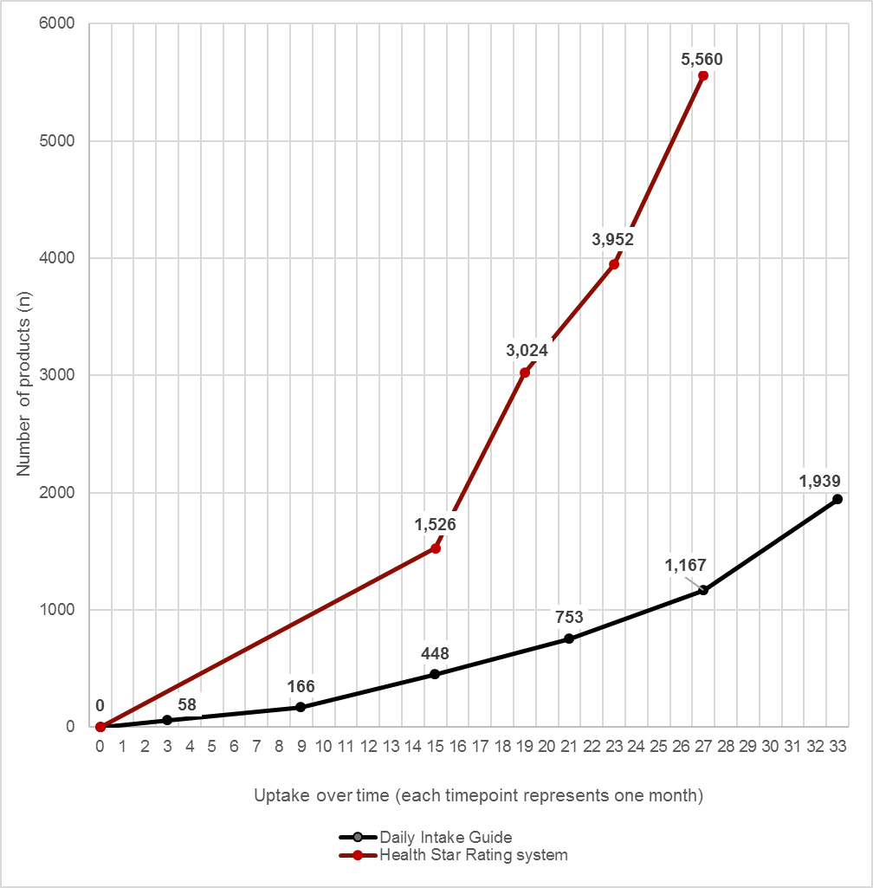

**Table A1-1** below outlines the total number of products displaying the HSR system by manufacturer and brand.

Table A1-1. Uptake of the Health Star Rating system by manufacturer and brand

| Manufacturers and brands | Number of products displaying the HSR system graphic |
| --- | --- |
| **Al & Dan's (Manufacturer)** | **2** |
| Al & Dan's | 2 |
| **Arnotts Biscuits** | **39** |
| Arnotts | 39 |
| **Atkins Nutritionals** | **3** |
| Atkins | 3 |
| **Australian Eatwell (Manufacturer)** | **8** |
| Australian Eatwell | 8 |
| **Australian Wholefoods** | **11** |
| Banquet | 1 |
| Clever Cooks | 10 |
| **Beanfields (Manufacturer)** | **4** |
| Beanfields | 4 |
| **Betta Foods Australia** | **9** |
| Capricorn | 9 |
| **BH Fine Foods** | **2** |
| Connect Foods | 2 |
| **Body Science International** | **4** |
| Body Science | 4 |
| **Byron Bay Superfoods Company** | **24** |
| Wallaby | 24 |
| **Campbell Australia** | **16** |
| Campbell's | 13 |
| V8 | 3 |
| **Carman’s Fine Foods** | **24** |
| Carman’s | 24 |
| **Cereal Partners Australia** | **93** |
| Nestlé | 8 |
| Uncle Tobys | 85 |
| **Chris' Dips** | **4** |
| Chris' | 4 |
| **Club Trading and Distribution** | **6** |
| Artisse Organic | 3 |
| Sippah | 3 |
| **Coca-Cola Amatil** | **112** |
| Barista Bros | 2 |
| Cascade | 5 |
| Coca-Cola | 12 |
| Coke Life | 8 |
| Coke Zero | 11 |
| Deep Spring | 5 |
| Diet Coke | 11 |
| Fanta | 10 |
| Fuze | 5 |
| Glaceau | 1 |
| Kirks | 2 |
| Lift | 6 |
| Mount Franklin | 1 |
| Powerade | 17 |
| Pump | 3 |
| Sprite | 6 |
| Vanilla Coke | 5 |
| Zico | 2 |
| **Emma & Tom Foods** | **12** |
| Emma & Toms | 12 |
| **Entyce Food Ingredients** | **6** |
| Creative Gourmet | 6 |
| **Fine Fettle Foods** | **20** |
| Fine Fettle | 20 |
| **Flavour Creations** | **2** |
| Nourish | 2 |
| **FODMAPPED Foods** | **9** |
| FODMAPPED For You! | 9 |
| **Fonterra Brands Australia** | **33** |
| Anchor | 5 |
| Nestlé | 28 |
| **Food For Health (Manufacturer)** | **22** |
| Food For Health | 22 |
| **Freedom Nutritional Products** | **36** |
| Freedom Foods | 36 |
| **Frucor Beverages** | **28** |
| Maximus | 3 |
| Mizone | 1 |
| Ovi | 3 |
| Ribena | 1 |
| Rockstar | 2 |
| V | 18 |
| **Go Natural (Manufacturer)** | **24** |
| Go Natural | 24 |
| **Greens General Foods** | **10** |
| Lowan | 10 |
| **Grove Fruit Juice** | **6** |
| Boost | 6 |
| **Hampden Trading** | **1** |
| Freelicious | 1 |
| **Harvest Box (Manufacturer)** | **12** |
| Harvest Box | 12 |
| **Heinz Watties** | **19** |
| Weight Watchers | 19 |
| **HJ Heinz Company Australia** | **55** |
| Golden Circle | 8 |
| Heinz | 47 |
| **Hot Shots Australia** | **3** |
| Hot Shots | 3 |
| **Innova Foods** | **2** |
| Mama Chow | 2 |
| **Kalfresh** | **1** |
| Just Veg | 1 |
| **Kellogg (Aust)** | **96** |
| Be Natural | 4 |
| Kelloggs | 89 |
| Vogels | 3 |
| **Kez’s Kitchen** | **7** |
| Kez’s | 7 |
| **Life Health Foods** | **29** |
| Bean Supreme | 3 |
| Naked Locals | 6 |
| The Alternative Meat Co | 5 |
| Vegie Delights | 15 |
| **Lindt & Sprüngli (Aust)** | **27** |
| Lindt | 27 |
| **Lion Dairy & Drinks** | **143** |
| Berri | 25 |
| Dairy Farmers | 5 |
| Dare | 10 |
| Just Juice | 18 |
| Masters | 7 |
| Sunnyboy | 3 |
| The Complete Dairy | 2 |
| The Daily Juice Company | 25 |
| Vitasoy | 15 |
| YoGo | 1 |
| Yoplait | 29 |
| Zooper Dooper | 3 |
| **Manassen Foods Australia** | **6** |
| Golden Days | 6 |
| **Mars Chocolate Australia** | **35** |
| Mars | 35 |
| **Mayvers Health Time** | **10** |
| Mayvers | 10 |
| **McCain Foods** | **10** |
| McCain | 10 |
| **Mexican Express** | **1** |
| Mexican Express | 1 |
| **Modern Baking** | **2** |
| Unibic | 2 |
| **Monster Health Food Co** | **13** |
| Monster | 13 |
| **Nestlé Australia** | **210** |
| Allens | 57 |
| Maggi | 66 |
| Nestlé | 49 |
| Uncle Tobys | 37 |
| Wonka | 1 |
| **New Fresh Foods** | **8** |
| Avo Fresh | 8 |
| **Norco Foods** | **3** |
| Mighty Cool | 3 |
| **One Harvest** | **1** |
| Harvest Freshcuts | 1 |
| **Pacific West Foods** | **2** |
| Ocean Chef | 2 |
| **Parilla Fresh** | **3** |
| Good 4U + U | 3 |
| **Patties Foods** | **53** |
| Four'N Twenty | 41 |
| Herbert Adams | 3 |
| Patties | 9 |
| **Picot Productions** | **3** |
| Pics | 3 |
| **Popina Foods** | **26** |
| Arnolds Farm | 12 |
| Goodness Superfoods | 14 |
| **Primo Moraitis Fresh** | **7** |
| Mrs Crocket's | 5 |
| The Real | 2 |
| **Private label – ALDI** | **494** |
| Asia Specialities | 1 |
| Bakers Life | 41 |
| Beautifully Butterfully | 3 |
| Belmont Biscuit Co. | 46 |
| Bramwells | 2 |
| Brookdale | 3 |
| Brooklea | 1 |
| Casa Barelli | 5 |
| Choceur | 46 |
| Corale | 8 |
| Dairy Dream | 13 |
| Dairy Fine | 36 |
| Damora | 9 |
| Deli Originals | 4 |
| Dominion Naturals | 14 |
| El Tora | 3 |
| Elmsbury | 8 |
| Emporium Selection | 2 |
| Flirt | 4 |
| Food Envy | 5 |
| Forresters | 5 |
| Goldenvale | 16 |
| Has No... | 1 |
| Health & Vitality | 1 |
| Hillcrest | 2 |
| Imperial Grain | 7 |
| International Cuisine | 14 |
| International Cuisine Health & Vitality | 14 |
| Just Organic | 2 |
| Lyttos | 2 |
| Market Fare | 22 |
| ME'N'U | 9 |
| Milfina | 2 |
| Monarc | 3 |
| Moser Roth | 26 |
| New Season | 18 |
| Nrg Maxx | 2 |
| Oh So Natural Wholefoods | 6 |
| Pure Tropics | 4 |
| Remano | 5 |
| Seasons Pride | 4 |
| Specially Selected | 6 |
| Sweet Haven | 5 |
| Sweet Valley | 3 |
| Sweet Vine | 1 |
| The Cake Stall | 7 |
| The Fresh Salad Co | 19 |
| The Soup Co. | 13 |
| Westcliff | 21 |
| **Private label – Coles** | **1,391** |
| Coles | 1,253 |
| Coles Finest | 19 |
| Coles Graze | 1 |
| Coles Grill | 19 |
| Coles Made Easy | 13 |
| Coles Organic | 9 |
| Coles Simply | 36 |
| Coles Simply Gluten Free | 25 |
| Coles Smart Buy | 14 |
| Graze | 2 |
| **Private label – Woolworths** | **1,530** |
| Bell Farms | 5 |
| Category Brand | 3 |
| Farmers Own | 2 |
| Hillview | 1 |
| Macro | 103 |
| Macro Natural | 6 |
| Macro Organic | 67 |
| Market Value | 1 |
| Mini Macro | 2 |
| Salad Fresh | 1 |
| Woolworths | 596 |
| Woolworths Cooking with Kylie Kwong | 12 |
| Woolworths Created With Jamie | 70 |
| Woolworths Essentials | 70 |
| Woolworths Free From Dairy | 3 |
| Woolworths Free From Gluten | 11 |
| Woolworths Gold | 53 |
| Woolworths Homebrand | 103 |
| Woolworths Select | 421 |
| **Prolife Foods** | **7** |
| Mother Earth | 7 |
| **PureBred Bakery** | **13** |
| Pure Bred | 13 |
| **Real Foods** | **8** |
| Corn Thins | 6 |
| Rice Thins | 2 |
| **Red Bull Australia** | **16** |
| Red Bull | 16 |
| **Red Tractor Foods (Manufacturer)** | **4** |
| Red Tractor Foods | 4 |
| **Republica Coffee** | **3** |
| Republica | 3 |
| **Ricegrowers Limited** | **4** |
| SunRice | 4 |
| **Rinoldi Pasta** | **10** |
| Vetta | 10 |
| **Sanitarium Health Foods Company** | **124** |
| Naturally Nood | 16 |
| Sanitarium | 108 |
| **Sargents (Manufacturer)** | **6** |
| Sargents | 6 |
| **Schweppes Australia** | **9** |
| Frantelle | 1 |
| Pop Tops | 5 |
| Schweppes | 1 |
| Solo | 2 |
| **Select Harvests Food Products** | **16** |
| Allinga Farms | 2 |
| Lucky | 10 |
| NuVitality | 3 |
| Sunsol | 1 |
| **Simplot Australia** | **203** |
| Birds Eye | 65 |
| Birds Eye | 2 |
| Chiko | 1 |
| Edgell | 11 |
| I & J | 5 |
| John West | 16 |
| Lean Cuisine | 25 |
| Leggos | 54 |
| Quorn | 23 |
| Seakist | 1 |
| **Slim Secrets (Manufacturer)** | **4** |
| Slim Secrets | 4 |
| **Smart Living Nutrition** | **8** |
| Activize Me | 2 |
| Love Me Low Carb | 6 |
| **Soma Organics** | **4** |
| Soma Bite | 4 |
| **Soulfresh** | **5** |
| Coconut Collective | 5 |
| **SPC Ardmona Operations** | **24** |
| Ardmona | 8 |
| Goulburn Valley | 3 |
| SPC | 6 |
| SPC Provital | 7 |
| **Spreyton Fresh Tasmania** | **5** |
| Spreyton Fresh | 5 |
| **Stahmann Farms** | **7** |
| Ducks | 2 |
| Riverside All Australian | 5 |
| **Sunbeam Foods** | **7** |
| Sunbeam | 7 |
| **Sunfresh Salads** | **8** |
| Down To Earth | 3 |
| Sunfresh | 5 |
| **Sunpork Fresh Foods (Manufacturer)** | **27** |
| Seven Mile | 5 |
| Sunpork Fresh Foods | 22 |
| **Sunraysia Natural Beverage Company** | **4** |
| Sunraysia | 4 |
| **Symingtons Australia** | **3** |
| Fuel Your Imagination | 3 |
| **Table Of Plenty (Manufacturer)** | **3** |
| Table Of Plenty | 3 |
| **Tasti Products** | **9** |
| Tasti | 9 |
| **Teys Australia** | **1** |
| Urban Menu | 1 |
| **The Happy Snack Co.** | **14** |
| The Happy Snack Company | 14 |
| **The Happy Sol Food Company** | **4** |
| The Happy Sol | 4 |
| **The Wrigley Company** | **25** |
| Skittles | 6 |
| Starburst | 19 |
| **The Yoghurt Co** | **3** |
| Evia | 3 |
| **Think Products** | **8** |
| Thinkfood | 8 |
| **Thirsty Brothers** | **24** |
| Healthy Inside | 2 |
| The Juice Lab | 22 |
| **Trumps** | **9** |
| Earths Bounty | 9 |
| **Tucker's Natural (Manufacturer)** | **4** |
| Tucker's Natural | 4 |
| **Unilever Australasia** | **74** |
| Continental | 51 |
| Flora | 6 |
| Lipton | 17 |
| **Vitality Brands Worldwide** | **6** |
| Well Naturally | 6 |
| **Wanniassa Wheeler Food** | **1** |
| Veggie Cookery | 1 |
| **Warrnambool Cheese & Butter Factory Company** | **2** |
| Coon | 2 |
| **Whole Kids (Manufacturer)** | **1** |
| Whole Kids | 1 |
| **YOLO (Manufacturer)** | **8** |
| YOLO | 8 |
| **Grand Total** | **5,497** |

The 63 multipacks that had more than one flavour or product variant are summarised here:

| Manufacturers, brands | Number of products displaying the HSR system graphic |
| --- | --- |
| Private label – Coles | 13 |
| Coles | 12 |
| Coles Smart Buy | 1 |
| Private label – Woolworths | 9 |
| Woolworths | 2 |
| Woolworths Select | 7 |
| Fonterra Brands Australia | 13 |
| Nestlé | 13 |
| Nestlé Australia | 7 |
| Uncle Toby’s | 7 |
| Cereal Partners Australia | 8 |
| Uncle Toby’s | 8 |
| Arnott’s Biscuits | 2 |
| Arnott’s | 2 |
| Lion Dairy & Drinks | 7 |
| Yoplait | 7 |
| Coca-Cola Amatil | 1 |
| Powerade | 1 |
| Patties Foods | 2 |
| Patties | 2 |
| Mars Chocolate Australia | 1 |
| Mars | 1 |

Appendix 2. Compliance checklist

| # | Question | Answer | Next step |
| --- | --- | --- | --- |
| 1 | Does the product display a HSR system graphic? | 1 = Yes  2 = No | 1 = Go to Q2  2 = End of questions |
| 2 | Is the product one that can display a HSR system graphic? | 1 = Yes  2 = No | Go to Q3 |
| 3 | Is the product one that is intended to display a HSR system graphic? | 1 = Yes  2 = No | Go to Q4 |
| 4 | Which version of the HSR system graphic does the product display? | 1 = HSR + energy icon + 3 prescribed nutrients + 1 optional nutrient  2 = HSR + energy icon + 3 prescribed nutrients  3 = HSR + energy icon  4 = HSR  5 = Energy icon | 1 = Go to Q5  2 = Go to Q6  3 = Go to Q7  4 = Go to Q8  5 = Go to Q9 |

| HSR + energy icon + 3 prescribed nutrients + 1 optional nutrient | | | |
| --- | --- | --- | --- |
| 5A | Which HSR system graphic configuration has been used? | 1 = Horizontal 2 = Vertical | Go to Q5B |
| 5B | Is the HSR system graphic on the front of pack? *Note location if not front of pack or is there are additional HSR system graphics on pack.* | 1 = Yes 2 = No | Go to Q5C |
| 5C | Is the HSR element of the graphic larger than the nutrient information elements? | 1 = Yes 2 = No | Go to Q5D |
| 5D | Is the HSR system graphic presented with contrasting background and text? | 1 = Yes 2 = No | Go to Q5E |
| 5E | Is the HSR system graphic a rating of ½ star to 5 stars in ½ star increments? | 1 = Yes 2 = No | Go to Q5F |
| 5F | Does the HSR system graphic value match the numerical rating value? | 1 = Yes 2 = No | Go to Q5G |
| 5G | Are the words ‘Health Star Rating’ displayed prominently below the HSR element of the graphic? | 1 = Yes 2 = No | Go to Q5H |
| 5H | Has sufficient space been provided to accommodate energy and nutrient names and values in a clear and legible way? | 1 = Yes 2 = No | Go to Q5I |
| 5I | Have the correct prescribed nutrients been used? | 1 = Yes 2 = No | Go to Q5J |
| 5J | Are all nutrient icons displayed in conjunction with the energy icon and does the order of the prescribed nutrient icons reflect their order in the NIP? | 1 = Yes 2 = No | Go to Q5K |
| 5K | Does the optional nutrient icon provide nutrition information only? | 1 = Yes 2 = No | Go to Q5L |
| 5L | Do the energy and nutrient values reflect those stated in the NIP? | 1 = Yes 2 = No | Go to Q5M |
| 5M | Have the energy and nutrient values been recorded in the correct units? | 1 = Yes 2 = No | Go to Q5N |
| 5N | Have the energy and nutrient values been recorded to the correct decimal places? | 1 = Yes 2 = No | Go to Q5O |
| 5O | Does the energy icon display %DI? | 1 = Yes 2 = No | 1 = Go to Q5P 2 = Go to Q5Q |
| 5P | If %DI is used, is the HSR system graphic displayed 'per serve' or 'per pack' and according to guidelines? | 1 = Yes 2 = No 3 = N/A | Go to Q5Q |
| 5Q | Does the product contain the dietary intake guide on pack? *Please note where on pack.* | 1 = Yes 2 = No | 1 = Go to Q5R 2 = Go to Q5S |
| 5R | If the dietary intake guide has been used on pack, has it been displayed in a manner not to mislead the consumer that the two systems are linked? | 1 = Yes 2 = No 3 = N/A | Go to Q5S |
| 5S | Do the nutrients use the terms ‘high’ or ‘low’? | 1 = Yes 2 = No | 1 = Go to Q5T 2 = Go to Q5U |
| 5T | If the nutrients use the terms 'high' or 'low', have they been used correctly? | 1 = Yes 2 = No 3 = N/A | Go to Q5U |
| 5U | Is the nominated reference measure appropriate? | 1 = Yes 2 = No | Go to Q5V |
| 5V | Is the nominated reference measure placed to the right hand side of the HSR system graphic (for horizontal graphics) or at the bottom of the HSR system graphic (for vertical graphics)? *Note any variations.* | 1 = Yes 2 = No | Go to Q5W |
| 5W | Is the serve size specified in the NIP? | 1 = Yes 2 = No | Go to Q5X |
| 5🗴 | Is the nominated reference measure legible? | 1 = Yes 2 = No | Go to Q5Y |
| 5Y | Is the product a multipack? | 1 = Yes 2 = No | 1 = Go to Q5Z 2 = End of questions |
| 5Z | If the product is a multipack, how is the HSR system graphic displayed? | 1 = One HSR system graphic reflecting a single variant multipack 2 = One HSR system graphic that is an average of all flavour variants 3 = One HSR system graphic of one of the flavour variants 4 = Multiple HSR system graphics for all flavour variants 5 = Other (please specify) 6 = N/A | End of questions |
| 5AA | What optional nutrient has been used? | C = Calcium  F = Fibre  Fo = Folate  I = Iron  M = Magnesium  Ma = Manganese  O = Omega 3 P = Protein  Se = Selenium  VA = Vitamin A  VC = Vitamin C VE = Vitamin E |  |

| HSR + energy icon + 3 prescribed nutrients | | | |
| --- | --- | --- | --- |
| 6A | Which HSR system graphic configuration has been used? | 1 = Horizontal 2 = Vertical | Go to Q6B |
| 6B | Is the HSR system graphic on the front of pack? *Note location if not front of pack or is there are additional HSR system graphics on pack.* | 1 = Yes 2 = No | Go to Q6C |
| 6C | Is the HSR element of the graphic larger than the nutrient information elements? | 1 = Yes 2 = No | Go to Q6D |
| 6D | Is the HSR system graphic presented with contrasting background and text? | 1 = Yes 2 = No | Go to Q6E |
| 6E | Is the HSR system graphic a rating of ½ star to 5 stars in ½ star increments? | 1 = Yes 2 = No | Go to Q6F |
| 6F | Does the HSR system graphic value match the numerical rating value? | 1 = Yes 2 = No | Go to Q6G |
| 6G | Are the words ‘Health Star Rating’ displayed prominently below the HSR element of the graphic? | 1 = Yes 2 = No | Go to Q6H |
| 6H | Has sufficient space been provided to accommodate energy and nutrient names and values in a clear and legible way? | 1 = Yes 2 = No | Go to Q6I |
| 6I | Have the correct prescribed nutrients been used? | 1 = Yes 2 = No | Go to Q6J |
| 6J | Are all nutrient icons displayed in conjunction with the energy icon and does the order of the prescribed nutrient icons reflect their order in the NIP? | 1 = Yes 2 = No | Go to Q6K |
| 6K | Do the energy and nutrient values reflect those stated in the NIP? | 1 = Yes 2 = No | Go to Q6L |
| 6L | Have the energy and nutrient values been recorded in the correct units? | 1 = Yes 2 = No | Go to Q6M |
| 6M | Have the energy and nutrient values been recorded to the correct decimal places? | 1 = Yes 2 = No | Go to Q6N |
| 6N | Does the energy icon display %DI? | 1 = Yes 2 = No | 1 = Go to Q6O 2 = Go to Q6P |
| 6O | If %DI is used, is the HSR graphic displayed 'per serve' or 'per pack' and according to guidelines? | 1 = Yes 2 = No 3 = N/A | Go to Q6P |
| 6P | Does the product contain the dietary intake guide on pack? *Please note where on pack.* | 1 = Yes 2 = No | 1 = Go to Q6Q 2 = Go to Q6R |
| 6Q | If the dietary intake guide has been used on pack, has it been displayed in a manner not to mislead the consumer that the two systems are linked? | 1 = Yes 2 = No 3 = N/A | Go to Q6R |
| 6R | Do the nutrients use the terms ‘high’ or ‘low’? | 1 = Yes 2 = No | 1 = Go to Q6S 2 = Go to Q6T |
| 6S | If the nutrients use the terms 'high' or 'low', have they been used correctly? | 1 = Yes 2 = No 3 = N/A | Go to Q6T |
| 6T | Is the nominated reference measure appropriate? | 1 = Yes 2 = No 3 = N/A | Go to Q6U |
| 6U | Is the nominated reference measure placed to the right hand side of the HSR system graphic (for horizontal graphics) or at the bottom of the HSR system graphic (for vertical graphics)? *Note any variations.* | 1 = Yes 2 = No | Go to Q6V |
| 6V | Is the serve size specified in the NIP? | 1 = Yes 2 = No | Go to Q6W |
| 6W | Is the nominated reference measure legible? | 1 = Yes 2 = No | Go to Q6X |
| 6🗴 | Is the product a multipack? | 1 = Yes 2 = No | 1 = Go to Q6Y 2 = End of questions |
| 6Y | If the product is a multipack, how is the HSR system graphic displayed? | 1 = One HSR system graphic reflecting a single variant multipack 2 = One HSR system graphic that is an average of all flavour variants 3 = One HSR system graphic of one of the flavour variants 4 = Multiple HSR system graphics for all flavour variants 5 = Other (please specify) 6 = N/A | End of questions |

| HSR + energy icon | | | |
| --- | --- | --- | --- |
| 7A | Which HSR system graphic configuration has been used? | 1 = Horizontal (refer to image) 2 = Vertical (refer to image) | Go to Q7B |
| 7B | Is the HSR system graphic on the front of pack? *Note location if not front of pack or is there are additional HSR system graphics on pack.* | 1 = Yes 2 = No | Go to Q7C |
| 7C | Is the HSR element of the graphic larger than the nutrient information elements? | 1 = Yes 2 = No | Go to Q7D |
| 7D | Is the HSR system graphic presented with contrasting background and text? | 1 = Yes 2 = No | Go to Q7E |
| 7E | Is the HSR system graphic a rating of ½ star to 5 stars in ½ star increments? | 1 = Yes 2 = No | Go to Q7F |
| 7F | Does the HSR system graphic value match the numerical rating value? | 1 = Yes 2 = No | Go to Q7G |
| 7G | Are the words ‘Health Star Rating’ displayed prominently below the HSR element of the graphic? | 1 = Yes 2 = No | Go to Q7H |
| 7H | Has sufficient space been provided to accommodate energy name and value in a clear and legible way? | 1 = Yes 2 = No | Go to Q7I |
| 7I | Does the energy value reflect that stated in the NIP? | 1 = Yes 2 = No | Go to Q7J |
| 7J | Has the energy value been recorded in the correct unit? | 1 = Yes 2 = No | Go to Q7K |
| 7K | Has the energy value been recorded to the correct decimal place? | 1 = Yes 2 = No | Go to Q7L |
| 7L | Does the energy icon sit to the right of the HSR element of the system graphic (if horizontal option) or below (if vertical option)? | 1 = Yes 2 = No | Go to Q7M |
| 7M | Does the energy icon display %DI? | 1 = Yes 2 = No | 1 = Go to Q7N 2 = Go to Q7O |
| 7N | If %DI is used, is the HSR graphic displayed 'per serve' or 'per pack' and according to guidelines? | 1 = Yes 2 = No 3 = N/A | Go to Q7O |
| 7O | Does the product contain the dietary intake guide on pack? *Please note where on pack.* | 1 = Yes 2 = No | 1 = Go to Q7P 2 = Go to Q7Q |
| 7P | If the dietary intake guide has been used on pack, has it been displayed in a manner not to mislead the consumer that the two systems are linked? | 1 = Yes 2 = No 3 = N/A | Go to Q7Q |
| 7Q | Is the Nominated Reference Measure appropriate? | 1 = Yes 2 = No | Go to Q7R |
| 7R | Is the Nominated Reference Measure placed to the right hand side of the HSR system graphic (for horizontal graphics) or at the bottom of the HSR system graphic (for vertical graphics)? *Note any variations.* | 1 = Yes 2 = No | Go to Q7S |
| 7S | Is the serve size specified in the NIP? | 1 = Yes 2 = No | Go to Q7T |
| 7T | Is the Nominated Reference Measure legible? | 1 = Yes 2 = No | Go to Q7U |
| 7U | Is the product a multipack? | 1 = Yes 2 = No | 1 = Go to Q7V 2 = End of questions |
| 7V | If the product is a multipack, how is the HSR system graphic displayed? | 1 = One HSR system graphic reflecting a single variant multipack 2 = One HSR system graphic that is an average of all flavour variants 3 = One HSR system graphic of one of the flavour variants 4 = Multiple HSR system graphics for all flavour variants 5 = Other (please specify) 6 = N/A | End of questions |

| HSR | | | |
| --- | --- | --- | --- |
| 8A | Is the HSR system graphic on the front of pack? *Note location if not front of pack or is there are additional HSR system graphics on pack.* | 1 = Yes 2 = No | Go to Q8B |
| 8B | Is the HSR system graphic presented with contrasting background and text? | 1 = Yes 2 = No | Go to Q8C |
| 8C | Is the HSR system graphic a rating of ½ star to 5 stars in ½ star increments? | 1 = Yes 2 = No | Go to Q8D |
| 8D | Does the HSR system graphic value match the numerical rating value? | 1 = Yes 2 = No | Go to Q8E |
| 8E | Are the words ‘Health Star Rating’ displayed prominently below the HSR element of the graphic? | 1 = Yes 2 = No | Go to Q8F |
| 8F | Does the product contain the dietary intake guide on pack? *Please note where on pack.* | 1 = Yes 2 = No | 1 = Go to Q8G 2 = Go to Q8H |
| 8G | If the dietary intake guide has been used on pack, has it been displayed in a manner not to mislead the consumer that the two systems are linked? | 1 = Yes 2 = No  3 = N/A | Go to Q8H |
| 8H | Is the product a multipack? | 1 = Yes 2 = No | 1 = Go to Q8I 2 = End of questions |
| 8I | If the product is a multipack, how is the HSR system graphic displayed? | 1 = One HSR system graphic reflecting a single variant multipack 2 = One HSR system graphic that is an average of all flavour variants 3 = One HSR system graphic of one of the flavour variants 4 = Multiple HSR system graphics for all flavour variants 5 = Other (please specify) 6 = N/A | End of questions |

| Energy icon | | | |
| --- | --- | --- | --- |
| 9A | Is the HSR system graphic on the front of pack? *Note location if not front of pack or is there are additional HSR system graphics on pack.* | 1 = Yes 2 = No | Go to Q9B |
| 9B | Is the HSR system graphic presented with contrasting background and text? | 1 = Yes 2 = No | Go to Q9C |
| 9C | Has sufficient space been provided to accommodate energy name and value in a clear and legible way? | 1 = Yes 2 = No | Go to Q9D |
| 9D | Does the energy value reflect that stated in the NIP? | 1 = Yes 2 = No | Go to Q9E |
| 9E | Has the energy value been recorded in the correct unit? | 1 = Yes 2 = No | Go to Q9F |
| 9F | Has the energy value been recorded to the correct decimal place? | 1 = Yes 2 = No | Go to Q9G |
| 9G | Does the energy icon display %DI? | 1 = Yes 2 = No | 1 = Go to Q9H 2 = Go to Q9I |
| 9H | If %DI is used, is the HSR graphic displayed 'per serve' or 'per pack' and according to guidelines? | 1 = Yes 2 = No 3 = N/A | Go to Q9I |
| 9I | Does the product contain the dietary intake guide on pack? *Please note where on pack.* | 1 = Yes 2 = No | 1 = Go to Q9J 2 = Go to Q9K |
| 9J | If the dietary intake guide has been used on pack, has it been displayed in a manner not to mislead the consumer that the two systems are linked? | 1 = Yes 2 = No 3 = N/A | Go to Q9K |
| 9K | Is the Nominated Reference Measure appropriate? | 1 = Yes 2 = No | Go to Q9L |
| 9L | Is the Nominated Reference Measure above or below the energy icon? | 1 = Below 2 = Above | Go to Q9M |
| 9M | Is the serve size specified in the NIP? | 1 = Yes 2 = No | Go to Q9N |
| 9N | Is the Nominated Reference Measure legible? | 1 = Yes 2 = No | Go to Q9O |
| 9O | Is the product a multipack? | 1 = Yes 2 = No | 1 = Go to Q9P 2 = End of questions |
| 9P | If the product is a multipack, how is the HSR system graphic displayed? | 1 = One HSR system graphic reflecting a single variant multipack 2 = One HSR system graphic that is an average of all flavour variants 3 = One HSR system graphic of one of the flavour variants 4 = Multiple HSR system graphics for all flavour variants 5 = Other (please specify) 6 = N/A | End of questions |

Appendix 3. Definitions for percentage fruit, vegetable, nut, legume, and percentage concentrated fruit or vegetables

This appendix gives definitions for percentage fruit, vegetable, nut, legume (% FVNL) and percentage concentrated fruit or vegetables (% conc FV). The definitions are based on those given in Standard 1.2.7 of the Food Standards Code (2), modified in accordance with decisions made by the Health Star Rating Advisory Committee (HSRAC).

What can count towards fruit and vegetable points (V points)

General

* Fruits, vegetables, nuts, legumes
* Coconut, spices, herbs, fungi, seeds, algae
* Foods can be fresh, cooked, frozen, canned, pickled, preserved
* Peeled, diced, cut or otherwise reduced in size
* Fruit or vegetable juices, including concentrated juices, purees

Specifically % FVNL

* Coconut flesh (to be scored as a nut; i.e. always % FVNL), whether juiced, dried or desiccated
* Water in the centre of a coconut
* Lemons, olives, avocado
* Canned vegetables, legumes – % FVNL determined on the product as consumed; that is, drained
* Seeds – chia seeds, flaxseeds/linseeds, poppy seeds, mustard seeds, pumpkin seeds, sesame seeds, sunflower seeds, linseed meal
* Corn as a vegetable; for example, sweetcorn
* Dates – in most instances FVNL (not conc FV unless specified in ingredients)
* Legumes in any form always % FVNL (not conc FV)
* Potato crisps – % FVNL only (not conc FVNL)

Specifically %FV

* Powdered pea, powdered corn (as a vegetable) – only if HSR is calculated dry
* Dried products (e.g. sultanas, sundried tomato)
* Pastes (e.g. tomato paste)
* Dates – packaged, dried specified

What cannot count towards fruit and vegetable points (V points)

* Coconut cream, coconut milk, coconut oil
* A constituent, extract or isolate of above foods; for example, peanut oil, fruit pectin, soy protein
* Cereal grains mentioned in Schedule 22 of the Food Standards Code of Standard (e.g. barley, buckwheat, millet, oats, popcorn, rice, rye, sorghum and wheat) (16) – and seeds of these products (e.g. millet seeds)
* Corn as a cereal grain (vs as a vegetable); for example, cornflour, cornflakes and corn chips
* Isolates of cacao – that is, cocoa, cocoa powder (and cocoa, e.g. in chocolate)
* Quinoa seeds, cacao nibs, cacao, coffee beans (HSRAC decisions)
* Oils derived from seeds, nuts, vegetables/herbs

Below is a series of product examples and how the % FVNL and/or % conc FV would be determined:

**Example 1: coconut milk original 1 L**

Ingredients: coconut milk 21% (water, coconut cream)

% FVNL / % conc FV: water is plain water, not coconut water

**Conclusion: % FVNL = 0**

**Example 2: mixed frozen vegetables 850 g**

Ingredients: broccoli, yellow beans, carrot, sugar snap peas, water chestnuts and capsicum

% FVNL / % conc FV: no percentages have been assigned to any of the ingredients; however, they are the only ingredients listed → 100% vegetables

**Conclusion: % FVNL = 100%**

**Example 3: fruit cordial 1 L**

Ingredients: reconstituted fruit juice (50%) [pineapple (35%), apple (10%), orange (5%)], sugar, water, acidity regulatory (330)

% FVNL / % conc FV: HSR relates to 'as consumed' → dilute 1:9 ratio as per recipe, 50% fruit becomes 5%

**Conclusion: % FVNL = 5%**

**Example 4: vegetable pasta 375 g (dry)**

Ingredients: Australian durum wheat, sweet corn powder (20%), pea powder (15%)

% FVNL / % conc FV: HSR calculated on dry product not ‘as consumed’ (also only dry NIP available on pack)

**Conclusion: % FVNL is actually % conc FV = total 35%**

Appendix 4. Area of enquiry 2 survey

Introduction

Thank you for agreeing to participate in this important survey.

We are conducting research to understand how Australians go about their grocery shopping. Your input will help shape future aspects of grocery shopping in Australia.

The survey will take about 15 minutes to complete and is being conducted on behalf of a well-known organisation.

Your answers will be de-identified and held in the strictest confidence, and the responses of everyone who participates in this survey will be combined for analysis. Under the Privacy Act, all information provided will only be used for research purposes.

Thank you again for your time.

Profile Section

#### S1. To begin with could you please confirm your age?

* Under 18
* 18 to 24
* 25 to 29
* 30 to 34
* 35 to 39
* 40 to 44
* 45 to 49
* 50 to 54
* 55 to 59
* 60 to 65
* Over 65

#### S2. Are you the main or shared grocery buyer in your household?

* Main grocery buyer
* Shared grocery buyer
* Not the grocery buyer
* Unsure

*[NB: Main grocery buyer is the person in your household who does most of the grocery shopping]*

#### S3. What gender are you?

* Male
* Female

#### S4. Where do you live?

* NSW
* VIC
* QLD
* SA
* WA
* NT
* TAS
* ACT

#### S5. What is your postcode?

* OPEN VERBATIM

Module A: General Supermarket

**The first set of questions are some general questions about supermarket shopping.**

#### QA1. When buying food at the supermarket, what is the main thing that influences your choice between two similar products?

* Price
* Product quality
* Product taste
* Product advertising or promotions
* Personal or family preference
* Portion size
* Nutritional value
* How healthy I think it is
* Front-of-pack labelling
* Other (please specify)
* Unsure

SINGLE REPSONSE

#### QA2. On average, how often do you visit a supermarket to do your grocery shopping?

* Every day
* Several times a week
* Once a week
* Once a fortnight
* Once a month
* Less often than monthly
* Unsure

SINGLE RESPONSE

#### QA3. Which supermarkets have you visited in the past month?

* ALDI
* BI-LO
* Coles
* IGA
* Woolworths/Safeway
* Foodworks
* Costco
* Other (Please specify)
* Unsure

*MULTIPLE RESPONSE*

#### QA4. On average, how much do you spend in one visit to the supermarket?

* Under $20
* $20 to $49
* $50 to $99
* $100 to $149
* $150 to $199
* $200 or more
* It varies
* Unsure

*SINGLE RESPONSE*

#### QA5. When choosing a new food during grocery shopping, how often do you compare how healthy products are?

* Always
* Most of the time
* Sometimes
* Just occasionally
* Never
* Not sure

*SINGLE RESPONSE*

#### QA6. On average, when at the supermarket, do you look at the nutrition information panel on?

* All food products
* Most food products
* Some food products
* Few food products
* Never
* Unsure

*SINGLE RESPONSE*

**A: AWARENESS AND REPUTATION OF THE RESEARCH PROGRAM**

Module B: Awareness of HSR

**The next set of questions is about labelling on food products.**

#### QB1. Apart from brand names, thinking about different logos that help customers choose the food they buy in the supermarket, which ones are you aware of?

*OPEN VERBATIM*

#### QB2. Are you aware of the Health Star Rating system?

* Yes
* No
* Unsure

#### QB3. Which of the following are you aware of on food packaging?

* GI (glycaemic index)
* No added salt / reduced salt
* Fat reduced/low fat
* Lite
* Fat-free
* Cholesterol free
* Heart Foundation Tick
* Low joule/low calories
* Energy/kilojoules
* Unsweetened/no added sugar/sugar-free
* Gluten-free
* Weight Watchers
* % Dietary intake
* Be treatwise
* None of the above (Exc)
* Unsure (Exc)

*MULTIPLE RESPONSE*

|  |  |
| --- | --- |
|  | |
|  |  |

Module C: Knowledge

|  |  |
| --- | --- |
| **The next set of questions is about your knowledge of the Health Star Rating system.** |  |

#### QC1. When the Health Star Rating system is on the packaging of food, what do you think it means?

*OPEN VERBATIM*

#### QC2. In your opinion, how is the number of stars on a product determined?

*OPEN VERBATIM*

#### QC3. Below are a series of statements about the Health Star Rating system.

**Please indicate how strongly you agree or disagree that the Health Star Rating system…**

1. Makes it easier for me to compare products that are in the same category in the supermarket
2. Makes it easier for me to compare products that are in different categories in the supermarket
3. Makes it easier for me to identify the healthier option within a category
4. Makes it easier for me to identify the healthier option across all categories
5. Helps me think about the healthiness of food
6. Helps me make decisions about which foods to buy
7. Makes me want to buy healthier products
8. It’s just another thing on a pack that makes shopping more confusing

*Strongly agree, Agree, Neither agree nor disagree, Disagree, Strongly disagree, Unsure*

#### QC4. How would you use the Health Star Rating system?

*OPEN VERBATIM*

#### QC5. If a food product has one star, what do you think this means?

OPEN VERBATIM

#### QC6. If a food product has five stars, what do you think this means?

OPEN VERBATIM

Module D: Understanding of HSR

**The next set of questions is about your understanding of the Health Star Rating system.**

#### QD1. Below are a series of statements about the Health Star Rating system.

**How strongly do you agree or disagree that a product with more stars means…?**

1. It is a healthier option compared to a similar food product with less stars
2. It is a healthier option compared to a food product with less stars
3. You can eat it as much as you like compared to a product with less stars
4. It is more expensive than a product with less stars
5. It is healthy
6. It does not taste as good as a product with less stars

*Strongly agree, Agree, Neither agree nor disagree, Disagree, Strongly disagree, Unsure*

#### QD2. The Health Star Rating can be displayed in five different ways. Please select the style you believe…

1. Is easiest to understand.
2. Is easiest to recognise.
3. Provides sufficient information.

**QD3. Overall, please select the style you prefer the most**

| *HSR only* | *HSR + energy icon + 3 prescribed nutrient icons + optional nutrient* | Energy icon only |
| --- | --- | --- |
| HSR + energy icon | HSR + energy icon + 3 prescribed nutrient icons | |

**QD4. Why do you prefer that option?**

*OPEN VERBATIM*

Module E: Purchasing Behaviour (Potential & Current)

**The next set of questions is about purchasing a product with the Health Star Rating system.**

#### QE1. In the past three months have you purchased a product that had the Health Star Rating system?

* Yes
* No
* Unsure

#### QE2. Did the Health Star Rating system on the product influence your choice?

* Yes
* No
* Unsure

#### QE3. How did it influence your choice?

* Yes, it confirmed I should buy my usual product
* Yes, I chose a product with more stars that I don’t often buy
* Yes, I chose a product with more stars that I’ve never tried before
* Yes, I chose not to buy my usual product because it had fewer stars than other options

#### QE4. Have you continued or will you continue to buy the product?

* Yes
* No
* Unsure

#### QE5. Why didn’t the Health Star Rating system influence your choice?

* Specify

#### QE6. How likely or unlikely is the Health Star Rating to influence choices you make in the future when buying food?

* Very likely
* Likely
* Unlikely
* Very unlikely
* Unsure

Module F: Comparison

| **QF. Of the Health Star Ratings below, please select which you think is a healthier option in each pair?** | | | |
| --- | --- | --- | --- |
| A | A graphic showing the Health Star Rating only with 1 star. | A graphic showing the Health Star Rating only with 2 stars. | These are the same |
| B | A graphic showing the Health Star Rating only with 2.5 stars. | A graphic showing the Health Star Rating only with 3.5 stars. | These are the same |
| C | A graphic showing the Health Star Rating only with 2 stars and the Energy icon. | A graphic showing the Health Star Rating only with 2.5 stars. | These are the same |
| D | A  graphic showing the Health Star Rating with 3.5 stars, the Energy icon, 3 prescribed nutrients and an optional nutrient. | A graphic showing the Health Star Rating with 3.5 stars, the Energy icon, 3 prescribed nutrients and an optional nutrient. | These are the same |
| E | A graphic showing the Health Star Rating with 4 stars, the Energy icon, 3 prescribed nutrients and an optional nutrient. | A graphic showing the Health Star Rating with 4 stars, the Energy icon, 3 prescribed nutrients and an optional nutrient. | These are the same |

**Module G: HSR & Food Categories**

**The next set of questions is related to the Health Star Rating and food categories.**

#### QG1. Please select which foods and/or beverages you purchased in the supermarket which had the Health Star Rating system on them

* Bread
* Breakfast cereals (e.g. ready-to-eat, muesli, oats, breakfast drinks)
* Cereal bars, nut/seed bars, fruit bars
* Cheese
* Confectionery (e.g. lollies, chocolates)
* Cooking sauces (pasta & other)
* Crisps and similar snacks
* Fruit and vegetables (frozen, fresh, canned, or dried)
* Finishing sauces
* Legumes (canned, e.g. baked beans)
* Margarines and spreads (including butter)
* Meat, poultry, seafood (plain, processed, canned, fresh, frozen)
* Milks (plain and flavoured)
* Non-alcoholic beverages (e.g. soft drinks, fruit/vegetable juices)
* Nuts and seeds
* Pasta & noodles, and products
* Pastries – sweet or savoury (e.g. pies/pasties, fruit pies, tarts)
* Ready meals, meal kits
* Recipe bases
* Rice & rice products
* Salad dressings and mayonnaise
* Savoury biscuits, crackers, crispbreads
* Spreads (e.g. peanut butter, jam)
* Sweet biscuits, cakes, muffins
* Table sauces (e.g. tomato sauce)
* Vegetable oils
* Yoghurt & dairy desserts (incl. custards, ice-cream, frozen yoghurt)
* None of the above

*MULTIPLE RESPONSE*

|  |
| --- |
| **MODULE H: ADVERTISING/CAMPAIGN** |

**Module H: Advertising / Campaign**

**The next set of questions is about your awareness of advertising of the Health Star Rating system.**

#### QH1. In the last three months, do you remember seeing, hearing or reading any advertising or promotions about the Health Star Rating system?

* Yes
* No
* Unsure

#### QH2. Where had you seen or heard about the Health Star Rating?

* On food packaging
* In-store promotion
* On posters/digital posters in shopping centres
* On a bus shelter/other outdoor areas
* In a newspaper/magazine
* In a catalogue (i.e. Coles/Woolworths)
* In online reviews/blogs
* In an online ad
* On the radio
* News program
* TV ad
* Supermarket website
* Food product website
* Social media (e.g. Facebook)
* Word of mouth
* Other (specify)
* Unsure

*MULTIPLE RESPONSE*

#### QH3. Which organisation or company did the advertising or promotion(s)?

* OPEN VERBATIM
* UNSURE

#### QH4. What product or products were being advertised or promoted?

* OPEN VERBATIM
* UNSURE

#### QH5. After seeing or hearing this advertising or promotion(s) for products with a Health Star Rating, did it influence you to buy a product or products you normally wouldn’t buy?

* Yes
* No
* Unsure

Module I: General Attitudes Towards the HSR

#### QI1. Below are a series of statements about the Health Star Rating system.

**How strongly do you agree or disagree that the Health Star Rating system…?**

1. Is a system I trust
2. Is easy to understand
3. Is easy to use
4. Makes choosing food easier
5. Has a poor reputation
6. Is a reliable system
7. Is a credible system
8. Is personally relevant to me
9. Is relevant to my family
10. Is open and transparent

*Strongly agree, Agree, Neither agree nor disagree, Disagree, Strongly disagree, Unsure*

#### QI2. Overall, what level of confidence do you have in the Health Star Rating system?

* High
* Somewhat high
* Indifferent
* Somewhat low
* Very low
* Unsure

Module J: Health Attitudes

**The next set of questions is about your attitude towards health.**

#### QJ1. In general, thinking about all the food you buy, how concerned are you about how healthy the food is for you?

* Not at all concerned
* A little concerned
* Moderately concerned
* Very concerned
* Extremely concerned
* Unsure

#### QJ2. Thinking about your diet, would you say that what you usually eat is …

* Very healthy
* Healthy
* Neither healthy nor unhealthy
* Unhealthy
* Very unhealthy
* Unsure

#### QJ3. Over the past six months, have you made any changes to your diet?

* Yes
* No
* Unsure

#### QJ4. Which of the following changes have you made in the past six months to your diet?

* Changing the types of foods I eat
* Changing the amount of food I eat
* Changing how often I eat
* Counting calories
* Excluding/cutting out types of food from my diet
* Other (please specify)
* Unsure

*MULTIPLE RESPONSE*

#### QJ5. For which of the following reasons did you make changes to your diet?

* To lose weight
* To improve my physical health
* Because of a specific health condition
* To maintain my weight
* To feel better
* To lower my cholesterol
* Other (please specify)
* Unsure

*MULTIPLE RESPONSE*

#### QJ6. In general, would you say your overall health is…?

* Excellent
* Very good
* Good
* Fair
* Poor
* Unsure

Module K: Healthy Weight

**The next set of questions is about health behaviours.**

#### QK1. What is your height?

* Metres (e.g. 1.65 m) (Specify)
* Centimetres (e.g. 165 cm) (Specify)
* Feet and inches (e.g. 5 ft, 5 in) (Specify)
* Prefer not to say/Unsure

*SINGLE RESPONSE*

#### QK2. What is your weight?

* Kilograms (e.g. 65 kg) (Specify)
* Pounds (e.g. 150 Ib) (Specify)
* Stones and Pounds (e.g. 10 st, 10 Ib) (Specify)
* Prefer not to say/Unsure

*SINGLE RESPONSE*

#### QK3. How many serves of vegetables (including fresh, frozen and tinned vegetables) do you usually eat each day?

* 1–2 serves
* 3–4 serves
* 5 serves or more
* Don’t eat vegetables
* Unsure

*(A ‘serving’ = ½ cup of cooked vegetables or 1 cup of salad vegetables)*

Module L: Respondent Profile

#### QK4. How many serves of fruit (including fresh, frozen and tinned fruit) do you usually eat each day?

* 1–2 serves
* 3–4 serves
* 5 serves or more
* Don’t eat fruit
* Unsure

#### QL1. Which of the following best describes your household structure?

* Single person, living alone
* Single person, living with parents/family
* Single person, living with one or more children
* Couple
* Couple living with one or more children
* Share house (group home of unrelated adults)
* Other
* Prefer not to say

#### QL2. What age ranges do your children (living at home) fall into?

* Under 6 years
* 16–12 years
* 13–17 years
* 18 years or over
* Prefer not to say

*MULTIPLE RESPONSE*

#### QL3. What is the highest level of education that you have completed?

* Year 11 or below
* Year 11
* Year 12
* Vocational qualification (e.g. trade/apprenticeship)
* Other TAFE or technical certificate
* Diploma
* Bachelor Degree (including Honours)
* Post graduate degree
* Other (please specify)
* Prefer not to say

#### QL4. Which of these categories best describes your main activity at the moment?

* Working full-time
* Working on a part-time or casual basis
* Doing study or training
* Looking for work
* Doing unpaid voluntary work
* Retired
* Home duties
* Something else (please specify)
* Prefer not to say

#### QL5. Which of the following broad ranges best describes your TOTAL GROSS ANNUAL HOUSEHOLD INCOME from all sources? Please include all income including pensions and allowances for all household members?

* Below $30,000
* Between $30,000 to $39,999
* Between $40,000 to $49,999
* Between $50,000 to $59,999
* Between $60,000 to $69,999
* Between $70,000 to $99,999
* Between $100,000 to $119,999
* Between $120,000 to $149,999
* Between $150,000 to $199,999
* $200,000 or more
* Prefer not to say

#### QL6. Are you of Aboriginal or Torres Strait Islander origin?

* Neither
* Aboriginal
* Torres Strait Islander
* Both
* Prefer not to say

#### QL7. Were you born in Australia or overseas?

* Australia
* Overseas
* Prefer not to say

#### QL8. Do you speak a language other than English at home?

* Yes
* No
* Prefer not to say

#### QL9. What language(s) do you speak at home?

* Mandarin
* Italian
* Arabic
* Cantonese
* Greek
* Vietnamese
* Spanish
* Hindi
* Tagalog
* German  
  Prefer not to say

*MULTIPLE RESPONSE*

Appendix 5. Industry survey discussion guide

| Section | Discussion guide |
| --- | --- |
| Position | What is your role in the company?  What role, if any, did you have in adopting the HSR on your products? |
| Rationale | Who was primarily responsible for the decision (*prompt if necessary – e.g. nutrition area, marketing, sales*)?  Who else, if any, was involved in the decision making?  What were the main reason your company decided to adopt the HSR system on its products? Any other reasons for adopting the HSR system?  *Prompts for this line of questioning may include: Organisational policy (national or global), specific brands or products, category specific, competition or health focus, nutrition, marketing, committees, consumers*  *Notes: Have they implemented the HSR system because they feel they should; because their competitors have or are planning to; are they using it for a competitive edge; trying to expand their customer base; as a health initiative; increase sales. What were the main drivers? Proactive vs reactive decision* |
| Pre implementation | What expectations, if any, did your company have when deciding to adopt the HSR system? *Explore e.g. from nutrition, sales, marketing, senior executive etc.* |
| Post implementation | Since adopting the HSR system, what has it meant for your company / and products? Has it meet your company’s expectations? |
| Customers | What does your company think the HSR system means to your customers or potential customers? |
| Implementing the HSR system on products | How easy/hard was it to implement the system?  Were there any barriers to implementing the HSR system on your products?  What were they? *Prompt e.g. related to the HSR system itself e.g. Style guide, calculator or were they internal e.g. sign-off, internal policies etc.*  How did you overcome these barriers? |
| HSR system graphic | What are your thoughts on the different versions of the HSR system graphics?  What were your reasons for choosing the version(s) of the system you implemented on your product range?  What were your reasons for using multiple versions on some products? (if applicable- need to scope this beforehand) |
| Relevance | Do you believe that the HSR system accurately reflects your products? Why do you say that? |
| Results | What, if any, change (positive or negative) has your company experienced since implementing the HSR system?  *Prompts here may include: sales, consumer awareness, change in company ideas/dialogue, criticism* |
| All or some products | What was your company’s decision to adopt the HSR system on all products?  OR  What was your company’s decision to adopt the HSR system on some but not all products?  Are there any intentions in the future to expand the HSR system across all products? |
| Formulation | Has your company formulated any products specifically to adopt the HSR system?  If YES – what were the drivers for this decision and what was involved in this process? |
| Reformulation | Has your company reformulated any products specifically to adopt the HSR system?  If YES – what were the drivers for this decision and what was involved in this process? |
| Targets | Does your company have any internal goals set in relation to the HSR system?  *E.g. sales, marketing, consumer awareness, product reformulation or expansion* |
| Future of HSR system | What do you think the HSR system will look like or become in the future?  What would you like it to look like? Are there any changes you would like to see? |

Appendix 6. Text-based Alternatives for Figures

Figure 1.1. Graph of Health Star Rating (HSR) categories that had more than 10 HSR products in Year 2, compared with Year 1.

In Year 1, Fruit-based frozen desserts had no HSR products, and in Year Two had 10 products.

Milk Modifiers and Flavourings had no products in Year One and 10 products in Year Two.

Smallgoods had 3 products in Year One and 12 products in Year Two.

Fruit bars had no products in Year One and 13 products in Year Two.

Plain dairy milk had 2 products in Year One and 13 products in Year Two.

Plain meat had 1 product in Year One and 13 products in Year Two.

Flavoured dairy milks had 0 products in Year One and 14 products in Year Two.

Plain pasta and noodles had 5 products in Year One and 14 products in Year Two.

Relishes, chutneys and pastes had 7 products in Year One and 14 products in Year Two.

Fruit pies, tarts and crumbles had 0 products in Year One and 15 products in Year Two.

Plain hot cereals had 8 products in Year One and 17 products in Year Two.

Canned or shelf-stable legumes milks had 0 products in Year One and 18 products in Year Two.

Savoury biscuits had 0 products in Year One and 19 products in Year Two.

Salad dressings and mayonnaise type dressings had 0 products in Year One and 20 products in Year Two.

Vegetable oils had 2 products in Year One and 20 products in Year Two.

Dips had 24 products in Year One and 21 products in Year Two.

Processed pasta and noodles had 0 products in Year One and 22 products in Year Two.

Bread had 0 products in Year One and 22 products in Year Two.

Processed Vegetables had 10 products in Year One and 24 products in Year Two.

Nuts and seed bars had 5 products in Year One and 25 products in Year Two.

Plain and flavoured milk substitutes had 7 products in Year One and 26 products in Year Two.

Nut and seed spreads had 1 product in Year One and 27 products in Year Two.

Sweet biscuits had 0 products in Year One and 27 products in Year Two.

Breakfast drinks had 0 products in Year One and 28 products in Year Two.

Plain grains had 5 products in Year One and 28 products in Year Two.

Processed poultry had 11 products in Year One and 28 products in Year Two.

Crisps and similar snacks had 0 products in Year One and 28 products in Year Two.

Flavoured hot cereals had 19 products in Year One and 30 products in Year Two.

Breakfast spreads had 3 products in Year One and 30 products in Year Two.

Savoury pies and pizzas had 0 products in Year One and 31 products in Year Two.

Nuts and seeds had 0 products in Year One and 32 products in Year Two.

Sugar or artificially sweetened beverages had 4 products in Year One and 34 products in Year Two.

Processed vegetarian food had 16 products in Year One and 38 products in Year Two.

Cereal-based bars had 1 product in Year One and 40 products in Year Two.

Recipe concentrates had 0 products in Year One and 40 products in Year Two.

Processed seafood had 8 products in Year One and 41 products in Year Two.

Plain vegetables had 3 products in Year One and 43 products in Year Two.

Yoghurt had 0 products in Year One and 47 products in Year Two.

Processed meat had 22 products in Year One and 49 products in Year Two.

Cakes, muffins and other baked products had 0 products in Year One and 53 products in Year Two.

Canned seafood had 4 products in Year One and 54 products in Year Two.

Frozen dairy and soy desserts had 0 products in Year One and 60 products in Year Two.

Ready meals had 2 products in Year One and 75 products in Year Two.

Cooking sauces had 7 products in Year One and 78 products in Year Two.

Mueslis had 36 products in Year One and 81 products in Year Two.

Soups had 25 products in Year One and 101 products in Year Two.

Fruit and vegetable juices had 29 products in Year One and 101 products in Year Two.

Confectionary had 21 products in Year One and 143 products in Year Two.

Ready to eat breakfast cereals had 60 products in Year One and 153 products in Year Two.

Figure 1.2. Manufacturers and retailers with more than five Health Star Rating (HSR) products in Year 2, compared with Year 1, excluding private label products for Coles and Woolworths.

Monster Health Food co had 6 products in Year Two compared to 4 in Year One.

Rinoldi Pasta had 6 products in Year Two compared to 5 in Year One.

Sunpork Fresh Foods had 7 products in Year Two compared to 0 in Year One.

Food For Health had 8 products in Year Two compared to 5 in Year One.

New Fresh Foods had 8 products in Year Two compared to 0 in Year One.

FODMAPPED Foods had 8 products in Year Two compared to 0 in Year One.

Frucor Beverages had 8 products in Year Two compared to 1 in Year One.

Lindt & Sprungli Australia had 8 products in Year Two compared to 0 in Year One.

Life Health Foods had 9 products in Year Two compared to 0 in Year One.

The Happy Snack Co. had 10 products in Year Two compared to 0 in Year One.

SPC Ardmona Operations had 10 products in Year Two compared to 4 in Year One.

Campbell Australia had 14 products in Year Two compared to 0 in Year One.

Thirsty Brothers had 15 products in Year Two compared to 0 in Year One.

The Wrigley Company had 16 products in Year Two compared to 13 in Year One.

Popina Foods had 16 products in Year Two compared to 3 in Year One.

Coca Cola Amatil had 17 products in Year Two compared to 0 in Year One.

Freedom Nutritional Products had 18 products in Year Two compared to 11 in Year One.

Carmans Fine Foods had 20 products in Year Two compared to 0 in Year One.

Private Label- ALDI had 22 products in Year Two compared to 0 in Year One.

Unilever Australasia had 23 products in Year Two compared to 0 in Year One.

Fonterra Brands Australia had 26 products in Year Two compared to 0 in Year One.

HJ Heinz Company Australia had 38 products in Year Two compared to 11 in Year One.

Kellogg Australia had 59 products in Year Two compared to 0 in Year One.

Cereal Partners Australia had 72 products in Year Two compared to 56 in Year One.

Lion Dairy and Drinks had 72 products in Year Two compared to 20 in Year One.

Sanitarium Health Foods Company had 83 products in Year Two compared to 17 in Year One.

Simplot Australia had 99 products in Year Two compared to 2 in Year One.

Nestle Australia had 105 products in Year Two compared to 3 in Year One.

Figure 1.3. Graph of the proportion of Health Star Rating (HSR) products in each Retail World category, in Year 1 and Year 2.

For Crisps and similar snacks, 0% in Year One and 9% in Year Two had the Health Star Rating.

For Ice cream, 0% in Year One and 18.2% in Year Two had the Health Star Rating.

For Breakfast cereals, 34.1% in Year One and 64.9% in Year Two had the Health Star Rating.

For Biscuits, 0% in Year One and 8.3% in Year Two had the Health Star Rating.

For Bread, 0% in Year One and 5.4% in Year Two had the Health Star Rating.

For Yoghurt and desserts, 0% in Year One and 11.1% in Year Two had the Health Star Rating.

For Milk, 1.2% in Year One and 13.3% in Year Two had the Health Star Rating.

For Cheese, 0.5% in Year One and 2.5% in Year Two had the Health Star Rating.

For Confectionary, 4% in Year One and 17.4% in Year Two had the Health Star Rating.

For the subcategory of cold beverages, 0.9% in Year One and 6.3% in Year Two had the Health Star Rating.

Figure 1.4. Proportion of Health Star Rating (HSR) products as a percentage in each survey category, in Year 1 and Year 2.

In Year One 34.1% of breakfast cereals had the HSR and in Year Two 64.9% had the rating.

In Year One 2.4% of cereal bars had the HSR and in Year Two 26.8% had the rating.

In Year One 0% of yoghurt and dairy desserts had the HSR and in Year Two 11.1% had the rating.

In Year One 0.6% of ready meals and meal kits had the HSR and in Year Two 23.1% had the rating.

In Year One 0% of sweet biscuits, cakes and muffins had the HSR and in Year Two 12.6% had the rating.

In Year One 1.6% of spreads, for example peanut butter and jam, had the HSR and in Year Two 22.8% had the rating.

In Year One 0% of Savoury biscuits, crackers and crispbreads had the HSR and in Year Two 7.1% had the rating.

In Year One 0.8% of Margarines and spreads including butter had the HSR and in Year Two 5.6% had the rating.

In Year One 2.4% of Cooking sauces had the HSR and in Year Two 20.1% had the rating.

In Year One 0% of crisps and similar snacks had the HSR and in Year Two 9.3% had the rating.

Figure 1.5. Line graph showing the comparison of uptake of the Health Star Rating (HSR) system to the uptake of the Daily Intake Guide (DIG), over time.

The overall pattern shows both labels are increasing in uptake, and a higher uptake of HSR than DIG, increasing over time. The graph shows timepoints in one month intervals and the data represents number of products which are using the two rating systems at each timepoint.

DIG uptake starts at 0 for 0 months, 58 at 3 months, 166 at 9 months 448 at 15 months, 753 at 21 months, 1167 at 27 months, 1939 at 33 months and 4631 at 57 months.

HSR starts at 0 for 0 months, 1526 at 15 months, 3024 at 19 months and 5560 at 27 months.

Figure 1.6. Number of Health Star Rating (HSR) products and number of HSR system graphics assessed, by HSR option, in Year 2.

For option one, all products displayed only one HSR system graphic on the front of the pack, and there were 314 HSR products and 314 HSR system graphics.

For option two, two products displayed 3 HSR system graphics on the front of the pack, and there were 628 HSR products and 632 HSR system graphics.

For option three, one product displayed 4, 7 products displayed 3 and three products displayed 2 HSR system graphics on the front of the pack, and there were 250 HSR products and 270 HSR system graphics.

For option four, all products displayed only one HSR system graphic on the front of the pack, and there were 668 HSR products and 668 HSR system graphics.

For option 5, one product displayed 3 HSR graphics on the front of the pack, and there were 112 HSR products and 114 HSR system graphics.

The combines score included 58 products which displayed option 3 and 5, one product displayed option 5 and an optional nutrient on the front of the pack, and there were 59 HSR products and 117 HSR system graphics.

Figure 1.7. Graph showing number of Health Star Rating (HSR) products displayed by Private label – Coles and Private label – Woolworths, by HSR option, in Year 2.

For Option One, Coles Private Label had 106 products and Woolworths Private Label had 15 products.

For Option Two, Coles Private Label had 243 products and Woolworths Private Label had 316 products.

For Option Three, Coles Private Label had 69 products and Woolworths Private Label had 101 products.

For Option Four, Coles Private Label had 175 products and Woolworths Private Label had 113 products.

For Option Five, Coles Private Label had 13 products and Woolworths Private Label had 0 products.

Figure 1.8. Number of Health Star Rating (HSR) products by manufacturers and retailers with greater than 20 retailers, by HSR option, in Year 2.

Nestle had 12 products in Option 1, 43 products in Option 2, 5 products in Option 3, 1 product in Option 4 and 44 products in Option 5.

Simplot Australia had no products in Options 1, 2 or 5, 13 products in Option 3 and 86 products in Option 4.

Sanitarium Health Foods Company had no products in Options 2, 3 or 5, 11 products in Option 1 and 72 products in Option 4.

Cereal Partners Australia had no products in Options 2, 4 or 5, 66 products in Option 1 and 6 products in Option 3.

Kellogg Australia had no products in Options 2, 3 or 5, 56 products in Option 1 and 3 products in Option 4.

HJ Heinz Company Australia had no products in Options 1, 2 or 5, 6 products in Option 3 and 32 products in Option 4.

Fonterra Brands Australia had no products in Options 1, 4 or 5, 14 products in Option 2 and 12 products in Option 3.

Unilever Australasia had no products in Options 1 or 2, 13 products in Option 3, 7 products in Option 4 and 3 products in Option 5.

ALDI Private label had no products in Option 5, 9 products in Option 1, 1 product in Option 2, 5 products in Option 3 and 7 products in Option 4.

Carman’s Fine Foods had no products in Option 1, 2, 3 or 5 and 20 products in Option 5.

Figure 1.9. Graph of number of Health Star Rating (HSR) products, by manufacturers and retailers with more than 20 HSR Products, by HSR option, in Year 2.

Freedom Nutritional Products had no products in Option 1, 2, 3 or 5 and 18 products in Option 4.

Coca-Cola Amatil had no products in Option 1, 2, 3, or 4 and 17 products in Option 5.

The Wrigley Company had no products in Option 1, 2, 3 or 4, and 16 products in Option 5.

Popina Foods had no products in Option 3, 4 or 5, 14 products in Option 1 and 2 products in Option 2.

Thirsty Brothers had no products in Option 1, 2, 3 or 5 and 15 products in Option 4.

Campbell Australia had no products in Option 1, 2 or 5, 10 products in Option 3 and 4 products in Option 4.

Lion Dairy and Drinks had no products in Option 1, 2, 3 or 5 and 14 products in Option 4.

SPC Ardmonda Operations had no products in Option 1, 2 or 5, 4 products in Option 3 and 6 products in Option 4.

The Happy Snack Co. had no products in Option 1, 2, 3 or 5, and 10 products in 4.

LHF had no products in Option 1, 2, 3 or 5, and 9 products in Option 4.

Lindt and Sprungli Australia had no products in Option 1, 2, 3, or 4, and 8 products in Option 5.

New fresh Foods had no products in Option 1, 2, 3 or 5, and 8 products in Option 4.

Food For Health had no products in Option 1, 2, 3 or 5, and 8 products in Option 4.

FODMAPPED Foods had no products in Option 1, 2, 3 or 5, and 8 products in Option 4.

Frucor Beverages had no products in Option 1, 2, 3 or 4 and 7 products in Option 5.

Sunpork Fresh Foods had no products in Option 2, 3, 4 or 5 and 7 products in Option 1.

Rinoldi Pasta had no products in Option 2, 3, 4 or 5 and 6 products in Option 1.

Monster Health Food Co. had no products in Option 2, 3 or 5, 4 products in Option 1 and 2 products in Option 4.

Vitality Brands Worldwide had no products in Option 1, 2, 3 or 5, and 5 products in Option 4.

Think Products had no products in Option 1, 2, 3 or 5, and 5 products in Option 4.

Arnott’s Biscuits had no products in Option 1, 2, 4 or 5, and 4 products in Option 3.

Sunbeam Foods had no products in Option 1, 2, 3 or 5, and 4 products in Option 4.

Mayvers Health Time had no products in Option 1, 2, 3 or 5, and 4 products in Option 4.

Go Natural had no products in Option 1, 2, 3 or 5, and 4 products in Option 4.

Sargents had no products in Option 1, 3, 4 or 5, and 3 products in Option 2.

Betta Foods Australia had no products in Option 1, 2, 3 or 4, and 3 products in Option 5.

Slim Secrets had no products in Option 1, 2, 3 or 5, and 3 products in Option 4.

Parilla Fresh had no products in Option 1, 2, 3 or 5, and 3 products in Option 4.

Norco Foods had no products in Option 1, 2, 3 or 5, and 3 products in Option 4.

Grove Fruit Juice had no products in Option 1, 2, 3 or 5, and 3 products in Option 4.

Primo Moraitis Fresh had no products in Option 1, 2, 4 or 5, and 2 products in Option 3.

Tuckers Natural had no products in Option 2, 3, 4 or 5 and 2 products in Option 1.

Symington’s Australia had no products in Option 2, 3, 4 or 5 and 2 products in Option 1.

Kez’s Kitchen had no products in Option 1, 3, 4 or 5, and 2 products in Option 2.

Green’s General Foods had no products in Option 3, 4 or 5, and 1 product in Option 1 and 2.

Flavour Creations had no products in Option 1, 3, 4 or 5, and 2 products in Option 2.

Australian Whole Foods had no products in Option 1, 3 or 5, and 1 product in Option 2 and 4.

Wallaby Foods had no products in Option 1, 2, 3 or 5, and 2 products in Option 4.

Sunraysia Natural Beverage Company had no products in Option 1, 2, 3 or 5, and 2 products in Option 4.

Sunfresh Salads had no products in Option 1, 2, 3 or 5, and 2 products in Option 4.

Club Trading and Distribution had no products in Option 1, 2, 3 or 5, and 2 products in Option 4.

Annex Foods had no products in Option 1, 2, 3 or 5, and 2 products in Option 4.

Teys Australia had no products in Option 2, 3, 4 or 5, and 1 product in Option 1.

Red Bull Australia had no products in Option 1, 2, 3 or 4, and 1 product in Option 5.

PureBred Bakery had no products in Option 2, 3, 4 or 5, and 1 product in Option 1.

Picot Distribution had no products in Option 2, 3, 4 or 5, and 1 product in Option 1.

The Yoghurt Co had no products in Option 1, 2, 3 or 5, and 1 product in Option 4.

Spreyton Fresh Tasmania had no products in Option 1, 2, 3 or 5, and 1 product in Option 4.

Soulfresh had no products in Option 1, 2, 3 or 5, and 1 product in Option 4.

Kalfresh had no products in Option 1, 2, 3 or 5, and 1 product in Option 4.

Chris’ Dips had no products in Option 1, 2, 3, or 5, and 1 product in Option 4.

Figure 1.10. Graph of number of Health Star Rating (HSR) products, by manufacturers and retailers, by HSR option, in Year 1.

Coles Private Label had 49 products in Option 1, 19 products in Option 2, 34 products in Option 3, 20 products in Option 5 and 10 products in Option 6.

Cereal Partners Australia had no products in Option 2, 4 or 5, 52 products in Option 1 and 4 products in Option 3.

Woolworths Private Label had no products in Option 1 or 5, 25 products in Option 2, 6 products in Option 3 and 20 products in Option 4.  
Sanitarium Health Foods had no products in Option 2, 3 or 5, 13 products in Option 1 and 4 products in Option 4.

The Wrigley Company had no products in Option1, 2, 3 or 4, and 13 products in Option 5.

The HJ Heinz Company Australia had no products in Option 1, 2, 3 or 5, and 11 products in Option 4.

Freedom Nutritional Products had no products in Option 1, 2, 3 or 5, and 11 products in Option 4.

Betta Foods Australia had no products in Option 1, 2, 3 or 4, and 8 products in Option 5.

Emma and Tom Foods had no products in Option 1, 2, 3 or 5, and 7 products in Option 4.

Rinoldi Pasta had no products in Option 3, 4 or 5, 4 products in Option 1 and 1 products in Option 2.

Food For Health had no products in Option 1, 2, 3 or 5, and 5 products in Option 4.

SPC Ardmona Operations had no products in Option 1, 2, 4 or 5, and 4 products in Option 3.

Monster Health Food Co had no products in Option 2, 3 or 5, 3 products in Option 1 and 1 product in Option 4.

Chris’ Dips had no products in Option 1, 2, 3 or 5, and 4 products in Option 4.

Vitality Brands Worldwide had no products in Option 1, 2, 3 or 5, and 3 products in Option 4.

Popina Foods had no products in Option 1, 3, 4 or 5, and 3 products in Option 2.

Nestle Australia had no products in Option 1, 2, 4 or 5, and 3 products in Option 3.

Simplot Australia had no products in Option 1, 2, 3 or 5, and 2 products in Option 4.

Spreyton Fresh had no products in Option 1, 2, 3 or 5, and 1 product in Option 4.

Mayver’s Health Time had no products in Option 1, 2, 3 or 5, and 1 product in Option 4.

Green’s General Foods had no products in Option 1, 3, 4 or 5, and 1 product in Option 2.

Figure 1.11. Graph of the number of Health Star Rating (HSR) products, by HSR category, by HSR option, in Year 2. This includes products with more than 30 products with the HSR.

Ready to eat breakfast cereals included no products in Option 3 or 5, 115 products in Option 1, 13 products in Option 2 and 25 products in Option 4.

Confectionary included 1 product in Option 1, 46 products in Option 2, 2 products in Option 3, 19 products in Option 4 and 75 products in Option 5.

Soups included no products in Option 1 or 5, 28 products in Option 2, 17 products in Option 3 and 56 products in Option 4.

Mueslis included no products in Option 5, 44 products in Option 1, 15 products in Option 2, 3 products in Option 3 and 19 products in Option 4.

Cooking sauces included no products in Option 1 or 5, 7 products in Option 2, 10 products in Option 3 and 61 products in Option 4.

Ready meals included no products in Option 1 or 5, 43 products in Option 2, 29 products in Option 3 and 3 products in Option 4.

Fruit and vegetable juices included no products in Option 5, 2 products in Option 1 and 2, 17 products in Option 3 and 53 products in Option 5.

Frozen dairy and soy desserts included no products in Option 1, 3 or 5, 56 products in Option 2 and 4 products in Option 4.

Canned seafood included no products in Option 5, 1 product in Option 1, 4 products in Option 2, 3 products in Option 3 and 46 products in Option 4.

Cakes, muffins and other baked products included no products in Option 5, 5 products in Option 1, 30 products in Option 2, 12 products in Option 3 and 6 products in Option 4.

Processed meat included no products in Option 5, 7 products in Option 1, 5 products in Option 2, 3 products in Option 3 and 34 products in Option 4.

Plain vegetables included no products in Option 5, 12 products in Option 1, 12 products in Option 2, 6 products in Option 3 and 13 products in Option 4.

Processed seafood included no products in Option 5, 12 products in Option 1, 12 products in Option 2, 5 products in Option 3 and 12 products in Option 4.

Cereal-based bars included no products in Option3 or 5, 10 products in Option 1, 13 products in Option 2 and 17 products in Option 4.

Recipe concentrates included no products in Option 1, 4 or 5, 37 products in Option 2 and 3 products in Option 3.

Processed vegetarian food included no products in Option 1 or 5, 16 products in Option 2, 2 products in Option 3 and 20 products in Option 4.

Yoghurt included no products in Option 5, 3 products in Option 1, 14 products in Option 2, 16 products in Option 3 and 4 products in Option 4.

Sugar- or artificially- sweetened beverages included no products in Option 1 or 2, 4 products in Option 3, 3 products in Option 4 and 27 products in Option 5.

Nuts and seeds included no products in Option 3 or 5, 14 products in Option 1, 15 products in Option 2 and 3 products in Option 4.

Savoury pies, pastries and pizzas included no products in Option 1 or 5, 20 products in Option 2, 8 products in Option 3 and 3 products in Option 4.

Flavoured hot cereals included no products in Option 5, 18 products in Option 1, 3 products in Option 2, 4 products in Option 3 and 5 products in Option 4.

Breakfast spreads included no products in Option 1, 2 or 5, 12 products in Option 3, 18 products in Option 4.

Figure 1.12. Number of Health Star Rating (HSR) products, by HSR category, by HSR option, In Year 2.

Processed Poultry had no products in Option 5, 1 product in Option 1, 14 products in Option 2, 6 products in Option 3 and 7 products in Option 4.

Plain grains had no products in Option 3 or 5, 4 products in Option 1, 22 products in Option 2 and 2 products in Option 4.

Crisps and similar snacks had no products in Option 1, 3 or 5, 18 products in Option 2 and 10 products in Option 4.

Breakfast drinks had no products in Option 1, 2, 3 or 5 and 28 products in Option 4.

Nut and seed spreads had no products in Option 5, 1 product in Option 1, 5 products in Option 2, 2 products in Option 3 and 19 products in Option 4.

Sweet biscuits had no products in Option 1, 3, 4 or 5 and 27 products in Option 2.

Nut and seed bars had no products in Option 1 or 5, 5 products in Option 2, 4 products in Option 3 and 16 products in Option 4.

Processed vegetables had no products in Option 5, 4 products in Option 1 and 2, 13 products in Option 3 and 3 products in Option 4.

Bread had no products in Option 3 or 5, 11 products in Option 1, 10 products in Option 2 and 1 product in Option 4.

Processed pasta and noodles had no products in Option 1, 3 or 5, 10 products in Option 2 and 12 products in Option 4.

Dips had no products in Option 1 or 2, 13 products in Option 3, 6 products in Option 4 and 2 products in Option 5.

Vegetable Oils had no products in Option 1 or 5, 2 products in Option 2, 8 products in Option 3 and 10 products in Option 4.

Salad dressings and mayonnaise type dressings had no products in Option 1, 2 or 5, 16 products in Option 3 and 4 products in Option 4.

Savoury biscuits had no products in Option 5, 2 products in Option 1, 12 products in Option 2, 4 products in Option 3 and 1 product in Option 4.

Canned and shelf-stable legumes had no products in Option 2, 3 or 5, 3 products in Option 1 and 15 products in Option 4.

Plain hot cereals had no products in Option 5, 8 products in Option 1, 6 products in Option 2, 1 products in Option 3 and 2 products in Option 4.

Plain and flavoured milk substitutes had no products in Option 2, 3 or 5, 6 products in Option 1 and 10 products in Option 4.

Fruit pies, tarts and crumbles had no products in Option 1 or 5, 8 products in Option 2, 3 products in Option 3 and 4 products in Option 4.

Relishes, chutneys and pastes had no products in Option 1 or 2, 2 products in Option 3, 7 products in Option 4 and 5 products in Option 5.

Plain pasta and noodles had no products in Option 3, 4 or 5, 6 products in Option 1 and 8 products in Option 2.

Fruit bars had no products in Option 1, 3 or 5, 1 product in Option 2 and 12 products in Option 4.

Plain meat had no products in Option 1, 2, 3 or 5 and 12 products in Option 4.

Smallgoods had no products in Option 3 or 5, 3 products in Option 1, 8 products in Option 2 and 1 product in Option 4.

Plain dairy milks had no products in Option 2, 3 or 5 and 6 products in Option 1 and 4.

Flavoured dairy milks had no products in Option 1, 2, 3 or 5 and 11 products in Option 4.

Milk modifiers and flavourings had no products in Option 3 or 5, 6 products in Option 1, 3 products in Option 2 and 1 product in Option 4.

Plain seafood had no products in Option 1 or 5, 2 products in Option 2, 6 products in Option 3 and 1 product in Option 4.

Processed grains had no products in Option 3 or 5, 1 product in Option 1, 5 products in Option 2 and 3 products in Option 4.

Dried fruit had no products in Option 3 or 5, 2 products in Option 1, 5 products in Option 2 and 2 products in Option 4.

Plain fruit had no products in Option 1, 3 or 5, 1 product in Option 2 and 8 products in Option 4.

Frozen potato products had no products in Option 1, 3 or 5, 4 products in Option 2 and 5 products in Option 4.

Flour had no products in Option 1, 3, 4 or 5 and 9 products in Option 2.

Soft cheese had no products in Option 1 or 4, 1 product in Option 2, 6 products in Option 3 and 1 product in Option 5.

Finishing sauces had no products in Option 1 or 5, 3 products in Option 2, 2 products in Option 3 and 2 products in Option 4.

Edible oil spreads had no products in Option 1, 4 or 5, 2 products in Option 2 and 5 products in Option 3.

Savoury snack combinations had no products in Option 1, 3, 4 or 5 and 7 products in Option 2.

Water had no products in Option 1 or 2, 1 product in Option 3 and 5 and 4 products in Option 4.

Sugar and sugar alternatives had no products in Option 1, 3 or 4, 5 products in Option 2 and 1 product in Option 5.

Dried fruit and nut mixes had no products in Option 3, 4 or 5, 4 products in Option 1 and 2 products in Option 2.

Baking goods had no products in Option 1, 3 or 5, 3 products in Option 2 and 3 products in Option 4.

Tea and coffee had no products in Option 1, 3, 4 or 5 and 6 products in Option 2.

Cream and cream alternatives had no products in Option 1 or 5, 3 products in Option 2 and 1 product in Option 3 and 4.

Frozen fruit-based desserts had no products in Option 1, 3, 4 or 5 and 5 products in Option 2.

Formulated foods had no products in Option 1, 2, 3 or 5 and 5 products in Option 4.

Shelf-stable fruit had no products in Option 1, 3, 4 or 5 and 5 products in Option 2.

Canned poultry had no products in Option 1, 2, 3 or 5 and 3 products in Option 4.

Pastry had no products in option 1, 4 or 5 and 1 product in Option 2 and 3.

Seasonings, herbs and spices had no products in 1, 2, 3, 4 or 5 and 1 product in Option 2.

Dessert toppings and baking syrups had no products in Option 1, 2, 3 or 5 and 1 product in Option 4.

Figure 1.13. Number of Health Star Rating (HSR) products, by HSR category, by HSR option, in Year 1.

Ready to eat breakfast cereals had no products in Option 3 or 5, 47 products in Option 1, 2 products in Option 2 and 10 products in Option 4.

Mueslis had no products in Option 3 or 5, 25 products in Option 1, 6 products in Option 2 and 6 products in Option 4.

Soups had no products in Option 1 or 5, 12 products in Option 2 and 4 and 1 product in Option 3.

Dips had no products in Option 1 or 2, 14 products in Option 3, 8 products in Option 4 and 2 products in Option 5.

Processed meat had no products in Option 5, 1 product in Option 1, 3 products in Option 2, 4 products in Option 3 and 15 products in Option 4.

Confectionary had no products in Option 1, 2, 3 or 4 and 21 products in Option 5.

Flavoured hot cereals had no products in Option 2, 4 or 5, 15 products in Option 1 and 4 products in Option 3.

Processed vegetarian had no products in Option 1 or 5, 14 products in Option 2 and 1 product in Option 3 and 4.

Processed poultry had no products in Option 1 or 5, 5 products in Option 2 and 3 and 1 product in Option 4.

Processed vegetables had no products in Option 4 or 5, 2 products in Option 1, 1 product in Option 2 and 7 products in Option 3.

Processed seafood had no products in Option 2 or 5, 3 products in Option 1, 4 products in Option 3 and 1 product in Option 4.

Plain hot cereals had no products in Option 3 or 5, 6 products in Option 1 and 1 product in Option 2 and 4.

Fruit and vegetable juices had no products in Option 1, 2, 3 or 5 and 8 products in Option 4.

Relishes, chutneys and pastes had no products in Option 1, 2, 3 or 4 and 7 products in Option 5.

Plain and flavoured milk substitutes had no products in Option 2, 3 or 5, 5 products in Option 1 and 2 products in Option 4.

Milk substitutes had no products in Option 2, 3 or 5, 5 products in Option 1 and 2 products in Option 4.

Cooking sauces had no products in Option 1, 2 or 5, 1 product in Option 3 and 6 products in Option 4.

Plain pasta and noodles had no products in Option 3, 4 or 5, 4 products in Option 1 and 1 product in Option 2.

Nut and seed bars had no products in Option 1 or 5, 1 product in Option 2 and 3 and 3 products in Option 4.

Plain grains had no products in Option 2, 3, 4 or 5 and 5 products in Option 1.

Sugar- or artificially-sweetened beverages had no products in Option 1, 2 or 5 and 2 products in option 3 and 4.

Canned seafood had no products in Option 1, 2, 3 or 5 and 3 products in Option 4.

Plain vegetables had no products in Option 2, 3 or 5, 1 product in Option 1 and 2 products in Option 4.

Smallgoods had no products in Option 2, 3 or 5, 2 products in Option 1 and 1 product in Option 4.

Canned poultry had no products in Option 1, 2, 3 or 5 and 3 products in Option 4.

Finishing sauces had no products in 1, 2, 4 or 5 and 3 products in Option 3.

Breakfast spreads had no products in Option 1, 2 or 5, 2 products in Option 3 and 1 product in Option 4.

Vegetable oils had no products in Option 1, 3, 4 or 5 and 2 products in Option 2.

Plain dairy milks had no products in Option 2, 3, 4 or 5 and 2 products in Option 1.

Hard and processed cheese had no products in Option 2, 3, 4 or 5 and 2 products in Option 1.

Nut and seed spreads had no products in 1, 2, 3 or 5 and 1 products in Option 4.

Ready meals had no products in Option 1, 2, 4 or 5 and 1 product in Option 3.

Plain meat had no products in Option 1, 2, 3 or 4 and 1 product in Option 5.

Processed grains had no products in Option 2, 3, 4 or 5 and 1 product in Option 1.

Cream and cream alternatives had no products in Option 1, 3, 4 or 5 and 1 product in Option 2.

Soft cheese had no products in Option 1, 2, 3 or 5 and 1 product in Option 4.

Cereal-based bars had no products in Option 1, 2, 3 or 5 and 1 product in Option 4.

Butter had no products in Option 1, 2, 4 or 5 and 1 product in Option 3.

Figure 1.14. Number of Health Star Rating (HSR) products displaying Option 1 of the HSR system graphic, by manufacturers and retailers, in Year 1 and Year 2.

Data for Private label – ALDI was collected from February 2016 onwards, in FoodTrack.

Coles Private label had 49 products in Year 1 and 106 products in Year 2.

Cereal Partners Australia had 52 products in Year 1 and 66 products in Year 2.

Kellogg Australia had 0 products in Year 1 and 56 products in Year 2.

Woolworths Private Label had 0 products in Year 1 and 15 products in Year 2.

Popina Foods had 0 products in Year 1 and 14 products in Year 2.

Nestle Australia had 0 products in Year 1 and 12 products in Year 2.

Sanitarium Health Foods Company had 13 products in Year 1 and 11 products in Year 2.

ALDI private label had 0 products in Year 1 and 9 products in Year 2.

Sunpork Fresh Foods had 0 products in Year 1 and 7 products in Year 2.

Rinoldi Pasta had 4 products in Year 1 and 6 products in Year 2.

Monster Health Food Co had 3 products in Year 1 and 4 products in Year 2.

Tucker’s Natural had 0 products in Year 1 and 2 products in Year 2.

Symington’s Australia had 0 products in Year 1 and 2 products in Year 2.

Green’s General Foods had 0 products in Year 1 and 1 product in Year 2.

Teys Australia had 0 products in Year 1 and 1 product in Year 2.

PureBred Bakery had 0 products in Year 1 and 1 product in Year 2.

Picot Productions had 0 products in Year 1 and 1 product in Year 2.

Figure 1.15. Graph of number of Health Star Rating (HSR) products displaying Option 1 of the HSR system graphic, by HSR category, in Year 1 and Year 2.

Ready to eat breakfast cereals had 47 products in Year 1 and 155 products in Year 2.

Mueslis had 25 products in Year 1 and 44 products in Year 2.

Flavoured hot cereals had 15 products in Year 1 and 18 products in Year 2.

Nuts and seeds had 0 products in Year 1 and 14 products in Year 2.

Processed seafood had 3 products in Year 1 and 12 products in Year 2.

Plain vegetables had 1 product in Year 1 and 12 products in Year 2.

Bread had 0 products in Year 1 and 11 products in Year 2.

Cereal-based bars had 0 products in Year 1 and 10 products in Year 2.

Plain hot cereals had 6 products in Year 1 and 8 products in Year 2.

Processed meat had 1 product in Year 1 and 7 products in Year 2.

Plain and flavoured milk substitutes had 5 products in Year 1 and 6 products in Year 2.

Plain pasta and noodles had 4 products in Year 1 and 6 products in Year 2.

Plain dairy milks had 2 products in Year 1 and 6 products in Year 2.

Milk modifiers and flavourings had 0 products in Year 1 and 6 products in Year 2.

Cakes, muffins and other baked products had 0 products in Year 1 and 5 products in Year 2.

Plain grains had 5 products in Year 1 and 4 products in Year 2.

Processed vegetables had 2 products in Year 1 and 4 products in Year 2.

Dried fruit and nut mixes had 0 products in Year 1 and 4 products in Year 2.

Smallgoods had 2 products in Year 1 and 3 products in Year 2.

Yoghurt had 0 products in Year 1 and 3 products in Year 2.

Canned and shelf-stable legumes had 0 products in Year 1 and 3 products in Year 2.

Hard and processed cheese had 2 products in Year 1 and 2 products in Year 2.

Fruit and vegetable juices had 0 products in Year 1 and 2 products in Year 2.

Savoury biscuits had 0 products in Year 1 and 2 products in Year 2.

Dried fruit had 0 products in Year 1 and 2 products in Year 2.

Processed grains had 1 product in Year 1 and 1 product in Year 2.

Confectionary had 0 products in Year 1 and 1 product in Year 2.

Canned seafood had 0 products in Year 1 and 1 product in Year 2.

Processed poultry had 0 products in Year 1 and 1 product in Year 2.

Nut and seed spreads had 0 products in Year 1 and 1 product in Year 2.

Figure 1.16. Graph showing number of Health Star Rating (HSR) products displaying Option 1 of the HSR system graphic, by optional nutrient, in Year 1 and Year 2.

Fibre was shown on 61 products in Year 1 and 169 products in Year 2.

Protein was shown on 20 products in Year 1 and 54 products in Year 2.

Iron was shown on 12 products in Year 1 and 24 products in Year 2.

Calcium was shown on 11 products in Year 1 and 16 products in Year 2.

Omega 3 was shown on 6 products in Year 1 and 14 products in Year 2.

Folate was shown on 4 products in Year 1 and 11 products in Year 2.

Vitamin E was shown on 2 products in Year 1 and 11 products in Year 2.

Vitamin C was shown on 3 products in Year 1 and 5 products in Year 2.

Selenium was shown on 0 products in Year 1 and 4 products in Year 2.

Manganese was shown on 0 products in Year 1 and 3 products in Year 2.

Vitamin A was shown on 1 product in Year 1 and 2 products in Year 2.

Magnesium was shown on 1 product in Year 1 and 1 product in Year 2.

Figure 1.17. Graph showing number of Health Star Rating (HSR) products displaying Option 2 of the HSR system graphic, by HSR category, in Year 1 and Year 2.

Frozen dairy and soy desserts had 0 products in Year 1 and 56 products in Year 2.

Confectionary had 0 products in Year 1 and 46 products in Year 2.

Ready meals had 0 products in Year 1 and 43 products in Year 2.

Recipe concentrates had 0 products in Year 1 and 37 products in Year 2.

Cakes, muffins and baked products had 0 products in Year 1 and 30 products in Year 2.

Soups had 12 products in Year 1 and 28 products in Year 2.

Sweet biscuits had 0 products in Year 1 and 27 products in Year 2.

Plain grains had 0 products in Year 1 and 22 products in Year 2.

Savoury pies and pizzas had 0 products in Year 1 and 20 products in Year 2.

Crisps and similar snacks had 0 products in Year 1 and 18 products in Year 2.

Processed vegetarian food had 14 products in Year 1 and 16 products in Year 2.

Mueslis had 6 products in Year 1 and 15 products in Year 2.

Nuts and seeds had 0 products in Year 1 and 15 products in Year 2.

Processed poultry had 5 products in Year 1 and 14 products in Year 2.

Yoghurt had 0 products in Year 1 and 14 products in Year 2.

Ready to eat breakfast cereals had 2 products in Year 1 and 13 products in Year 2.

Cereal-based bars had 0 products in Year 1 and 13 products in Year 2.

Plain vegetables had 0 products in Year 1 and 12 products in Year 2.

Processed seafood had 0 products in Year 1 and 12 products in Year 2.

Savoury biscuits had 0 products in Year 1 and 12 products in Year 2.

Bread had 0 products in Year 1 and 10 products in Year 2.

Processed pasta and noodles had 0 products in Year 1 and 10 products in Year 2.

Flour had 0 products in Year 1 and 9 products in Year 2.

Plain pasta and noodles had 1 product in Year 1 and 8 products in Year 2.

Fruit pies, tarts and crumbles had 0 products in Year 1 and 8 products in Year 2.

Smallgoods had 0 products in Year 1 and 8 products in Year 2.

Cooking sauces had 0 products in Year 1 and 7 products in Year 2.

Savoury snack combinations had 0 products in Year 1 and 7 products in Year 2.

Plain hot cereals had 1 product in Year 1 and 6 products in Year 2.

Tea and coffee had 0 products in Year 1 and 6 products in Year 2.

Processed meat had 3 products in Year 1 and 5 products in Year 2.

Nut and seed bars had 1 product in Year 1 and 5 products in Year 2.

Nut and seed spreads had 0 products in Year 1 and 5 products in Year 2.

Processed grains had 0 products in Year 1 and 5 products in Year 2.

Dried fruit had 0 products in Year 1 and 5 products in Year 2.

Sugar and sugar alternatives had 0 products in Year 1 and 5 products in Year 2.

Fruit based frozen desserts had 0 products in Year 1 and 5 products in Year 2.

Processed vegetables had 1 product in Year 1 and 4 products in Year 2.

Canned seafood had 0 products in Year 1 and 4 products in Year 2.

Frozen potato products had 0 products in Year 1 and 4 products in Year 2.

Non-frozen custards and dairy desserts had 0 products in Year 1 and 4 products in Year 2.

Shelf-stable fruit had 0 products in Year 1 and 4 products in Year 2.

Cream and cream-alternatives had 1 product in Year 1 and 3 products in Year 2.

Flavoured hot cereals had 0 products in Year 1 and 3 products in Year 2.

Milk modifiers and flavourings had 0 products in Year 1 and 3 products in Year 2.

Finishing sauces had 0 products in Year 1 and 3 products in Year 2.

Baking goods had 0 products in Year 1 and 3 products in Year 2.

Vegetable oils had 2 products in Year 1 and 2 products in Year 2.

Fruit and vegetable juices had 0 products in Year 1 and 2 products in Year 2.

Plain seafood had 0 products in Year 1 and 2 products in Year 2.

Edible oil spreads had 0 products in Year 1 and 2 products in Year 2.

Dried fruit and nut mixes had 0 products in Year 1 and 2 products in Year 2.

Fruit bars had 0 products in Year 1 and 1 product in Year 2.

Plain fruit had 0 products in Year 1 and 1 product in Year 2.

Soft cheese had 0 products in Year 1 and 1 product in Year 2.

Hard and processed cheese had 0 products in Year 1 and 1 product in Year 2.

Pastry had 0 products in Year 1 and 1 product in Year 2.

Seasonings, herbs and spices had 0 products in Year 1 and 1 product in Year 2.

Figure 1.18. Graph showing number of Health Star Rating (HSR) products displaying Option 3 of the HSR system graphic, by manufacturers and retailers, in Year 1 and Year 2.

Woolworths private label had 6 products in Year 1 and 101 products in Year 2.

Coles private label had 34 products in Year 1 and 69 products in Year 2.

Unilever Australasia had 0 products in Year 1 and 13 products in Year 2.

Simplot Australia had 0 products in Year 1 and 13 products in Year 2.

Fonterra Brands Australia had 0 products in Year 1 and 12 products in Year 2.

Campbell Australia had 0 products in Year 1 and 10 products in Year 2.

Cereal partners Australia had 4 products in Year 1 and 6 products in Year 2.

HJ Heinz Company Australia had 0 products in Year 1 and 6 products in Year 2.

Nestle Australia had 3 products in Year 1 and 5 products in Year 2.

ALDI private label had 0 products in Year 1 and 5 products in Year 2.

SPC Ardmona Operations had 4 products in Year 1 and 4 products in Year 2.

Arnott’s Biscuits had 0 products in Year 1 and 4 products in Year 2.

Primo Moraitis Fresh had 0 products in Year 1 and 2 products in Year 2.

Figure 1.19. Graph showing number of Health Star Rating (HSR) products displaying Option 3 of the HSR system graphic, by HSR category, in Year 1 and Year 2

Ready Meals had 1 product in Year 1 and 29 products in Year 2.

Soups had 1 product in Year 1 and 17 products in Year 2.

Fruit and vegetable juices had 0 products in Year 1 and 17 products in Year 2.

Yoghurt had 0 products in Year 1 and 16 products in Year 2.

Salad dressings and mayonnaise type dressings had 0 products in Year 1 and 16 products in Year 2.

Dips had 14 products in Year 1 and 13 products in Year 2.

Processed vegetables had 7 products in Year 1 and 13 products in Year 2.

Breakfast spreads had 2 products in Year 1 and 12 products in Year 2.

Cakes, muffins and other baked products had 0 products in Year 1 and 12 products in Year 2.

Cooking sauces had 1 product in Year 1 and 10 products in Year 2.

Savoury pies, pastries and pizzas had 0 products in Year 1 and 8 products in Year 2.

Vegetable oils had 0 products in Year 1 and 8 products in Year 2.

Processed poultry had 5 products in Year 1 and 6 products in Year 2.

Plain vegetables had 0 products in Year 1 and 6 products in Year 2.

Plain seafood had 0 products in Year 1 and 6 products in Year 2.

Soft cheese had 0 products in Year 1 and 6 products in Year 2.

Processed seafood had 4 products in Year 1 and 5 products in Year 2.

Edible oils and spreads had 0 products in Year 1 and 5 products in Year 2.

Flavoured hot cereals had 4 products in Year 1 and 4 products in Year 2.

Sugar- and artificially- sweetened beverages had 2 products in Year 1 and 4 products in Year 2.

Nut and seed bars had 1 product in Year 1 and 4 products in Year 2.

Savoury biscuits had 0 products in Year 1 and 4 products in Year 2.

Processed meat had 4 products in Year 1 and 3 products in Year 2.

Mueslis had 0 products in Year 1 and 3 products in Year 2.

Canned seafood had 0 products in Year 1 and 3 products in Year 2.

Recipe concentrates had 0 products in Year 1 and 3 products in Year 2.

Fruit pies, tarts and crumbles had 0 products in Year 1 and 3 products in Year 2.

Finishing sauces had 3 products in Year 1 and 2 products in Year 2.

Processed vegetarian food had 1 products in Year 1 and 2 products in Year 2.

Confectionary had 0 products in Year 1 and 2 products in Year 2.

Nut and seed spreads had 0 products in Year 1 and 2 products in Year 2.

Relishes, chutneys and pastes had 0 products in Year 1 and 2 products in Year 2.

Plain hot cereals had 0 products in Year 1 and 1 product in Year 2.

Water had 0 products in Year 1 and 1 product in Year 2.

Cream and cream alternatives had 0 products in Year 1 and 1 product in Year 2.

Pastry had 0 products in Year 1 and 1 product in Year 2.

Butter had 1 product in Year 1 and 0 products in Year 2.

Figure 1.20. Number of Health Star Rating (HSR) products displaying Option 4 of the HSR system graphic, by manufacturers and retailers (excluding top 2: Woolworths and Coles Private Label), in Year 1 and Year 2.

Simplot Australia had 2 products in Year 1 and 86 products in Year 2.

Sanitarium Health Foods Company had 4 products in Year 1 and 72 products in Year 2.

HJ Heinz Company Australia had 11 products in Year 1 and 32 products in Year 2.

Carman’s Fine Foods had 0 products in Year 1 and 20 products in Year 2.

Freedom Natural Products had 11 products in Year 1 and 18 products in Year 2.

Thirsty Brothers had 0 products in Year 1 and 15 products in Year 2.

Lion Dairy and Drinks had 0 products in Year 1 and 14 products in Year 2.

The Happy Snack Co had 0 products in Year 1 and 10 products in Year 2.

LHF had 0 products in Year 1 and 9 products in Year 2.

Food For Health had 5 products in Year 1 and 8 products in Year 2.

New Fresh Foods had 0 products in Year 1 and 8 products in Year 2.

FODMAPPED Foods had 0 products in Year 1 and 8 products in Year 2.

Unilever Australasia had 0 products in Year 1 and 7 products in Year 2.

ALDI Private Label had 0 products in Year 1 and 7 products in Year 2.

SPC Ardmona Operations had 0 products in Year 1 and 6 products in Year 2.

Vitality Brands Australia had 3 products in Year 1 and 5 products in Year 2.

Think Products had 0 products in Year 1 and 5 products in Year 2.

Mayver’s Health Time had 1 product in Year 1 and 4 products in Year 2.

Sunbeam Foods had 0 products in Year 1 and 4 products in Year 2.

Go Natural had 0 products in Year 1 and 4 products in Year 2.

Campbell Australia had 0 products in Year 1 and 4 products in Year 2.

Slim Secrets had 0 products in Year 1 and 3 products in Year 2.

Parilla Fresh had 0 products in Year 1 and 3 products in Year 2.

Norco Foods had 0 products in Year 1 and 3 products in Year 2.

Kellogg Australia had 0 products in Year 1 and 3 products in Year 2.

Grove Fruit Juice had 0 products in Year 1 and 3 products in Year 2.

Monster Food Co had 1 product in Year 1 and 2 products in Year 2.

Wallaby Foods had 0 products in Year 1 and 2 products in Year 2.

Sunraysia Natural Beverage Company had 0 products in Year 1 and 2 products in Year 2.

Sunfresh Salads had 0 products in Year 1 and 2 products in Year 2.

Club Trading and Distribution had 0 products in Year 1 and 2 products in Year 2.

Annex Foods had 0 products in Year 1 and 2 products in Year 2.

Chris’ Dips had 4 products in Year 1 and 1 product in Year 2.

Spreyton Fresh Tasmania had 1 product in Year 1 and 1 product in Year 2.

The Yoghurt Co had 0 products in Year 1 and 1 product in Year 2.

Soulfresh had 0 products in Year 1 and 1 product in Year 2.

Nestle Australia had 0 products in Year 1 and 1 product in Year 2.

Kalfresh had 0 products in Year 1 and 1 product in Year 2.

Australian Whole Foods had 0 products in Year 1 and 1 product in Year 2.

Emma and Tom Foods had 7 products in Year 1 and 0 products in Year 2.

Figure 1.21. Number of Health Star Rating (HSR) products displaying Option 4 of the HSR system graphic, by HSR category (with 10 or more HSR products), in Year 1 and Year 2.

Crisps and similar snacks had 0 products in Year 1 and 10 products in Year 2.

Vegetable Oils had 0 products in Year 1 and 10 products in Year 2.

Plain and flavoured milk substitutes had 2 products in Year 1 and 10 products in Year 2.

Flavoured Dairy Milks had 0 products in Year 1 and 11 products in Year 2.

Fruit bars had 0 products in Year 1 and 12 products in Year 2.

Processed pasta and noodles had 0 products in Year 1 and 12 products in Year 2.

Processed seafood had 1 product in Year 1 and 12 products in Year 2.

Plain meat had 0 products in Year 1 and 13 products in Year 2.

Plain vegetables had 2 products in Year 1 and 13 products in Year 2.

Canned/shelf-stable legumes had 0 products in Year 1 and 15 products in Year 2.

Nut and seed bars had 3 products in Year 1 and 16 products in Year 2.

Cereal-based bars had 1 product in Year 1 and 17 products in Year 2.

Breakfast spreads had 1 product in Year 1 and 18 products in Year 2.

Confectionary had 0 products in Year 1 and 19 products in Year 2.

Nut and seed spreads had 1 products in Year 1 and 19 products in Year 2.

Mueslis had 6 products in Year 1 and 19 products in Year 2.

Processed vegetarian food had 1 products in Year 1 and 20 products in Year 2.

Ready to eat breakfast cereals had 10 products in Year 1 and 25 products in Year 2.

Breakfast drinks had 0 products in Year 1 and 28 products in Year 2.

Processed meat had 15 products in Year 1 and 34 products in Year 2.

Canned seafood had 4 products in Year 1 and 46 products in Year 2.

Fruit and vegetable juices had 8 products in Year 1 and 53 products in Year 2.

Soups had 12 products in Year 1 and 56 products in Year 2.

Cooking sauces had 6 products in Year 1 and 61 products in Year 2.

Figure 1.22. Number of Health Star Rating (HSR) products displaying Option 5 of the HSR system graphic, by manufacturers and retailers, in Year 1 and Year 2.

Nestle had 0 products in Year 1 and 44 products in Year 2.

Coca-Cola Amatil had 0 products in Year 1 and 17 products in Year 2.

The Wrigley Company had 13 products in Year 1 and 16 products in Year 2.

Coles Private Label had 10 products in Year 1 and 13 products in Year 2.

Lindt and Sprungli Australia had 0 products in Year 1 and 8 products in Year 2.

Frucor Beverages had 0 products in Year 1 and 7 products in Year 2.

Betta Foods Australia had 8 products in Year 1 and 3 products in Year 2.

Unilever Australia had 0 products in Year 1 and 3 products in Year 2.

Red Bull Australia had 0 products in Year 1 and 1 product in Year 2.

Figure 1.23. Number of Health Star Rating (HSR) products displaying Option 5 of the HSR system graphic, by HSR category, in Year 1 and Year 2. Data for water was collected in Year 2 only.

Confectionary had 21 products in Year 1 and 75 products in Year 2.

Sugar- or artificially-sweetened beverages had 0 products in Year 1 and 27 products in Year 2.

Relishes, chutneys and pastes had 7 products in Year 1 and 5 products in Year 2.

Dips had 2 products in Year 1 and 2 products in Year 2.

Water had 0 products in Year 1 and 1 product in Year 2.

Sugar and sugar alternatives had 0 products in Year 1 and 1 product in Year 2.

Soft cheese had 0 products in Year 1 and 1 product in Year 2.

Plain meat had 1 product in Year 1 and 0 products in Year 2.

Figure 1.24. Number of multipacks, by Health Star Rating (HSR) option, by display method, in Year 2

For Option 1, there were 24 multipacks with variation 1, 8 multipacks with variation 2 and 0 multipacks with variation 3.

For Option 2, there were 84 multipacks with variation 1, 7 multipacks with variation 2 and 2 multipacks with variation 3.

For Option 3, there were 25 multipacks with variation 1, 0 multipacks with variation 2 and 11 multipacks with variation 3.

For Option 4, there were 92 multipacks with variation 1, 7 multipacks with variation 2 and 0 multipacks with variation 3.

For Option 5, there were 6 multipacks with variation 1, 1 multipack with variation 2 and 1 multipack with variation 3.

For Combined HSR Option, there were 7 multipacks with variation 1, 7 multipacks with variation 2 and 0 multipacks with variation 3.

Figure 1.25. Proportion of Health Star Rating (HSR) system graphics as a percentage, by HSR option, that were consistent with the Style Guide, in Year 1 and Year 2.

For Option 1, 90% were consistent in Year 1 and 96% were consistent in Year 2.

For Option 2, 90% were consistent in Year 1 and 95% were consistent in Year 2.

For Option 3, 100% were consistent in Year 1 and 91% were consistent in Year 2.

For Option 4, 100% were consistent in Year 1 and 99% were consistent in Year 2.

For Option 5, 79% were consistent in Year 1 and 79% were consistent in Year 2.

Figure 1.26. Number of Health Star Rating (HSR) system graphics displaying the top-three technical variation themes, by HSR category, in Year 2.

Yoghurt had 3 products displaying Theme 1, 29 products displaying Theme 2 and 21 products displaying Theme 3, totalling 53 products.

Confectionary had 17 products displaying Theme 1, 0 products displaying Theme 2 and 5 products displaying Theme 3, totalling 22 products.

Fruit and vegetable juices had 16 products displaying Theme 1, 0 products displaying Theme 2 and 0 products displaying Theme 3, totalling 16 products.

Plain pasta and noodles had 5 products displaying Theme 1, 0 products displaying Theme 2 and 0 products displaying Theme 3, totalling 5 products.

Ready to eat breakfast cereals had 0 products displaying Theme 1, 3 products displaying Theme 2 and 0 products displaying Theme 3, totalling 3 products.

Frozen fruit-based desserts had 3 products displaying Theme 1, 0 products displaying Theme 2 and 0 products displaying Theme 3, totalling 3 products.

Hard and processed cheese had 3 products displaying Theme 1, 0 products displaying Theme 2 and 0 products displaying Theme 3, totalling 3 products.

Mueslis had 0 products displaying Theme 1, 0 products displaying Theme 2 and 2 products displaying Theme 3, totalling 2 products.

Cereal-based bars had 1 product displaying Theme 1, 1 product displaying Theme 2 and 0 products displaying Theme 3, totalling 2 products.

Fruit pies, tarts and crumbles had 2 products displaying Theme 1, 0 products displaying Theme 2 and 0 products displaying Theme 3, totalling 2 products.

Shelf-stable fruit had 0 products displaying Theme 1, 0 products displaying Theme 2 and 1 product displaying Theme 3, totalling 1 product.

Bread had 0 products displaying Theme 1, 1 product displaying Theme 2 and 0 products displaying Theme 3, totalling 1 product.

Processed meat had 1 product displaying Theme 1, 0 products displaying Theme 2 and 0 products displaying Theme 3, totalling 1 product.

Soft cheese had 1 product displaying Theme 1, 0 products displaying Theme 2 and 0 products displaying Theme 3, totalling 1 product.

Cakes, muffins and other baked products had 1 product displaying Theme 1, 0 products displaying Theme 2 and 0 products displaying Theme 3, totalling 1 product.

Figure 1.27. Number of Health Star Rating (HSR) system graphics displaying the top-three design variation themes, by HSR category, in Year 2.

Ready to eat breakfast cereal had 27 products displaying Theme 4, 14 products displaying Theme 5 and 0 products displaying Theme 6.

Confectionary had 0 products displaying Theme 4, 0 products displaying Theme 5 and 19 products displaying Theme 6.

Crisps and similar snacks had 0 products displaying Theme 4, 10 products displaying Theme 5 and 0 products displaying Theme 6.

Savoury pies, pastries and pizzas had 0 products displaying Theme 4, 3 products displaying Theme 5 and 0 products displaying Theme 6.

Nuts and seeds had 3 products displaying Theme 4, 0 products displaying Theme 5 and 0 products displaying Theme 6.

Mueslis had 0 products displaying Theme 4, 0 products displaying Theme 5 and 3 products displaying Theme 6.

Cereal-based bars had 0 products displaying Theme 4, 3 products displaying Theme 5 and 0 products displaying Theme 6.

Vegetable oils had 1 product displaying Theme 4, 0 products displaying Theme 5 and 0 products displaying Theme 6.

Sugar- or artificially- sweetened beverages had 1 product displaying Theme 4, 0 products displaying Theme 5 and 0 products displaying Theme 6.

Processed seafood had 1 product displaying Theme 4, 0 products displaying Theme 5 and 0 products displaying Theme 6.

Ready meals had 0 products displaying Theme 4, 1 product displaying Theme 5 and 0 products displaying Theme 6.

Nut and seed bars had 0 products displaying Theme 4, 1 product displaying Theme 5 and 0 products displaying Theme 6.

Dried fruit and nut mixes had 1 product displaying Theme 4, 0 products displaying Theme 5 and 0 products displaying Theme 6.

Figure 2A1. Respondents were asked, “When buying food at the supermarket, what is the main thing that influences your choice between two similar products?”. Graph of percentage of people who stated that each answer was their main influencer.

In September 2015, 43% said price was the main influencer, 15% said product quality, 14% said personal or family preference, 8% said how healthy I think it is, 8% said product taste, 6% said nutritional value, 2% said portion size, 1% said product advertising or promotions, 1% said front of pack labelling, 1% said country or origin and 1% said unsure.

In February 2016, 40% said price was the main influencer, 17% said product quality, 15% said personal or family preference, 9% said how healthy I think it is, 7% said product taste, 7% said nutritional value, 1% said portion size, 1% said product advertising or promotions, 1% said front of pack labelling, 0% said country or origin and 1% said unsure.

In July 2016, 41% said price was the main influencer, 14% said product quality, 15% said personal or family preference, 9% said how healthy I think it is, 7% said product taste, 7% said nutritional value, 1% said portion size, 2% said product advertising or promotions, 1% said front of pack labelling, 0% said country or origin and 1% said unsure.

Figure 2A2. Respondents were asked, “Which supermarkets have you visited in the past month?”

80% of respondents had visited Woolworths in September 2015, 81% in February 2016 and 80% in July 2016.

80% of respondents had visited Coles in September 2015, 81% in February 2016 and 81% in July 2016.

43% of respondents had visited ALDI in September 2015, 43% in February 2016 and 47% in July 2016.

33% of respondents had visited IGA in September 2015, 35% in February 2016 and 36% in July 2016.

6% of respondents had visited Costco in September 2015, 7% in February 2016 and 7% in July 2016.

5% of respondents had visited Foodworks in September 2015, 5% in February 2016 and 7% in July 2016.

1% of respondents had visited BI-LO in September 2015, 1% in February 2016 and 2% in July 2016.

4% of respondents had visited other supermarkets in September 2015, 4% in February 2016 and 4% in July 2016.

Figure 2A3. Respondents were asked, “When choosing a new food during grocery shopping, how often do you compare how healthy products are?” Graph showing the percentage of respondents for each frequency.

18% responded “Always” in September 2015, 19% in February 2016, and 18% in July 2016.

39% responded “Most of the time” in September 2015, 39% in February 2016, and 38% in July 2016.

30% responded “Sometimes” in September 2015, 27% in February 2016, and 28% in July 2016.

9% responded Just Occasionally” in September 2015, 10% in February 2016, and 11% in July 2016.

4% responded “Never” in September 2015, 4% in February 2016, and 4% in July 2016.

1% responded “Unsure” in September 2015, 1% in February 2016, and 0% in July 2016.

Figure 2A4. Respondents were asked, “On average, when at the supermarket, do you look at the nutrition information panel on products?” and answered for all, most, some, few, or never, or answered that they were unsure. Graph showing percentage of respondents for each frequency.

Percentage of respondents for “all food products”: 11% in September 2015, 9% in February 2016 and 11% in July 2016.

Percentage of respondents for “most food products”: 31% in September 2015, 34% in February 2016 and 32% in July 2016.

Percentage of respondents for “some food products”: 33% in September 2015, 34% in February 2016 and 33% in July 2016.

Percentage of respondents for “few food products”: 16% in September 2015, 13% in February 2016 and 15% in July 2016.

Percentage of respondents for “Never”: 9% in September 2015, 9% in February 2016 and 8% in July 2016.

Percentage of respondents for “Unsure”: 1% in September 2015, 1% in February 2016 and 1% in July 2016.

Figure 2B1  
Graph showing percentage of respondents who used different types of information on food packaging to make purchase decisions. Respondents were asked, “Apart from brand names, thinking about different logos that help customers choose the food they buy in the supermarket, which ones are you aware of?”.

In September 2015, a sample of 2036 people were asked, in February 2016, 2005 people were asked and in July 2016, 2003 people were asked.

In September 2015, 40% responded that they were aware of the Heart Foundation tick, 15% were aware of Australian made, 11% were aware of the Health Star Rating, 4% were aware of Heart Smart, 3% were aware of organic,3% were aware of gluten free, 2% were aware of Unsweetened/no added/sugar free, 2% were aware of Glycemic index, 2% were aware of Halal, 1% were aware of fat free, 1% were aware of Homebrand, 1% were aware of no added/reduced salt, 1% were aware of natural, 9% were aware of other logos and 37% responded unsure. In February 2016, 36% responded that they were aware of the Heart Foundation tick, 17% were aware of Australian made, 13% were aware of the Health Star Rating, 6% were aware of Heart Smart, 3% were aware of organic, 3% were aware of gluten free, 3% were aware of Unsweetened/no added/sugar free, 3% were aware of Glycemic index, 2% were aware of Halal, 1% were aware of fat free, 2% were aware of Homebrand, 2% were aware of no added/reduced salt, 1% were aware of natural, 8% were aware of other logos and 23% responded unsure. In July 2016, 30% responded that they were aware of the Heart Foundation tick, 20% were aware of Australian made, 13% were aware of the Health Star Rating, 7% were aware of Heart Smart, 3% were aware of organic, 2% were aware of gluten free, 3% were aware of Unsweetened/no added/sugar free, 2% were aware of Glycemic index, 1% were aware of Halal, 1% were aware of fat free, 3% were aware of Homebrand, 1% were aware of no added/reduced salt, 0% were aware of natural, 13% were aware of other logos and 27% responded unsure.

Figure 2B2. Graph showing awareness of different labels on food packaging. Respondents were asked, “Which of the following are you aware of on food packaging?”  
  
In September 2015 a sample of 2036 people were asked, in February 2016 2005 people were asked and in July 2016 2003 people were asked.

In September 2015, 77% were aware of the Heart Foundation Tick, 69% were aware of Fat Reduced/low fat, 69% were aware of no added salt/reduced salt, 67% were aware of gluten free, 66% were aware of fat free, 60% were aware of unsweetened/no added/sugar free, 60% were aware of Weight Watchers, 56% were aware of lite, 56% were aware of cholesterol free, 55% were aware of Energy/kilojoules, 53% were aware of the Health Star Rating system, 43% were aware of GI, 43% were aware of low joule/low calories, 41% were aware of percentage dietary intake, 8% were aware of Be treatwise and 5% were unsure or answered none of the above. In February, 78% were aware of the Heart Foundation Tick, 69% were aware of Fat Reduced/low fat, 70% were aware of no added salt/reduced salt, 66% were aware of gluten free, 69% were aware of fat free, 61% were aware of unsweetened/no added/sugar free, 60% were aware of Weight Watchers, 56% were aware of lite, 53% were aware of cholesterol free, 57% were aware of Energy/kilojoules, 61% were aware of the Health Star Rating system, 45% were aware of GI, 44% were aware of low joule/low calories, 45% were aware of percentage dietary intake, 8% were aware of Be treatwise and 1% were unsure or answered none of the above. In July 2016, 75% were aware of the Heart Foundation Tick, 66% were aware of Fat Reduced/low fat, 67% were aware of no added salt/reduced salt, 65% were aware of gluten free, 64% were aware of fat free, 58% were aware of unsweetened/no added/sugar free, 59% were aware of Weight Watchers, 52% were aware of lite, 53% were aware of cholesterol free, 55% were aware of Energy/kilojoules, 67% were aware of the Health Star Rating system, 42% were aware of GI, 41% were aware of low joule/low calories, 44% were aware of percentage dietary intake, 11% were aware of Be treatwise and 4% were unsure or answered none of the above.

Figure 2B3.   
Graph showing prompted awareness of the Health Star Rating system over time.

In September 2014 1000 people were asked, in April 2015 1011 people were asked, in September 2015 2036 people were asked, in February 2016 2005 people were asked and in July 2016 2003 people were asked. In September 2014 13% were aware aware of the Health Star Rating, in April 2015 33% were aware, in September 2015 53% were aware, in February 2016 61% were aware and in July 2016 67% were aware.

Figure 2C1. Graph showing percentage of respondents who answered in various ways when asked, “When the Health Star Rating system is on the packaging of food, what do you think it means?”.

In September 2015, 1084 people were asked, in February 2016, 1213 people were asked and in July 2016 1335 people were asked.

The percentage of those who responded “A rating or guide of how healthy a food is” was 63% in September 2015, 54% in February 2016 and 54% in July 2016.

The percentage of those who responded, “It’s healthy/good for health” was 10% in September 2015, 9% in February 2016 and 10% in July 2016.

The percentage of those who responded “nutritional information on display” was 8% in September 2015, 10% in February 2016 and 5% in July 2016.

The percentage who responded “approved/assessed by government/National food standards” was 6% in September 2015, 3% in February 2016 and 5% in July 2016.

The percentage who responded “comparison between different brands of similar products” was 3% in September 2015, February 2016 and July 2016.

The percentage who responded “Low in fat/sugar/CHO/cholesterol” was 2% in September 2015, 1% in February 2016 and 3% in July 2016.

The percentage who responded “other” was 3% in September 2015, 8% in February 2016 and 11% in July 2016.

The percentage who responded “Unsure” was 10% in September 2015, 9% in February 2016 and 8% in July 2016.

Figure 2C2  
Graph shows opinions on how is the number of stars on a product determined?

In September 2015, 32% marked nutritional analysis, with this figure rising to 35% in February 2016 and falling to 32% in July 2016. The Higher the stars, the healthier the product rated 12% in September 2015, 11% in February 2016 and 14% in July 2016. How healthy the product is rated 9% in September 2015, 8% in February 2016 and 9% in July 2016. According to standards/RDIs was 8% in September 15 and February 2016 and 9% in July 2016. In September 2015 2% of respondents believed that the manufacturer/producer decides, 3% in February 2016 and 1% in July 2016. Comparing similar products rate 1% in September 2015, 2% in February 2016 and 1% in July 2016. Those who marked Other was 4% in September 2015, 5% in February 2016 and 10% in July 2016. Those who marked Unsure were 33% in September 2015, 30% in February 2016 and 29% in July 20G16.

Figure 2C3.  
The graph shows how respondents would use the Health Star Rating (HSR) system

In September 2015, 31% of respondents marked comparing products/better choice. This figure was 30% in February 2016 and 26% in July 2016. The more stars the better/healthier rated 18% in September 205, 12% in February 2016 and 12% in July 2016. In February 2015, 15% rated as a general/quick guide to determine healthiness for using HSR while this figure was 19% February 2016 and 16% in July 2016. Some 14% in September 15 said they wouldn’t use it. This figure was 17% in February 2017 and 15% July 2016. Checking the nutritional value rated 3% in September 2015, 6% February 2016 and 6% in July 2016. Other scored in September 2015, 8% February 2016 and 12% in July 2016. Those who responded unsure was 22% in September 2015, 10% in February 2016 and 13% in July 2016.

Figure 2C4.   
The graph shows percentage answers when a respondent was asked iff a food product has one star, what do you think this means?

The graph shows that in September 2015, 78% thought it meant the product was unhealthy with little nutritious value. This figure was 70% in February 2016 and 56% in July 2016. Percentages to Less healthy than products with more stars were 10% in September 2015, 15% in February 2016 and 18% in July 2016. Under the heading limit/avoid consumption 1% responded in September 2015, 5% in February 2016 and 12% in July 2016. Under the heading Other 2% responded in September 2015, 8% in February 2016 and 12% in July 2016. Some 9% were unsure in September 2015, 6% in February 2016 and 6% in July 2016.

Figure 2C5  
The graph shows percentage answer when a respondent was asked if a food product has five stars, what do you think it means?

In September 2015 88% said it meant the healthiest choice/good for health, the figure was the same for February 2016 and 85% in July 2016. Under the heading Recommended/approved 3% responded in September 2015, 2% in February 2016 and 2% in July 2016. Under the heading Manufacturer paid, 1% was scored for September 15, February 2016 and July 2016. Other rated 3% in September 2015, 5% in February 2016 and 7% in July 2016. Under Unsure the percentage in September 2015 was 6%, 4% in February 2016 and 6% in 2016.

Figure 2D1.   
This graph shows the percentage answers when respondents were asked why didn’t the Health Star Rating system influence your choice?

In September 2015, 56% said the Heath Star Rating system was their first choice. In February 2016 this figure was 46% and 39% in July 2016. Under the heading Confident in choosing health food the percentage was 16% In September 2015, 15% in February 2016 and 17% in July 2016. Some 11% of respondents chose issues after the HSR, 8% in February 2016 and 9% in July 2016. More important issues when shopping (such as price and taste) were rated at 9% in September 15, 12% in February 2016 and 12% in July 2016. Under the Other category the percentages were 11% in September 2015, 4% in February 2016 and 6% in July 2016. Some 2% were Unsure in September 2015, 4% in February 2016 and 6% in 2016.

Figure 2D2  
In this graph respondents were ask to select which food and/or beverages that they purchase in a supermarket had the Health Star Rating system on them.

Under the heading Breakfast cereals the percentages were 59% in September 2015, 60% in February 2016 and 58% in July 2016. For Yoghurt and dairy desserts the percentages were 34% in September 2015, 37% in February 2016 and 35% in July 2016. For Cereals bars, nut/seed bars/ fruit bars, the percentages were 33% in September 2015, 36% in February 2016 and 34% in July 2016. Under Margarines and spread (including butter) the percentage for September 2015 was 33%, 31% for February 2016 and 31% for July 2016. In Spreads (such as peanut butter and jam), the percentages were 23% for September 2015, 24% for February 2016 and 25% for July 2016. Under Cheese the percentages were 19% for September 2015, 21% for February 2016 and 25% for July 2016. The percentages for Bread are 22% for September 2015, 22% for February 2016 and 24% for July 2016. Under Savoury biscuits, crackers, crispbreads the percentages for September 2015 is 21%, 23% for February 2016 and 24% for July 2016. For Sweet biscuits, cakes, muffins the percentages are 17% for September 2015, 20% for February 2016 and 21% for July 2016. Under the heading Milk (plain and flavoured) the percentages are 22% for September 2015, 21% for February 2016 an 20% for July 2016. For Cooking sauces (pasta and others), the percentages are 21% for September 2015, 18% for February 2016 and 20% for July 2016. Under Ready meals, meal kits the percentages are 20% for September 2015, 21% for February 2016 and 20% for July 2016. The percentages for Pasta and noodles and products are 19% for September 2015, 17% for February 2016 and 19% for July 2016. Under the heading Meat poultry seafood the percentages are 18% in September 2015, 19% in February 2016 and 19% in July 2016. For Crisps and similar snacks the percentages are 17% for September 2015, 17% for February 2016 an 19% for July 2016. Under the heading Salad dressing and mayonnaise the percentages are 19% for September 2015, 19% for February 2016 and 19% for July 2016. For Confectionary (lollies and chocolate), the percentages are 53% for September 2015, 51% for February 2016 and 52% for July 2016. For Pastries, sweet and savoury the percentages are 55% for September 2015, 54% for February 2016 and 51% for July 2016. Under the heading Table sauces such as tomato sauce the percentages are 50% for September 2015, 53% for February 2016 and 49% for July 2016. For Non-alcoholic beverages the percentages are 50% for September 2015, 50% for February 2016 and 46% for July 2016. Under Finishing Sauces the percentages are 47% for September 2015, 50% for February 2016 and 46% for July 2016. Under Recipe bases the percentages are 45% for September 2015, 46% for February 2016 and 44% for July 2016. Under Cheese the percentages are 43% for September 2015, 45% for February 2016 and 42% for July 2016. For Bread the percentages are 43% for September 2015, 46% for February 2016 and 41% for July 2016. In terms of Pasta and noodles and products the percentages are 41% for September 2015, 39% for February 2016 and 40% for July 2016. Under Milk (plain and flavoured), the percentages are 40% for September 2015, 43% for February 2016 and 39% for July 2016. For Vegetable oils the percentages are 38% for September 2015, 36% for February 2016 and 37% for July 2016. Under Meat poultry seafood the percentages are 35% for September 2015, 34% for February 2016 and 31% for July 2016. Under Rice and rice products the percentages are 31% for September 2014, 32% for February 2016 and 29% for July 2016. Under Legumes (canned beans such as baked beans), the percentages are 30% for September 2015, 32% for February 2016 and 27% for July 2016. For Nuts and seeds the percentages are 25% for September 2015, 26% for February 2016 and 25% for July 2016. Under Fruit and vegetables the percentages are 25% for September 2015, 26% for February 2016 and 23% for July 2016. Under None of the above, the percentages are 7% for September 2015, 7% for February 2016 and 8% for July 2016.

Figure 2D3.   
Respondents were asked to select which foods and/or beverages you believe it is important to have the Health Star Rating system on.

Under the heading Breakfast cereals the percentages were 73% in September 2015, 74% in February 2016 and 69% in July 2016. For Cereal bars, nut/seed bar/ fruit bars the percentages are 67% in September 2015, 68% in February 2016 and 63% in 2016. For Yoghurt and dairy desserts the percentages are 63% in September 2015, 65% in February 2016 and 62% in July 2016. For Ready meals and meal kits the percentages are 64% for September 2015, 64% for February 2016 and 60% for July 2016. Under the heading Sweet biscuits, crackers, crispbreads the percentages are 59% for September 2015, 58% got February 2016 and 56% for July 2016. For Spreads (such as peanut butter and jam) the percentages are 60% for September 2015, 63% for February 2016 and 57% for July 2016. For Savoury biscuits, crackers, the percentages are 59% for September 2015, 58% in February 2016 and 56% in July 2016. For Margarines and spreads (including butter) the percentages are 59% for September 2015, 57% for February 2016 and 55% for July 2016. Under the heading cooking sauces (pasta and other) the percentages are 55% September 2015, 56% for February 2016 and 54% for July 2016. Under Breakfast cereals the percentages are 73% for September 2015, 74% for February 2016 and 69% for July 16. The percentages for Crisps and similar snacks are 55% for September 2015, 58% for February 2016 and 53% for July 2016. Under the heading Salad dressing and mayonnaise the percentages are 56% for September 2015, 60% for February 2016 and 52% for July 2016. Under Confectionary, such as lollies and chocolates, the percentages are 53% for September 2015, 51% for February 2016 and 52% for July 2016. For Pastries – sweet or savoury the percentages are 55% for September 2015, 54% for February 2016 and 51% for July 2016. Under Table sauces such as tomato sauces the percentages are 50% for September 2015, 53% for February 2016 and 49% for July 2016. Under the heading Non-alcoholic beverages the percentages are 50% for September 2015, 50% for February 2016 and 46% for July 2016. For Finishing sauces the percentages are 47% for September 2015, 50% for February 2016 and 46% for July 2016.

Figure 2E1.   
This graph illustrates the answers when respondents were asked where they had seen or heard about the Health Star Rating system?

Under the heading TV ad the percentages were 50% in September 2015, 47% in February 2016 and 42% in July 2016. For On Food packaging the percentages are 29% for September 2015, 31% for February 2016 an 28% for July 2016. When it comes to In a catalogue such as Woolworths or Coles the percentages are 22% for September 2015, 23% for February 2016 and 18% for July 2016. For Supermarket website the percentages are 15% for September 2015, 21% for February 2016 and 15% for July 2016. Under the heading News program the percentages are 14% for September 2015, 22% for February 2016 and 19% for July 2016. For the heading In a newspaper/magazine the percentages are 13% for September 2015, 15% for February 2016 and 15% for July 2016. Under the heading In an online and the percentages are 12% for September 2015, 8% for February 2016 and 15% for July 2016. For In an online ad the percentages are 12% for September 2015, 8% for February 2016 and 15% for July 2016. For In Store promotion the percentages are 10% for September 2015, 13% for February 2016 and 19% for July 2016. Under Social media such as Facebook the percentages are 10% for September 2015, 10% for February 2016 and 13% for July 2016. For On the radio the percentages are 9% for September 2015, 11% for February 2016 and 14% for July 2016. Under Word of mouth the percentages are 9% for September 2015, 15% for February 2016 and 12% for July 2016. For On Posters/digital in shopping centres the percentages are 8% for September 2015, 10% for February 2016 and 8% for July 2016. For Food product website the percentages are 7% for September 2015, 11% for February 2016 and 13% for July 2016. For On a bus shelter/other outdoor areas the percentages are 6% for September 2015, 4% for February 2016 and 6% for July 2016. For Online reviews/blogs the percentages are 5% for September 2015, 10% for February 2016 and 12% for July 2016. Under Unsure the percentages are 3% for September 2015, 2% for February 2016 and 2% for July 2016.

Figure 2E2  
This graph asked respondents what product or products were being advertised or promoted?

Under Breakfast cereal the percentages are 26% for September 2015, 22% for February 2016 and 17% or July 2016. Under No particular product the percentages are 12% for September 2015, 9% for February 2016 and 8% for July 2016. For Dairy foods the percentages are 5% for September 2015, 9% for February 2016 and 9% for July 2016. Under Cereal, nut/fruit/seed bars the percentages are 4% for September 2015, 3% for February 2016 and 3% for July 2016. For Bread the percentages are 2% for September 2015, 1% for February 2016 and 5% for July 2016. Under Other the percentages are 18% for September 2015, 15% for February 2016 and 25% for July 2016. Under Unsure the percentages are 37% for September 2015, 38% for February 2016 and 40% for July 2016.

Figure 2G1.  
This graph shows the percentages when respondents were asked which of the following changes have you made in the past six months to your diet?

Under Changing the types of food I eat, the percentages are 67% in September 2015, 65% in February 2016 and 67% in July 2016. For Changing the amount of food I eat, the percentages are 57% for September 2015, 59% for February 2016 and 55% for July 2016. Under Excluding/cutting out types of food from my diet the percentage are 43% for September 2015, 47% for February 2016 and 42% for July 2016. Under Changing how often I eat the percentages are 25% for September 2015, 20% for February 2016 and 25% for July 2016. For Counting calories the percentages are 15% for September 2015, 15% for February 2016 and 18% for July 2016. Under Other the percentages are 7% for September 2015, 5% for February 2016 and 6% for July 2016.

Figure 2G2   
Graph depicting the percentage answers when respondents were asked for which of the following reasons did you make changes to your diet?

Under To improve my physical health the percentages are 65% for September 2015, 68% for February 2016 and 64% for July 2015. For To lose weight the percentages are 59% for September 2015, 62% for February 2016 and 56% for July 2016. Under To feel better the percentages are 4% for September 2015, 46% for February 2016 and 44% for July 2016. For Because of a specific health condition the percentages are 21% for September 2015, 22% for February 2016 and 26% for July 2016. To Maintain my weight the percentages are 18% for September 2015, 16% for February 2016 and 19% for July 2016. Under To lower my cholesterol the percentages are 16% for September 2015, 14% for February 2016 and 16% for July 2016. Under Other, the percentages for 6% for September 2015, February 2016 and July 2016.

Figure 3.1  
This bar graph shows the number of Health Star Rating (HSR) products displaying each HSR on pack, in Year 1 and Year 2.

For first bar is 0.5 for a count of 1. The second bar is 1.0 with a count of 2. The third bar is 1.5 with a count of four while the fourth bar is 2.0 with a count of 12. The fifth bar is 2.5 with a count of 10. The sixth bar is 3.0 and the count is 9. The seventh bar is 3.5 with a count of 31 while the eighth bar is 4.0 with a count of 77. The ninth bar is 4.5 with a count of 36 and the tenth is 5.0 with a count of 43. The Energy Icon count is 20.

Figure 3.2.  
This is a bar graph showing the Mean Health Star Rating (HSR) displayed on pack, by HSR category class, in Year 1 and Year 2.

For the Category class of 1 Beverages the figure for year 1 is 4.55 and 4.33 in Year 2. For Category class ID Dairy beverages the figure for year 1 is 4.06 and 4.31 for year 2. For Category class 2 Food the figure for year 1 is 3.75 and 3.35. For Category class 2D Dairy food for figure for year 1 is 2.50 and 3.35 for year 2. For Category Class 3 oils and spreads the figure is 1.83 for year 1 and 3.20 for year 2. For Category Class 3D Cheese and processed cheese the year 1 figure is 2.25 and 2.75 for year 2.

Figure 3.3.   
The bar graph shows the number of Health Star Rating (HSR) products displaying each HSR on pack, within the ‘1 – Beverages’ HSR category class, in Year 1 and Year 2.

The first bar of 0.5 with a count of 1 in year 2. The second bar of 1.0 has a count of 1 in year 1 and 6 in year 2. The third bar of 1.5 has a count of 2 in year 1 and 9 in year 2. The fourth bar of 2.0 has a year 1 count of 1 and a year 2 count of 3. The fifth bar of 2.5 has a count of 2 in year 2. The sixth bar of 3.5 has no counts in year 1 and 2. The seventh bar of 3.5 has a count of 4 in year 2. The eighth bar of 4.0 has no counts in year 1 and 2. The ninth bar of 4.5 has a count of 1 in year 1 and 2 in year 2. The next bar of 5 has a count of 27 in year 1 and 93 in year 2. The next bar for energy icon is 1 for year 1 and 29 for year 2.

Figure 3.4.  
This bar graph shows the number of Health Star Rating (HSR) products displaying each HSR on pack, within the 1D – Dairy Beverages HSR category class, in Year 1 and Year 2

The first bar of 0.5 shows no counts in year 1 and 2. The next bar of 1.0 shows no count in year 1 and 2. The next bar of 1.5 shows no count in year 1 and 2. The next bar of 2.0 shows no count in year 1 and 2. The next bar of 2.5 shows a count of 2 in year 2. The next bar of 3.0 shows a count of 1 in year 1 and 4 in year 2. The next bar of 3.5 shows a count of 1 in year 1 and 7 in year 2. The next bar of 4 shows a count of 4 in year 1 and 15 in year 2. The next bar of 4.5 shows a count pf 2 in year 1 and a count of 45 in year 2. The next bar is 5.0 with a count of 1 in year 1 and 18 in year two. The next Energy icon bar shows no counts for year 1 and 2.

Figure 3.5  
This bar graph shows the number of Health Star Rating (HSR) products displaying each HSR on pack, within the 2 – Food HSR category class, in Year 1 and Year 2.

The first bar of 0.5 shows a count of 1 in year 1 and 58 in year 2. The next bar of 1.0 shows a count of 1 in year 1 and 52 in year 2. The next bar of 1.5 shows a count of 10 of year 1 and 113 in year 2. The next bar of 2.0 shows a count of 15 in year 1 and 116 in year 2. The next bar of 2.5 shows a count of 13 in year 1 and 95 in year 2. The next bar of 3.0 shows a count of 18 in year 1 and 123 in year 2. The next bar of 3.5 shows a count of 47 for year 1 and 263 for year 2. The next bar of 4.0 shows a count of 103 for year 1 and 485 for year 2. The next bar of 4.5 shows a count of 47 for year 1 and 169 for year 2. The next bar of 5.0 shows a count of 29 for year 1 and 142 for year 2. The next bar of Energy Icons shows a count of 31 for year 1 and 83 for year 2.

Figure 3.6  
This bar graph shows number of Health Star Rating (HSR) products displaying each HSR on pack, within the ‘2D – Dairy’ food HSR category class, in Year 1 and Year 2.

The first bar of 0.5 shows a count of 1 in year 2. The next bar of 1.0 shows a count of 6 in year 2. The next bar of 1.5 shows a count of 4 in year 2. The next bar of 2.0 shows no counts for year 1 and 2. The next bar of 2.5 shows a count of 1 for both year 1 and 2. The next bar of 3 shows a count of 7 for year 2. The next bar of 3.5 shows a count of 6 for year 2. The next bar of 4 shows a count of 4 for year 2. The next bar of 4.5 shows a count of 2 for year 2. The next bar of 5.0 shows a count of 16 for year 2. There are no counts for the next Energy Icon bar.

Figure 3.7  
This bar graph shows the Number of Health Star Rating (HSR) products displaying each HSR on pack, within the ‘3 – Oils and spreads’ HSR category class, in Year 1 and Year 2

The first bar of 0.5 shows a count of 1 in year 1 and 2 in year 2. There are no counts of the next bar of 1.0 and also for the next bar of 1.5. For the next bar of 2.0 the counts are 1 for year 1 and 2 for year 2. There are no counts of the next bar of 2.5. For the next bar of 3.0 the counts are 1 for year 1 and 10 for year 2. For the next bar of 3.5 the count for year 2 is 4. For the next bar of 4.0 the count for year 2 is 7. For the next bar of 4.5 the count is 1 for year 2 and for the next bar of 5.0 the count is 1 for year 2. There are not count for the next Energy Icon bar.

Figure 3.8   
This graph shows the number of Health Star Rating (HSR) products displaying each HSR on pack, within the ‘3D – Cheese and processed cheese’ HSR category class, in Year 1 and Year 2

The first bar of 0.5 shows no counts for year 1 and 2. The next bar of 1.0 shows a count of 1 for year 2. The next bar of 1.5 shows a count of 1 for year 2. The next bar of 2.0 shows a count of 1 for year 1 and 2 for year 2. The next bar of 2.5 shows a count of 1 for year 1 and 1 for year 2. The next bar of 3.0 has no counts for year 1 and 2. The next bar of 3.5 shows no counts for year 1 and 2. The next bar of 4.0 shows a count of 2 in year 2. The next bar of 4.5 shows no counts for year 1 and 2. The next bar of 5.0 shows a count of 1 in year 2. The next bar of Energy Icon shows a count of 1 in year 2.

Figure 3.9.  
This bar graph shows the mean energy content of Health Star Rating (HSR) products, by HSR category class, in Year 1 and Year 2 .

The bar graph shows beverages at 172 for year 1 and 176 for year 2. The next bar is for 1D Dairy beverages the number is 186 for year 1 and 260 for year 2. The next bar is for 2 – Food with 1022 for year 1 and 1083 for year 2. The next bar is 2D Dairy food with 487 for year 1 and 373 for year 2. The next bar is 3 oils and spreads with 3373 for year 1 and 3086 for year 2. The next bar is for cheese and processed cheese and shows 1685 for year 1 and 1467 for year 2.

Figure 3.10  
This bar graph shows the mean saturated fat content of Health Star Rating (HSR) products, by HSR category class, in Year 1 and Year 2.

The first bar shows beverages at 0 for year 1 and 0.2 for year 2. The second bar for 2D dairy food shows 0.8 year 1 and 0.7 in year 2. The next bar is for 2 Food with 2.1 in year 1 and 3.2 in year 2. The next bar is for 2D dairy with 2.1 in year 1 and 1.9 in year 2. The next bar is 3 oils and spreads with 31.7 for year 1 and 18.6 for year 2. The next bar is cheese and processed cheese with 22.3 for year 1 and 18.6 for year 2.

Figure 3.11  
This bar graph shows the mean sugars content of Health Star Rating (HSR) products, by HSR category class, in Year 1 and Year 2.

The first bar shows beverages at 9.0 in year 1 and 8.5 in year 2. The next bar is 1D dairy beverages at 2.8 in year 1 and 5.8 in year 2. The next bar is 2 Food at 8.9 in year 1 and 13.8 in year 2. The next bar is 3 oils and spreads at 0.5 in year 1 and 0.4 in year 2. The next bar is cheese and processed cheese with 1.0 for year 1 and 1.1 for year 2.

Figure 3.12.   
This bar graph show the mean sodium content of Health Star Rating (HSR) products, by HSR category class, in Year 1 and Year 2.

The first bar shows 1 Beverages at 8 in year 1 and 14 in year 2. The next bar is 1D dairy beverages at 44 in year 1 and 54 in year 2. The next bar is 2 Food at 270 in year 1 and 262 in year 2. The next bar is D dairy foods at 310 for year 1 and 96 for year 2. The next bar is 3 oils and spreads at 212 in year 1 and 107 in year 2. The next bar is for cheese and processed cheese at 613 in year 1 and 758 in year 2.

Figure 3.13.   
This bar graph shows the mean protein content of Health Star Rating (HSR) products, by HSR category class, in Year 1 and Year 2.

The first bar shows 1 Beverages at 0.5 in year 1 and 0.7 in year 2. The next bar is 1D dairy beverages at 1.6 in year 1 and 3.3 in year 2. The next bar is 2 Food at 8.9 in year 1 and 8.3 in year 2. The next bar is D dairy foods at 5.1 for year 1 and 5.1 for year 2. The next bar is for cheese and processed cheese at 25.5 in year 1 and 24.5 in year 2.

Figure 3.14  
This bar graph shows the mean fibre content of Health Star Rating (HSR) products, by HSR category class, in Year 1 and Year 2.

The first bar shows 1 Beverages at 0.7 in year 1 and 0.6 in year 2. The next bar shows 1D dairy beverages at 0.3 in year 1 and 0.3 in year 2. The next bar is 2 Food at 5.7 in year 1 and 4.5 in year 2. The next bar is DD dairy foods at 0.3 in year 1 and 0.7 in year 2

Figure 3.15  
This bar graph shows the number of Health Star Rating (HSR) products displaying each HSR on pack, for products displaying the same HSR in Year 1 and Year 2.

The first bar at 0.5 has a count of 1. The second bar at 1.0 has a count of 2. The next bar at 1.5 has a count of 4. The next bar at 2.0 has a count of 12. The next bar at 2.5 has a count of 10. The next bar at 3.0 has a count of 9. The next bar at 3.5 has a count of 31. The next bar at 4.0 has a count of 77. The next bar at 4.5 has a count of 36. The next bar at 5.0 has a count of 20. The next bar, the Energy Icon has a count of 20.

Figure 3.16  
This bar graph shows the number of Health Star Rating (HSR) products (n) in each HSR category, for products displaying the same HSR in Year 1 and Year 2.

The bar graph begins with ready to eat breakfast cereals at 53. Next mueslis at 2, next fruit and vegetable juices at 19, soups at 18, dips at 17, vegetarian process at 15, hot cereals flavoured at 13, confectionary at 12, hot cereals – plain at 7, milk substitutes plain and flavoured at 6, nut and seed bars at 5, poultry – processed at 5, relishes, chutneys and pastes at 5, vegetables – processed at 5, cooking sauces at 4, grains – plain at 4, pasta and noodles – plain at 4, breakfast spreads at 3, cheese – hard and processed at 3, poultry – canned at 3, seafood processed at 3, sugar – artificial or sweetened beverage at 3, dairy milk – plain at 2, finishing sauces at 2, seafood canned at 2, small goods at 2, vegetable plain at 2, cream and cream alternatives at 1, grains – processed at 1, spreads nuts and seeds at 1 and vegetable oils at 1.

Figure 3.17  
This bar graph shows the number of Health Star Rating (HSR) products (n) displaying each HSR on pack, for HSR products that were new in Year 2.

The first bar at 0.5 has a count of 39. The next bar at 1.0 has a count of 43. The next bar at 1.5 has a count of 77. The next bar at 2.0 has a count of 70. The next bar at 2.5 has a count of 68. The next bar at 3.0 has a count of 76. The next bar at 3.5 has a count of 186. The next bar at 4.0 has a count of 299. The next bar at 4.5 has a count of 98. The next bar at 5.0 has a count of 128. The final Energy Icon bar has a count of 46.

Figure 4.1  
This graph shows the distribution of interviewees by company size.

For small companies there were 10 interviewees. For medium companies the number was 14. For large companies the figure was 12 – making a total of 36 interviewees.

Figure 4.2  
This graph shows the range of Health Star Rating (HSR) system rating, by company size.

In the small business category for Dahlcious the maximum was 5, minimum 5 and the average was 5. For Fine Foods the maximum was 5, minimum was 4.5 and the average 4.8. For Soulfresh the maximum was 5, minimum was 5 and the average 5. For Symingtonn’s the maximum is 4,5, the minimum 4 and the average 4.3. For the Happy Snack Company the maximum is 5, the minimum 5 and the average 5. For Al & Dan’s the maximum is 3.5, minimum 3.5 and the average 3.5. For Monster Muesli the maximum was 5, the minimum 5 and the average 4.5. For Soma Organics maximum was 5, the minimum 4.5 and the average 4.8. For Yummia the maximum was 5, the minimum was 5 and the average was 5. For the Yoghurt Co the maximum was 4, the minimum was 4 and the average is 4.

For medium sized businesses the maximum for Australian Wholefoods was 4, the minimum 3.5 and the average 3.8. For Carman’s fine goods the maximum is 5, the minimum 3 and the average 4. For Emma & Tom’s foods the maximum is 5, minimum 5 and the average 5. For Kez’s Kitchen the maximum is 5, minimum 4 and average 4.5. For Rinoldi Pasta the maximum is 5, the average is 4.5 and the average 4.8. For Sargents the maximum is 3, minimum 2 and the average 2.5. For Stahman Farms the maximum is 3, minimum 2 and average 2.5.

For large companies Aldi had a maximum of 5, minimum of 0.5 and an average of 2.8. For Cereal partners Australia has a maximum of 5, minimum of 3.5 and an average of 4.3. For Kellogg’s the maximum is 5, minimum 0.5 and an average of 2.8. For Sanitarium the maximum was 5, the minimum 1 and an average of 3. For Woolworths the maximum was 5, minimum 0.5 and an average of 2.8. For Coco Cola the maximum was 5, the minimum 0.5 and the average 2.8. For Lion dairy and drinks the maximum was 4, minimum 2.5 and average 3.8. For Nestle the maximum is 5, the minimum 5 and the average 2.8. For Simplot the maximum is 5, minimum 2.5 and average 3.8. For Unilever the maximum is 5, minimum 0.5 and average 2.8. For Coles the maximum is 5, minimum 0.5 and average 2.8. For Fonterra the maximum is 5, the minimum is 4 and the average 4.5.

Figure 4.3 This bar graph shows the coverage of products by company size.

The first figure shows partial count at 5 for small business, 9 for medium businesses and 8 for large businesses. The second shows the full count at 5 for small business, 5 for medium business and 4 for large business.

The B section of this bar graph shows these figures on top of each other with five each for small business, 5 and 9 for medium sized businesses and 4 and 8 for large businesses.

Figure 4.4 This bar graph shows the intentions to expand coverage of Health Star Rating system by company size.

For small companies none said they would expand their coverage, none said no to expansion and 1 was unsure. For medium sized businesses 5 said they would expand coverage, 5 said no to expansion and 1 was unsure. For large companies 5 said they would expand coverage, 2 said no to expansion and 1 was unsure.

Figure A1-1. This is a chart showing the comparison of the uptake of the Daily Intake Guide to the Health Star Rating system, over time.

For the Health Star Rating the line begins at 0, rising to 1526, then 3024, then 3952 and then 5560. For the daily intake line the figures start at 0, rise to 58, 166, 448, 753, 1167 and 1,939.

14% February 2016 and 16% in July 2016. For Rice and rice products the percentages are 13% in September 2015, 12% in February 2016 and 16% in July 2016. For Table sauces such as tomato sauce the percentages are 17% September 2015, 15% February 2016 and 15% July 2016. In Vegetable oils the percentages were 17% September 2015, 16% February 2016 and 15% July 2016. For Nuts and seeds the percentages are 12% September 2015, 13% February 2016 and 15% July 2016. Under Fruit and vegetables the percentages are 13% for September 2015, 12% for February 2016 and 13% for July 2016. Under Non-alcoholic beverages the percentages are 10% for September 2015, 12% for February 2016 and 13% for July 2016. For Finishing sauces the percentages are 11% for September 2015, 9% for February 2016 and 12% for July 2016. Under Pastries – sweet or savoury the percentages are 11% for September 2015, 10% for February 2016 and 11% for July 2016. For Legumes (canned such as baked beans) the percentages are 9% for September 2015, 11% for February 2016 and 11% for July 2016. Under Recipe bases the percentages are 12% for September 2015, 10% for February 2016 and 10% for July 2016. Under the heading None of the above the percentages are 5% for September 2015, 4% for February 2016 and 3% for July 2016

Abbreviations and acronyms

| Shorthand | Full version |
| --- | --- |
| AoE | area of enquiry |
| BMI | body mass index |
| BoP | back of pack |
| conc FV | concentrated fruit or vegetables |
| CSIRO | Commonwealth Scientific and Industrial Research Organisation |
| Department | Australian Government Department of Health |
| FoP | front of pack |
| FoPL | front-of-pack labelling |
| Forum | Australia and New Zealand Ministerial Forum on Food Regulation |
| framework | program logic framework |
| FRSC | Food Regulation Standing Committee |
| FSANZ | Food Standards Australia New Zealand |
| FVNL | fruit, vegetable, nut, legume |
| Heart Foundation | National Heart Foundation of Australia |
| HSR | Health Star Rating |
| HSRAC | Health Star Rating Advisory Committee |
| HSRC | Health Star Rating Calculator |
| NIP | nutrition information panel |
| SOP | standard operating procedure |
| vs | versus |

Glossary

| Term | Definition |
| --- | --- |
| App | Smartphone application |
| Calculated Health Star Rating (HSR) | The HSR determined by the HSR Calculator |
| Checklist | The compliance checklist developed by the Heart Foundation for assessment against the Style Guide |
| Combined version | A product that displays more than one HSR option of the HSR system graphic on the front of pack |
| Company | Manufacturer or retailer |
| conc FV | Concentrated fruit or vegetables, as defined in the Food Standards Australia New Zealand Food Standards Code |
| Design variation | A variation from the HSR Style Guide that would not change the meaning of the HSR |
| Excel HSR Calculator | A predetermined Microsoft Excel spreadsheet into which specific nutrition values are put to generate an HSR |
| FoodTrackTM HSR Calculator | A pre-programmed feature in the FoodTrackTM database that draws on specific nutrition data to generate an HSR |
| HSR | A star rating scale of 0.5 to 5.0 stars (with 0.5 star increments) |
| HSR option | The different ways in which the HSR system graphic can be displayed (Option 1, Option 2, Option 3, Option 4 and Option 5) |
| HSR product | A product displaying the HSR system graphic |
| HSR system | A star rating scale of 0.5 to 5.0 stars (with 0.5 star increments, underpinned by the Health Star Rating Calculator) and the display of information icons for energy and specific nutrients |
| HSR system graphic | A display of the HSR with or without information icons for energy, saturated fat, sugars and sodium; can include one optional positive nutrient (e.g. calcium or fibre) |
| HSR Calculator | An instrument into which specific nutrition values are put to generate an HSR |
| Multipack | A pack that contains individual prepacked units that are intended for consumption as single portions and not intended for individual sale |
| Optional nutrient | A single positive nutrient that food companies may choose to display in addition to the prescribed nutrients; optional nutrients are defined as properties of food in Schedule 5 *– Nutrition, Health and Related Claims* of the Food Standards Code |
| Style Guide | HSR Style Guide |
| Technical variation | A variation from the HSR Style Guide that would change the meaning of the HSR system graphic and/or content |
| Year 1 | The first year of implementation of the HSR system (June 2014 to June 2015) |
| Year 2 | The second year of implementation of the HSR system (June 2015 to June 2016) |

References

1. Commonwealth of Australia. Labelling Logic – Review of Food Labelling Law and Policy. Canberra: Commonwealth of Australia; 2011. Available at[: www.foodlabellingreview.gov.au/internet/foodlabelling/publishing.nsf/Content/labelling-logic.](http://www.foodlabellingreview.gov.au/internet/foodlabelling/publishing.nsf/Content/labelling-logic) Accessed 10 January 2017.
2. Food Standards Australia New Zealand (FSANZ). Australia New Zealand Food Standards Code – Standard 1.2.7 – Nutrition, health and related claims. Canberra: FSANZ; 2015. Available at: https://www.legislation.gov.au/Series/F2015L00394. Accessed 10 January 2017.
3. Department of Health. Health Star Rating System. Available at: http://www.healthstarrating.gov.au/internet/healthstarrating/publishing.nsf/Content/style-guide. Accessed 10 January 2017.
4. Program Logic 2015. Available at[: http://evaluationtoolbox.net.au/.](http://evaluationtoolbox.net.au/) Accessed 10 January 2017.
5. Australian Bureau of Statistics (ABS). Australian Health Survey: First results, 2011–1, cat. no. 4364.0.55.001. Canberra: ABS; 2014. Available at: www.abs.gov.au/ausstats/abs@.nsf/Lookup/4364.0.55.001main+features12011–12. Accessed 17 March 2016.
6. Department of Health. Guide for industry to the Health Star Rating Calculator: Version 4. Canberra: Commonwealth of Australia; 2015.
7. Department of Health. Health Star Rating System Style Guide: Version 3. Canberra: Commonwealth of Australia; 2014.
8. Retail Media. Retail World Annual Report December 2015. Sydney: Retail Media; 2016.
9. Australian Food and Grocery Council (AFGC). Daily Intake Guide Audit Report May 2013. Canberra: AFGC; 2013.
10. Department of Health. Health Star Rating System Style Guide: Version 4. Canberra: Commonwealth of Australia; 2014.
11. Food Standards Australia New Zealand (FSANZ). Australia New Zealand Food Standards Code. Canberra: FSANZ; 2015. Available at[: www.foodstandards.gov.au/code/Pages/default.aspx.](http://www.foodstandards.gov.au/code/Pages/default.aspx) Accessed 10 January 2017.
12. Department of Health. Health Star Rating Calculator v 4.0 (released September 2015). Available at: http://healthstarrating.gov.au/internet/healthstarrating/publishing.nsf/Content/calculator. Accessed 10 January 2017.
13. Parker G, Frith R, Pollinate Research. Health Star Rating System: Campaign evaluation report. Canberra: Commonwealth of Australia; 2015. Available at[: http://healthstarrating.gov.au/internet/healthstarrating/publishing.nsf/Content/formative-research.](http://healthstarrating.gov.au/internet/healthstarrating/publishing.nsf/Content/formative-research) Accessed 10 January 2017.
14. Parker G, Souvlis P, Parry-Husbands H, Pollinate Research. Health Star Rating System: Consumer use and understanding. Canberra: Commonwealth of Australia; 2015. Available at: www.healthstarrating.gov.au/internet/healthstarrating/publishing.nsf/Content/474CBBEC911CFF01CA25803A007E7B2B/$File/HSR-Consumer-Use-and-Understanding-Benchmark-report.pdf. Accessed 10 January 2017.
15. Australian Bureau of Statistics (ABS). Small Business in Australia, 2001, cat. no. 1321.0. Canberra: ABS; 2002. Available at http://www.abs.gov.au/ausstats/abs@.nsf/mf/1321.0. Accessed 24 January 2017.
16. Food Standards Australia New Zealand (FSANZ). Australia New Zealand Food Standards Code: Schedule 22 – Foods and classes of foods. Canberra: FSANZ; 2015. Available at[:](http://www.foodstandards.gov.au/code/Pages/default.aspx)  http://www.foodstandards.gov.au/code/Pages/default.aspx. Accessed 10 January 2017.

For enquiries about this report, please contact:

Front-of-Pack Labelling Secretariat Australian Government Department of Health

GPO Box 9848, Canberra, ACT, 2601

Phone: 1800 099 658

[Email: frontofpack@health.gov.au](mailto:Email:%20frontofpack@health.gov.au)

© 2017 National Heart Foundation of Australia, ABN 98 008 419 761

Suggested citation: National Heart Foundation of Australia. National Heart Foundation of Australia. Report on the monitoring of the implementation of the Health Star Rating system in the first two years of implementation: June 2014 to June 2016. Melbourne: National Heart Foundation of Australia, 2017.

Disclaimer: This materialhas been developed by the Heart Foundation for general information. The statements and recommendations it contains are, unless labelled as ‘expert opinion’, based on independent review of the available evidence.

While care has been taken in preparing the content of this material, the Heart Foundation and its employees cannot accept any liability, including for any loss or damage, resulting from the reliance on the content, or for its accuracy, currency and completeness. The information is obtained and developed from a variety of sources including, but not limited to, collaborations with third parties and information provided by third parties under licence. It is not an endorsement of any organisation, product or service.

This material may be found in third parties’ programs or materials (including, but not limited to, show bags or advertising kits). This does not imply an endorsement or recommendation by the National Heart Foundation of Australia for such third parties’ organisations, products or services, including their materials or information. Any use of National Heart Foundation of Australia materials or information by another person or organisation is at the user's own risk.

The entire contents of this material are subject to copyright protection.

COR-214.0117

1. An optional nutrient is a single positive nutrient that food companies may choose to display in addition to the prescribed nutrients (10).
2. The DIG is a FoPL system that was introduced in 2006 to provide consumers with at-a-glance nutritional information on food products (9).
3. Multipacks as defined in Version 3 of the Style Guide are ‘packs that contain individual pre-packed units that are intended for consumption as single portions and not intended for individual sale’ (Attachment 3 (7)).
4. Products displaying a combined version of the HSR system graphic are those that display more than one option of the HSR system graphic on the FoP.
5. Excludes those products for which it has been deemed not appropriate to implement the HSR system (7).
6. There were 82 HSR categories in Year 1 and 83 HSR categories in Year 2, because ‘Water’ was not collected in Year 1.
7. There were 82 HSR categories in Year 1 and 83 HSR categories in Year 2, because ‘Water’ was not collected in Year 1.
8. The symbol ↓ indicates a decrease and ↑ indicates an increase in the proportion of HSR products in each HSR category from Year 1 to Year 2.
9. The HSR category ‘Water’ was not collected in Year 1. In the instances where more than one HSR system graphic was displayed, HSR products in the ‘Fruit and vegetable juices’ HSR category have been classified according to the primary HSR option displayed on the pack.
10. Emma & Toms Foods had seven HSR products in Year 1 and no HSR products in Year 2 (and were therefore excluded from Table 1.6).
11. At the time of data collection, Lion Dairy & Drinks owned the Coon brand of Cheeses, of which there were two HSR products in Year 2. The Coon brand is now owned by the Warrnambool Cheese & Butter Factory Company.
12. Excludes results for Private label – Coles and Private label – Woolworths.
13. Data for Private label – ALDI was collected from February 2016 onwards; therefore, there are no data for this retailer in Year 1.
14. The symbol ↓ indicates a decrease and ↑ indicates an increase in the proportion of HSR products for each manufacturer or retailer from Year 1 to Year 2. The symbol ↔ indicates there was no change in the proportion of HSR products in each manufacturer or retailer products from Year 1 to Year 2. Data for Private label – ALDI were collected from February 2016 onwards; therefore, there are no data for this retailer in Year 1.
15. Aldi data were collected from Waves 2–4.
16. Data for the uptake of the DIG FoPL system was available as a whole number encompassing in-store counts only for ALDI, IGA, Coles and Woolworths. As the two time points of implementation and uptake of the DIG and the HSR system differed (i.e. in terms of date and year), uptake has been reported in months post implementation as a standardised measure, where zero (0) on the x-axis represents the point of implementation for both the HSR system and the DIG, and each time point thereafter represents months 1,2, 3 and so on after implementation.
17. The symbol ↓ indicates a decrease and ↑ indicates an increase in the proportion of products displaying that particular HSR option from Year 1 to Year 2.
18. For products displaying two HSR system graphics, n = 20 in Year 1 and n = 58 in Year 2 – excludes one HSR product in Year 1 and Year 2 that displayed Option 5 plus an additional optional nutrient.
19. Data for Private label – ALDI was collected from February 2016 onwards, in FoodTrackTM.
20. Note that ‘Water’ was collected in Year 2 only.
21. The total number of HSR system graphics in Year 2 exceeded the total number of HSR products because some HSR products displayed more than one HSR system graphic on the pack.
22. Key exclusions from FoodTrack data collection include: alcoholic beverages, infant formula and food for infants. According to the Style Guide, these products should not display the HSR system graphic (10).
23. A total of eight products classified in the ‘Fruit – plain’ HSR category were intended to display the HSR system graphic because they contained ingredients other than plain fruit; however, this was the most appropriate category in FoodTrackTM for these products. Although the ‘Water’ HSR category is not intended to carry the HSR system, the Style Guide notes that an automatic five star rating can apply to packaged water (10).
24. Products for which industry-agreed standardised serve sizes exists are specified in Version 3 of the Style Guide (pages 11–12 (7)).
25. The guidelines for use of %DI are specified in Version 3 of the Style Guide (page 9 (7)).
26. Version 3 of the Style Guide notes that the ‘HSR system graphic is placed on the front facing of the pack’ (Page 2 (7)); however, this excludes products that displayed the HSR system graphic on the top of pack but were deemed appropriate due to their positioning on the shelf.
27. Version 3 of the Style Guide outlines the number of decimals places to be used for each nutrient (Page 8 (7)).
28. See Attachment A of Version 3 of the Style Guide (7).
29. Tables 2B1–2B8: Sample: Age group – under 35 (September 2015, n = 610; February 2016, n = 609; July 2016, n = 633), 35–54 (n = 655; n = 710; n = 709), 55 and over (n = 771; n = 686; n = 661). Gender – Female (n = 989; n = 1,027; n = 1,037), Male (n = 1,047; n = 978; n = 966). Gross household income – < $50,000 (n = 636; n = 515; n = 564), $50,000 to $99,999 (n = 652; n = 575; n = 603), $100,000 or more (n = 471; n = 623; n = 501). BMI – Less than 25.0 (n = 731; n = 736; n = 700), 25.0 to 29.9 (n = 588; n = 542; 583), ≥ 30.0 (n = 395; n = 363; n = 363). Indigenous status – Indigenous (Sept-15, n = 45; Feb-16, n = 30; Jul-16, n = 46), Non-Indigenous (n = 1,942; n = 1,931; n = 1,909). Language – English only (n = 1,651; n = 1,665; n = 1,616), Language other than English (n = 358; n = 319; n = 348). Location – Metro (n = 1,467; n = 1,423; n = 1,440), Regional / Rural (n = 568; n = 578; n = 559). Children at home – with children (n = 661; n = 680; n = 720), No children (n = 1,335; n = 1,268; n = 1,222).
30. This result should be viewed with caution because of the small sample size.
31. Tables 2B9–2B16: Which of the following are you aware of on food packaging? Sample: Age group – Under 35 (September 2015, n = 610; February 2016, n = 609; July 2016, n = 633), 35–54 (n = 655; n = 710; n = 709), 55 and over (n = 771; n = 686; n = 661). Gender – Female (n = 989; n = 1,027; n = 1,037), Male (n = 1,047; n = 978; n = 966). Gross household income – < $50,000 (n = 636; n = 515; n = 564), $50,000 to $99,999 (n = 652; n = 575; n = 603), $100,000 or more (n = 471; n = 623; n = 501), BMI – Less than 25.0 (n = 731; n = 736; n = 700), 25.0 to 29.9 (n = 588; n = 542; 583), ≥ 30.0 (n = 395; n = 363; n = 363). Indigenous status – Indigenous (Sept-15, n = 45; Feb-16, n = 30; Jul-16, n = 46), Non-Indigenous (n = 1,942; n = 1,931; n = 1,909). Language – English only (n = 1,651; n = 1,665; n = 1,616), Language other than English (n = 358; n = 319; n = 348). Location – Metro (n = 1,467; n = 1,423; n = 1,440), Regional / Rural (n = 568; n = 578; n = 559). Children at home – With children (n = 661; n = 680; n = 720), No children (n = 1,335; n = 1,268; n = 1,222).
32. This result should be viewed with caution because of the small sample size.
33. Tables 2D.2–2D.8: In the past three months, have you purchased a product that had the HSR system? Sample: Age group – Under 35 (September 2015, n = 389; February 2016, n = 402; July 2016, n = 493), 35–54 (n = 331; n = 435; n = 471), 55 and over (n = 364; n = 376; n = 371). Gender – Female (n = 547; n = 655; n = 729), Male (n = 537; n = 558; n = 606). Gross household income – < $50,000 (n = 310; n = 300; n = 358), $50,000 to $99,999 (n = 383; n = 363; n = 424), $100,000 or more (n = 252; n = 376; n = 399), BMI – Less than 25.0 (n = 418; n = 476; n = 498), 25.0 to 29.9 (n = 300; n = 314; n = 366), ≥ 30.0 (n = 195; n = 204; n = 218). Language – English only (n = 872; n = 994; n = 1,089), Language other than English (n = 197; n = 210; n = 235). Location – Metro (n = 798; n = 864; n = 971), Regional / Rural (n = 286; n = 345; n = 362). Children at home – With children (n = 382; n = 430; n = 525; n = 525), No children (n = 685; n = 767; n = 789).
34. Tables 2F4–2F11: Sample: Age Group - Under 35 (September 2015, n = 389; February 2016, n = 402; July 2016, n = 493), 35 to 54 (n = 331; n = 435; n = 471), 55 and over (n = 364; n = 376; n = 371). Gender – Females (n = 547; n = 655; n = 729), Males (n = 537; n = 558; n = 606). Gross Household Income - <$50,000 (n = 310; n = 300; n = 358), $50,000 to $99,999 (n = 383; n = 363; n = 424), $100,000 or more (n = 252; n = 376; n = 399), Body Mass Index – Less than 25.0 (n = 418; n = 476; n = 498), 25.0 to 29.9 (n = 300; n = 314; n = 366), ≥ 30.0 (n = 195; n = 204; n = 218). Language – English only (n = 872; n = 994; n = 1,089), Language other than English (n = 197; n = 210; n = 235). Location – Metro (n = 798; n = 864; n = 971), Regional / Rural (n = 286; n = 345; n = 362). Children at Home – With Children (n = 382; n = 430; n = 525; n = 525), No Children (n = 685; n = 767; n = 789).
35. The analysis excludes 11 multipacks that did not have an average HSR on the FoP.
36. The mean HSR has been displayed as it is a more sensitive measure than the median to assess small changes and/or trends between years and category classes. The HSRs displayed on pack are rounded to 0.5 from the algorithm that underpins the HSRC, but their means can be anywhere between 0.5 and 5.0.
37. Excludes HSR products displaying Option 5 (Energy icon only) (n = 145, total for Y1 and Y2), and excludes 11 multipacks that did not have an average HSR on the FoP.
38. Category class counts are as follows: Year 1 (2, 3, 1, 284, 9 and 32) and Year 2 (8, 27, 53, 1621, 89 and 120) for classes 3D, 3, 2D, 2, 1D and 1, respectively.
39. Category class counts were as follows: Year 1 (2, 3, 1, 284, 9 and 32) and Year 2 (8, 27, 53, 1621, 89 and 120) for classes 3D, 3, 2D, 2, 1D and 1, respectively; excludes 11 multipacks in Year 2 that did not have an average HSR on the FoP.
40. Excludes 11 multipacks that did not display an average HSR on the FoP.
41. Although not visible on Figure 3.5 in Year 1 because of the scale of the y-axis, one product displayed an HSR of 0.5 and one product displayed an HSR of 1.0 in the ‘2 – Food’ HSR category class.
42. Fruit, vegetable, nut, legume (FVNL) content has been excluded from the analyses in this section.
43. Excludes those products displaying Option 5 (Energy icon only). Also excludes products for which NIP data was not available in the correct form – Year 1 and Year 2.
44. Mapped on barcode, see Methodology (Section 3.2).
45. Coles was also approached but declined to participate.
46. Data for the uptake of the DIG front-of-pack labelling (FoPL) system was available as a whole number encompassing in-store counts only, for ALDI, IGA, Coles and Woolworths. As the two time points of implementation and uptake of the DIG and the HSR system differed (in terms of the dates and years), uptake has been reported in months post implementation, as a standardised measure, where zero (0) on the x-axis represents the point of implementation for both the HSR system and the DIG, and each time point thereafter represents months 1, 2, 3 and so on post implementation.